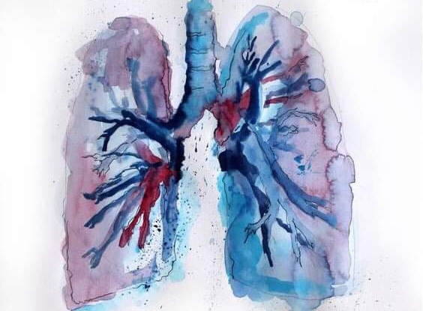
pathology

- Sub-system : physiology
- Lecture title : last 2 slides from lec 7 + lec 8
- Lecture date : 24/11
- Sheet writer :farah Ibrahim khraisat

- Pneumothorax :
- Simple/spontaneous…without known lung disease…young healthy men.
## mainly smokers.
## there’s no specific cause.
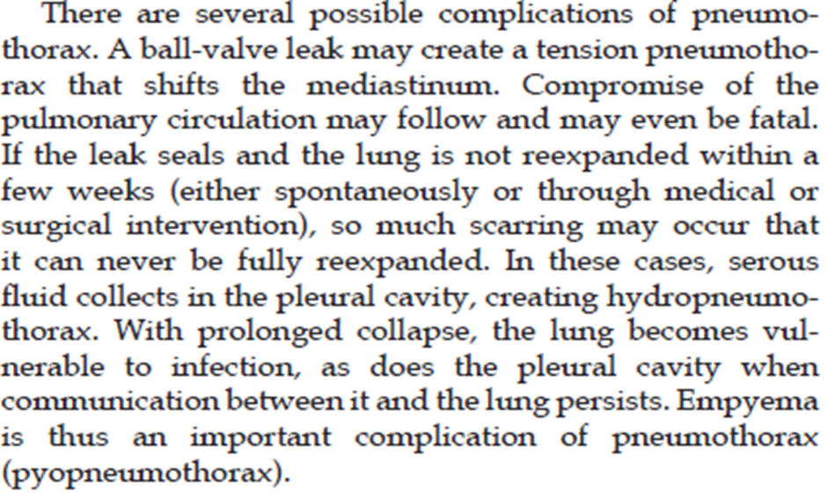
- Secondary…with known thoracic or lung disorder .
in all types of pneumothorax especially that associated with trauma , if the air accumulates in the pleural spaces without return (enters and doesn’t exit) a life threatening condition called “ball-valve effect” arise leading to tension pneumothorax
* tension pneumothorax can push the lungs and causes lung collapse which increases the risk of infection which in turn can lead to empyema ( pyopneumothorax )== is a collection of pus in the pleural cavity caused by microorganisms

* hydropneumothorax : the presence of both air and fluid within the pleural space ( pneumothorax with effusion )
Related to: * specific lung disease *or trauma
In trauma there’s a rupture allows the air to enter from outside the body to the pleural spaces.
Lung diseases ( asthma , COPD , RLD )will also allow the air to flow out from the lungs to the pleural spaces

- Other pleural fluid accumulations:
There’s hemorrhage inside the pleural cavity as a complication of trauma , surgery or ruptured intrathoracic aortic aneurysm
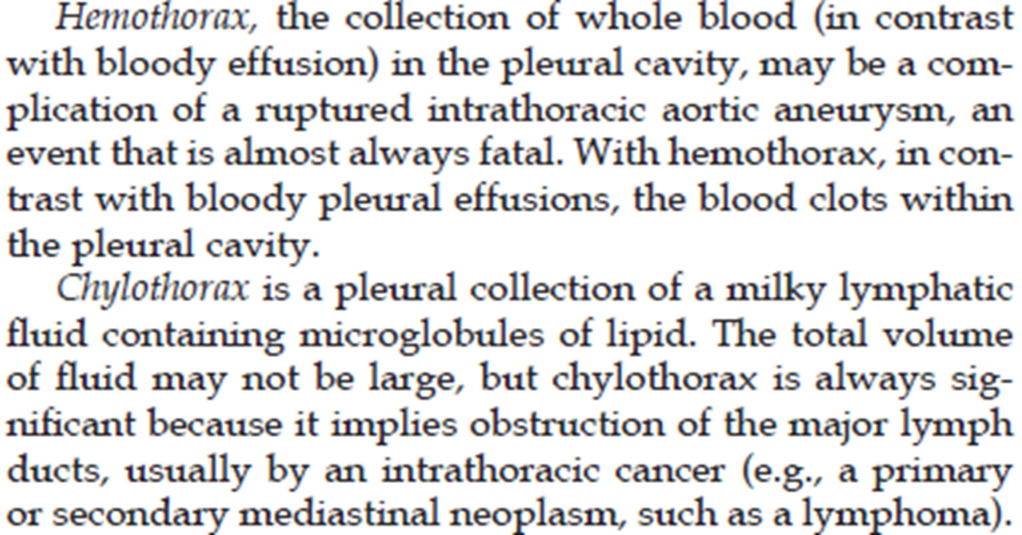
Chylothorax : lipid-rich milky fluid ( lymphatic obstruction in the thorax =< lymphatic drainage in the thorax lead to lipid-rich fluid accumulation in the pleural spaces )
Here we think about these three conditions : 1- lymphoma 2- TB 3- metastasis ( cancer )

Lecture 8: Tumors of the nose, sinuses, nasopharynx & larynx

- Nasal polyps :
*polypoid of the stroma of nose or sinus covered by epithelium.
*There is recurrent inflammation in the nasal mucosa makes the stroma become edematous and infiltrated with eosinophils and neutrophils….. so nasal polyps is a reactive process ( recurrent inflammation )

- Focal protrusions of nasal mucosa due to recurrent rhinitis
- Edematous mucosa having a loose stroma, often harboring hyperplastic or cystic mucous glands, infiltrated with a variety of inflammatory cells, including neutrophils, eosinophils, and plasma cells with occasional clusters of lymphocytes
- May become ulcerated or infected

- When multiple or large, the polyps may encroach on the airway and impair sinus drainage ( ** can obstruct the sinus drainage leading to recurrent chronic sinusitis )
- Although they point to allergy ( ** the pathogenesis of the nasal polyps associated with the allergy ), most people with nasal polyps are not atopic, and only 0,5% of atopic patients develop polyps
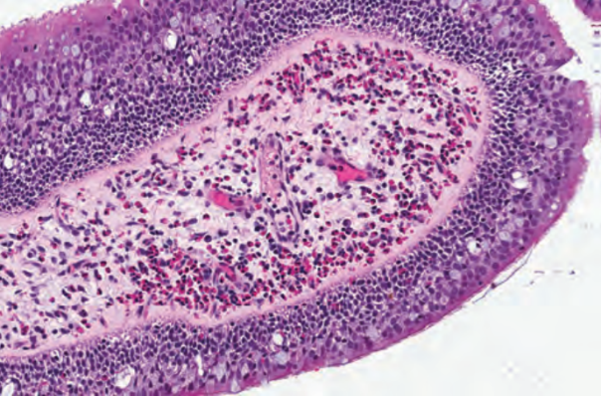
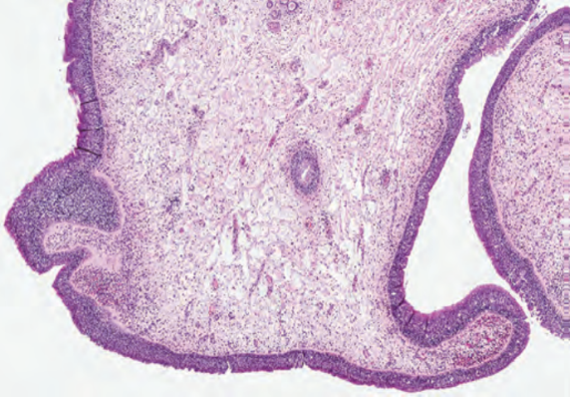

- Nasopharyngeal angiofibroma : ( neoplasm )

- Benign, highly vascular tumor.( angio = vascular )
- Occurs almost exclusively in adolescent males who are often fair-skinned and red headed.
- Epistaxis.
- There is an association with familial adenomatous polyps ( fap ) .( mutation in the tumor suppressor gene (ABC)=( Adenomatous polyposis coli) and oncogenic mutation in beta catenin )

- Surgical removal is the treatment of choice. However, because of its locally aggressive nature and intracranial extension ( leading to fatal hemorrhage ), recurrence rates can be as high as 20% ( but that does not mean its malignant , there’re tumers with high recurrence rate and they are benign ).
- Can be fatal because of hemorrhage and intracranial extension (9%).

- Sinonasal (Schneiderian) papilloma :

- A benign neoplasm ( ** in respiratory lining or squamous lining )

- Can occur in 1 of three forms: 1- exophytic (most common) ( ** finger like projections ), 2- endophytic (inverted; most important biologically)and 3- cylindrical .
#endophytic ;
(** finger like projections but towards inside )
(** more dangerous, because there’s higher risk of transformation into carcinoma and higher rate of recurrence than exophytic )

- HPV DNA, often types 6 and 11, has been identified…not in cylindrical type.
- Most commonly in adult males between the ages of 30 and 60.
- Inverted type has a high rate of recurrence if not adequately excised (** adequate excision is very important in high recurrence tumors ), with the potentially serious complication of invasion of the orbit or cranial vault. Furthermore, malignant transformation is observed in approximately 10% of cases

- Nasopharyngeal carcinoma:
- Epstein-Barr virus-associated in a high percentage (** more than 80% ) especially in our region.
(**EBV associated mainly with Burkitt lymphoma (type of B cell lymphoma ))

- Risk factors: EBV infection, diets high in nitrosamines (such as fermented foods and salted fish), as well as smoking and chemical fumes.

- 1-Keratinizing squamous (** the most dangerous because it has a weak response to radiotherapy,in contrast the other two types have a good response ) . 2- nonkeratinizing squamous and 3- undifferentiated types (** this type mainly associated with EBV ).

- Often clinically occult for long periods, and present with nasal obstruction, epistaxis, and often metastases to the cervical lymph nodes in as many as 70% of the patients (sometimes only as this).

- Good response to radiotherapy (except the keratinizing type-bad).

- Vocal cord nodules & polyps: (** or laryngeal nodules and polyps )
  - Reactive, not neoplastic (** and doesn’t transform into cancer )

  - Most often in heavy smokers or in individuals who impose great strain on their vocal cords (singer’s nodules)

  - These nodules are smooth, rounded, sessile or pedunculated excrescences, generally only a few millimeters in the greatest dimension, located usually on the true vocal cords

  - They characteristically change the character of the voice and often cause progressive hoarseness. They virtually never give rise to cancers.

- Laryngeal squamous papilloma and papillomatosis:
- Laryngeal squamous papillomas are benign neoplasms, usually located on the true vocal cords. (** papillomatosis = multiple papilloma )

- Microscopically: finger-like projections supported by central fibrovascular cores and covered by an orderly stratified squamous epithelium

- Papillomas are usually single (** but it can be multiple ) in adults but are often multiple in children, in whom they are referred to as juvenile laryngeal papillomatosis. However, multiple recurring papillomas also occur in adults

- The lesions are caused by HPV types 6 and 11

- They do not become malignant, but frequently recur (** specially papillomatosis and the problem here that we may need to do multiple surgeries because its multiple papilloma )

- They often spontaneously regress at puberty, but some affected patients undergo numerous surgeries before this occurs

- Carcinoma of the larynx:

* Typically: Squamous cell carcinoma in male chronic smokers…old age

*Sequence: hyperplasia atypical hyperplasia dysplasia
carcinoma in situ invasive carcinoma (** this is the normal sequence before any squamous cell carcinoma )

*Other factors: alcohol, nutritional factors, exposure to asbestos, irradiation, and infection with HPV (** HPV it’s also a risk factor for SCC in cervix and anogenital area )

*Variable gross presentation: may be only white plaques (leukoplakia) especially in precursor lesions (** or as an ulcer in the larynx or as exophytic growth )

*Most common site: glottic (vocal cords)
*Persistent hoarseness, dysphagia, and dysphonia

