Gastrointestinal Physiology
Structure and Innervation of the Gastrointestinal Tract
Structure of the gastrointestinal (GI) tract, Layers of the Gastrointestinal Tract
1. Mucosa: including
A lining epithelium, including glandular tissue,
an underlying layer of loose connective tissue called the lamina propria, which provides vascular support for the epithelium, and often contains mucosal glands. Products of digestion pass into these capillaries. Lymphoid follicles and plasma cells are also often found here.
Finally, a thin double layer of smooth muscle is often present; the muscularis mucosa for local movement of the mucosa.
2. Sub-mucosa:
A loose connective tissue layer, with larger blood vessels, lymphatic vessels, nerves, and can contain mucous secreting glands.
3. Muscularis propria (externa):
There are usually two smooth muscle layer;
the inner layer is circular (contraction causes decrease diameter), and the
outer layer is longitudinal (contraction causes shorting).
4. Adventia layer (or serosa):
Outermost layer of loose connective tissue; covered by the visceral peritoneum. Contains blood vessels, lymphatics and nerves
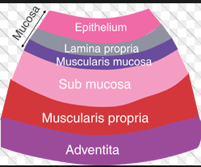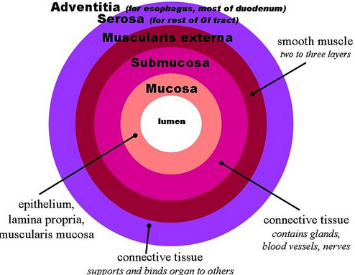
Gastrointestinal Smooth Muscle Functions as a Syncytium.
The individual smooth muscle fibers in the gastrointestinal tract are 200 to 500 micrometers in length and 2 to 10 micrometers in diameter, and they are arranged in bundles of as many as 1000 parallel fibers. In the longitudinal muscle layer, the bundles extend longitudinally down the intestinal tract; in the circular muscle layer, they extend around the gut.
Within each bundle, the muscle fibers are electrically connected with one another through large numbers of gap junctions that allow low-resistance movement of ions from one muscle cell to the next. Therefore, electrical signals that initiate muscle contractions can travel readily from one fiber to the next within each bundle but more rapidly along the length of the bundle than sideways.
Each bundle of smooth muscle fibers is partly separated from the next by loose connective tissue, but the muscle bundles fuse with one another at many points, so in reality each muscle layer represents a branching latticework حصيرةof smooth muscle bundles. Therefore, each muscle layer functions as a syncytium; that is, when an action potential is elicited anywhere within the muscle mass, it generally travels in all directions in the muscle. The distance that it travels depends on the excitability of the muscle; sometimes it stops after only a few millimeters, and at other times it travels many centimeters or even the entire length and breadth of the intestinal tract.
Also, because a few connections exist between the longitudinal and circular muscle layers, excitation of one of these layers often excites the other as well
Digestive motility and secretion are carefully regulated to maximize digestion and absorption of ingested food. Four factors are involved in regulating digestive system function: (1) autonomous smooth-muscle function, (2) intrinsic nerve plexuses, (3) extrinsic nerves, and (4) gastrointestinal hormones.
Innervation of the GI tract
• The autonomic nervous system (ANS) of the GI tract comprises both extrinsic and intrinsic nervous systems.
1. Extrinsic innervation (parasympathetic and sympathetic nervous systems)
• Efferent fibers carry information from the brain stem and spinal cord to the GI tract.
• Afferent fibers carry sensory information from chemo-receptors (activated by H+, proteins, and lipids in chime), mechano-receptors (activated by distension of the digestive walls by food (bolus or chyme)) and osmo-receptors (activated by amino acids and glucose) in the GI tract to the brain stem and spinal cord.
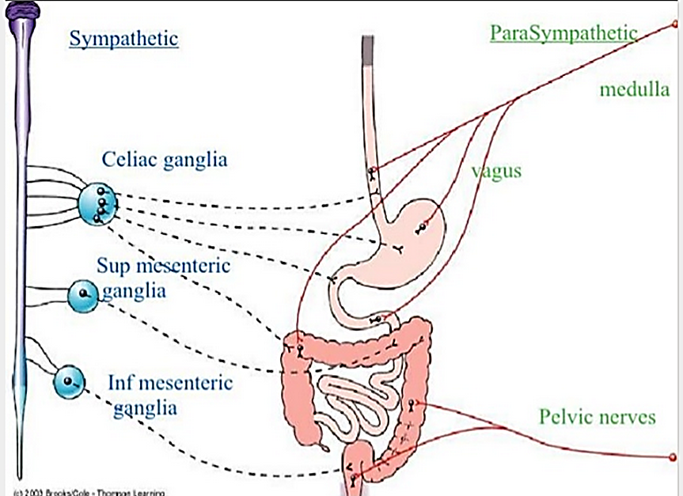
a. Parasympathetic nervous system
• is usually excitatory on the functions of the GI tract.
• is carried via the vagus and pelvic nerves.
• Pre-ganglionic parasympathetic fibers synapse in the enteric plexuses.
• Cell bodies in the ganglia of the enteric plexuses then send information to the smooth muscle, secretory cells, and endocrine cells of the GI tract.
All effects of vagal and pelvic efferent neurons are mediated via synapses on enteric neurons
(1) The vagus nerve innervates the esophagus, stomach, pancreas, and upper large intestine.
• Reflexes in which both afferent and efferent pathways are contained in the vagus nerve are called vagovagal reflexes.
(2) The pelvic nerve innervates the lower large intestine, rectum, and anus.
b. Sympathetic nervous system
• is usually inhibitory on the functions of the GI tract (the)
• Fibers originate in the spinal cord between T-8 and L-2.
• Pre-ganglionic sympathetic cholinergic fibers synapse in the pre-vertebral ganglia.
• Postganglionic sympathetic adrenergic fibers leave the pre-vertebral ganglia and synapse in
the enteric plexuses. Cell bodies in the ganglia of the enteric plexuses then send information to the smooth muscle, secretory cells, and endocrine cells of the GI tract;
End on post-ganglionic cholinergic neurons, where the nor-epinephrine they secret inhibits acetylcholine secretion
direct postganglionic adrenergic innervation of blood vessels and some smooth muscle cells also occurs where they produce vasoconstriction
Extrinsic nerves functions:
The autonomic nerves influence digestive tract motility and secretion either by
Modifying ongoing activity in the intrinsic plexuses,
Altering the level of gastrointestinal hormone secretion
Acting directly on the smooth muscle and glands.
One of the major purposes of specific activation of extrinsic innervations is to coordinate activity between different regions of the digestive system.
The parasympathetic nerve fibers supplying the digestive tract, which arrive primarily by way of the vagus nerve, tend to increase smooth muscle motility and promote secretion of digestive enzymes and hormones. The sympathetic nervous system activation has an opposite effect
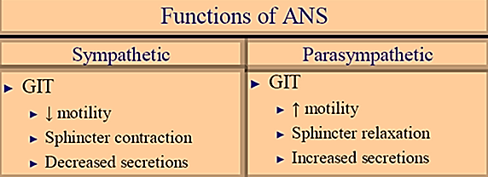
- The autonomic nerves, especially the vagus nerve, can be discretely activated to modify only digestive activity.
In GIT the neurotransmitter are either major neurotransmitters (like (1) acetylcholine, (2) norepinephrine, (3) adenosine triphosphate, (4) serotonin, (5) dopamine, (6) cholecystokinin, (7) substance P, (8) vasoactive intestinal polypeptide, (9) somatostatin, (10) leu-enkephalin, (11) met-enkephalin, and (12) bombesin and (13) nitric oxide or neuropeptides.
Neuropeptides are short chains of amino acids; it may act as hormones or neurotransmitter.
The primary criteria of neurotransmitter are:
1. The substance must be present within the presynaptic neuron.
2. The substance must be released in response to pre-synaptic depolarization,
3. Specific receptors for the substance must be present on the postsynaptic cell.
Acetylcholine most often excites gastrointestinal activity. Norepinephrine almost always inhibits gastrointestinal activity, as doe’s epinephrine, which reaches the gastrointestinal tract mainly by way of the blood after it is secreted by the adrenal medullae into the circulation.
2. Intrinsic innervation (enteric nervous system)
Enteric nervous system comprises submucosal plexus and myenteric plexus
Enteric nervous system lies entirely in the wall of the gut
Enteric nervous system beginning in the esophagus and extending all the way to the anus.
Enteric nervous system number of neurons is about 100 million, nearly equal to the number of neurons in the entire spinal cord.
A. Enteric nervous system integrates and coordinates the motility, secretory, and endocrine functions of the GI tract.
B. Enteric nervous system coordinates and relays information from the parasympathetic and sympathetic nervous systems to the GI tract.
C. The enteric nervous system (ENS) generates and modulates many digestive functions especially motility and secretion without input from the central nervous system and has been described as the “little brain.”
The enteric nervous system uses local reflexes to relay information within the GI tract.
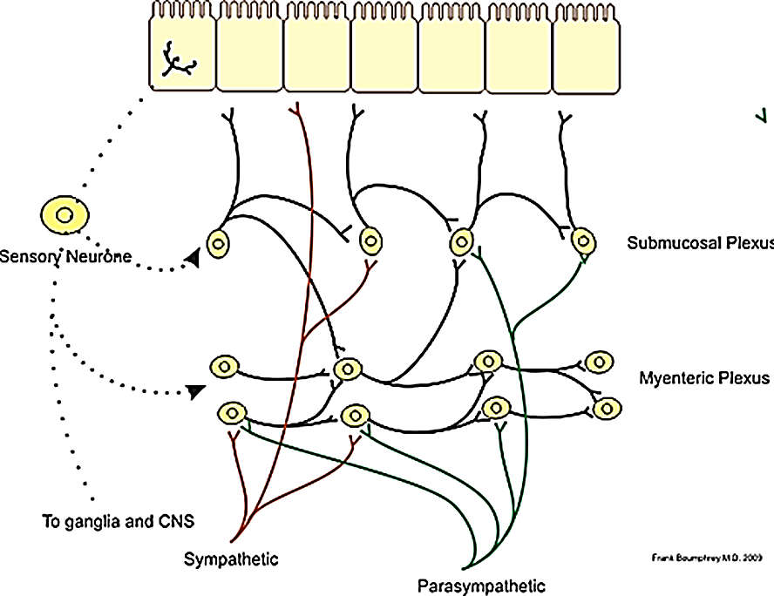
The enteric nervous system contains
sensory or afferent neurons (sometimes called intrinsic primary afferent neurons [IPANs]) that sense the environment so can be stimulated by chemoreceptors: any chemical changes (eg, intestinal pH, osmorlality), irritation (toxins) or mechanoreceptors wall stretch
inter-neurons (the connectors)
As with the central nervous system, these input and output neurons of the enteric nervous system are linked by inter-neurons. Some of the output neurons are excitatory, and some are inhibitory. These intrinsic nerve networks primarily coordinate local activity within the digestive tract.
secreto-motor or efferent neurons that control all facets of digestive tract activity; many cell types to stimulate or inhibit motility, secretion, absorption, and immune function of the GI tract.
Some are sensory neurons; other local neurons innervate the smooth muscle cells and exocrine and endocrine cells of the digestive tract to directly affect digestive tract motility, secretion of digestive juices, and secretion of gastrointestinal hormones.
The extrinsic sympathetic and parasympathetic fibers that connect to both the myenteric and submucosal plexuses. Although the enteric nervous system can function independently of these extrinsic nerves, stimulation by the parasympathetic and sympathetic systems can greatly enhance or inhibit gastrointestinal functions.
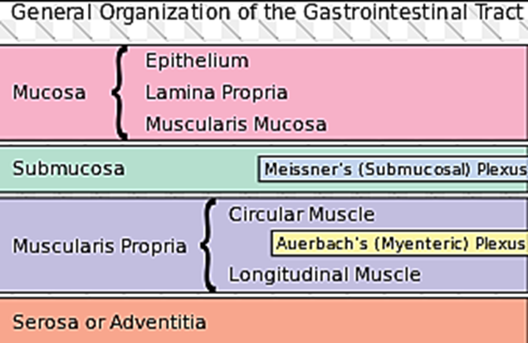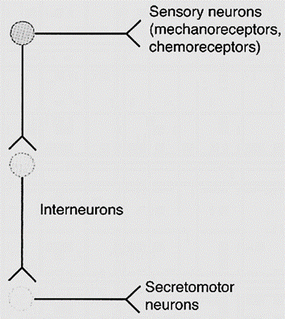
The enteric nervous system consists of nerve cell bodies that are connected by their processes to form two major ganglionated plexi in the digestive tract:
a. Myenteric plexus (Auerbach's plexus)
The myenteric plexus consists mostly of a linear chain of many interconnecting neurons
The myenteric plexus extends the entire length of the gastrointestinal tract.
The myenteric plexus is located between the circular and longitudinal smooth muscle layers
The myenteric plexus primarily controls the motility of the GI smooth muscle.
Because the myenteric plexus extends all the way along the intestinal wall and lies between the longitudinal and circular layers of intestinal smooth muscle, it is concerned mainly with controlling muscle activity along the length of the gut.
The myenteric plexus should not be considered entirely excitatory because some of its neurons are inhibitory; their fiber endings secrete an inhibitory transmitter, possibly vasoactive intestinal polypeptide or some other inhibitory peptide. The resulting inhibitory signals are especially useful for inhibiting some of the intestinal sphincter muscles that impede movement of food along successive segments of the gastrointestinal tract, such as the pyloric sphincter, which controls emptying of the stomach into the duodenum, and the sphincter of the ileocecal valve, which controls emptying from the small intestine into the cecum.
When the myenteric plexus plexus is stimulated, its principal effects are
(1) increased tonic contraction, or “tone,” of the gut wall;
(2) increased intensity of the rhythmical contractions;
(3) slightly increased rate of the rhythm of contraction; and
(4) increased velocity of conduction of excitatory waves along the gut wall, causing more rapid movement of the gut peristaltic waves.
b. Sub-mucosal plexus (Meissner's plexus)
The submucosal plexus is located between the inner layer of the circular muscle layer and the sub-mucosa
The submucosal plexus primarily controls secretion and blood flow.
The submucosal plexus, in contrast to the myenteric plexus, is mainly concerned with controlling function within the inner wall of each minute segment of the intestine. For instance, many sensory signals originate from the gastrointestinal epithelium and are then integrated in the sub-mucosal plexus to help control local intestinal secretion, local absorption, and local contraction of the sub-mucosal muscle that causes various degrees of in folding of the gastrointestinal mucosa.
The submucosal plexus receives sensory information from chemoreceptors and mechanoreceptors in the GI tract.
3. Interstitial cells of Cajal (Gastrointestinal action potential and Mechanical contraction):
The interstitial cells of cajal are specialized pacemaker cells located between the smooth muscle in the wall of the stomach, small intestine, and large intestine.
The interstitial cells of cajal are connected to the smooth muscle and the myentric plexus via gap junctions.
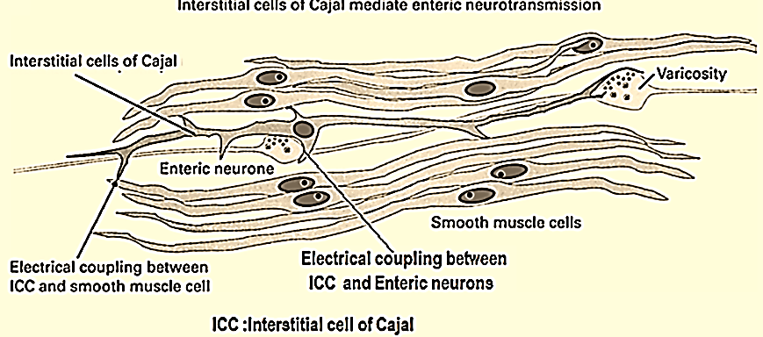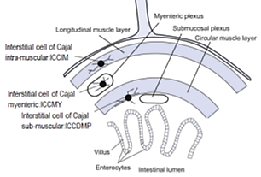
The functions of interstitial cells of Cajal are
(a) Generation of electrical slow wave activity,
Interstitial cells of Cajal are the pacemaker cells, which have the capacity to generate the basic electric rhythm or slow wave of smooth muscle.
(b) coordination of pacemaker activity and active propagation of slow waves,
(c) transduction of motor neural inputs from the enteric nervous system to the smooth cells
enteric nervous system ►interstitial cells of Cajal transmit ►to the smooth cells
(d) mechano-sensation to stretch of GI muscles
(e) setting the membrane potential gradient of gut smooth muscles.
These cells characterizes by:
  - These cells are stellate single nucleus pacemaker cells with smooth muscle-like feature that send long multiply branched processes into the intestinal smooth muscle.
  - In stomach and the small intestine, these cells are located in the outer circular muscle layer near the myenteric plexus; in the colon, they are at the sub-mucosal layer.
  - In the stomach and small intestine, there is a descending gradient in pacemaker frequency, and as in the heart, the pacemaker with higher frequency usually dominate.
  - ICC have been grouped according to either their
localization within the muscle layers
intra-muscular (ICC-IM are involved in the stimulation of smooth muscle cells, neurotransmitters act through them
myenteric (ICC-MY) serve as a pacemaker which creates the bioelectrical slow wave that leads to contraction of smooth muscle
submuscular: their basic morphology (stellate and bipolar
B. their primary function
pacemakers cells that mediate neuromuscular neurotransmission mechano-reception
Slow wave:
The cell membranes of the pacemaker cells (interstitial cells of Cajal) undergo a rhythmic depolarization and re-polarization from -65mV to -45mV.

This rhythm of depolarization-repolarization of the cell membrane creates a slow wave (general name for spontaneous electrical rhythm) known as a BER (Basal or Basic electrical rhythm (BER) or electrical control activity (ECA): specific name of slow wave in GIT), and it is transmitted to the smooth muscle cells.
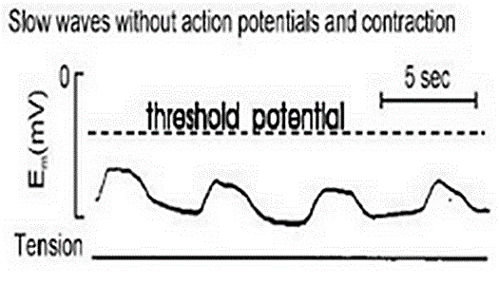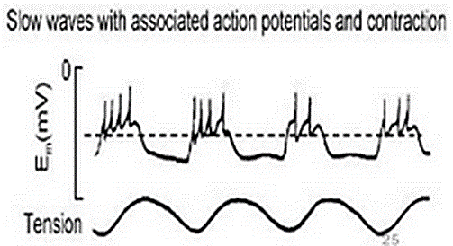
Slow wave are undulating متموجand regular change in resting membrane potential
Slow wave are produced by interstitial cell of cajal
Slow wave are not action potentials.
Slow waves are rhythmic, wave-like fluctuations in membrane potential (between -65 and -45mV) that cyclically bring the membrane closer to or farther from threshold potential.
Slow waves is not seen in the esophagus and the proximal portion of the stomach
Slow wave when reach a threshold action potential appears (called spike potential).
Slow wave do cause smooth muscle contraction only when spike potential occurs; except perhaps in the stomach. GI smooth muscle have unstable resting membrane potential of (-65mV to -45mV). If the slow wave potential rise above (-40mV), spike potential (true action potential) appears superimposed on the slow wave.
Slow wave function is to coordinate peristaltic and other motor activity
The rate of the BER is about 4/min in the stomach. It is about 12/min in the duodenum and falls to about 8/min in the distal ileum. In the colon, the BER rate rises from about 2/min at the cecum to about 6/min at the sigmoid. The function of the BER is to coordinate peristaltic and other motor activity; contractions occur only during the depolarizing part of the waves. After vagotomy or transection of the stomach wall, for example, peristalsis in the stomach becomes irregular and chaotic.
- Sheets of smooth muscle cells are connected by gap junctions through whom charge-carrying ions can flow. In this way, electrical activity initiated in a digestive-tract pace-maker cell spreads to the adjacent contractile smooth-muscle cells.
- The whole muscle sheet behaves like a functional syncytium, becoming excited and contracting as a unit when threshold is reached. If threshold is not achieved, the oscillating slow-wave electrical activity continues to sweep اكتسحacross the muscle sheet without being accompanied by contractile activity.
- Threshold is reached depends on the effect of various mechanical, neural, and hormonal factors that influence the starting point around which the slow-wave rhythm oscillates.
- The rate of self-induced rhythmic digestive contractile activities depends on the inherent rate established by the involved pace-maker cells.
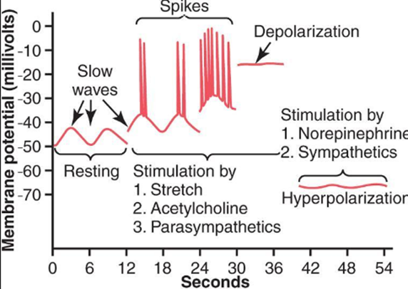
Important difference between the action potentials of the gastrointestinal smooth muscle and those of nerve fibers
1. The spike potentials duration: The spike potentials last 10 to 40 times as long in gastrointestinal muscle as the action potentials in large nerve fibers
The spike potentials spike lasting as long as 10 to 20 milliseconds.
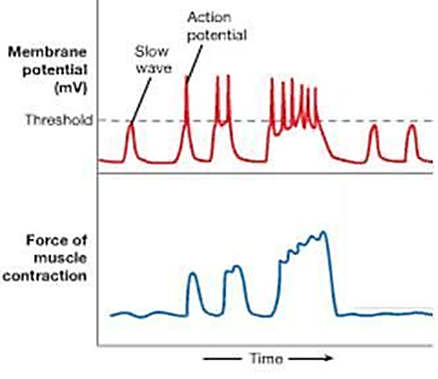
2. Ionic bases of slow wave
Slow wave without spike potential:
Depolarization: opening Fast Na channels,
Repolarization: opening of K channels
Slow wave with spike potential:
Depolarization: opening Ca-Na channels,
Repolarization: opening of K channels
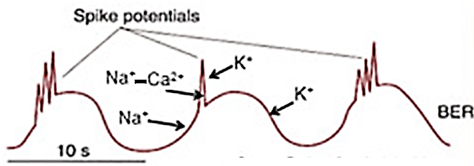
Note:
- opening Ca-Na channels allows large amount of calcium to enter and small amount of sodium to enter. These channels are much slower to open and close than are the rapid sodium channels of large nerve fibers. The slowness of opening and closing of the calcium-sodium channels accounts for the long duration of the action potentials.
Among the principle factors that can increase the basal electrical rhythm of GI smooth muscle making them to be more excitable and less negative (depolarization) including: stretch, acetylcholine, parasympathetic stimulation, some GI hormones
These factors Increase the frequency of spikes (and contraction) as well as the force of contraction
The number of spikes in slow wave will determine the degree of contraction.
The higher the frequency of spike potential ►the higher smooth muscle tension (force of contraction)

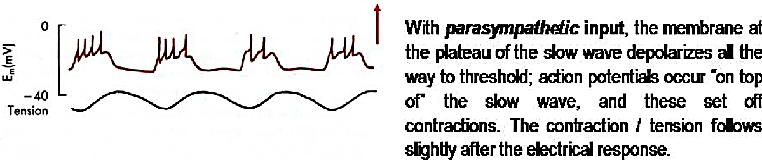
Among the principle factors that can decrease the basal electrical rhythm of GI smooth muscle making them to be less excitable including and more negative (hyperpolarization): sympathetic stimulation, epinephrine and norepinephrine
These factors decrease the frequency of spikes (and contraction) as well as the force of contraction
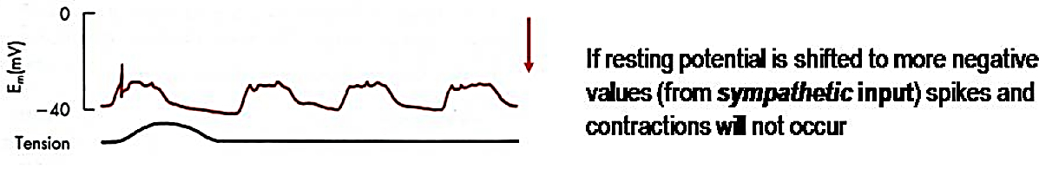
Innervation of smooth muscle cells.
Two mechanisms for neuronal innervation of gastrointestinal smooth muscle exist.
a. Most innervation occurs through interstitial cells of Cajal.
b. Neurons can also directly innervate intestinal smooth muscle cells.
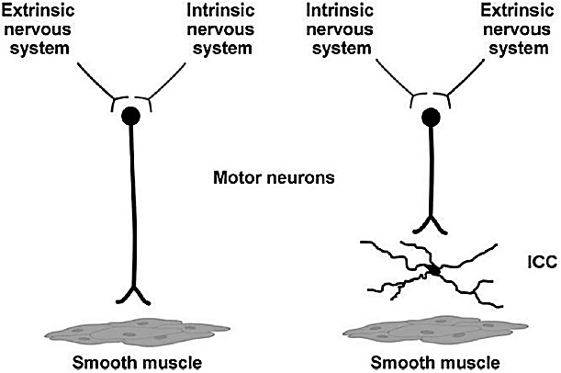
Entry of Calcium Ions Causes Smooth Muscle Contraction
The slow waves do not cause calcium ions to enter the smooth muscle fiber (they only cause entry of sodium ions). Therefore, the slow waves by themselves usually do not cause muscle contraction. Instead, it is during the spike potentials, generated at the peaks of the slow waves, that significant quantities of calcium ions enter the fibers and cause most of the contraction.
Spike potential allows L-type calcium channel and Na-Ca channel to open which causes smooth muscle contraction due to entry of calcium
Gastrointestinal Reflexes
The anatomical arrangement of the enteric nervous system and its connections with the sympathetic and parasympathetic systems support three types of gastrointestinal reflexes that are essential to gastrointestinal control:
1. Local Reflexes: that are integrated entirely within the gut wall enteric nervous system. These reflexes include those that control much gastrointestinal secretion, peristalsis, mixing contractions, local inhibitory effects, and so forth.
2. Regional Reflexes: from the gut to the pre-vertebral sympathetic ganglia and then back to the gastrointestinal tract. These reflexes transmit signals long distances to other areas of the gastrointestinal tract, such as signals from the stomach to cause evacuation of the colon (the gastro-colic reflex), signals from the colon and small intestine to inhibit stomach motility and stomach secretion (the entero-gastric reflexes), and reflexes from the colon to inhibit emptying of ileal contents into the colon (the colono-ileal reflex).
3. Systemic Reflexes: from the gut to the spinal cord or brain stem and then back to the gastrointestinal tract. These reflexes include especially
(a) Vagovagal reflex from the stomach and duodenum to the brain stem and back to the stomach—by way of the vagus nerves (vagus do have afferent sensory and efferent motor) to control gastric motor and secretory activity;
(b) pain reflexes that cause general inhibition of the entire gastrointestinal tract; and
(c) defecation reflexes that travel from the colon and rectum to the spinal cord and back again to produce the powerful colonic, rectal, and abdominal contractions required for defecation (the defecation reflexes).
Regulatory Substances in the Gastrointestinal Tract
GI hormone can be classified depending on structure to two families:
- The gastrin family: the primary members of which are gastrin and chole-cysto-kinin(CCK).
- The secretin family: the primary members of which are secretin, glicentin, VIP (vaso-active intestinal peptide), and gastric inhibitory peptide (GIP).
GI hormone can be classified depending on function to
A. GI endocrine (hormones)
GI hormones are released from endocrine cells in the GI mucosa into the portal circulation, enter the general circulation, and have physiologic actions on target cells.
Four substances meet the requirements to be considered "official" GI hormones; others are considered "candidate" مرشحhormones. The four official GI hormones are gastrin, cholecystokinin (CCK), secretin, and glucose-dependent insulino-tropic peptide (GIP).
1. Gastrin
Gastrin is produced by cells called G cells in the lateral walls of gasglands in the antral portion of the gastric mucosa.
Gastrin found in other organs in addition to stomach, including pituitary gland, , hypothalamus, medulla oblongata, vagus and sciatic nerve.
Gastrin contains 17 amino acids ("little gastrin": G₁₇). Little gastrin is the form secreted in response to a meal.
Gastrin other form is ("Big gastrin": G₃₄) contains 34 amino acids, although it is not a dimer of little gastrin.
Gastrin all biologic activity resides in the four C-terminal amino acids.
Gastrin different forms are tailored مخصصfor different action.
G₁₇ have half-life of 2 to 3 minutes in the circulation, whereas G₃₄ has a half-life of 15 min
a. Actions of gastrin
  - Stimulation of gastric acid and pepsin secretion.
  - Stimulation of growth of mucosa of the stomach, and small and large intestines (trophic action). Stimulates growth of gastric mucosa by stimulating the synthesis of RNA and new protein. Patients with gastrin-secreting tumors have hypertrophy (size of cells) and hyperplasia (number of cells) of the gastric mucosa.
  - Stimulation of gastric motility.
  - Stimulation of insulin secretion; however, only after a protein meal, and not carbohydrate meal.
b. Stimuli for secretion of gastrin
1. Luminal: Small peptides and amino acids, Distention of the stomach.
2. Neural: Vagal stimulation, mediated by gastrin-releasing peptide (GRP)
Atropine does not block vagally mediated gastrin secretion because the mediator of the vagal effect is GRP, not acetylcholine (Ach).
3. Blood borne: Calcium (hypercalcemia),Epinephrine
c. Inhibition of gastrin secretion
1. Luminal: acid in the antrum inhibit secretion partly by direct action on G cells and partly by release of somatostatin. The effect of acid is biased on negative feed-back loop regulating gastrin secretion. This negative feedback control ensures that gastrin secretion is inhibited if the stomach contents are sufficiently acidified. This is why in pernicious anemia in which the acid-secreting cells of the stomach are damaged, gastrin secretion is chronically elevated.
2. Blood borne: Secretin, somatostatin, GIP (Gastric inhibitory polypeptide also known as the glucose-dependent insulin-tropic peptide), VIP (vasoactive intestinal peptide), glucagon
d. Zollinger-Ellison syndrome (gastrinoma)
• occurs when gastrin is secreted by non-β-cell tumors of the pancreas.
2. CCK (chole-cysto Kinin) or Chole-cysto-kinin Pancero-zymin (CCK-PZ)
CCK half-life of circulating is about 5 minute.
CCK is secreted from I cells in duodenum and jejunum.
CCK In the brain, especially the cerebral cortex, may be involved in regulation of food intake
CCK appears to be related to the production of anxiety and analgesia.
CCK contains 33 amino acids.
CCK is homologous to gastrin. The seven C-terminal amino acids are the same in CCK and gastrin.
• The biologic activity of CCK resides in the C-terminal heptapeptide (7). Thus, the heptapeptide contains the sequence that is homologous to gastrin and has gastrin activity as well as CCK activity.
a. Actions of CCK
(1) Stimulates contraction of the gallbladder and simultaneously causes relaxation of the sphincter of Oddi for secretion of bile.
(2) Stimulates pancreatic enzyme secretion.
(3) Potentiates secretin-induced stimulation of pancreatic HCO3- secretion.
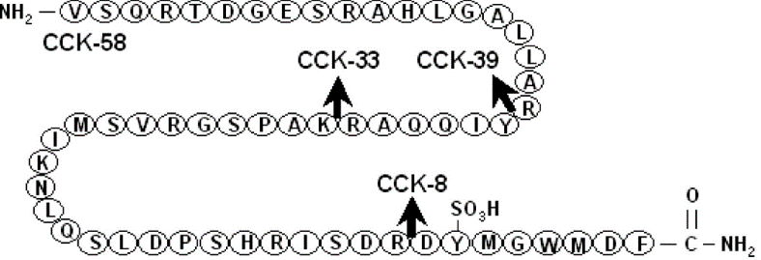
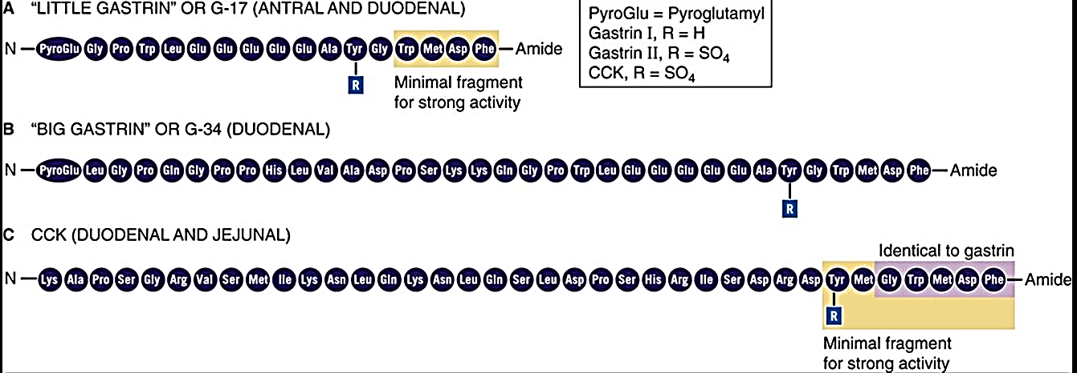
(4) Stimulates growth (trophic effect) of the exocrine pancreas.
(5) Inhibits gastric emptying. Thus, meals containing fat stimulate the secretion of CCK, which slows gastric emptying to allow more time for intestinal digestion and absorption.
Number 1+5 to give adequate time for digestion of the fats in the upper intestinal tract.
(6)Increase the secretion of entero-kinase.
(7) Enhance the motility of the small intestine and colon.
(8) CCK and secretin augments the contraction of the pyloric sphincter.
(9)Gastrin and CCK stimulate glucagon secretion after protein meal.
(10) Inhibits appetite to prevent overeating during meals by stimulating sensory afferent nerve fibers in the duodenum; these fibers, in turn, send signals by way of the vagus nerve to inhibit feeding centers in the brain
b. Stimuli for the release of CCK
(1) Small peptides and amino acids
(2) Fatty acids containing more than 10 carbon atoms and mono-glycerides
• Triglycerides do not stimulate the release of CCK because they cannot cross intestinal cell membranes.
CCK receptors are (A and B), receptor CCK-A found in the periphery, and CCK-A and CCK-B receptors found in brain.
3. Secretin
The secretin contains 27 amino acids, synthesized by S cells, which are found in the mucosa of the duodenum and the jejunum of the gastrointestinal tract.
The secretin half-life is about 5 minute. All of the amino acids are required for biologic activity.
The secretin is homologous to glucagon; 14 of the 27 amino acids in secretin are the same as those in glucagon.
a. Actions of secretin
(1) Secretin increase secretion of bicarbonate by the duct cells of the pancreas and biliary tract.
A. Secretin thus causes the secretion of watery, alkaline pancreatic juice. Pancreatic HCO3⁻ neutralizes H+ in the intestinal lumen.
B. Secretin Stimulates HCO3- and H2O secretion by the liver, and increases bile production.
(2) Secretin Inhibits H+ secretion by gastric parietal cells.
Secretin are coordinated to reduce the amount of H+ in the lumen of the small intestine.
(3) Secretin increases growth of the exocrine pancreas.
(4) Secretin augments the action of CCK in producing pancreatic secretion of digestive enzyme.
(5)Secretin has a mild effect on motility of the gastrointestinal tract
b. Stimuli for the release of secretin
• Secretin is released by the S cells of the duodenum in response to:
(1) H+ in the lumen of the duodenum
(2) Protein in the lumen of the duodenum
4. GIP (Glucose-dependent insulin-tropic peptide or Gastro-inhibitory peptide)
GIP contains 42 amino acids.
GIP is produced by K cells in the mucosa of the duodenum and jejunum.
GIP is homologous to secretin and glucagon.
a. Actions of GIP
(1) Stimulates insulin release. In the presence of an oral glucose load, GIP causes the release of insulin from the pancreas. Thus, oral glucose is more effective than intravenous glucose in causing insulin release and, therefore, glucose utilization.
(2) Large dose (not small dose) of this hormone inhibits gastric secretion (H+ secretion by gastric parietal cells) and motility this why this hormone named gastric inhibitory peptide
b. Stimuli for the release of GIP
• GIP is the only GI hormone that is released in response to fat, protein, but to a lesser extent in response carbohydrate.
• GIP secretion is stimulated by fatty acids, amino acids, and orally administered glucose.
5. Motilin
Motilin is secreted by the stomach and upper duodenum during fasting,
Motilin only known function of this hormone is to increase gastrointestinal motility.
Motilin secretion is inhibited after ingestion of food by mechanisms that are not fully understood.
Motilin is released cyclically and stimulates waves of gastrointestinal motility called inter-digestive myoelectric complexes (or migrating myoelectric complexes: MMC) that move through the stomach and small intestine every 90 minutes in a person who has fasted and MMC contraction stop when you eat
The migrating myoelectric complex functions to move undigested food into the colon and keep the upper parts of the GIT (small intestine and stomach) clear
The mid stomach to the terminal ileum parts of the GIT can have an active migrating myoelectric complex
Inter-digestive myoelectric complexes (or MMC) is often divided into four consecutive phases
(1) basal (Phase I) is a quiescent period with virtually no contractions lasts from 40–60 min
(2) pre-burst (Phase II) consists of intermittent, irregular low-amplitude contractions lasts for 40–60 min
(3) burst (Phase III) consists of intense short burst (4–6 min) of regular high-amplitude contractions for short periods. Due to this contraction all the undigested material is swept out of the stomach down to the small intestine.
Phase III contractions periodically occur every 90-120 minutes in humans.
Plasma motilin level is highly associated with the appearance of gastric phase III in humans
Plasma motilin levels vary in a cyclic fashion and its peaks regularly occur every 90-100 minutes during the period of gastric phase III in humans.
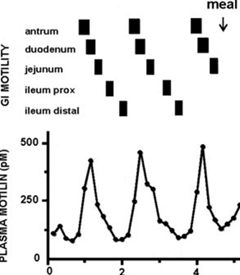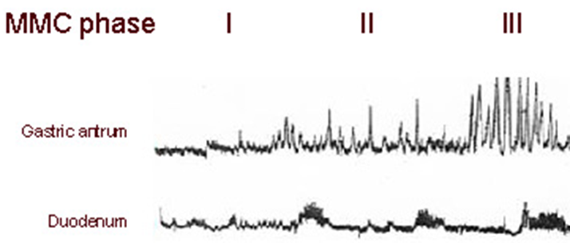
Motilin administration causes gastric phase III contractions in humans.
(4) Phase IV represents a short transition period back to the quiescence of phase I and lasts for 0–5 min, with very little or no contractions.
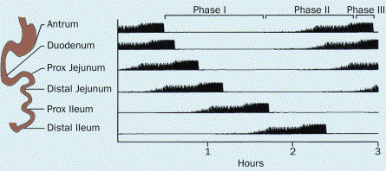
B. GI Paracrines
• are released from endocrine cells in the GI mucosa.
• diffuse over short distances to act on target cells located in the GI tract.
• The GI paracrines are somatostatin and histamine.
1. Somatostatin
Somatostatin is secreted by cells throughout the GI tract in response to H+ in the lumen.
Somatostatin secretion is inhibited by vagal stimulation.
Somatostatin inhibits the release of all GI hormones.
Somatostatin inhibits pancreatic exocrine secretion; gastric acid secretion and motility; gallbladder contraction; and the absorption of glucose, amino acid, and triglycerides.
2. Histamine
• is secreted by mast cells of the gastric mucosa.
• increases gastric H+ secretion directly and by potentiating the effects of gastrin and vagal stimulation
C. GI Neurocrines
• Neurocrines are synthesized in neurons of the GI tract, moved by axonal transport down the axon, and released by action potentials in the nerves; then diffuse across the synaptic cleft to a target cell.
• The GI neurocrines are vasoactive intestinal peptide (VIP), GRP (bombesin), and enkephalins.
1. Vasoactive intestinal peptide (VIP)
VIP contains 28 amino acids and is homologous to secretin.
VIP is released from neurons in the mucosa, smooth muscle of the GI tract and blood (which it has a half-life of about 2 minutes).
Functions of VIP
Produces relaxation of GI smooth muscle, including the lower esophageal sphincter dilation of peripheral blood vessels
Stimulates pancreatic HCO3- secretion and inhibits gastric H+ secretion. In these actions, it resembles secretin.
VIP markedly stimulate intestinal secretion of electrolytes and hence of water.
VIP potentates the action of acetylcholine in salivary glands
However, VIP and acetylcholine do not coexist in neurons that innervate other parts of GIT.
2. GRP (Gastrin Releasing peptide or bombesin)
• is released from vagus nerves that innervate the G cells.
• stimulates gastrin release from G cells.
3. Enkephalins (met-enkephalin and leu-enkephalin)
• stimulate contraction of GI smooth muscle, particularly the lower esophageal, pyloric, and ileocecal sphincters.
• inhibit intestinal secretion of fluid and electrolytes. This action forms the basis for the usefulness of opiates in the treatment of diarrhea.
Gastrointestinal Motility
• Contractile tissue of the GI tract is almost exclusively unitary smooth muscle, with the exception of the pharynx, upper one-third of the esophagus, and external anal sphincter, all of which are striated muscle.
Single-unit smooth muscle tissues: the autonomic nervous system innervates a single cell within a sheet or bundle and the action potential is propagated by gap junctions to neighboring cells such that the whole bundle or sheet contracts as a syncytium.
• Depolarization of circular muscle leads to contraction of a ring of smooth muscle and a decrease in diameter of that segment of the GI tract.
• Depolarization of longitudinal muscle leads to contraction in the longitudinal direction and a decrease in length of that segment of the GI tract.
• Phasic contractions:
Phasic contraction is twitch-like shortening followed by relaxation.
Phasic contraction occur in the esophagus, gastric antrum, and small intestine, which contract and relax periodically.
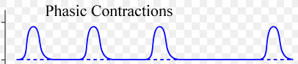
Tonic contractions:
Tonic contractions is sustained contraction of a muscle without relaxation
The tonic contraction is continuous often lasts several minutes or even hours.
The tonic contraction is not associated with the basic electrical rhythm of the slow waves
The tonic contraction often increases or decreases in intensity but continues.
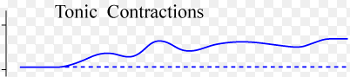
The tonic contraction is sometimes caused by
1. Continuous repetitive spike potentials—the greater the frequency, the greater the degree of contraction.
2. Hormones or other factors that bring about continuous partial depolarization of the smooth muscle membrane without causing action potentials.
3. Continuous entry of calcium ions into the interior of the cell brought about in ways not associated with changes in membrane potential.
The details of these mechanisms are still unclear.
Tonic contractions occur in the lower esophageal sphincter, orad stomach (fundus and superior part of the body), ileo-cecal sphincters internal anal sphincters.
Some smooth muscle of the gastrointestinal tract exhibits tonic contraction as well as, or instead of, rhythmical contractions.
Functional types of movements in GIT
Two types of movements occur in the gastrointestinal tract:
(1) Propulsive movement (Peristalsis)
Propulsive movement which is the basic movement of the gastrointestinal tract is peristalsis.
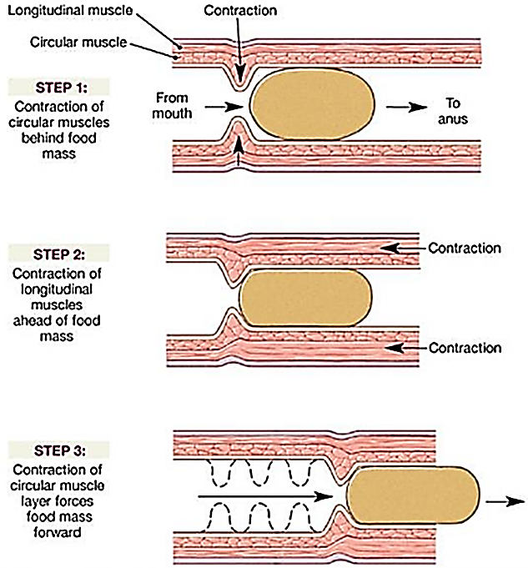
Propulsive movements (Peristalsis) which cause food to move forward along the tract at an appropriate rate to accommodate digestion and absorption
Propulsive movements (Peristalsis) is a contractile ring appears around the gut and then moves forward
Propulsive movements (Peristalsis) is a reflex response that is initiated when the gut wall is stretched by the contents of the lumen
Propulsive movements (Peristalsis) occurs in all parts of the gastrointestinal tract from the esophagus to the rectum. The stretch initiates a circular contraction behind the stimulus and an area of relaxation in front of it. The wave of contraction then moves in an oral-to-caudal direction, propelling the contents of the lumen forward at rates that vary from 2 to 25 cm/s.
Propulsive movements (Peristalsis) activity can be increased or decreased by the autonomic input to the gut
Propulsive movements (Peristalsis) occurrence is independent of the extrinsic innervation.
Propulsive movements (Peristalsis) progression of the contents is not blocked by removal and re-sutureاعادة خياطة of a segment of intestine in its original position
Propulsive movements (Peristalsis) is blocked only if the segment is reversed before it is sewn back into place.
Propulsive movements (Peristalsis) is an excellent example of the integrated activity of the enteric nervous system.
Propulsive movements (Peristalsis) appears that
local stretch releases serotonin,
▼
activates sensory neurons
▼
activate the myenteric plexus+
A. Cholinergic neurons passing in a retrograde direction in this plexus activate neurons that release substance P and acetylcholine, causing smooth muscle contraction.
B. cholinergic neurons passing in an anterograde direction activate neurons that secrete NO, vasoactive intestinal polypeptide (VIP), and adenosine triphosphate (ATP), producing the relaxation ahead of the stimulus.
The usual stimulus for intestinal peristalsis is
A. distention of the gut. Effectual peristalsis requires an active myenteric plexus.
B. chemical or strong parasympathetic nervous signals to the gut will elicit strong peristalsis. It is greatly depressed or completely blocked in the entire gut when a person is treated with atropine to paralyze the cholinergic nerve endings of the myenteric plexus.
“Law of the Gut.”
Peristalsis, theoretically, can occur in either direction from a stimulated point, but it normally dies out rapidly in the orad (toward the mouth) direction while continuing for a considerable distance toward the anus.
The peristaltic reflex plus the anal direction of movement of the peristalsis is called the “law of the gut.”
(2)Mixing movement:
Mixing movements, which keep the intestinal contents thoroughly mixed at all times.
Mixing movements differ in different parts of the alimentary tract:
A. In some areas, the peristaltic contractions cause most of the mixing. This is especially true when forward progression of the intestinal contents is blocked by a sphincter so that a peristaltic wave can then only churn يخضthe intestinal contents, rather than propelling them forward.
B. At other times, local intermittent constrictive contractions occur every few centimeters in the gut wall. These constrictions usually last only 5 to 30 seconds; new constrictions then occur at other points in the gut, thus “chopping” and “shearing” the contents first here and then there.
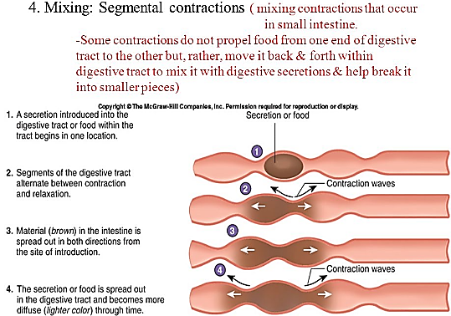
Mixing movements, retrograde movement of the chyme occurs routinely in the setting of segmentation. Mixing movements persists for as long as nutrients remain in the lumen to be absorbed.
Mixing movements presumably reflects programmed activity of the bowel dictated مقررby the enteric nervous system
Mixing movements can occur independent of central input, although the latter can modulate it.
Effect of GUT activity and metabolic factors on gastrointestinal blood flow
Under normal conditions, the blood flow in each area of the gastrointestinal tract, as well as in each layer of the gut wall, is directly related to the level of local activity.
For instance,
during active absorption of nutrients, blood flow in the villi and adjacent regions of the submucosa increases as much as eightfold.
blood flow in the muscle layers of the intestinal wall increases with increased motor activity in the gut.
after a meal, the motor activity, secretory activity, and absorptive activity all increase; likewise, the blood flow increases greatly but then decreases back to the resting level over another 2 to 4 hours.
Possible causes of the increased blood flow during gastrointestinal activity.
Although the precise causes of the increased blood flow during increased gastrointestinal activity are still unclear, some facts are known.
First, several vasodilator substances are released from the mucosa of the intestinal tract during the digestive process. Most of these substances are peptide hormones, including cholecystokinin, vasoactive intestinal peptide, gastrin, and secretin. These same hormones control specific motor and secretory activities of the gut
Second, some of the gastrointestinal glands also release into the gut wall two kinins, kallidin and bradykinin, at the same time that they secrete other substances into the lumen. These kinins are powerful vasodilators that are believed to cause much of the increased mucosal vasodilation that occurs along with secretion.
Third, decreased oxygen concentration in the gut wall
A. decreased oxygen concentration in the gut wall can increase intestinal blood flow at least 50 to 100 percent; therefore, the increased mucosal and gut wall metabolic rate during gut activity probably lowers the oxygen concentration enough to cause much of the vasodilation.
B. decreased oxygen concentration in the gut wall can also lead to as much as a fourfold increase of adenosine, a well-known vasodilator that could be responsible for much of the increased flow.
Thus, the increased blood flow during increased gastrointestinal activity is probably a combination of many of the aforementioned سابق الذكرfactors plus still others yet undiscovered.
“Countercurrent” Blood Flow in the Villi.
Countercurrent means
The arterial flow into the villus and the venous flow out of the villus are (counter current mechanism)
in directions opposite to each other
lie in close apposition to each other.
parallel to each other
Because of this vascular arrangement, much of the blood oxygen diffuses out of the arterioles directly into the adjacent venules without ever being carried in the blood to the tips of the villi.
As much as 80 percent of the oxygen may take this short-circuit route and is therefore not available for local metabolic functions of the villi.
Under normal conditions, this shunting of oxygen from the arterioles to the venules is not harmful to the villi, but in disease conditions in which blood flow to the gut becomes greatly curtailed قليل مجتزء, such as in circulatory shock, the oxygen deficit in the tips of the villi can become so great that the villus tip or even the whole villus undergoes ischemic death and disintegratesتالف. For this reason and other reasons, in many gastrointestinal diseases the villi become seriously bluntedمثلوم خشن, leading to greatly diminished intestinal absorptive capacity.
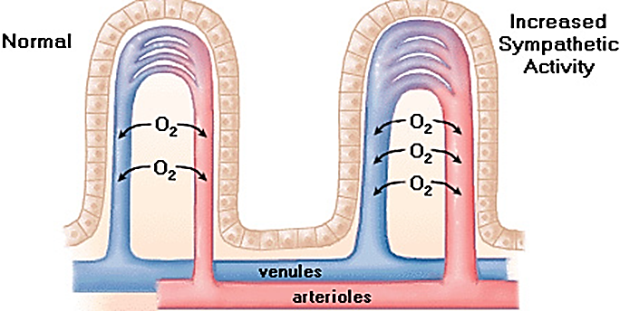
Nervous control of gastrointestinal blood flow
Stimulation of the parasympathetic nerves going to the stomach and lower colon increases local blood flow at the same time that it increases glandular secretion. This increased flow probably results secondarily from the increased glandular activity, not as a direct effect of the nervous stimulation.
Sympathetic stimulation, by contrast, has a direct effect on essentially all the gastrointestinal tract to cause intense vasoconstriction of the arterioles with greatly decreased blood flow. After a few minutes of this vasoconstriction, the flow often returns to near normal by means of a mechanism called “autoregulatory escape.” That is, the local metabolic vasodilator mechanisms that are elicited by ischemia override the sympathetic vasoconstriction, returning toward normal the necessary nutrient blood flow to the gastrointestinal glands and muscle.
Importance of nervous depression of gastrointestinal blood flow when other parts of the body need extra blood flow.
A major value of sympathetic vasoconstriction in the gut is that
It allows shutoff of gastrointestinal and other splanchnic blood flow for short periods during heavy exercise, when the skeletal muscle and heart need increased flow.
in circulatory shock, when all the body’s vital tissues are in danger of cellular death for lack of blood flow—especially the brain and the heart—sympathetic stimulation can decrease splanchnic blood flow to very little for many hours.
Sympathetic stimulation also causes strong vasoconstriction of the large-volume intestinal and mesenteric veins. This vasoconstriction decreases the volume of these veins, thereby displacing large amounts of blood into other parts of the circulation. In persons experiencing hemorrhagic shock or other states of low blood volume, this mechanism can provide as much as 200 to 400 milliliters of extra blood to sustain the general circulation.

