Motor Functions of the Spinal Cord; the Cord Reflexes
Organization of the spinal cord for motor function
The cord gray matter is the integrative area for the cord reflexes.
Sensory signals enter the cord almost entirely through the sensory roots, also known as the posterior or dorsal roots.
After entering the cord, every sensory signal travels to two separate destinations:
First branch of the sensory nerve terminates almost immediately in the gray matter of the cord and elicits local segmental cord reflexes and other local effects,
Second branch transmits signals to higher level of the nervous system (that is, to higher levels in the cord itself, to the brain stem, or even to the cerebral cortex).
Each segment of the spinal cord (at the level of each spinal nerve) has several million neurons in its gray matter. Aside from the sensory relay neurons the other neurons are of two types:
(1) anterior motor neurons and (2) interneurons.
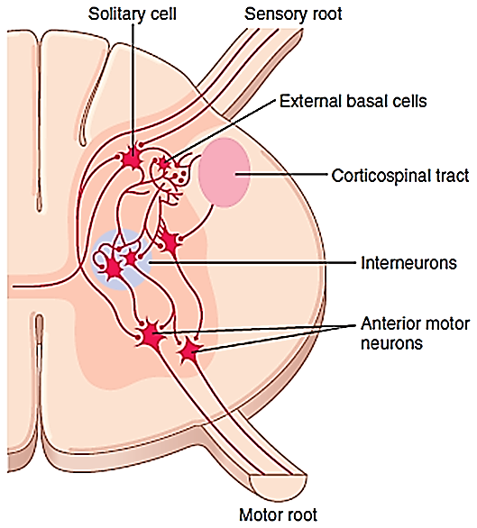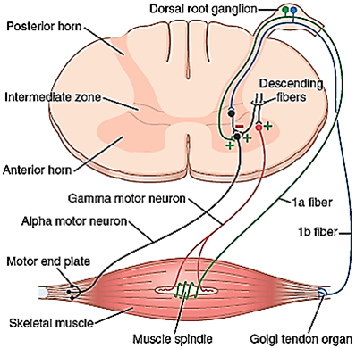
(1) Anterior Motor Neurons.
Anterior motor neurons located in each segment of the anterior horns of the cord gray matter
Anterior motor neurons are several thousand neurons
Anterior motor neurons are 50 to 100 percent larger than most of the others
Anterior motor neurons give rise to the nerve fibers that leave the cord by way of the anterior roots and directly innervate the skeletal muscle fibers.
Anterior motor neurons are of two types, alpha motor neurons and gamma motor neurons.
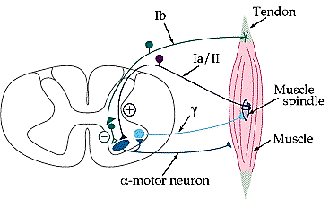
(2) Interneurons.
Interneurons are present in all areas of the cord gray matter (in the dorsal horns, the anterior horns, and the intermediate areas between them)
Interneurons are about 30 times as numerous as the anterior motor neurons.
Interneurons are small and highly excitable, often exhibiting spontaneous activity and capable of firing as rapidly as 1500 times per second.
Interneurons have many
Interconnections with one another
May synapse directly with the anterior motor neurons.
The interconnections among the interneurons and anterior motor neurons are responsible for most of the integrative functions of the spinal.
The interaction between interneurons allow the brain to perform complex functions such as learning, and decision making.
Only a few incoming sensory signals from the spinal nerves or signals from the brain terminate directly on the anterior motor neurons. Instead, almost all these signals are transmitted first through interneurons, where they are appropriately processed. Thus, the cortico-spinal tract from the brain is shown to terminate almost entirely on spinal interneurons, where the signals from this tract are combined with signals from other spinal tracts or spinal nerves before finally converging on the anterior motor neurons to control muscle function.
Interneurons can be further broken down into two groups:
Local interneurons have short axons and form circuits with nearby neurons to analyze small pieces of information.
Relay interneurons have long axons and connect circuits of neurons in one region of the brain with those in other regions
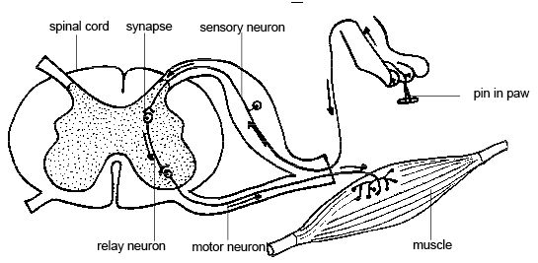
Renshaw Cells Transmit Inhibitory Signals to Surrounding Motor Neurons.
Renshaw cells located in the anterior horns of the spinal cord, in close association with the motor neurons,
Renshaw cells are a large number of small neurons. Almost immediately after the anterior motor neuron axon leaves the body of the neuron, collateral branches from the axon pass to adjacent Renshaw cells.
Renshaw cells are inhibitory cells that transmit inhibitory signals to the surrounding motor neurons. Thus, stimulation of each motor neuron tends to inhibit adjacent motor neurons, an effect called lateral inhibition.
Lateral inhibition is important for the following major reason:
The motor system uses this lateral inhibition to focus, or sharpen, its signals in the same way that the sensory system uses the same principle to allow unabated غير محدودtransmission of the primary signal in the desired direction while suppressing the tendency for signals to spread laterally.
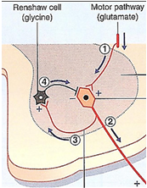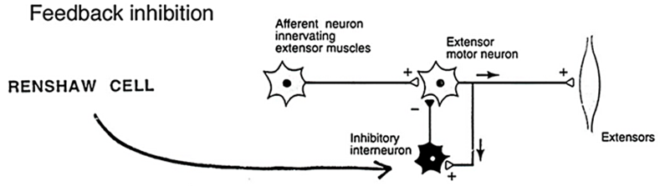
Inter-segmental (or proprio-spinal) tract:
Proriospinal fibers are the fibers that interconnect adjacent or distant segment of the spinal cord
Propriospinal Fibers run from one segment of the cord to another.
Proriospinal fibers lie close to the gray matter
Propriospinal Fibers represent more than half of all the nerve fibers that ascend and descend in the spinal cord
Propriospinal ascending and descending fibers of the cord provide pathways for the multi-segmental reflexes, including reflexes that coordinate simultaneous movements in the forelimbs and hind limbs.
In addition, as the sensory fibers enter the cord from the posterior cord roots, they bifurcate and branch both up and down the spinal cord; some of the branches transmit signals to only a segment or two, whereas others transmit signals to many segments.
Muscle sensory receptors:
Proper control of muscle function requires not only excitation of the muscle by spinal cord anterior motor neurons but also continuous feedback of sensory information from each muscle to the spinal cord, indicating the functional status of each muscle at each instant.
That is, what is the length of the muscle, what is its instantaneous tension, and how rapidly is its length or tension changing?
To provide this information, the muscles and their tendons are supplied abundantly with two special types of sensory receptors:
(1) Muscle spindles, which are distributed throughout the belly of the muscle and send information to the nervous system about muscle length rate of change of length (or velocity of a muscle)
(2) Golgi tendon organs which are located in the muscle tendons and transmit information about tendon tension (or load) and force applied to a muscle rate of change of tension.
The signals from these two receptors are
Almost entirely for the purpose of intrinsic muscle control
They operate almost completely at a subconscious level.
Even so, they transmit tremendous amounts of information to the spinal cord to the cerebellum
to the cerebral cortex, helping each of these portions of the nervous system function to control muscle contraction.
Receptor function of the muscle spindle
Structure and motor innervation of the muscle spindle.
Ordinary muscle fiber is called (extra-fusal)
Muscle spindle is also called (intra-fusal)
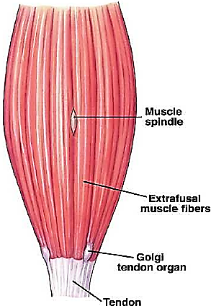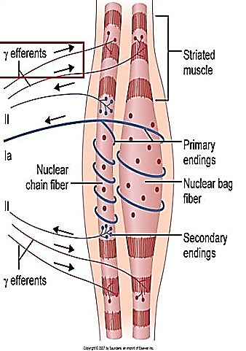
Muscle spindle is 3 to 10 millimeters long.
Muscle spindle is built around 3 to 12 tiny intra-fusal muscle fibers that are pointed at their ends and attached to the glycocalyx of the surrounding large extra-fusal skeletal muscle fibers.
Each intra-fusal muscle fiber is a tiny skeletal muscle fiber.
There are also two types of muscle spindle intra-fusal fibers:
(1) Nuclear bag muscle fibers
Nuclear bag muscle fibers is one to three in each spindle,
Nuclear bag muscle fibers several muscle fiber nuclei are congregated in expanded “bags” in the central portion of the receptor area
Types of nuclear Bag:
a. Static Nuclear Bag fibers (bag2 fibers).
These fibers signal information about the static length (no change in length) of a muscle.
b. Dynamic Nuclear Bag fibers(bag1 fibers).
These fibers signal primarily information about the rate of change (velocity) of muscle length.
A typical muscle spindle is composed of 1 dynamic nuclear bag fiber, 1 static nuclear bag fiber
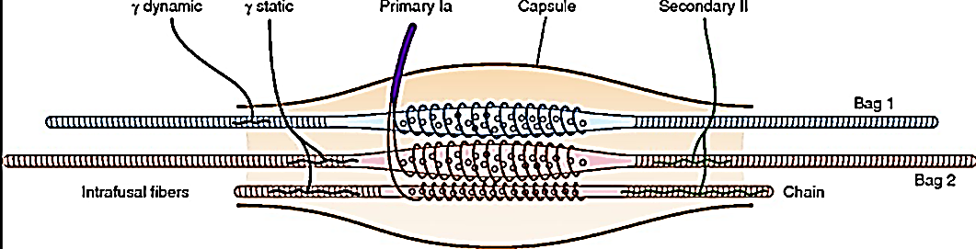
(2) Nuclear chain fibers
A typical muscle spindle is composed of three to nine nuclear chain fibers
Nuclear chain fibers are about half as large in diameter and half as long as the nuclear bag.
Nuclear chain fibers have nuclei aligned in a chain throughout the receptor area
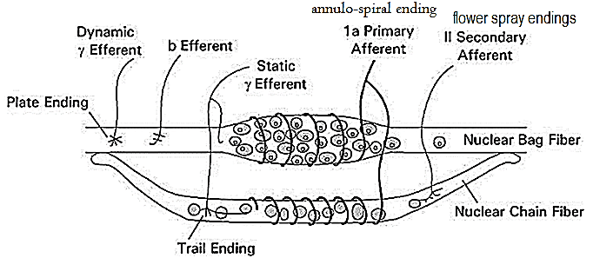
Sensory Innervation of the Muscle Spindle.
The receptor portion of the muscle spindle is its central portion.
The central region of each of these fibers (that is, the area midway between its two ends) has few or no actin and myosin filaments. Therefore, this central portion does not contract when the ends do.
Sensory fibers originate in this area and are stimulated by stretching of this mid-portion of the spindle. One can readily see that the muscle spindle receptor can be excited in two ways:
1. Lengthening the whole muscle stretches the mid-portion of the spindle and, therefore, excites the receptor.
2. Even if the length of the entire muscle does not change, contraction of the end portions of the spindle’s intra-fusal fibers stretches the mid-portion of the spindle and therefore excites the receptor.
Two types of sensory endings, the primary afferent and secondary afferent endings, are found in this central receptor area of the muscle spindle.
(1) Primary Ending or primary afferent (Ia):
In the center of the receptor area, a large sensory nerve fiber encircles the central portion of each intra-fusal fiber, forming the so-called primary afferent ending (or annulo-spiral ending (حلقية حلزونية. This nerve fiber is a type Ia fiber averaging 17 micrometers in diameter, and it transmits sensory signals to the spinal cord at a velocity of 70 to 120 m/sec, as rapidly as any type of nerve fiber in the entire body.
Because they innervate all 3 types (dynamic and static nuclear bag fibers and nuclear chain fibers) of intrafusal fibers, Group Ia afferents provide information about both length and velocity.
(2)Secondary Ending secondary afferent (II):
This sensory ending is called the secondary afferent ending; sometimes
it encircles the intrafusl fibers in the same way that the type Ia fiber does,
but often it spreads like branches on a bush (termed flower spray endings)
Usually one but sometimes two smaller sensory nerve fibers (type II fibers with an average diameter of 8 micrometers)
This sensory ending innervate the receptor region on one or both sides of the primary ending.
This sensory ending innervate the ends of the nuclear chain fibers and the static nuclear bag fibers.
Because they do not innervate the dynamic nuclear bag fibers (only static nuclear bag fibers and nuclear chain fibers), Group II afferents signal information about muscle length only. The Group II afferent increases its firing rate steadily as the muscle is stretched. Its firing rate does not depend on the rate of change of the muscle; rather, its firing rate depends only on the immediate length of the muscle.
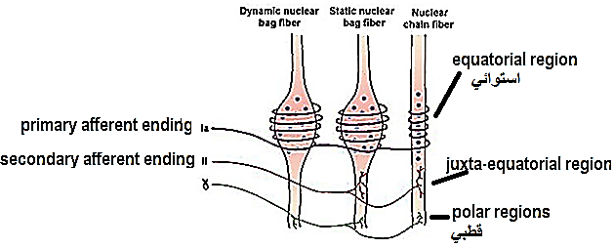
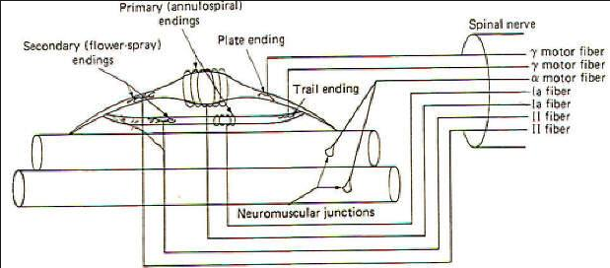
Motor innervation of extra-fusal muscle fibers by Alpha Motor Neurons (skeleto-motor fibers)
The alpha motor neurons give rise to large, lower motor neuron of the brainstem and spinal cord
The alpha motor neurons are type A alpha (Aα) motor nerve fibers
The alpha motor neurons averaging 14 micrometers in diameter
The alpha motor neurons fibers branch many times after they enter the muscle and innervate the large skeletal muscle fibers. Stimulation of a single alpha nerve fiber excites anywhere from three to several hundred skeletal muscle fibers, which are collectively called the motor unit.
Motor Innervation of the Muscle Spindle
The fusimotorمغزلي system is a system by which the central nervous system controls muscle spindle sensitivity.
The fusimotor system consists of
muscle spindles
fusimotor neurons (beta motor neurons and gamma motor neurons) because they activate the intrafusal muscle fibers.
Fusimotor drive causes a contraction and stiffening of the end portions of the intrafusal muscle fibers.
In humans, the motor component is provided by up to a dozen gamma motor neurons and to a lesser extent by one or two beta motor neurons.
(a)Gamma Motor Neurons.
Gamma motor neurons are smaller (averaging 5 micrometers in diameter) about one half than alpha motor neurons
Gamma motor neurons are type A gamma (Aγ) motor nerve fibers
Gamma motor neurons helps control basic muscle “tone,”
Gamma motor neurons innervate only intrafusal muscle fibers
Gamma motor neurons originate in the anterior horn of the spinal cord and innervate the polar regions of the intrafusal muscle fibers.
The presence of myelination in gamma motor neurons allows a conduction velocity of 4 to 24 meters per second slower than in alpha motor neurons.
When Gamma motor neurons stimulate the polar regions of the intrafusal muscle fibers to contract it stretches the non-contractile equatorial region. This allows the gamma motor neurons to control how sensitive muscle spindles are to being stretched. The contraction of the intrafusal fibers doesn't cause a difference in the overall tension of the muscle.
Gamma motor neurons do not directly adjust the lengthening or shortening of muscles. However,
Gamma motor neurons role is important in keeping muscle spindle taut by contracting the polar part of muscle spindle which is the only part contains actin and myosin to cause enough stretching of the equitorial استوائي, وسطيregion so that the Ia and II fibers receive their adequate stimulus , thereby allowing the continued firing of alpha neurons, leading to muscle contraction.
Gamma motor neurons play a role in adjusting the sensitivity of muscle spindles.
Types of gamma motor neurons:
Static gamma motor neurons (gamma-s)
Static gamma motor neurons innervate static nuclear bag fibers (bag2 fibers) and nuclear chain fibers. Static gamma motor neurons
a. increase the firing of static nuclear bag fibers (bag2 fibers) and nuclear chain fibers, in response to an increase in magnitude of change in length
b. has very little effect on dynamic nuclear bag fibers
c. controls the static sensitivity of the stretch reflex.
For this reason, this type of Static gamma motor neurons is mostly used in the maintenance of postures and slower movements such as lifting a box, rather than activities requiring rapid changes in muscle length.
Dynamic gamma motor neurons (gamma-d)
Dynamic gamma motor neurons innervate the dynamic nuclear bag fibers (bag1 fibers)
a. Dynamic gamma motor neurons can enhance the sensitivities of Ia sensory neurons and increases its discharge in response to velocity, the rate of change of muscle length rather than simply the magnitude as it is with static gamma motor neurons
b. has very little effect on static nuclear bag fibers and nuclear chain fibers
c. Dynamic gamma motor neurons firing removes the slack التراخي in dynamic nuclear bags, bringing Ia fibers closer to the firing threshold.
Therefore, this type of gamma motor neuron can be used for activities requiring quick changes in muscle length to adjust such as balancing on a rail القضيب او السلك .
(b) Type A beta (Aβ) motor nerve fibers.
Beta motor neurons innervate both extrafusal and intrafusal muscle fibers
Beta motor neurons are referred to as skeleton-fusimotor neurons
Beta muscles have smaller diameters than alpha neurons, and therefore conduct slower

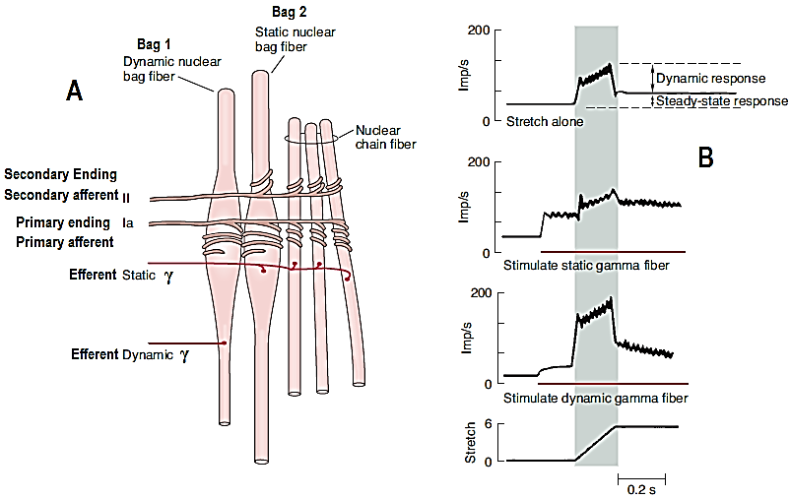
A) Three types of intrafusal muscle fibers: dynamic nuclear bag, static nuclear bag, and nuclear chain fibers. A single Ia afferent fiber innervates all three types of fibers to form a primary sensory ending. A group II sensory fiber innervates nuclear chain and static bag fibers to form a secondary sensory ending. Dynamic γ-motor neurons innervate dynamic bag fibers; static γ-motor neurons innervate combinations of chain and static bag fibers.
B) Comparison of discharge pattern of Ia afferent activity during stretch alone and during stimulation of static or dynamic γ-motor neurons.
Without γ-stimulation, Ia fibers show a small dynamic response to muscle stretch and a modest increase in steady-state firing.
When static γ-motor neurons are activated, the steady-state response increases and the dynamic response decreases.
When dynamic γ-motor neurons are activated, the dynamic response is markedly increased but the steady-state response gradually returns to its original level.
What will happen when the muscle is stretched by 10 Kg?
Continuous discharge of the muscle spindles (tonic discharge) under normal conditions.
Normally, when there is some degree of gamma nerve excitation, the muscle spindles emit sensory nerve impulses continuously.
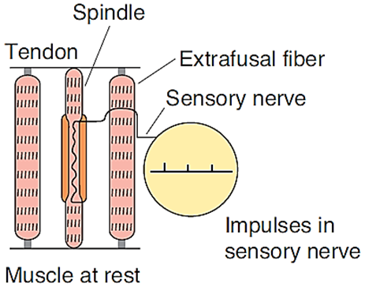
Stretching the muscle spindles increases the rate of firing of sensory nerve impulses (positive signals)
Shortening (un-stretched) the spindle decreases the rate of firing of sensory nerve impulses (negative signals)
First step:
Stimulation of muscle spindle
When the muscle is stretched by 10 Kg this will also stretch the muscle spindle and this stretch will stimulate muscle spindle causing:
A. “Static” Response II (secondary)
When the receptor portion of the muscle spindle is stretched slowly, the number of impulses transmitted from both the primary and the secondary endings increases almost directly in proportion to the degree of stretching and the endings continue to transmit these impulses for several minutes if the muscle spindle remains stretched. This effect is called the static response of the spindle receptor
The type II fibers which are attached to the chain intra-fusal fibers monitor the static stretch and length of the muscle. These fibers are slowing adapting therefore they fire while the muscle is stretching and continue to fire after the muscle has stopped moving.
B. “Dynamic” Response. Ia (primary)
When the length of the spindle receptor increases suddenly, the primary ending (but not the secondary ending i.e. Ia) is stimulated powerfully. This stimulus of the primary ending is called the dynamic response.
The rate at which the length changes is monitored by the Ia fibers around the dynamic bag fibers because these fibers are more compliant and less sensitive to stretch. These fibers are rapidly adapting so there is a quick change in their firing rate during muscle stretch but once the stretch is completed the Ia adapts and stops firing.
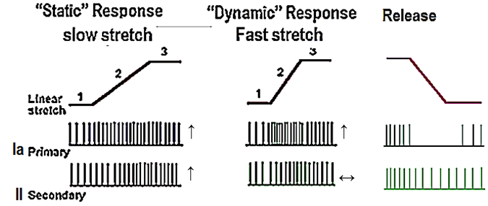
Static response | Dynamic response
a. II (secondary)  b. static Bag & chain,  c. Length changes  d. slow stretch,  e. Slow adapt, | a. Ia, (primary)  b. Dynamic Bag & static Bag & chain,  c. velocity & Length changes  d. rapid stretch,  e. rapid adapt,
The difference in the firing of rates of the muscle spindle before and after a stretch or a change in length is called the dynamic response.
If the difference is small this means there was a slow change in muscle length.
If the difference is large there was a rapid change in length.
There is a linear relationship between the rate of discharge of the afferent fibers and the length of the muscle.

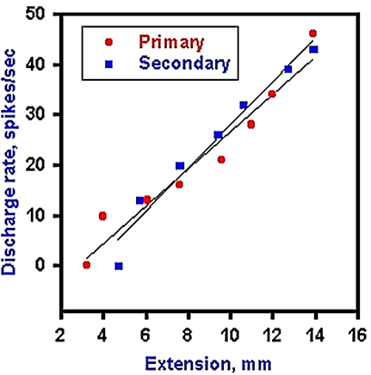
Second step:
Stimulation of alpha motor neurons (Muscle contraction)
When the whole muscle is stretched, the muscle spindle is also stretched and its sensory endings are activated at a frequency proportional to the degree of stretching (“loading the spindle”).
Spindle afferents stop firing when the muscle contracts (“unloading the spindle”).
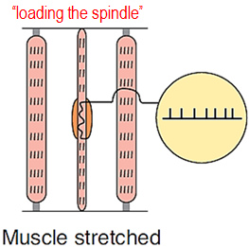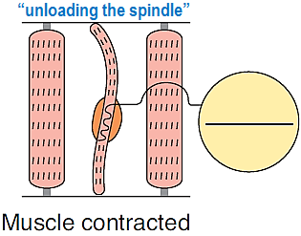
A subsequent contraction of the muscle, however, removes the pull on the spindle, and it becomes slack تثاقل او تأخر, causing the spindle afferents to cease firing. This decrease in firing rates is known as the dynamic index.
These information sent from muscle spindle through sensory nerve (Ia and II) will end in the spinal cord. Once the signal reaches the spinal cord it has a monosynaptic synapse with an alpha motor neuron that leads to the muscle where the spindle is located. This causes autogenic excitation and results in muscle contraction
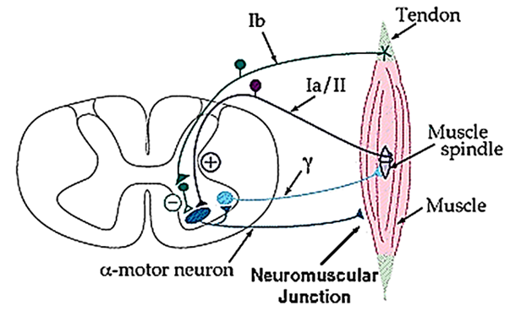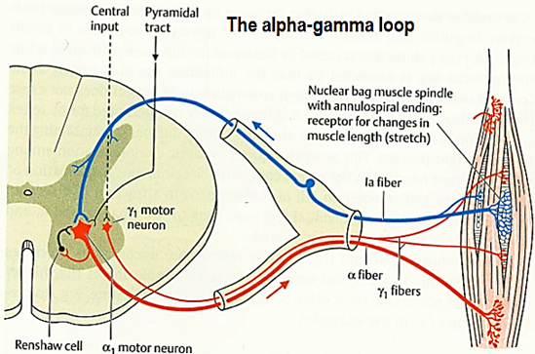
Third step:
Stimulation of gamma motor neurons (contraction of muscle spindle)
To understand the importance of the gamma efferent system, one should recognize that 31 percent of all the motor nerve fibers to the muscle are the small type A gamma (Aγ) efferent fibers rather than large type A alpha (Aα) motor fibers. Whenever signals are transmitted from the motor cortex or from any other area of the brain to the alpha motor neurons, in most instances the gamma motor neurons are stimulated simultaneously, an effect called co-activation of the alpha and gamma motor neurons. This effect causes both the extrafusal skeletal muscle fibers and the muscle spindle intrafusal muscle fibers to contract at the same time.
The purpose of contracting the muscle spindle intrafusal fibers at the same time that the large skeletal muscle fibers contract is twofold:
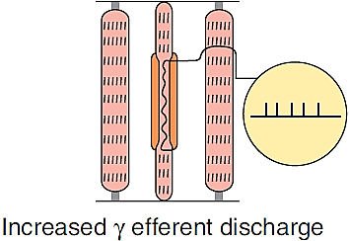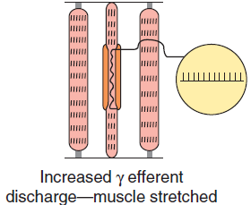
First, it keeps the length of the receptor portion of the muscle spindle from changing during the course of the whole muscle contraction. Therefore, co-activation keeps the muscle spindle reflex from opposing the muscle contraction.
Second, it maintains the proper damping function of the muscle spindle, regardless of any change in muscle length. For instance, if the muscle spindle did not contract and relax along with the large muscle fibers, the receptor portion of the spindle would sometimes be flail and sometimes be overstretched, in neither instance operating under optimal conditions for spindle function.
Dynamic and static responses of muscle spindle afferents influence physiological tremor.
The response of the Ia sensory fiber endings to the dynamic (phasic) as well as the static events in the muscle is important because the prompt, marked phasic response helps to dampen oscillations caused by conduction delays in the feedback loop regulating muscle length.
Normally a small oscillation occurs in this feedback loop. This physiologic tremor has low amplitude (barely visible to the naked eye) and a frequency of approximately 10 Hz.
Physiological tremor is a normal phenomenon which affects everyone while maintaining posture or during movements. However, the tremor would be more prominent if it were not for the sensitivity of the spindle to velocity of stretch. It can become exaggerated in some situations such as when we are anxious, tired, thyrotoxicosis, hypoglycemia or drug toxicity. Numerous factors contribute to the genesis of physiological tremor. It is likely dependent on not only central (inferior olivary nucleus also called inferior olive in the medulla oblongata) sources but also peripheral factors including motor unit firing rates, reflexes, and mechanical resonance
Muscle reflexes
Muscle reflex arc components
Reflexes or reflex actions are involuntary, almost instantaneous movements in response to a specific stimulus.
There are two types of reflexes:
Autonomic reflex or visceral (affecting inner organs)
Somatic reflex (affecting muscles):
The basic unite of this reflex is (reflex arc).
A somatic reflex arc defines the pathway by which a reflex travels, from the stimulus to sensory neuron to motor neuron to reflex muscle movement.
This arc consists of
Sense organ,
Activity in the reflex arc starts in a sensory receptor with a receptor potential (generator potential) whose magnitude is proportional to the strength of the stimulus.
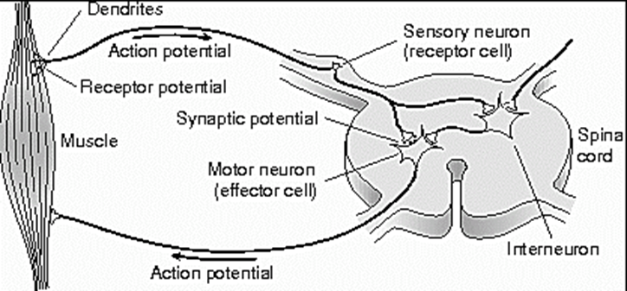
An afferent sensory neuron (sensory neurons)
The receptor potential generates all-or none action potentials in the afferent nerve, the number of action potentials being proportional to the size of the receptor potential.
Sensory neurons are typically classified as the neurons responsible for converting various external stimuli that comes from the environment into corresponding internal stimuli.
Synapses in the central integration station or sympathetic ganglion,
In the central nervous system (CNS), the responses are again graded in terms of excitatory postsynaptic potentials (EPSPs) and inhibitory postsynaptic potentials (IPSPs) at the synaptic junctions.
An efferent motor neuron (motor neurons)
Motor neurons located in the central nervous system that projects its axon outside the CNS and directly or indirectly control muscles
All-or-none responses (action potentials) are generated in the efferent nerve
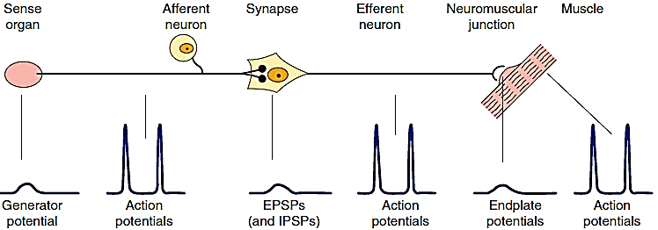
Effecter organ.
When the effector is smooth muscle, responses summate to produce action potentials in the smooth muscle, but when the effector is skeletal muscle, the graded response is adequate to produce action potentials that bring about muscle contraction.
The connection between the afferent and efferent neurons is in the CNS, and activity in the reflex arc is modified by the multiple inputs converging on the efferent neurons or at any synaptic station within the reflex arc.
General properties of reflexes:
1. Reaction time and central delay:
Reaction Time: the time between the application of stimulus and the response. In humans, the reaction time for a stretch reflex such as the knee jerk is 19–24 ms
Central delay: the time taken for the reflex activity to transverse the spinal cord.
The central delay of knee jerk is (0.6 to 0.9 ms).
2. Adequate stimulation:
The stimulation that triggers a reflex is generally very precise (i.e. adequate stimulation) e.g., the scratch reflex in a dog requires multiple touch stimuli arranged in a line, as would be produced by an insect crawling across the skin; if the touch stimuli are widely separated, or not in a line, there is no scratching (fleas take advantage of this; by jumping instead of crawling, they don't evoke the reflex)
3. Final common path:
The motor neurons that supply the extra-fusal fiber in skeletal muscle are the efferent side of many reflex acres. All neural influences affecting muscular contraction ultimately funnel through them to the muscles, and they are therefore called (final common paths).
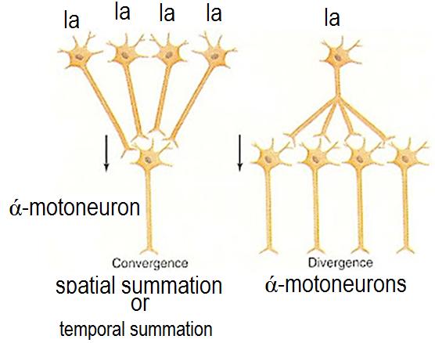
Final common pathway by spinal cord (Spinal organization of motor systems)
a. Convergence
• occurs when a single ά-motoneuron receives its input from many muscle spindle group la afferents in the homonymous muscle.
• produces spatial summation because, although a single input would not bring the muscle to threshold, multiple inputs will
• also can produce temporal summation when inputs arrive in rapid succession
b. Divergence
• occurs when the muscle spindle group la afferent fibers project to all of the ά-motoneurons that innervate the homonymous متشابهة النضفينmuscle.
4. Central excitatory and inhibitory states:
The spinal cord modified the output signals to excitatory or inhibitory output depending on the needs.
5. Habituation and sensitization of reflex responses:
The reflexes responses are stereotype نمطيdose not exclude the possibility of their being modified by experience. Reflex responses can habituate (decline in amplitude in response to repeated stimuli) or be sensitized (augmented postsynaptic responses after a habituated stimulus is paired with a noxious stimulus)
The reflexes can be classified to mono- bi- and polysynaptic reflexes, or simple mono and polysynaptic reflexes
Muscle stretch reflex (myotatic reflex) or monosynaptic reflex
Neuronal Circuitry of the Stretch Reflexمنعكس الشد
The simplest manifestation of muscle spindle function is the muscle stretch reflex.
Whenever a muscle is stretched suddenly,

excitation of the muscle spindles

Excitation of type Ia proprioceptor nerve fiber originating in a muscle spindle

entering a dorsal root of the spinal cord.

A branch of this fiber then goes directly to the anterior horn of the cord gray matter and

synapses with anterior motor neurons that send motor nerve fibers back to the same muscle from which the muscle spindle fiber originated also of closely allied synergistic muscles.
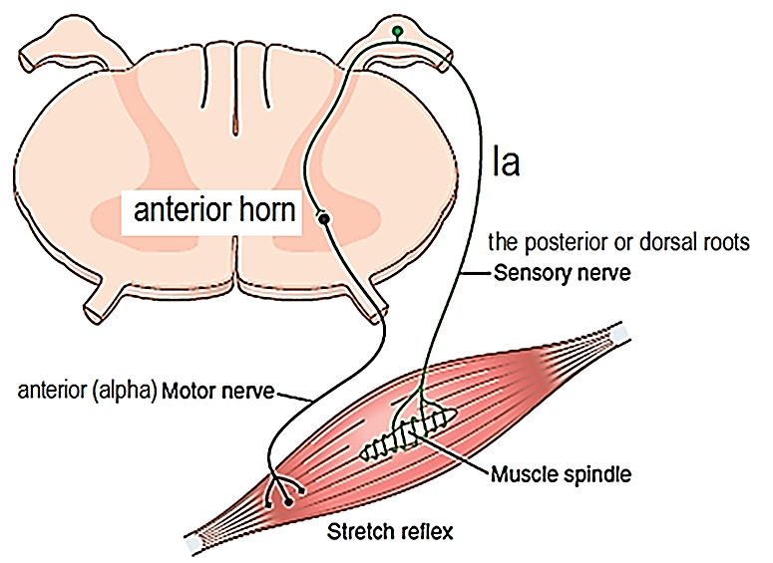
Thus, this monosynaptic pathway allows a reflex signal to return with the shortest possible time delay back to the muscle after excitation of the spindle.
Proprioceptor: a sensory receptor which receives stimuli from within the body, especially one that responds to position and movement
Changes in muscle length are associated with changes in joint angle; thus muscle spindles provide information on position (ie, proprioception).
Clinical Applications of the Stretch Reflex
The purpose of multiple stretch reflexes is to determine how much background excitation, or “tone,” the brain is sending to the spinal cord. This reflex is elicited as follows.
Stretch myotatic reflex (is monosynaptic)
Knee Jerk and Other Muscle Jerks Can Be Used to Assess Sensitivity of Stretch Reflexes.
Clinically, a method used to determine the sensitivity of the stretch reflexes is to elicit the knee jerk and other muscle jerks.
The knee jerk can be elicited by simply striking the patellar tendon with a reflex hammer; this action instantaneously stretches the quadriceps muscle and excites a dynamic stretch reflex that causes the lower leg to “jerk” forward.
Muscle reflexes can be obtained from almost any muscle of the body either by striking the tendon of the muscle or by striking the belly of the muscle itself. In other words, sudden stretch of muscle spindles is all that is required to elicit a dynamic stretch reflex.
The muscle jerks are used by neurologists to assess the degree of facilitation of spinal cord centers.
Facilitation of spinal cord centers: means how spinal cord centers handle injures. It occurs when sensory information from an area of pathology is sent via the afferents to the spinal cord.
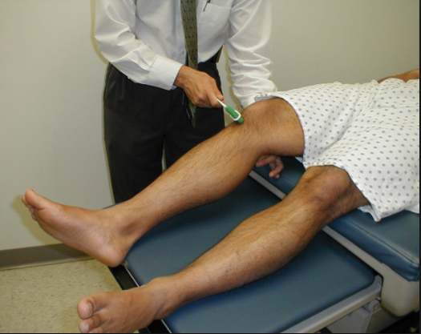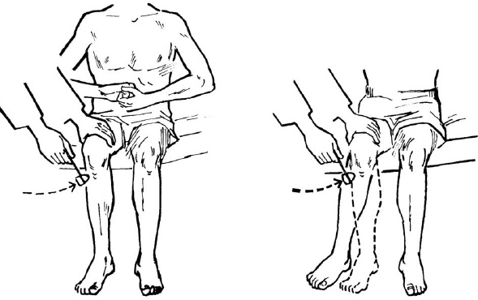
Stretch myotatic reflex or knee jerks reflex
Tapping on the patellar tendon causes the quadriceps to stretch. Stretch of the quadriceps stimulates group la afferent fibers, which activate ά-motor neurons that make the quadriceps contract. Contraction of the quadriceps forces the lower leg to extend. As the muscle contracts, it shortens, decreasing the stretch on the muscle spindle and returning it to its original length.
Increases in γ-motor neuron activity increase the sensitivity of the muscle spindle and therefore exaggerate the knee-jerk reflex.
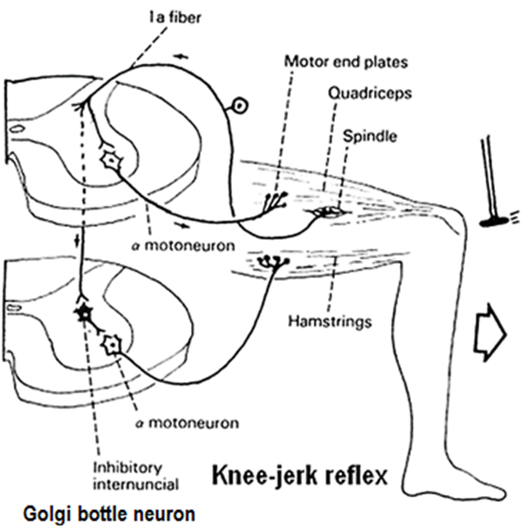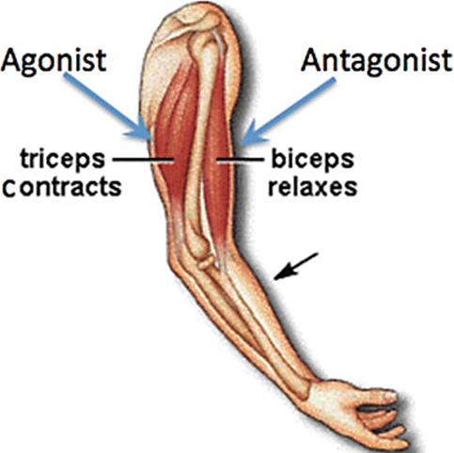
When a stretch reflex occurs, the muscle that antagonizes the action of the muscle involved (antagonists) relax. This phenomenon is said to be due to reciprocal innervation. Impulses in the Ia fibers from the muscle spindles of the protagonist muscle causes post-synaptic muscle cause post-synaptic inhibition of the motor neurons to the antagonists. The pathway mediating this effect is bi-synaptic. A collateral from each Ia fiber passes in the spinal cord to an inhibitory inter-neuron (Golgi bottle neuron is the inhibitory interneuron which is involved in the phenomenon of Reciprocal Innervation by which the antagonist muscles relax during protagonist muscle contraction) that synapses directly on one of the motor neurons supplying antagonist muscles. The best example is the reflex contraction of the biceps muscle and relaxation of triceps muscle, the reflex contraction of the quadriceps muscle and relaxation of hamstrings muscle
When contraction of a muscle is stimulated, there is a simultaneous inhibition of the antagonist muscle this is called (Sherrington’s Law of reciprocal innervation)
Dynamic Stretch Reflex and Static Stretch Reflexes.
The stretch reflex can be divided into two components:
The dynamic stretch reflex
When a muscle is suddenly stretched, simulation of dynamic nuclear bag impulses transmitted by primary nerve causing strong signal is transmitted to the spinal cord, which causes an instantaneous strong reflex contraction (or decrease in contraction) of the same muscle from which the signal originated. Thus, the reflex functions to oppose sudden changes in muscle length.
The dynamic stretch reflex is over within a fraction of a second after the muscle has been stretched to its new length
Example Knee jerk or ankle jerk reflex
The static stretch reflex
When the muscle is stretched slowly; static stretch reflex is elicited استثارby the continuous static receptor signals transmitted by both primary and secondary endings.
Static stretch reflex are weaker and continues for a prolonged period thereafter.
The importance of the static stretch reflex is that it causes the degree of muscle contraction to remain reasonably constant; this is why it play an important role in control of posture e.g. when the person is standing, gravity continue stretching on the antigravity muscle making them to continue stretching as long as the gravity making them stretched
“Damping” تقليل الاهتزازاتFunction of the Dynamic and Static Stretch Reflexes in Smoothing Muscle Contraction.
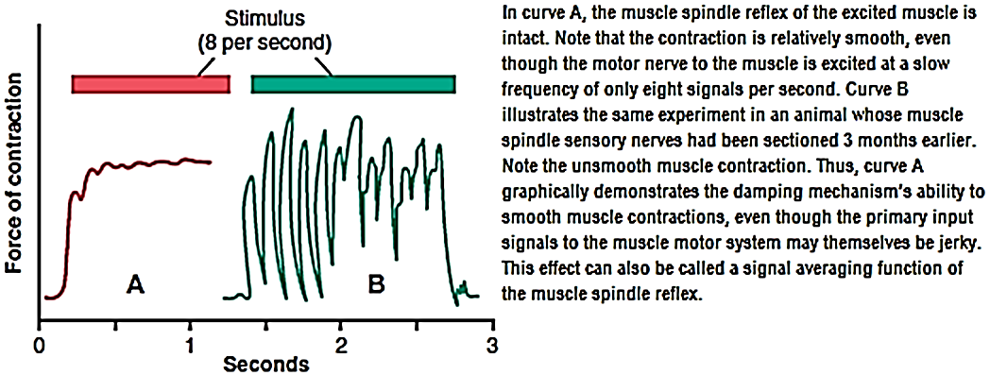
An especially important function of the stretch reflex is its ability to prevent oscillation or jerkiness of body movements, which is a damping, or smoothing, function.
Signals from the spinal cord are often transmitted to a muscle in an unsmooth form, increasing in intensity for a few milliseconds, then decreasing in intensity, then changing to another intensity level, and so forth. When the muscle spindle apparatus is not functioning satisfactorily, the muscle contraction is jerky غير متناسقduring the course of such a signal.
Golgi Tendon reflex:
The Golgi tendon organ
The Golgi tendon organ is a specialized receptor that is located between the muscle and the tendon at the musculo-tendinous junctions of somatic muscle.
The Golgi tendon organ consists of a netlike collection of knobby nerve endings among the fascicles of a tendon.
The Golgi tendon organ is located in series with the muscle, unlike the muscle spindle, which is located in parallel with extrafusal fibers.
There are 3–25 muscle fibers per tendon organ (approximately 1 Golgi tendon organ for every 10 muscle fibers).
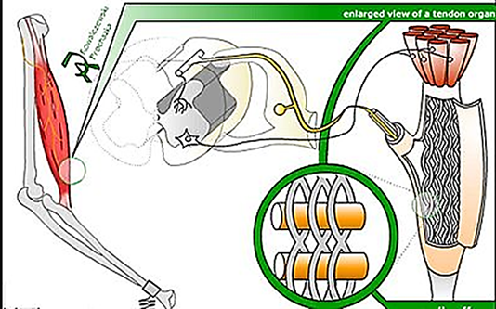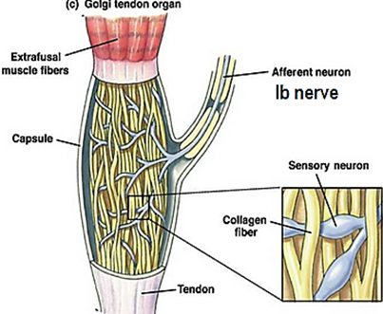
When force is applied to a muscle, the Golgi tendon organ is stretched, causing the collagen fibers to squeeze and distort the membranes of the primary afferent sensory endings. As a result, the afferent is depolarized, and it fires action potentials to signal the amount of force.
These ending produce generator potentials and action potential discharges with frequency proportional to the force exerted on the capsule.
The tendon organ acts as a "force transducer and signals information about the load or force being applied to the muscle in a sustained fashion when the muscle is active.
Transmission of Impulses from the tendon organ into the central nervous system.
Signals from the tendon organ are transmitted through type Ib nerve fibers. These fibers, like those from the primary spindle endings, transmit signals both into
a. local areas of the cord
The local cord signal excites a single inhibitory interneuron that inhibits the anterior motor neuron. This local circuit directly inhibits the individual muscle without affecting adjacent muscles.
b. long fiber pathways
The cerebellum by the dorsal spino-cerebellar tracts at conduction velocities approaching 120 m/sec, the most rapid conduction anywhere in the brain or spinal cord.
Additional pathways transmit similar information into the reticular regions of the brain stem and, to a lesser extent, all the way to the motor areas of the cerebral cortex
The fibers from the Golgi tendon organs make up the Ib group of myelinated, rapidly conducting sensory nerve fibers.
Stimulation of these Ib fibers leads to
The production of IPSPs on the motor neurons that supply the muscle from which the fibers arise. The Ib fibers end in the spinal cord on inhibitory interneurons that in turn terminate directly on the motor neurons.
Excitatory connections with motor neurons supplying antagonists to the muscle.
Because the Golgi tendon organs, unlike the spindles, are in series with the muscle fibers, they are stimulated by both passive stretch and active contraction of the muscle.
The threshold of the Golgi tendon organs is low.
The degree of stimulation by passive stretch is not great because the more elastic muscle fibers take up much of the stretch, and this is why it takes a strong stretch to produce relaxation. The CNS has information about the force output of individual motor units and can make feedback adjustments appropriately in the efferent side.
The Golgi tendon organ function:
The Golgi tendon organ detects:
a) The rate of increase of tension on a muscle during active contraction so helps control muscle tension and prevents excessive tension on the muscle
When tension on the muscle—and therefore on the tendon—becomes extreme, the inhibitory effect from the tendon organ can be so great that it leads to a sudden reaction in the spinal cord that causes instantaneous relaxation of the entire muscle. This effect is called the lengthening reaction; it is probably a protective mechanism to prevent tearing of the muscle or avulsion of the tendon from its attachments to the bone.
b) The absolute amount of tension on a muscle during an isometric contraction
The tendon organ, like the primary receptor of the muscle spindle, has both a dynamic response and a static response, reacting intensely when the muscle tension suddenly increases (the dynamic response) but settling down within a fraction of a second to a lower level of steady-state firing that is almost directly proportional to the muscle tension (the static response). Thus, Golgi tendon organs provide the nervous system with instantaneous information on the degree of tension in each small segment of each muscle.
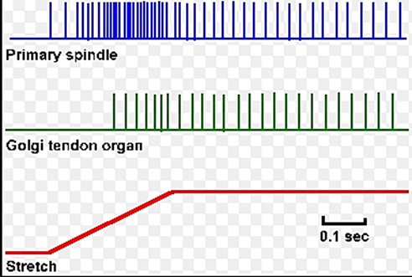
Thus, the major difference in excitation of the Golgi tendon organ versus the muscle spindle is that the spindle detects muscle length and changes in muscle length, whereas the tendon organ detects muscle tension as reflected by the tension in itself.
The possible role of the tendon reflex to equalize contractile force among these fibers.
Another likely function of the Golgi tendon reflex is to equalize contractile forces of the separate muscle fibers. That is, the fibers that exert excess tension become inhibited by the reflex, whereas those that exert too little tension become more excited because of the absence of reflex inhibition. This phenomenon spreads the muscle load over all the fibers and prevents damage in isolated areas of a muscle where small numbers of fibers might be overloaded.
Golgi tendon reflex or (inverse myotatic reflex) or Ib Reflex
Golgi tendon reflex is di-synaptic.
Golgi tendon reflex occurs when the tension become great enough, so the contraction suddenly ceases and muscle relaxes.
Golgi tendon reflex is the opposite, or inverse, of the stretch reflex. Up to a point, the harder a muscle is stretched, the stronger is the reflex contraction. However, when the tension becomes great enough, contraction suddenly ceases and the muscle relaxes. This relaxation in response to strong stretch is called the inverse stretch reflex
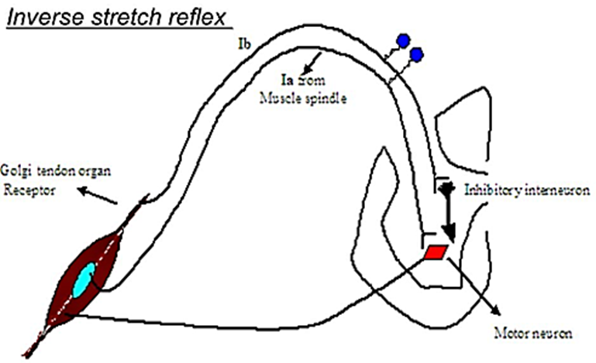
Active muscle contraction stimulates the Golgi tendon organs that detect muscle tension
▼
Golgi tendon organs connected to group Ib afferent fibers
▼
The group Ib afferents stimulate inhibitory interneurons in the spinal cord.
▼
These inter-neurons inhibit ά-motoneurons and cause relaxation of the muscle that was originally contracted. At the same time, antagonistic muscles are excited.
Muscle tone
The resistance of a muscle to stretch is often referred to as its tone or tonus. If the motor nerve to a muscle is severed, the muscle offers very little resistance and is said to be flaccid.
A hypertonic (spastic) muscle is one in which the resistance to stretch is high because of hyperactive stretch reflexes.
Somewhere between the states of flaccidity and spasticity is the ill-defined area of normal tone. The muscles are generally hypotonic when the rate of γ-motor neuron discharge is low and hypertonic when it is high.
When the muscles are hypertonic, the sequence of moderate stretch → muscle contraction, strong stretch → muscle relaxation is clearly seen. Passive flexion of the elbow, for example, meets immediate resistance as a result of the stretch reflex in the triceps muscle. Further stretch activates the inverse stretch reflex. The resistance to flexion suddenly collapses, and the arm flexes. Continued passive flexion stretches the muscle again, and the sequence may be repeated. This sequence of resistance followed by give when a limb is moved passively is known as the clasp-knife effect because of its resemblance to the closing of a pocket knife.
It is also known as the lengthening reaction because it is the response of a spastic muscle to lengthening.
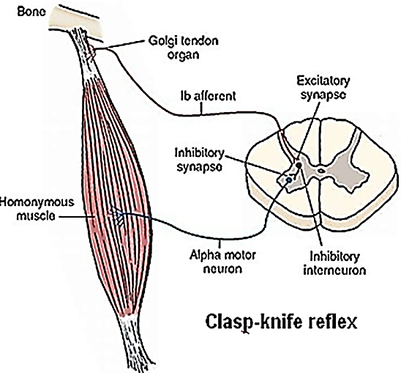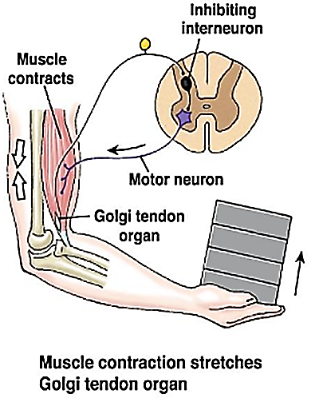
The withdrawal انسحاب او سحبreflex:
The withdrawal reflex is a typical polysynaptic reflex
The withdrawal reflex occurs in response to a noxious stimulus such as by a pinprick, heat, or a wound, to the skin or subcutaneous tissues and muscle such as arm is jerked away from the stove that can most effectively remove the pained part of the body away from the object causing the pain. For this reason it is also called a nociceptive reflex, or simply a pain reflex
When a strong stimulus is applied to a limb, the response includes
A. The flexor reflex
The flexor reflex is the withdrawal reflex response at the ipsilateral side of stimuli
a. Pain (e.g., touching a hot stove) stimulates the flexor reflex afferents of groups II, III, and IV.
b. The afferent fibers synapse poly-synaptically (via inter-neurons) onto moto-neurons in the spinal cord.
The pathways for eliciting the flexor reflex do not pass directly to the anterior motor neurons but instead pass first into the spinal cord interneuron pool of neurons and only secondarily to the motor neurons. The shortest possible circuit is a three- or four-neuron pathway; however, most of the signals of the reflex traverse many more neurons and involve the following basic types of circuits:
(1) Diverging circuits spread of the reflex to the necessary muscles for withdrawal; flexors are stimulated (they contract)
(2) Reciprocal inhibition circuits to inhibit the antagonist muscles; extensors are inhibited (they relax) because of inhibitory effects of Renshaw cells
(3) After-discharge circuits to cause that lasts many fractions of a second after the stimulus is over.
The after-discharge can be explained as follows:
The number of synapses in each of their branches varies. Because of the synaptic delay at each synapse, activity in the branches with fewer synapses reaches the motor neurons first, followed by activity in the longer pathways. This causes prolonged bombardment of the motor neurons from a single stimulus and consequently prolonged responses.

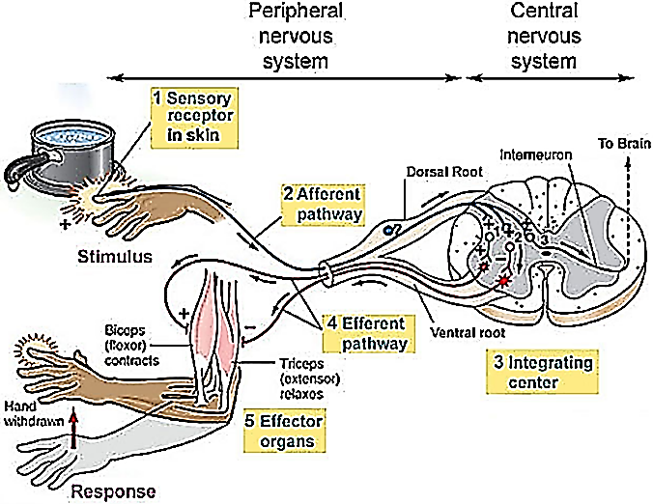
Repetitive discharge circuits (reverberating circuits): some of the branch pathways turn back on themselves, permitting activity to reverberate until it becomes unable to cause a propagated trans-synaptic response and dies out.
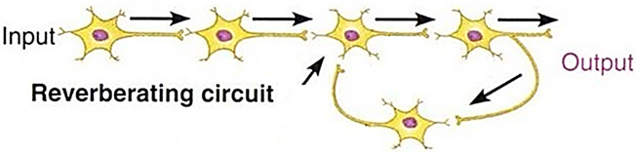
The duration of after-discharge depends on the intensity of the sensory stimulus that elicited the reflex; a weak tactile stimulus causes almost no after-discharge, but after a strong pain stimulus, the after-discharge may last for a second or more.
As the strength of a noxious stimulus is increased, the reaction time is shortened. Spatial and temporal facilitation occurs at synapses in the polysynaptic pathway. Stronger stimuli produce more action potentials per second in the active branches and because more branches to become active; summation of the EPSPs to the threshold level for action potential generation occurs more rapidly.
B. Fraction and occlusion التجزءة و التجميع
Another characteristic of the withdrawal response is the fact that supramaximal stimulation of any of the sensory nerves from a limb never produces as strong a contraction of the flexor muscles as that elicited by direct electrical stimulation of the muscles themselves. This indicates that the afferent inputs fractionate the motor neuron pool; that is, each input goes to only part of the motor neuron pool for the flexors of that particular extremity. On the other hand, if all the sensory inputs are dissected out and stimulated one after the other, the sum of the tension developed by stimulation of each is greater than that produced by direct electrical stimulation of the muscle or stimulation of all inputs at once. This indicates that the various afferent inputs share some of the motor neurons and that occlusion occurs when all inputs are stimulated at once
Myogram of the flexor reflex:
a. Within a few milliseconds after a pain nerve begins to be stimulated, the flexor response appears. b. Then, in the next few seconds, the reflex begins to fatigue, which is characteristic of essentially all complex integrative reflexes of the spinal cord.
c. Finally, after the stimulus is over, the contraction of the muscle returns toward the baseline, but because of after-discharge, it takes many milliseconds for this contraction to occur.
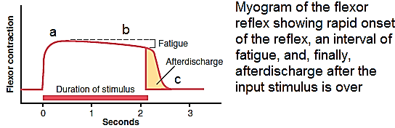
B. Cross extensor reflex
About 0.2 to 0.5 second after a stimulus elicits a flexor reflex in one limb, the opposite limb begins to extend. This reflex is called the crossed extensor reflex.
The crossed extensor response on contralateral side is extension muscle contraction and inhibition of flexor muscles
Extension of the opposite limb can push the entire body away from the object, causing the painful stimulus in the withdrawn limb.
Strong stimuli can generate activity in the interneuron pool that spreads to all four extremities. This spread of excitatory impulses up and down the spinal cord to more and more motor neurons is called irradiation of the stimulus, and the increase in the number of active motor units is called recruitment of motor units.
