

**Al- Balqa Applied University**

**Faculty of Medicine Dr. Hala Al Daghistani**

**Lecture Three**

**Blood protozoan: Plasmodium**

The causative agent of malaria (swamp fever) in human : four species including

* ***Plasmodium vivax***
* ***P. falciparum***
* ***P. malariae***
* ***P. ovale***.

[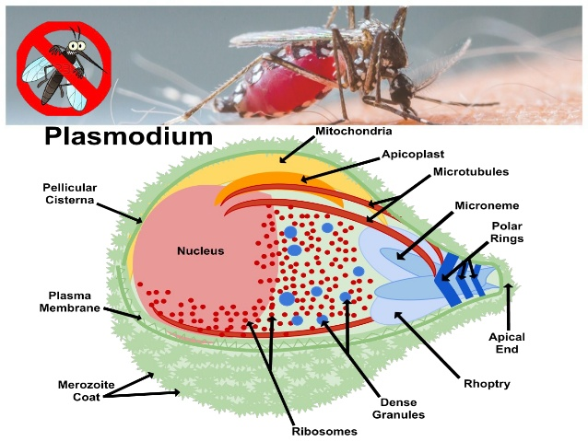](http://www.suggest-keywords.com/cGxhc21vZGl1bSBrbm93bGVzaQ/)

**The Plasmodium spp. life cycle can be divided into two parts**

1. **Asexual multiplication within the human** **host**
2. **Sexual reproduction within the mosquito vector**.

* The two most common species are ***P. vivax***and ***P. falciparum****,* with falciparum being the most pathogenic of all.
* Human infection results from the bite of an infected female *Anopheles* mosquito (380 spp.), through which the **Sporozoites** are injected into the bloodstream.
* The **sporozoites** rapidly **enter parenchymal cells of the liver**, where the first stage of development in humans takes place and numerous **asexual progeny,** the **Merozoites**, **rupture and leave the liver cells, enter the bloodstream, and invade erythrocytes.**
* During the erythrocytic cycles, certain **merozoites become differentiated as male or female gametocytes.**
* **Gametocytes develop in erythrocytes through five morphologically distinct stages, from a ring-like early stage gametocyte to a crescent-shaped mature gametocyte.**
* **Gametocytes** must be taken up and ingested by bloodsucking female *Anopheles*.

***Plasmodium vivax* and *P.ovale* may persist as dormant forms, Hypnozoites**, after the parasites have disappeared from the peripheral blood. **Reinfection (relapse) occurs when merozoites from hypnozoites in the liver break out, are not phagocytosed in the bloodstream, and succeed in reestablishing a RBC infection.**

* ***Plasmodium malariae***infections lasting 40 years have been reported; this is thought to be a **cryptic erythrocytic (RBC)** rather than an **exoerythrocytic infection (liver)** and is therefore termed a **recrudescence** to distinguish it from a **relapse.**

**Pathology and Pathogenesis**

* The incubation period for malaria is usually between 9 and 30 days, depending on the infecting species.
* For ***P vivax* and *P falciparum****,* this period is usually **10–15 days**, but it may be weeks or months.
* **Falciparum malaria**, which can be fatal, must always be suspected if **fever**, with or without other symptoms

[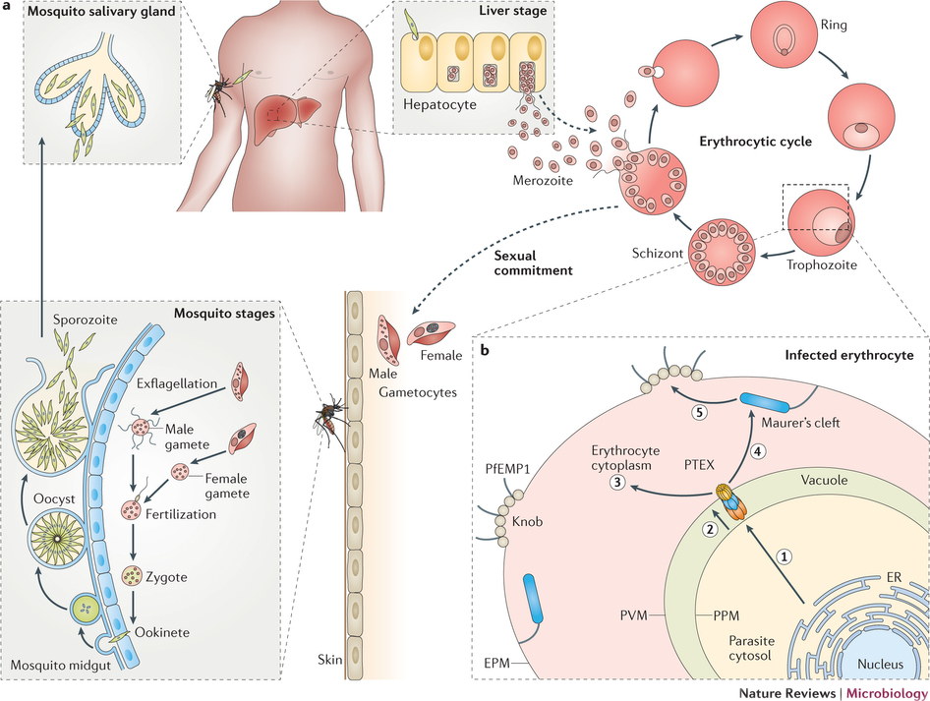](https://www.google.jo/url?sa=i&rct=j&q=&esrc=s&source=images&cd=&ved=0ahUKEwiNt_-JsZDSAhXEtBoKHatcB78QjRwIBw&url=http://www.nature.com/nrmicro/journal/v14/n8/fig_tab/nrmicro.2016.79_F1.html&psig=AFQjCNEIYUzQ693Ve5ekIB-wcajgO0D_Wg&ust=1487188678215379)

[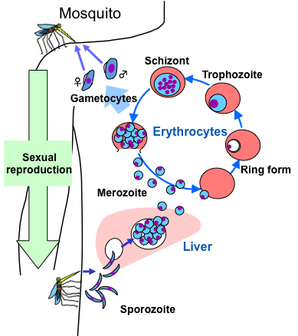](http://www.intechopen.com/books/an-overview-of-tropical-diseases/mitochondria-of-malaria-parasites-as-a-drug-target)

[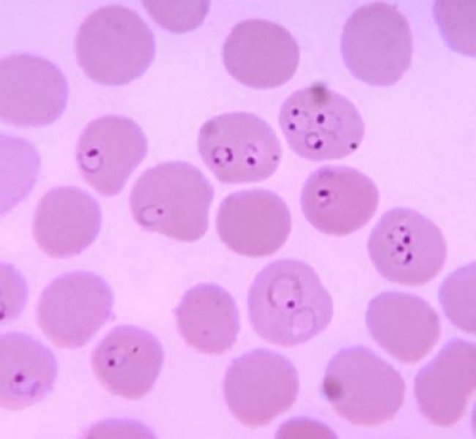](https://www.sciencedaily.com/releases/2012/07/120731200620.htm)

* ***Plasmodium falciparum*** inside RBC produce numerous **projecting knobs** that adhere to the endothelial lining of blood vessels, with resulting **obstruction, thrombosis, and local ischemia**.

**Stages of malaria**

1. **Periodic paroxysms** **النوبات الدورية** are closely related to events in the bloodstream.

* An initial **chill,** lasting from 15 minutes to 1 hour, begins as a synchronously dividing generation of parasites rupture their host red cells and escape into the blood.
* **Nausea**
* **Vomiting**
* **headache** are common at this time.
* During the paroxysms, there may be transient **leukocytosis;** subsequently, **leukopenia develops**, with a relative increase in large mononuclear cells.
* **Liver function tests may give abnormal results** during attacks
* In severe *P falciparum* infections, **renal damage may cause oliguria and the appearance of casts, protein, and red cells in the urine.**

1. **Febrile stage**, lasting several hours, is characterized by a spiking fever that frequently reaches 40°C or more. During this stage, the parasites invade new red cells.
2. **Sweating stage** concludes the episode.

The fever subsides, and the patient falls asleep and later awakes feeling relatively well.

* As the disease progresses, splenomegaly and, to a lesser extent, hepatomegaly appear. **A normocytic anemia** also develops, particularly in *P falciparum* infections.

**Babesia microti (Babesiosis)**

* Hemoprotozoan infection of the RBCs
* Babesia are pyriform, round, or oval parasites spread to humans by a **tick bite, *Ixodes scapularis.***
* Babesia species are widespread animal parasites that cause infectious jaundice in dogs and Texas cattle fever (red-water fever).
* Babesiosis infection, is caused mainly by ***Babesia microti***.

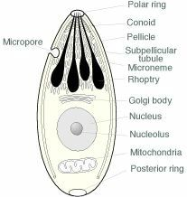

**Hosts**

* **Definitive Host**- White footed mouse
* **Intermediate Host**- Deer Tick (*Ixodes scapularis*). Deer are the hosts which adult ticks feed on but are indirectly part of the life cycle.
* **Accidental Host** – Humans (Dead end host)

Usually, the Babesia microti life cycle involves **two hosts**, which include a **rodent, primarily the white-footed mouse**,  and a **tick in the genus Ixodes**.

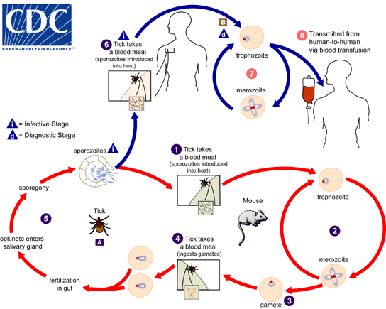

During a blood meal, a Babesia-infected tick introduces **sporozoites** into the mouse host The number 1 . Sporozoites enter erythrocytes and undergo asexual reproduction (budding) The number 2 . In the blood, some parasites differentiate into male and female gametes, although these cannot be distinguished by light microscopy The number 3 . The definitive host is the tick. Once ingested by an appropriate tick The number 4 , gametes forms and undergo a sporogonic cycle resulting in sporozoites The number 5 .

Humans enter the cycle when bitten by infected ticks. During a blood meal, a Babesia-infected tick introduces sporozoites into the human host The number 6 . Sporozoites enter erythrocytes  and undergo asexual replication (budding) The number 7 . **Multiplication of the blood-stage parasites is responsible for the clinical manifestations of the disease**. Humans usually are dead-end hosts. However, human-to-human transmission is well recognized to occur via contaminated blood transfusions  .

**Clinical picture**

* Babisiosis is considered as an emerging infectious disease of humans and is increasing in numbers
* The great majority of infections in immunologically intact individuals are asymptomatic
* In affected persons the illness develops 7–10 days after the tick bite and is characterized by
* Malaise
* Anorexia
* Nausea
* Fatigue
* Fever
* Sweats
* Myalgia
* Arthralgia and depression.
* Human babesiosis is more severe in the elderly than in the young, in splenectomized individuals, and in AIDS patients.
* Babesiosis in these individuals may resemble falciparum malaria, with **high fever, hemolytic anemia, hemoglobinuria, jaundice, and renal failure; infections are sometimes fatal.**

**Diagnosis**: Diagnosis should therefore involve a complete descriptive history that includes any clinical manifestations, travel history to endemic areas, tick bite exposure, splenectomy and recent blood transfusion

* **Examining blood smear samples stained with Giesma is the most common way for diagnosis.** .**Babesia is characterized by its “Maltese cross” form in the RBC.**
* **Antibody detection by indirect fluorescent antibody (IFA) test is a diagnostic test.**
* **Isolation of Babesia by inoculation of patients blood into hamsters and gerbils assists in diagnosis also.**
* **PCR-based detection assays usually involve the amplification of DNA sequences that are highly conserved and comparison of the resulting fragments with known sequences stored in a database. This enables accurate identification of the infecting parasite.**

**[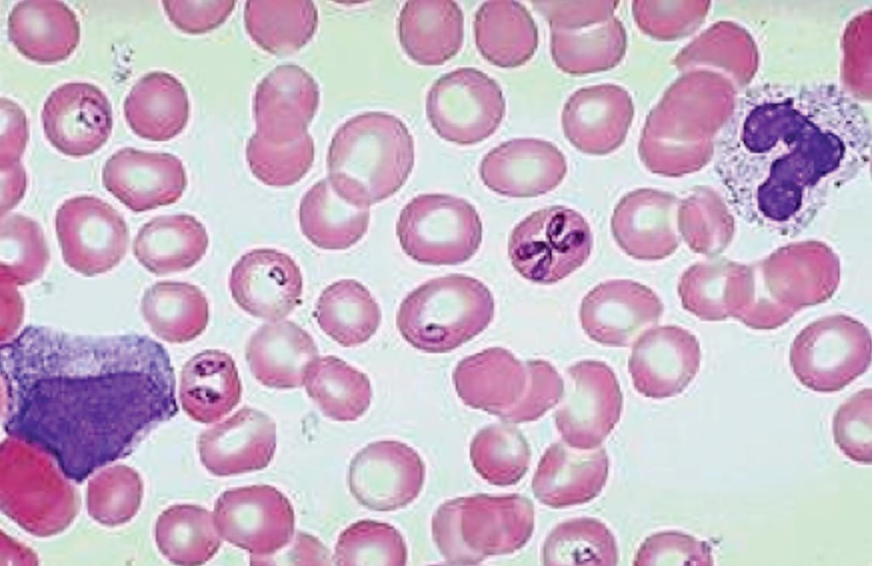](https://www.labmedica.com/microbiology/articles/294767750/molecular-test-improves-diagnosis-of-human-babesiosis.html)**

**Blood film: Tetrad of Merozoits arranged in cross-like pattern (Maltese cross)**