**Al Balqa App[lied University**

**College of Medicine**



Lecture 4

V. cholera, E. coli, C. botulium, S. aureus, and Bacillus

**Dr. Hala Al Daghistani**

**A bacterial intoxication** results from the ingestion of preformed bacterial **toxins.** Symptoms appear 1–48 hours after ingestion of the toxin. Fever is not usually a symptom of intoxication. Both Infections and intoxications cause **diarrhea, dysentery, or gastroenteritis.**

**Pathogens associated with food intoxication include:**

Vibrios species

* Gram-negative that are all widely distributed in nature. They are among the most common bacteria in surface waters worldwide.
* *Vibrio cholerae* produces an enterotoxin that causes cholera, a profuse watery diarrhea that can rapidly lead to dehydration and death.
* They are curved aerobic rods, motile possessing a polar flagellum.
* *V. cholerae* serogroups O1 and O139 cause cholera in humans, and other vibrios may cause sepsis.

Vibrio cholerae

**Typical Organisms**

V. choleraeis a comma-shaped, curved rod. On prolonged cultivation, vibrios may

become straight rods that resemble the gram-negative enteric bacteria.

**Culture**

* *V cholera* grows well on **thiosulfate-citrate-bile-sucrose (TCBS)**, on which it produces yellow colonies (sucrose fermented) .
* Vibrios are oxidase positive, which differentiates them from enteric gram-negative bacteria.
* Characteristically, vibrios grow at a high pH (8.5–9.5) and are rapidly killed by acid.

**Growth Characteristics**

*-* Most *Vibrio* species are **halotolerant**, and NaCl often stimulates their growth.

**Antigenic Structure and Biologic Classification**

* heat-labile flagellar H antigen.
* O lipopolysaccharides that confer serologic specificity.
* There are at least 206- O antigen groups.
* *V cholerae* strains of O group 1 and O group 139 cause classic cholera.
* non-O1/non-O139 *V cholerae* causes cholera-like disease.
* The *V cholerae* serogroup O1, further typing; the serotypes are Ogawa, Inaba, and Hikojima.
* Two biotypes of epidemic *V cholerae* have been defined, classic and El Tor.
* *V cholerae* O139 makes a polysaccharide capsule, *V cholerae* O1 does not make a capsule.

***Vibrio cholerae*****Enterotoxin**

* *V cholerae* produce a heat-labile enterotoxin with A and B.
* Ganglioside GM1 serves as the mucosal receptor for subunit B, which promotes entry of subunit A into the cell.
* Activation of subunit A yields increased levels of intracellular cyclic adenosine monophosphate (cAMP) and results in prolonged hypersecretion of water and electrolytes.
* Electrolyte-rich diarrhea occurs—as much as 20–30 L/day—with resulting dehydration, shock, acidosis, and death.

[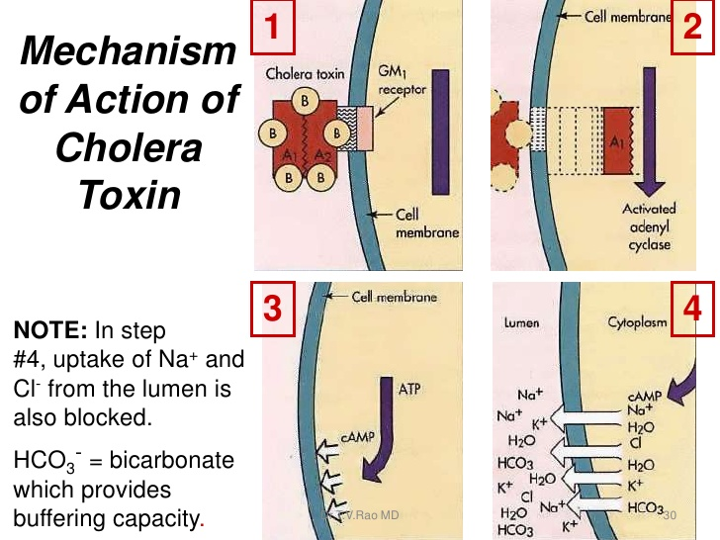](https://www.slideshare.net/doctorrao/vibrio-cholera-an-update)

**Pathogenesis and Pathology**

* *V cholerae* is pathogenic only for humans.
* A person with normal gastric acidity may have to ingest as many as **1010** or more *V. cholerae* to become infected when the vehicle is water because the organisms are susceptible to acid.
* When the vehicle is food, as few as **102–104**organisms are necessary because of the buffering capacity of food.
* Any medication or condition that decreases stomach acidity makes a person more susceptible to infection with *V. cholerae.*
* Cholera is not an invasive infection. The organisms do not reach the bloodstream but remain within the intestinal tract.

**Clinical Findings**

* Incubation period is 12 hours–3 days for persons who develop symptoms
* There is a sudden onset of nausea and vomiting and profuse diarrhea with abdominal cramps.
* Stools, which resemble “rice water,” contain mucus, epithelial cells, and large numbers of vibrios.
* The mortality rate without treatment is between 25% and 50%.

**Diagnostic Laboratory Tests**

**A. Specimens**

Specimens for culture consist of mucus flecks from stools.

**B. Smears**

**C. Culture**

- Growth is rapid on blood agar with a pH near 9.0, or on TCBS agar

- For enrichment, a few drops of stool can be incubated for 6–8 hours in taurocholate peptone broth (pH, 8.0–9.0). Organisms from this culture can be stained or subcultured.

**D. Specific Tests**

Serological slide agglutination, biochemical reaction patterns.

**Treatment**

* Water and electrolyte replacement
* Repeated injection of a vaccine containing dense vibrio suspensions

*Vibrio parahaemolyticus*

* ***V. parahaemolyticus***is a halophilic bacterium that causes acute gastroenteritis after ingestion of contaminated seafood such as raw fish or shellfish.
* After an incubation period of 12–24 hours, **nausea and vomiting, abdominal cramps, fever, and watery to bloody diarrhea** occur.
* No enterotoxin has yet been isolated from this organism.
* While infection can occur by the [fecal-oral route](https://en.wikipedia.org/wiki/Fecal-oral_route), ingestion of bacteria in raw or undercooked seafood, usually oysters, is the predominant cause of the acute [gastroenteritis](https://en.wikipedia.org/wiki/Gastroenteritis) caused by *V. parahaemolyticus*.
* Wound infections also occur, but are less common than seafood-borne disease. The disease mechanism of *V. parahaemolyticus* infections has not been fully elucidated.
* Clinical isolates usually possess a [pathogenicity island](https://en.wikipedia.org/wiki/Pathogenicity_island) (PAI) on the chromosome.  PAI contains a genetically-distinct [Type III Secretion System](https://en.wikipedia.org/wiki/Secretion#Type_III_secretion_system_.28T3SS_or_TTSS.29) (T3SS), which is capable of injecting virulence proteins into host cells to disrupt host cell functions or cause cell death by apoptosis. In addition, two genes encoding virulence proteins are typically found on the PAI, the thermostable direct [hemolysin](https://en.wikipedia.org/wiki/Hemolysis) gene (*tdh*) and/or  thermostable-related hemolysin gene (*trh*). Strains possessing one or both of these hemolysins exhibit beta-hemolysis on [blood agar plates](https://en.wikipedia.org/wiki/Blood_agar_plates).

*Vibrio vulnificus* can cause severe wound infections, bacteremia, and probably gastroenteritis.

*Escherichia coli*

**Traveler's diarrhea (TD)**

Traveler’s diarrhea is related to

1. **Enterotoxigenic *E.coli* (ETEC), the most common pathogen.**
2. **Enteroinvasive strains of  *E. coli* (Shiga- like dysentery)** produces a disease very similar to shigellosis.

* The disease occurs most commonly in children in developing countries and in travelers to these countries.
* Sometimes called tourist diarrhea or traveler's dysentery, is a stomach and intestinal infection, and the most common illness affecting travelers.
* It is defined as three or more unformed [stools](https://en.wikipedia.org/wiki/Human_feces) passed by a traveler within a 24-hour period. It is commonly accompanied by abdominal cramps, nausea, and bloating.

**Enterotoxigenic *E coli* (ETEC)**

* Is a common cause of “traveler’s diarrhea” and a very important cause of diarrhea in infants in developing countries.
* Colonization factors promote adherence of ETEC to epithelial cells of the small bowel.
* Some strains of ETEC produce a heat-labile exotoxin (LT). Its subunit B attaches to the GM1 ganglioside in the membrane of enterocytes and facilitates the entry of subunit A, where the latter activates adenylyl cyclase.
* This markedly increases the local concentration of cyclic adenosine monophosphate (cAMP).
* The end result is an intense and prolonged hypersecretion of water and chlorides and inhibition of the reabsorption of Sodium and the diarrhea lasting for several days.
* Some strains of ETEC produce the heat-stable enterotoxin STa. which activates guanylyl cyclase in enteric epithelial cells and stimulates fluid secretion by converting GTP to cGMP to .
* Many STa-positive strains also produce LT.

[**Bacteria**](https://en.wikipedia.org/wiki/Bacteria)**are responsible for roughly 80% of Travelar diarrhea cases; most of the rest are caused by**[**viruses**](https://en.wikipedia.org/wiki/Viruses)**and**[**protozoans**](https://en.wikipedia.org/wiki/Protozoans)**.**

**Other M.O. include: Salmonella, Shigella and Campylobacter, parasites (including Giardia, Cryptosporidium, Cyclospora and others) and viruses (such as norovirus and rotavirus).**

*Staphylococcus aureus*

The staphylococci are gram-positive spherical cells, usually arranged in grapelike irregular clusters. Some are members of the normal microbiota of the skin and mucous membranes of humans; others cause suppuration, abscess formation, a variety of pyogenic infections, and even fatal septicemia. The genus *Staphylococcus* has at least 40 species. The most frequently encountered species of clinical importance is ***Staphylococcus aureus***

* *S. aureus* is coagulase positive, which differentiates it from the other species. *S aureus* is a major pathogen for humans.

Enterotoxins

* There are multiple (A–E, G–J, K–R and U, V) (19) enterotoxins that are superantigens.
* The enterotoxins are heat stable and resistant to the action of gut enzymes. Important causes of food poisoning.
* Ingestion of 25 µg of enterotoxin B results in vomiting and diarrhea. The emetic effect of enterotoxin is probably the result of central nervous system stimulation (vomiting center) after the toxin acts on neural receptors in the gut.

**Staphylococcal Food Poisoning**

Staphylococcus aureus is a true food poisoning organism. It produces a heat stable enterotoxin when allowed to grow for several hours in foods such as cream-filled food, poultry meat, eggs, meat salads, and vegetables. It is important to note that the toxins may be present in dangerous amounts in foods that have no signs of spoilage, such as a bad smell, any off color, odor, or textural or flavor change.

Enterotoxins are chromosomally encoded exotoxins that are produced and secreted from several bacterial organisms. It is the ingestion of the toxin that causes the inflammation and swelling of the intestinal cells.

## Symptoms: Common symptoms of *Staphylococcus aureus* food poisoning include: nausea, explosive vomiting for up to 24 hours, abdominal cramps/pain, headache, weakness, diarrhea and usually a subnormal body temperature. Symptoms usually start one to six hours after eating and last less than 12 hours. The duration of some cases may take two or more days to fully resolve.

## Diagnosis: For the detection of *Staphylococcus aureus* food poisoning, a stool culture may be required beside the Toxicity study.

Spore-Forming Gram-Positive Bacilli

The gram-positive spore-forming bacilli are the **Bacillus** and **Clostridium**species.

* They form spores, can survive in the environment for many years. The
* **Bacillus species include:**
* **Bacillus cereus** **causes food poisoning**
* **Bacillus thuringiensis** cause **food poisoning and occasionally eye or other localized infections.**
* **Clostridia cause several important toxin mediated diseases, however**
* **Clostridium botulinum, botulism**
* **Clostridium perfringens, gas gangrene, food poisoning**

Bacillus species

* The genus *Bacillus* includes large aerobic, gram-positive rods occurring in chains. Saprophytic organisms prevalent in soil, water, and air and on vegetation, such as ***Bacillus cereus***and ***Bacillus subtilis***.

*Bacillus cereus*

Food poisoning caused by *B. cereus* has two distinct forms

* **Emetic type**, which is associated with fried rice
* **Diarrheal type**, which is associated with meat dishes and sauces.
* *B. cereus* produces toxins disease that is more an intoxication than a foodborne infection.
* **The emetic form** is manifested by nausea, vomiting, abdominal cramps, and occasionally diarrhea and is self-limiting, with recovery occurring within 24 hours. It begins 1–5 hours after ingestion of rice and occasionally pasta dishes.
* **The diarrheal form** has an incubation period of 1–24 hours and is manifested by profuse diarrhea with abdominal pain and cramps; fever and vomiting are uncommon.
* **The enterotoxin may be preformed in the food or produced in the intestine.**

[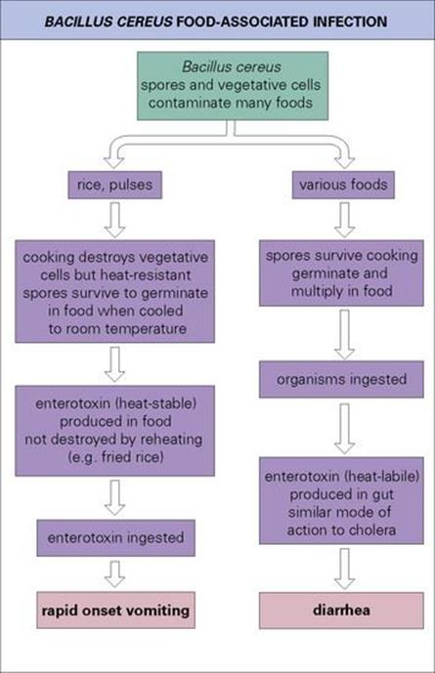](http://schoolbag.info/biology/microbiology/23.html)

* **The diarrhetic syndromes** observed in patients are thought to stem from the three enterotoxins:
* [**Hemolysin**](https://en.wikipedia.org/wiki/Hemolysin)**(Hbl), pore forming toxin**
* **Nonhemolytic**[**enterotoxin**](https://en.wikipedia.org/wiki/Enterotoxin)**(Nhe), pore forming toxin**
* [**Cytotoxin**](https://en.wikipedia.org/wiki/Cytotoxin)**K (CytK) toxin.**

These enterotoxins are all produced in the small intestine of the host, thus impairing digestion by host endogenous enzymes.

**The 'Emetic' form** is commonly caused by rice cooked for a time and temperature insufficient to kill any spores present, then improperly refrigerated. It can produce a [toxin](https://en.wikipedia.org/wiki/Toxin),[**cereulide**](https://en.wikipedia.org/wiki/Cereulide), which is not inactivated by later reheating.

* **Cereulide** is a cyclic polypeptide, potent cytotoxin that destroys mitochondria.
* In addition to its cytotoxicity, cereulide causes nausea and vomiting. This effect is believed to be caused by its increased afferent vagus nerve stimulation and the vomiting center in the brain

*Clostridium species*

* The Clostridia are large anaerobic, gram-positive, motile rods. Many decompose proteins or form toxins, and some do both.
* Their natural habitat is the soil or the intestinal tract of animals and humans, where they live as saprophytes.

**Morphology and Identification**

**A. Typical Organisms**

- Spores of clostridia are usually wider than the diameter of the rods in which they are formed. Most species of clostridia are motile and possess peritrichous flagella.

**B. Culture**

In general, the clostridia grow well on the blood-enriched media or other media used to grow anaerobes.

*Clostridium botulinum*

- The causative agent of botulism.

*- C. botulinum* is distributed throughout the environment. The spores find their way into preserved or canned foods with low oxygen levels and nutrients that support growth.

- The organisms germinate and elaborate the toxins as growth and lysis occur. Seven antigenic varieties of toxin (A–G) are known. Types A, B, E, and F are the principal causes of human illness.

- Botulinum neurotoxins are the most potent toxins known. It is heat-labile, so properly heated food does not transmit botulism.

[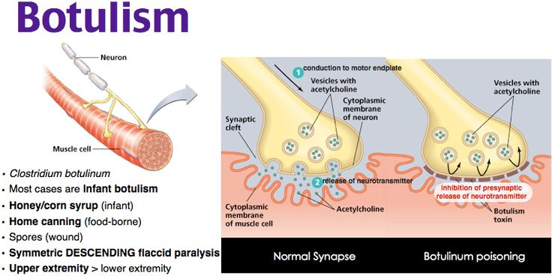](https://www.pinterest.com/pin/429812358163389908/)

- Toxin is ingested and absorbed. **It acts on the peripheral nervous system by inhibiting the release of acetylcholine at cholinergic synapses, causing paralysis**.

- Once the toxin is bound, the process is irreversible. The symptoms include **dysphagia, dry mouth, diplopia, and weakness or inability to breathe.**

- Botulism should be treated with antitoxin. **Infant botulism follows the ingestion of spores. Honey is a common vehicle for spread of the spores in infants**.

*Clostridium perfringens*

*C. perfringens* is present throughout the environment. There are at least 12 different soluble antigens, many of which are toxins. Two important diseases are associated with C. perfringens

* 1. **Gas gangrene**.

**2. Food poisoning** (but less so than *Staphylococcus aureus*).

* Enterotoxin produced and released during sporulation. The incubation period for the abdominal pain, nausea, and acute diarrhea is 8–24 hours.
* Perfringens poisoning can also lead to another disease known as **enteritis necroticans** **(also known as pigbel)**; this is caused by the same strain that causes perfringens food poisoning. However, this infection is often fatal. Large numbers of *C. perfringens* (group C) grow in the intestines, and secrete **β- toxin**. This exotoxin causes necrosis of the intestines, with varying levels of hemorrhaging and perforation of the intestine. Inflammations usually occur in sections of **the jejunum, midsection of the small intestine.** This disease eventually leads to septic shock and death.

Common Food Vehicles for Specific Pathogens or Toxins

**Undercooked chicken** : *Salmonella* spp.

**Eggs**: *Salmonella* spp. (especially *S. enteritidis*),

**Unpasteurized milk** *: Brucella spp., Salmonella spp*.

**Fried rice** : *Bacillus cereus*

**Fish, Shellfish** : *Vibrio cholerae, V. parahaemolyticus, V. vulnificus*, other Vibrio spp., **Beef, gravy** *Salmonella* spp., *Clostridium perfringens*

Diagnosis of Diarrheal infections

**Laboratory Studies**

* leukocytosis in invasive infections
* Anemia may be present in cases of severe gastrointestinal blood loss or a hemolytic infection.
* Thrombocytopenia may be present in some infections.
* Evaluation of the patient’s blood chemistries can show electrolyte abnormalities from the diarrhea and is a good indicator of the hydration status of the patient.
* Examination of the stool for RBC and evidence of invasivness (either white blood cells in the stool called **fecal leukocytes**  or **fecal lactoferrin** testing [a neutrophil marker that is associated with inflammation]
* **Differentiate those patients who have invasive disease and those patients suffering from toxin-mediated illnesses**.
* The patient with **intoxication produced stool that contained** **no blood**, **pus**, **or mucus**. In addition, the patient was **afebrile.** The absence of fever and cellular materials is indicative of a toxin-mediated illness.

Laboratory Diagnosis of Infectious Diseases

**History: Recent food ingestion, Travel, Recreational activity**

**Culture**

* Stool specimens, rectal swabs
* Selective and differential culture media are commonly used to attempt to identify bacterial pathogens in stool.

**Direct Microscopic Examination**

* Microscopic examination of the stool may reveal WBCs if the patient has an inflammatory diarrhea (e.g., *Salmonella, Shigella, Yersinia, Campylobacter,* EIEC, and various *Vibrio* species).
* The bacterial pathogen may be visible on direct microscopic examination of the stool. If gram-negative, curved rods are present, the patient may have a *Vibrio* infection.