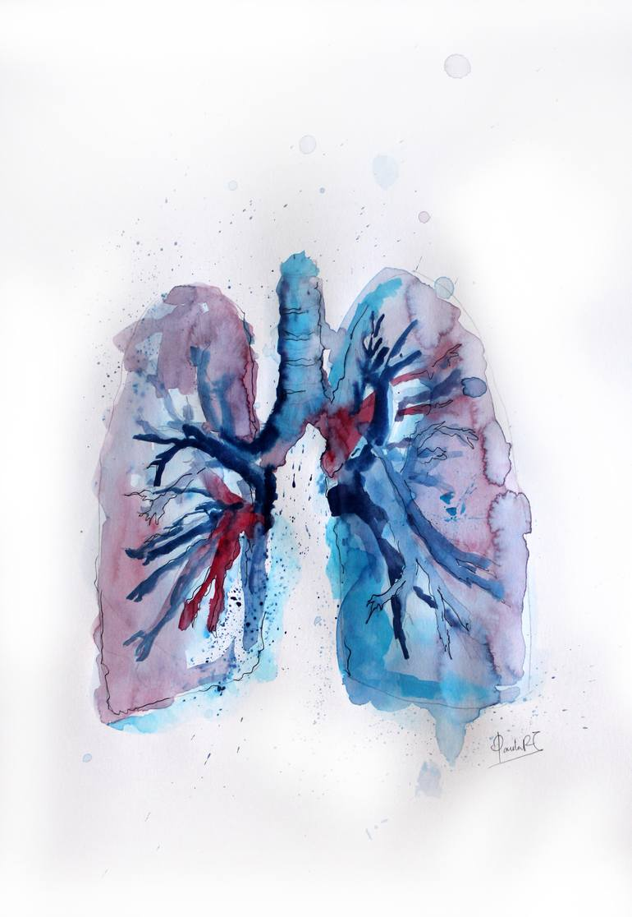

Sub-system: Pathology
Lecture Title: lecture #6 Pulmonary infections
Lecture Date: 11/19
Sheet Writer :Zain Alsharrab

THE RESPIRATORY SYSTEM

Pulmonary infections
It is the functional part of the lung ( gas exchange ) which involve alveoli and respiratory bronchioles
Pneumonia (= infection of lung parenchyma)
Pneumonitis : is a general term that refers to inflammation of lung tissue caused by infections , chemicals & other factors
Pneumonitis : is a general term that refers to inflammation of lung tissue
Pneumonia : inflammation caused by infections

Types of pneumonia :
- Community-Acquired Acute Pneumonia
- lung infection in otherwise healthy individuals that is acquired from the normal environment (in contrast to hospital acquired pneumonia)
- Mostly: Bacterial or viral (can be difficult to distinguish clinically and radiologically) :
- Clinically :
- typical : severe cough/sputum, high fever, chills, needs hospitalization (Bacterial…typical more)
- atypical = walking pneumonia: low-grade fever, no chills, not hospitalized (Viral…atypical more)&( Some bacteria…atypical more (like Chlamydia and Mycoplasma)
- x-rays/grossly: Lobar pneumonia or bronchopneumonia
- Bacterial or viral infections can be distinguished by acute phase reactant :
C-reactive protein and procalcitonin…significantly elevated in bacterial more than in viral infections
- Often, the bacterial infection follows an upper respiratory tract viral infection
- In Community-Acquired Acute Pneumonia the alveoli will be filled with an inflammatory exudate, thus causing consolidation (“solidification”) of the pulmonary tissue
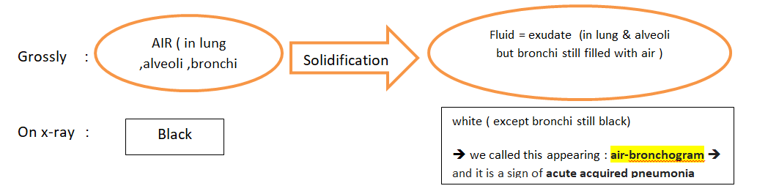
Consolidation = solidification…remember air-bronchogram sign on chest x-ray…a gross and radiology term…a part of lung that contains air spaces that are supposed to be filled with air becomes filled with exudate

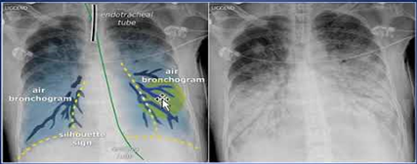
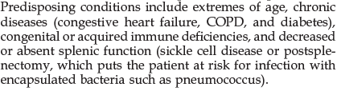
air-bronchogram sign
عوامل بتفاقم الinfectionوتسبب حدوث ال pneumonia

Explanation from dr : sickle cell dz ( one of its complication is autosplenectomy) & splenic injuries ( some injuries caused by seatbelt trauma ) will lead to absent splenic function : risk for encapsulated infections )

(min 19 – min 23 )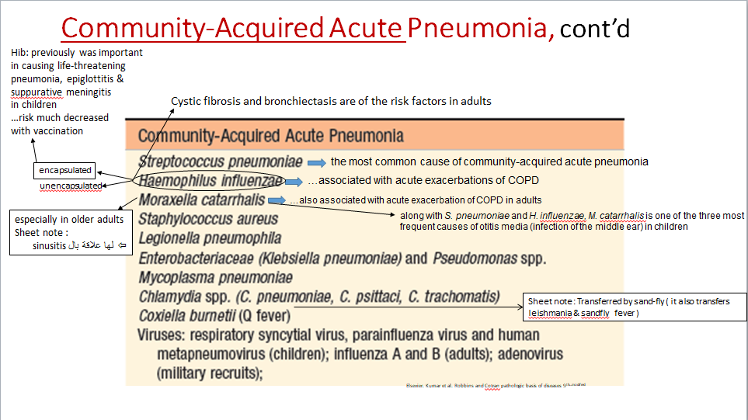
Community-Acquired Acute Pneumonia, some bacterial causes :
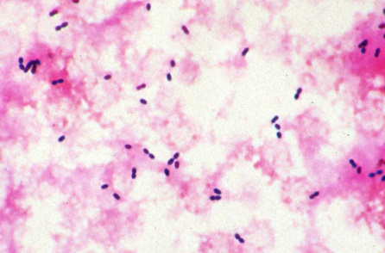
1-Streptococcus pneumonia

- Gram stain of sputum: numerous neutrophils containing the typical gram-positive, lancet-shaped diplococcic
…but it is of the endogenous flora in 20% of adults( carriers ), and therefore false-positive results may be obtained (in this situation you should do a blood culture)
Isolation of pneumococci from blood cultures is more specific but less sensitive (in the early phase of illness, only 20% to 30% of patients have positive blood cultures)

- Pneumococcal vaccines containing capsular polysaccharides from the common serotypes are used in individuals at high risk for pneumococcal sepsis (sheet not : conjugate vaccine is now available and it has stronger effect than the previous vaccines )
2-Staphylococcus aureus
…an important cause of secondary bacterial pneumonia in children and healthy adults after viral respiratory illnesses (e.g., measles in children and influenza in both children and adults)
…associated with a high incidence of complications, such as lung abscess and empyema
…Staphylococcal pneumonia occurring in association with right-sided staphylococcal endocarditis is a serious complication of intravenous drug abuse
Sheet note :
- In IV drug abuse s.aureus will cause :
- right-sided endocarditis
- Community-Acquired Acute Pneumonia
…It is also an important cause of nosocomial pneumonia

4-Pseudomonas aeruginosa

…mostly nosocomial pneumonia
…important cause of community acquired pneumonia
in cystic fibrosis
…important cause in burns and in neutropenia due to chemotherapy (غير مطلوبة )
…invades the vessels (pseudomonal vasculitis with resultant coagulative necrosis of lung tissue on microscopy) with propensity for extrapulmonary spread and bacteremia with fulminant disease
3-Legionella pneumophila

…Its pneumonia is called: Legionnaire disease داء المحاربين القدامي …may be quite severe
…Pontiac fever is a related self-limited upper-respiratory tract infection caused by L. pneumophila, without pneumonic symptoms
…artificial aquatic environments, such as watercooling
towers and within the tubing system of domestic
(potable) water supplies…the mode of transmission is thought to be either inhalation of aerosolized organisms (from air condition) or aspiration of contaminated drinking water
…rapid diagnosis is facilitated by demonstration of
Legionella in the urine or by a positive fluorescent antibody test on sputum samples; culture remains the standard diagnostic modality. PCR-based tests can be used on bronchial secretions in atypical cases

Only things you need to know about these two bacteria are in the boxes below

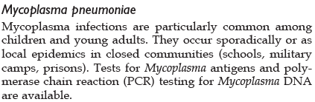
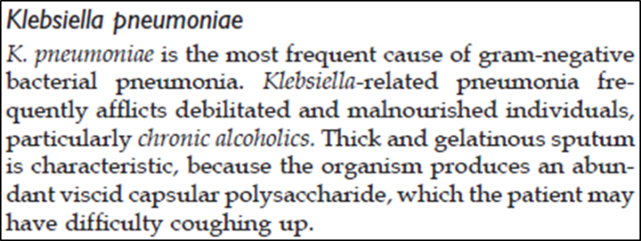

6-Mycoplasma pneumonia atypical pneumonia + common among children and young adult ( younger than 40 ) + could be epidemics (camps , prisons,…
5-Klebsiella pneumoniae related to alcoholics ( alcohol consumption causes ciliary & phagocytes dysfunction

Morphology of community-acquired acute pneumonia ( grossly or on x-rays )
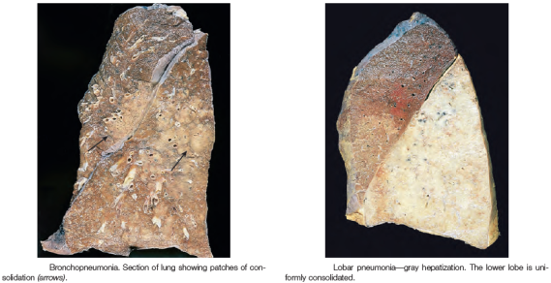
- One of 2 patterns:
Lobar pneumonia ( consolidation that affects a large and continuous area of the lobe of a lung)
bronchopneumonia (patchy consolidation )
# overlap is common

Morphology of lobar pneumonia, stages:
Pleuritis accompanies the process
1-Congestion:
- The lung is heavy, boggy, and red. It is characterized by vascular engorgement, intraalveolar fluid with few neutrophils, and often the presence of numerous bacteria
2-Red hepatization:(
- Massive confluent exudation, as neutrophils, red cells, and fibrin fill the alveolar spaces. On gross examination, the lobe is red, firm, and airless, with a liver-like consistency, hence the term hepatization
3-Gray hepatization:
- Disintegration of red cells and the persistence of a fibrinosuppurative exudate
4-Resolution: The exudate within the alveolar spaces is broken down by enzymatic digestion
Sheet not : (“this stage is occurred by taking antibiotics ,& lobar pneumonia is mostly a bacterial infection” this statement was an answer for a question & dr said that you don’t have to know it )
Clinical features of typical community-acquired acute pneumonia:
- Abrupt onset of high fever
- Shaking chills
- Cough producing mucopurulent sputum
- Occasional patients have hemoptysis
- When pleuritis is present, it is accompanied by pleuritic pain and pleural friction rub
- The whole lobe is radiopaque in lobar pneumonia, whereas there are focal opacities in bronchopneumonia
Complications of community-acquired acute bacterial pneumonia :
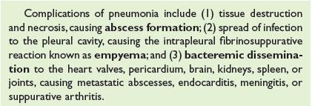
By Broncho-pleural fistula which is a fistula between the pleural cavity and the lung ; might be a way for pus moving from the lung in to the cavity in infection cases , and it may cause pneumothorax

- Community-Acquired Viral Pneumonia :
Pathogenesis :
- Nearly all of these agents also cause upper-respiratory tract infections (“common cold”)
- There is usually interstitial inflammation
\\ تميل ان يكون الالتهاب في ال wall مش ال spaces
, but some outpouring of fluid into alveolar spaces may also occur, so that on chest films the changes may mimic those of bacterial pneumonia
- Damage leading to necrosis of the respiratory epithelium inhibits
mucociliary clearance and predisposes to secondary bacterial infections.
…such serious complications of viral infection are more likely in infants, older adults, malnourished patients, alcoholics, and immunosuppressed individuals

Most common are:
-Influenza types A and B
-The respiratory syncytial viruses
-Human metapneumovirus
-Adenovirus
-Rhinoviruses
-Rubeola virus
-Varicella virus

Morphology :
- Patchy or involving whole lobes bilaterally or unilaterally
- On histologic examination, the inflammatory reaction (mainly mononuclear) is largely confined to the walls of the alveoli
- Less intraalveolar infiltrate but outpouring into alveoli by inflammatory cells occurs
- Diffuse alveolar damage may occur
- Dad يميل للحدوث في ال viral infection لانه الفيروس بسبب الالتهاب بال wall

Slide 16 :The localization of the inflammatory exudate to the alveolar walls, prevents oxygenation of blood flowing through the affected air spaces which in turn causes mismatch of ventilation and perfusion
…as a result, the degree of respiratory distress often seems out of proportion to the physical and radiographic findings
\\ Dr explanation :
Viral infections are more atypical (walking) pneumonia
But respiratory distress signs are expressed more in patient who have viral infection rather than bacterial .
respiratory distress signs :
- Cyanosis
- Nasal flaring
- Retraction of ribs , others ….

- Hospital-Acquired (Nosocomial) Pneumonias

- Defined as pulmonary infections acquired in the course of a hospital stay
- Of them: ventilator-associated pneumonia
- Gram-negative rods (members of Enterobacteriaceae and Pseudomonas spp.) and S. aureus are the most common isolates
…unlike community-acquired pneumonias, S. pneumoniae is not a common pathogen in the hospital setting.

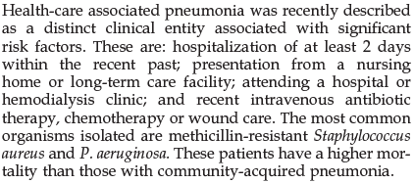
- Health Care-Associated Pneumonia الكادر الطبي او الزوار

- Aspiration pneumonia
مواد كيميائية المفروض تمشي في الجهاز الهضمي بس بتروح على الجهاز التنفسي
…in debilitated patients or those who aspirate gastric contents while unconscious (e.g., after a stroke) or during repeated vomiting
…the resultant pneumonia is partly chemical, due to the extremely irritating effects of the gastric acid, and partly bacterial
\\ تبدأ ب chemical pneumonitis و تبعها infection
…more than one organism is recovered on culture, aerobes being more common than anaerobes
…often necrotizing and fulminant
…in those who survive, abscess formation is a common complication (on the right side, in the posterior segment of the upper lobe and in the apical segments of the lower lobe)
- Lung abscess
…a localized area of suppurative necrosis(liquefactive necrosis) within the pulmonary parenchyma, resulting in the formation of one or more large cavities
- Sources:
-from sinuses, tonsils or carious teeth during oral surgery, anesthesia (sheet note : because the ciliary function is off , so mucus (with the trapping microbes ) will stay in the lung) , coma, or alcoholic intoxication, and in debilitated patients with depressed cough reflexes
-after necrotizing bacterial pneumonias (esp. S. aureus, Streptococcus pyogenes, K. pneumoniae, Pseudomonas spp.) or mycotic infections
-Bronchiectasis
-Bronchial obstruction, esp. tumors
-Septic embolism, from right-sided endocarditis
-Hematogenous, esp. Staphylococcal…multiple lung abscesses
- Anaerobic bacteria are present in almost all lung abscesses, especially oral commensals (Prevotella, Fusobacterium, Bacteroides, Peptostreptococcus, and microaerophilic streptococci)
- Complications:
-Abscesses may rupture into the pleural cavity and produce bronchopleural fistulas, the consequence of which is pneumothorax or empyema
-Embolization of septic material to the brain, giving rise to meningitis or brain abscess
-Amyloidosis
- Symptoms: similar to bronchiectasis
…also: clubbing of the fingers, weight loss, and anemia may all occur

- Chronic pneumonias ( fungul)

- Most often: a localized lesion in an immunocompetent individual, with or without regional lymph node involvement

- There is typically granulomatous inflammation, which may be due to bacteria (e.g., M. tuberculosis) or fungi

- In immunocompromised patients: widespread disease \\ fulminant & Hematogenous spreading

- Among the fungal causes: Histoplasmosis-Blastomycosis-Coccidioidomycosis

The end

