Al Balqa Applied University
College of Sciences
Dr. Hala Al Daghistani

Fungal infections
Dermatophytoses are superficial infections of the skin and its appendages, commonlyknown as ringworm, athlete’s foot, and jock itch.
They are caused by species of the genera including:
- Microsporum
- Trichophyton
- Epidermophyton

These fungi are highly adapted to the nonliving, keratinized tissues ofnails, hair, and the stratum corneum of the skin. The source of infection may be humans.

Agents of Superficial and Subcutaneous Mycoses
FUNGUS INFECTION DISEASE
Dermatophytes
Microsporum canis Hair,skin Ringworm
Microsporum audouini HairRingworm
Microsporum gypseum Hair, skin Ringworm
Trichophyton tonsurans Hair, skin, nails Ringworm
Trichophyton rubrum Hair, skin, nails Ringworm
Trichophyton mentagrophytes Hair, skin Ringworm
Trichophyton violaceum Hair, skin, nails Ringworm
Epidermophyton floccosum Skin Ringworm

Other superficial fungi
Malassezia furfur Skin (pink to brown) Pityriasis (tinea) versicolor
Hortaea werneckii Skin (brown–black) Tinea nigra
Trichosporon cutaneum Hair (white) White piedra
Piedraia hortae Hair (black) Black piedra

Subcutaneous fungi
Sporothrix schenckii Subcutaneous Sporotrichosis
Fonsecaea pedrosoi Wart-like foot lesions Chromoblastomycosis
Phialophora verrucosa Wart-like foot lesions Chromoblastomycosis
Cladophialophora Wart-like foot lesions Chromoblastomycosis
- Dermatophytes require a few days to a week or more to initiate growth.
- Most grow best at 25°C on Sabouraud dextrose agar, which is usually used for culture.
- The hyphae are septate, and their conidia may be borne directly on the hyphae or on conidiophores.
- Dermatophytoses are slowly progressive eruptions of the skin and its appendages, are not painful or life threatening.
- The manifestations (and names) vary depending on the nature of the inflammatory response in the skin, but typically involve erythema, itching, and scaling.
- The most familiar is “ringworm,” which gets its name from the annular shape of creeping margin at the advancing edge of dermatophyte growth.

EPIDEMIOLOGY
- There are both ecologic and geographic differences in the occurrence of the various dermatophytespecies. Some are primarily adapted to the skin of humans, others to animals,and others to the environment. All may serve as the source for human infection.
- Human-to-human transmission usually requires close contact with an infected subjector infected person or animal, because dermatophytes are of low infectivity and virulence.
- Transmission usually takes place within families or in situations involving contact with detached skin or hair, such as barber shops and locker rooms.

PATHOGENESIS
- Dermatophytoses begin when minor traumatic skin lesions come in contact with dermatophytehyphae shed from another infection. Susceptibility may be enhanced by local factors such as the composition surface fatty acids.
- Once the stratum corneum is penetrated,the organism can proliferate in the keratinized layers of the skin aided by a variety of proteinases.

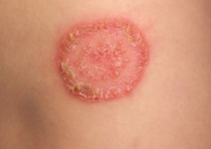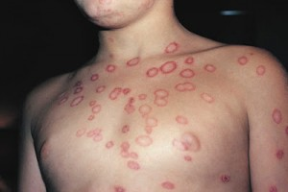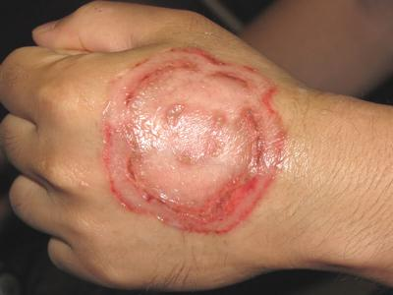

- The course of the infection is dependent on the location, moisture, the dynamics of skin growth and desquamation, the speed and extent of the inflammatory response,and the infecting species.

Inflammation tends to increase skin growth and desquamation rates and helps limit infection, whereas immunosuppressive agents such as corticosteroids tend to prolong the infection.
- Invasion of any deeper structures is extremely rare.
- The lateral spread of infection and its associated inflammation produce the characteristic sharp advancing margins that were once believed to be the burrows of worms.This characteristic is the origin of the common name ringworm and the Latin term tinea(worm) that is often applied to the clinical forms of the disease.
- Infection may spread from skin to other keratinized structures, such as hair and nails,or may invade them primarily. The hair shaft is penetrated by hyphae and the end result is damage to the hair shaft structure, which oftenbreaks off. Loss of hair at the root and plugging of the hair follicle with fungal elements may result.
- Invasion of the nail bed causes a hyperkeratotic reaction, which dislodges or distorts the nail.

IMMUNITY
- The great majority of dermatophyte infections pass through an inflammatory stage to spontaneous healing.
- Phagocytes are able to use oxidative pathways to kill the fungi both intracellularly and extracellularly.
- Antibodies may be formed during infection but play no known role in immunity.
- Most clinical evidence points to the importance of cell-mediated immunity (CMI), as with other fungal infections.
- Enhanced desquamation with the inflammatory response helps remove infected skin.Occasionally, dermatophyte infections become chronic and widespread.
- Hair infection leads to itching and hair loss
- Skin infection favors moist areas and skin folds
- Hyperkeratosis can dislodge the nail bed
- KOH mounts of skin scrapings and infected hairs demonstrate hyphae
- Culture is used when KOH preparations negative

Subcutaneous fungi
- Fungal pathogens can produce many subcutaneous manifestations as part of their disease spectrum. Some are introduced traumatically through theskin and involve mainly subcutaneous tissues, lymphatic vessels, and cause contiguous tissues.They rarely spread to distant organs.
- The diseases they cause include Sporotrichosis, Chromoblastomycosis, and Mycetoma.
Only Sporotrichosis“Rose handler’s disease” has a single specific etiologic agent, Sporothrix schenckii. Sporotrichosis is a rare type of fungal infection that can occur in both humans and animals. This type of fungal infection can lead to serious complications.

This fungal disease usually affects the skin, although other rare forms can affect the lungs, joints, bones, and even the brain.
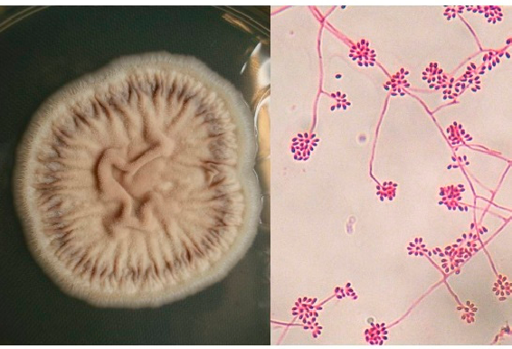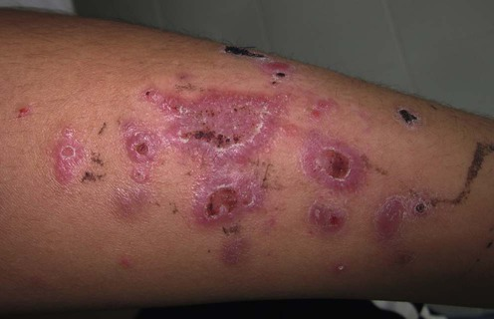

Chromoblastomycosis and Mycetoma
Are clinical syndromes with multiple fungal or bacterial etiologies.

Mycetoma
- Mycetoma is a clinical term for an infection associated with trauma to the foot which causes inoculation of any of a dozen fungal or bacterial species. Bacteria, primarily Nocardia species and other Atinomycetes, cause more than half the cases.
- It is a chronic inflammation of the tissues caused by infection with a fungus or with certain bacteria.When caused by fungi, it is referred to as mycotic mycetoma or eumycetoma. When it is caused by bacteria, it usually involves infection by the Actinomycetes group; such cases are called Actinomycotic mycetoma or actinomycetoma
- These bacteria and fungi may enter the body through a break in the skin, often on the person's foot.
- The usual clinical appearance is of massive induration with draining sinuses.
- Clinical features include: tumor like swelling, multiple drainage sinuses, grains in sinuse(sclerotia, hard mass of hyphal threads, capable of remaining dormant for long periods). Long-term mycetoma can eventually destroy the underlying muscle and bone.
- Tissue reactions may be primarily suppurative or granulomatous depending on the specific causative agent. As the infection progresses, bacterial superinfections can develop.
- Most cases, however, occur in the tropics, probably because the chronically damp, macerated skin رطبة متاكلة of the feet that causes predisposition toward mycetoma
- Diagnosis requires laboratory evaluation of a biopsy, or small tissue sample, of the infected area.

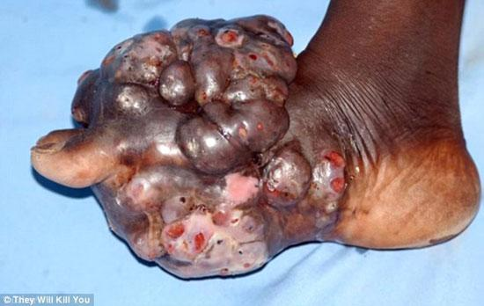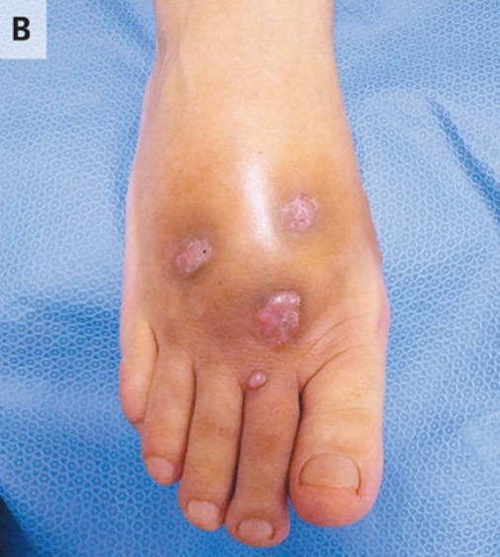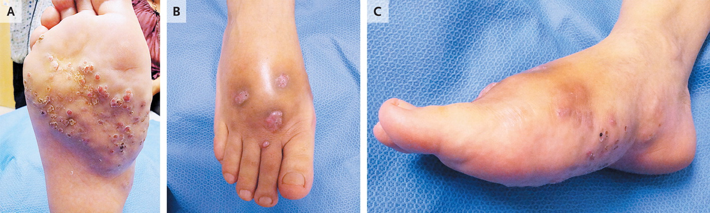
Opportunistic infection
Agents of Opportunistic Mycoses

Organism Tissue Source Infection
Candida Yeast Endogenous Skin, mucous membranes, UT, disseminated
Aspergillus Hyphae (septate)Environment Lung, disseminated

Zygomycetes Hyphae (nonseptate) Environment Rhinocerebral, lung,disseminated

Candida Spp.
- C. albicans grows in multiple morphologic forms, most often as a yeast with budding
- C. albicans is also able to form hyphae triggered by changes inconditions such as temperature, pH, and available nutrients. When observed in their initial stages when still attached to the yeast cell, these hyphae look like buds and are called germ tubes. The elongated forms of hyphae with restrictions at intervals are called pseudohyphae because they lack the parallel walls and septation of the true hyphae.

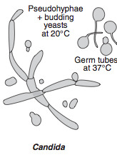
Clinical Manifestations
- Candidiasis occurs in localized and disseminated forms. Localized disease is seen as erythema and white plaques in moist skin folds (diaper rash) or on mucosal surfaces(oral thrush).
- It may also cause the itching and thick white discharge of vulvovaginitis.
- Deep tissue and disseminated disease are limited almost exclusivelyto the immunocompromised.
EPIDEMIOLOGY
- C. albicans is a common member of the oropharyngeal, gastrointestinal, and female genitalflora.
- Infections are endogenous except in cases of direct mucosal contact with lesionsin others (eg, through sexual intercourse).
- Although C. albicans is a common cause of nosocomial infections, the fungi are also derived more frequently from the patient’s ownflora than from infection.
- Invasive procedures and indwelling devices may providethe portal of entry, and the number of available Candida may be enhanced by the used ofantibacterial agents.

PATHOGENESIS
- Because C. albicans is regularly present on mucosal surfaces, disease implies a change inthe organism, the host, or both. The change from the yeast to the hyphal form is strongly associated with enhanced pathogenic potential of C. albicans.
- In histologic preparations, hyphae are seen only when Candida starts to invade, either superficially or in deep tissues.
- C. albicans hyphae have the capacity to form strong attachments to human epithelial cells. A mediator of this binding may be a surface hyphal wall protein (Hwp1),which is found only on the surface of germ tubes and hyphae.
- Hyphae also secrete proteinases and phospholipasesthat are able to digest epithelial cells and probably facilitate invasion
- C. albicans has protein surface receptors that bind the C3 component of complement thus prevent opsonization.
- Infections are from endogenous flora mostly

Clinical picture
- TheManfestationC. albicans skin infections occur in crural folds and other areas in which wet, macerated skin surfaces are opposed. The initial lesions are erythematous papules associated with tenderness, and fissures of the skin.
- Infection usually remains confined to the chronically irritated area, but may spread beyond it, particularly in infants.
- Chronic mucocutaneous candidiasis is associated with specific T-cell defects

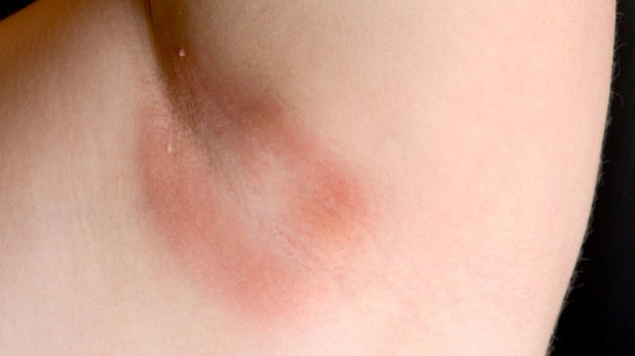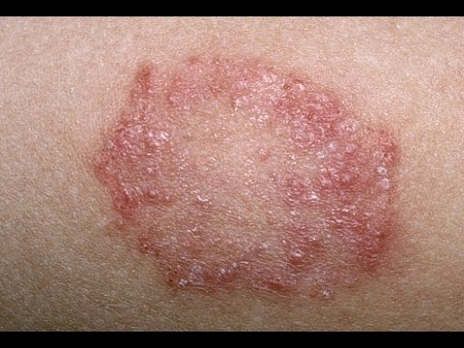
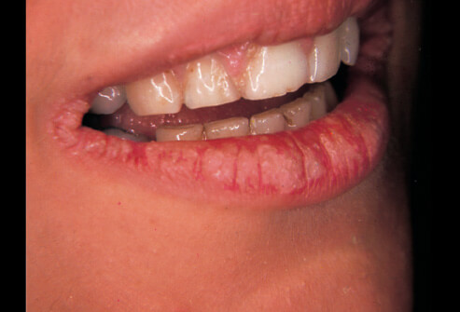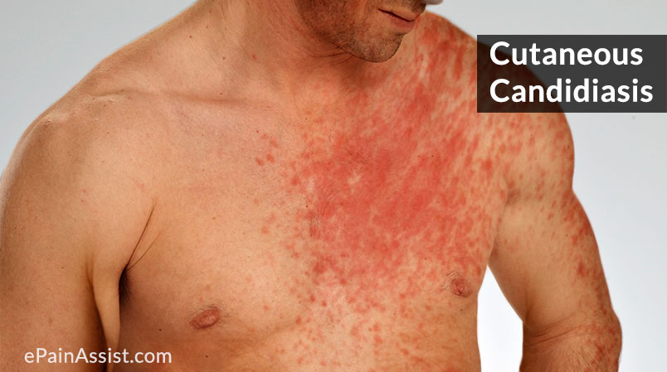

DIAGNOSIS
- Superficial C. albicans infections provide ready access to diagnostic material.
- Exudate or epithelial scrapings examined by potassium hydroxide (KOH) preparations or Gram smear demonstrate abundant budding yeast cells
- if associated hyphae are present, the infection is almost certainly caused by C. albicans. Diagnosis mainly by germ tube test.
- C. albicans is readily isolated from clinical specimens including blood if aerobic conditions are provided.
- Cultures on SDA is critical for diagnosis

