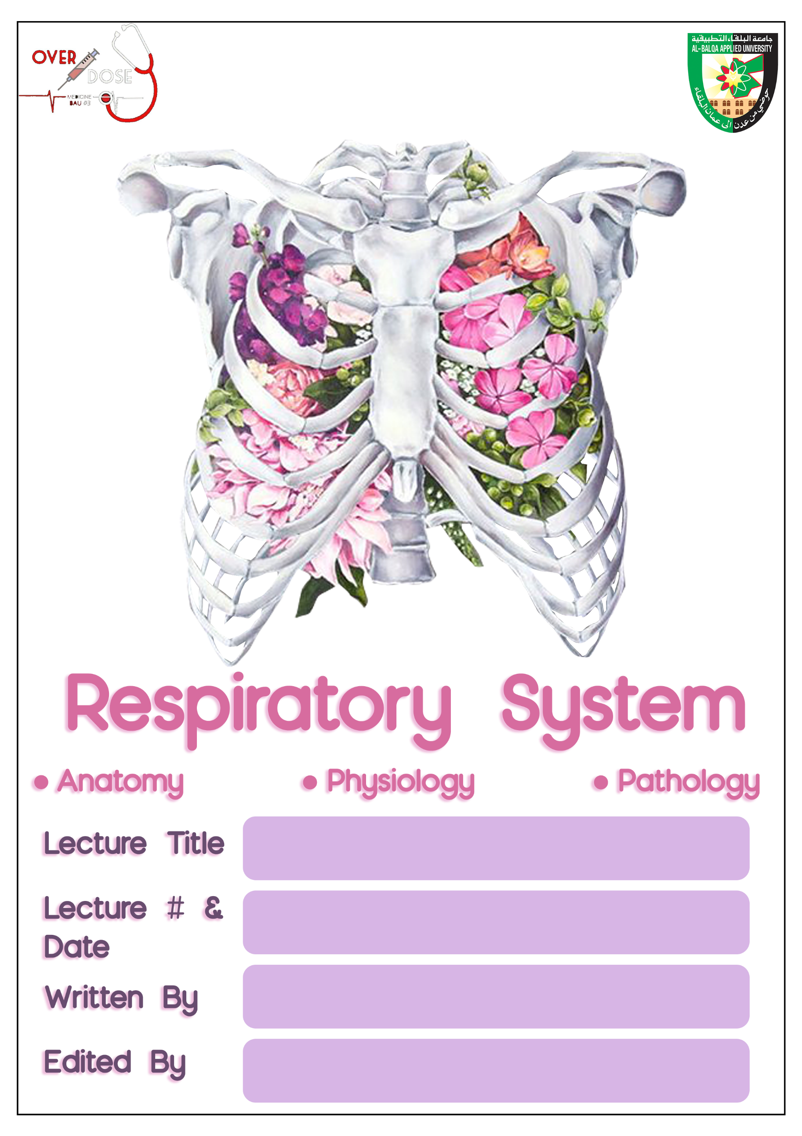
Physical principles of gas exchange
5-11-2019
Ruba Altheeb, Hala Hani
Sheet correction link: bit.ly/rsphysio
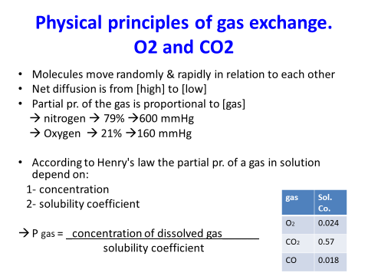
- For diffusion to occur, we need a source of energy, which is provided by the kinetic motion of the molecules themselves, meaning all free molecules are continuously undergoing motion until they strike another molecule and bounce off of it, then repeat this cycle and that’s how the molecules move randomly and rapidly among one another.
- We already know that according to physical laws gasses move from the higher concentration area to the lower concentration area, this applies to gass exchange in the alveoli.
- We need to know that pressure is directly proportional to the concentration of the gas molecules.
- In respiratory physiology, one deals with mixtures of gases, mainly of oxygen, nitrogen, and carbon dioxide. The rate of diffusion of each of these gases is directly proportional to the pressure caused by that gas alone, which is called the partial pressure of that gas. The concept of partial pressure can be explained as follows.
Consider air, which has an approximate composition of 79 percent nitrogen and 21 percent oxygen. The total pressure of this mixture at sea level averages 760 mm Hg. It is clear from the preceding description of the molecular basis of pressure that each gas contributes to the total pressure in direct proportion to its concentration. Therefore, 79 percent of the 760mm Hg is caused by nitrogen (so it’s partial pressure is 600 mm Hg) and 21 percent by oxygen (so it’s partial pressure is 160 mm Hg). The partial pressures of individual gases in a mixture are designated by the symbols Po2, Pco2, Pn2, Phe, and so forth.
- In the same way we have partial pressure for gasses that are dissolved in fluid.
- Now we’re going to talk about the factors the determine the partial pressure of a gas dissolved in fluid:
The partial pressure of a gas in a solution is determined not only by its concentration but also by the solubility coefficient of the gas. That is, some types of molecules, especially carbon dioxide, are physically or chemically attracted to water molecules, whereas others are repelled. When molecules are attracted, far more of them can be dissolved without building up excess partial pressure within the solution. Conversely, in the case of those that are repelled, high partial pressure will develop with fewer dissolved molecules. Meaning, the higher solubility coefficient is, the lower the partial pressure is, These relations are expressed by Henry’s law.
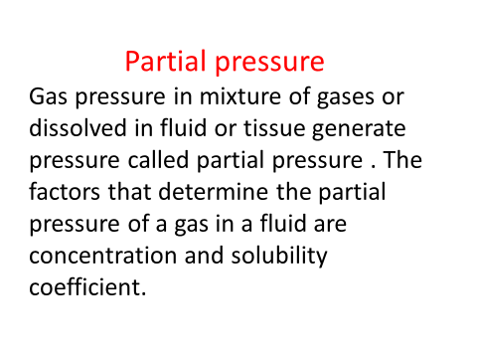

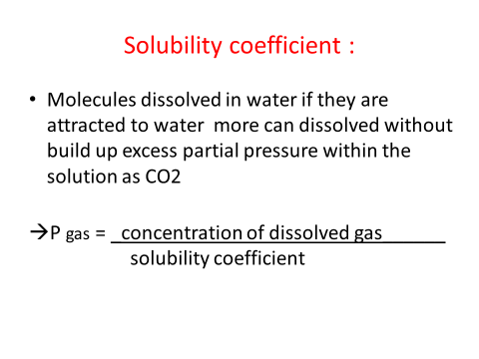
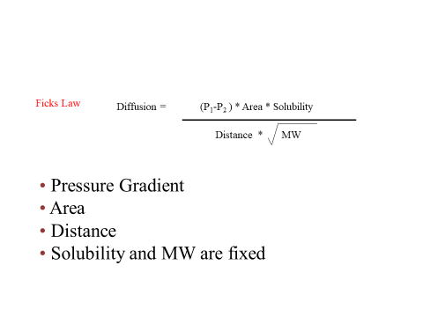
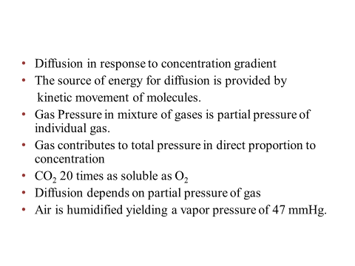
- Vapor Pressure of Water: When nonhumidified air is breathed into the respiratory passageways, water immediately evaporates from the surfaces of these passages and humidifies the air. This results from the fact that water molecules, like the different dissolved gas molecules, are continually escaping from the water surface into the gas phase. The partial pressure that the water molecules exert to escape through the surface is called the vapor pressure of the water. At normal body temperature, 37°C, this vapor pressure is 47 mm Hg, like the other partial pressures, is designated Ph2o. water vapor pressure depend entirely on the temperature, the higher it is the more likely water molecules will turn to gas.

- The greater the solubility of the gas, the greater the number of molecules available to diffuse for any given partial pressure difference. The greater the cross-sectional area of the diffusion pathway, the greater the total number of molecules that diffuse. Conversely, the greater the distance the molecules must diffuse, the longer it will take the molecules to diffuse the entire distance. Finally, the greater the velocity of kinetic movement of the molecules, which is inversely proportional to the square root of the molecular weight, the greater the rate of diffusion of the gas.

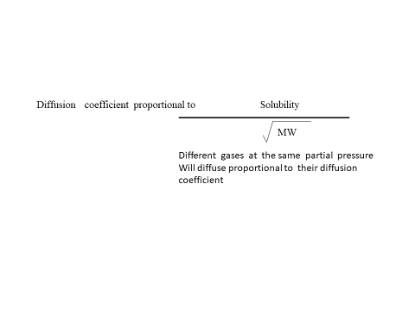
- It is obvious from this formula that the characteristics of the gas itself determine two factors of the formula: solubility and molecular weight. Together, these two factors determine the diffusion coefficient of the gas, which is proportional to the root of the MW that is, the relative rates at which different gases at the same partial pressure levels will diffuse are proportional to their diffusion coefficients.
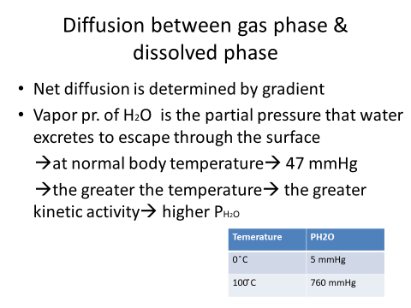

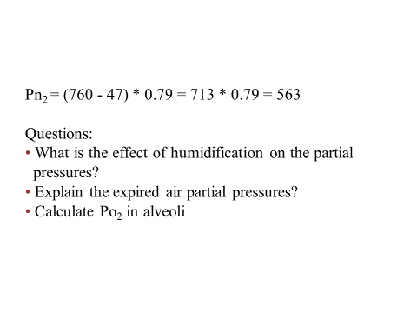
- To answer these questions, we must observe this table:
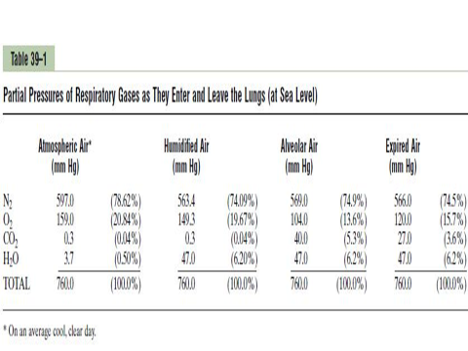

- The table shows that atmospheric air is composed almost entirely of nitrogen and oxygen; it normally contains almost no carbon dioxide and little water vapor. However, as soon as the atmospheric air enters the respiratory passages, it is exposed to the fluids that cover the respiratory surfaces. Even before the air enters the alveoli, it becomes totally humidified.
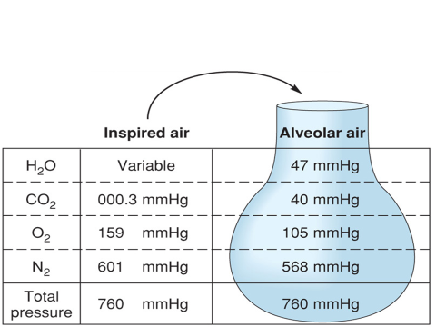
The partial pressure of water vapor at a normal body temperature of 37°C is 47mm Hg, which is therefore the partial pressure of water vapor in the alveolar air. Because the total pressure in the alveoli cannot rise to more than the atmospheric pressure (760mm Hg at sea level), this water vapor simply dilutes all the other gases in the inspired air. Table also shows that humidification of the air dilutes the oxygen partial pressure at sea level from an average of 159mm Hg in atmospheric air to 149mm Hg in the humidified air, and it dilutes the nitrogen partial pressure from 597 to 563 mm Hg.
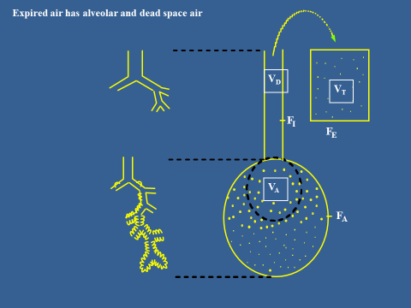

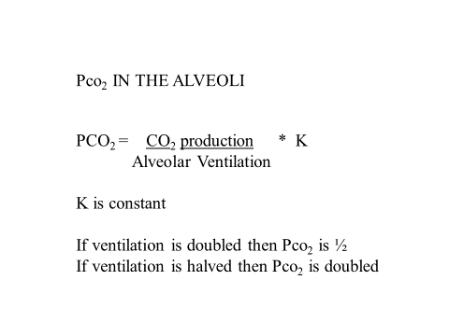
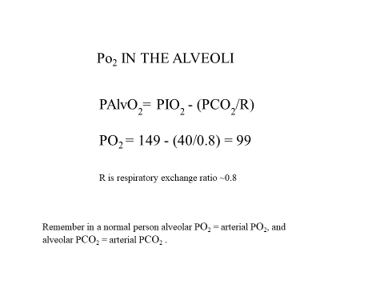
- The expired air has higher content of oxygen than alveolar air and that’s because expired air has alveolar and dead space air.

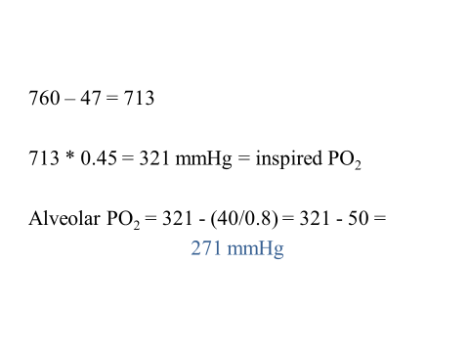
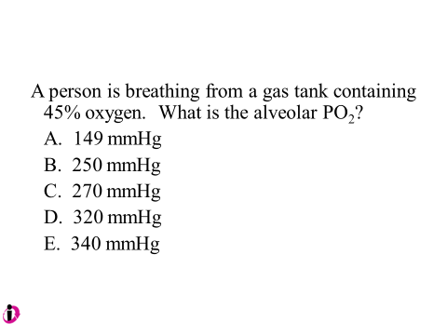
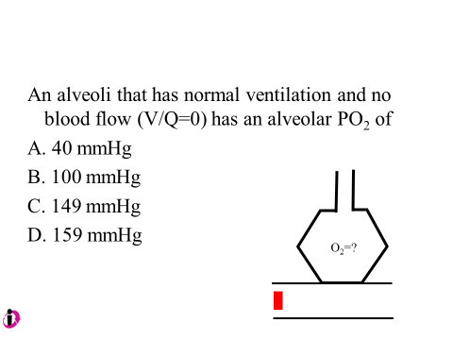
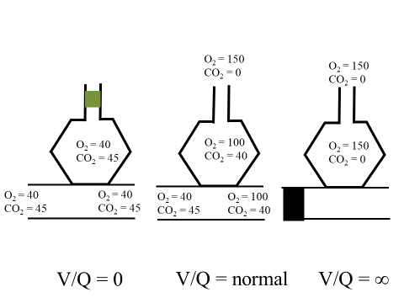
- The V/Q ratio can be defined as the ratio of the amount of air reaching the alveoli per minute to the amount of blood reaching the alveoli per minute—a ratio of volumetric flow rates. These two variables, V & Q, constitute the main determinants of the blood oxygen (O2) and carbon dioxide (CO2) concentration.
- In normal conditions its 0.8
- Now in the upper part of the lungs we have good ventilation in the alveoli but less perfusion of blood meaning that the ratio will be >0.8.
- In places like the lower part of the lung it will be opposite, the alveoli will have less ventilation and higher perfusion of blood, therefore the ratio will be <0.8
- Recall: Dead space: space not involved in exchange
        - Anatomical dead space- structure wise
        - Physiological dead space – functional wise
          - Ex: alveoli with good ventilation and poor perfusion we call it physiological dead space because part of alveoli’s air is not involved in exchange
          - In case of good perfusion and poor ventilation; ventilation is lower than needed so some blood is not oxygenated (shunt)
          - Bronchial shunt part of blood which supply supportive tissue of lung
          - Blood is not receiving enough O2 shunt blood
Sum up :
- Whenever V/Q is below normal, there is inadequate ventilation to provide the O2 needed to fully oxygenate the blood flowing through the alveolar capillaries. Therefore, a certain fraction of the venous blood passing through the pulmonary capillaries does not become oxygenated. This fraction is called shunted blood.
- When ventilation of some of the alveoli is great but alveolar blood flow is low, there is far more available oxygen in the alveoli than can be transported away from the alveoli by the flowing blood. Thus, the ventilation of these alveoli is said to be wasted. The ventilation of the anatomical dead space areas of the respiratory passageways is also wasted. The sum of these two types of wasted ventilation is called the physiological dead space
Factors increase shunt:
- Obstruction of the alveoli
- Problem with pulmonary capillaries (perforation less than ventilation)
Factors mentioned previously happen in case of OPD and emphysema.
- Physiologic shunt
  - Va/Q < normal
  - low ventilation
- Physiologic dead space
  - Va/Q > normal
  - wasted ventilation
- Abnormalities
  - Upper lung Va/Q 3 x normal
  - Lower lung Va/Q .5 x normal
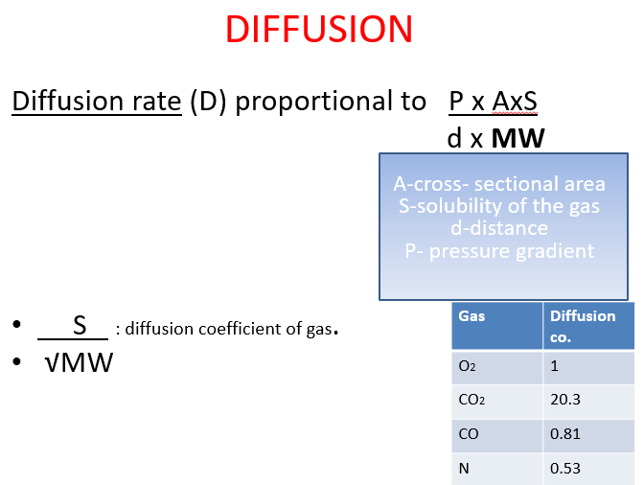
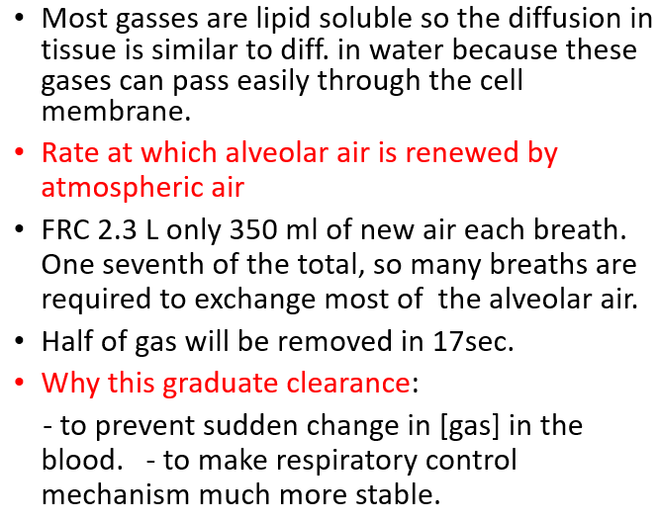
- Normally, air in the alveoli is not washed out completely it is gradual, because regulation of the respiratory system is steady rather than going up and down so wash out of CO2 and supply of O2 take time it is not sudden change of concentration.
- The figure below shows how steady the dilution develops from the first breath to 16
    - only 350 millilitres of new air are brought into the alveoli with each normal inspiration, and this same amount of old alveolar air is expired. Therefore, the volume of alveolar air replaced by new atmospheric air with each breath is only one seventh of the total, so multiple breaths are required to exchange most of the alveolar air.
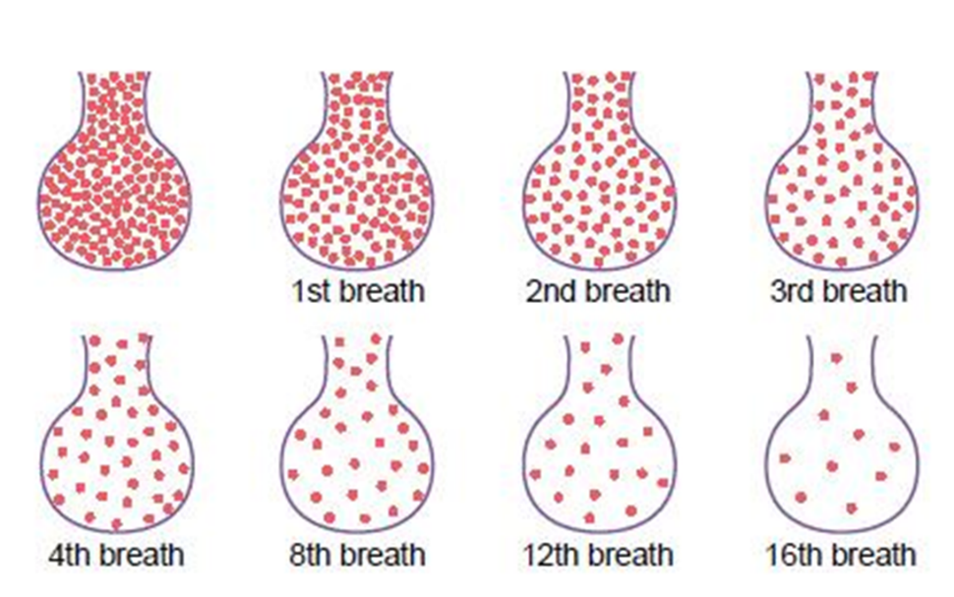
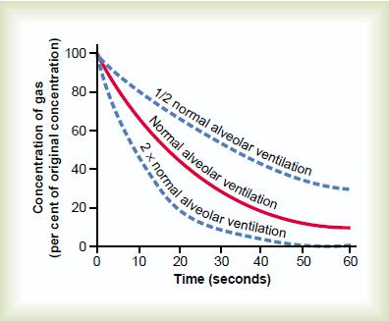
- With normal alveolar ventilation, about one half the gas is removed in 17 seconds.
- rate of alveolar ventilation is only one-half normal, one half the gas is removed in 34 seconds
- the rate of ventilation is twice normal, one half is removed in about 8 seconds
O2 concentration in the alveoli is controlled by:
(1) the rate of absorption of O2 into the blood
(2) the rate of entry of new O2 into the lungs by the ventilatory process.
when 1000 millilitres of O2 are being absorbed each minute, as occurs during moderate
exercise, the rate of alveolar ventilation must increase fourfold to maintain the alveolar Po2 at the normal value of 104 mm Hg.

Exchange depend on:
- ventilation
- respiration
how much we lose OR how much we inspire
extreme increase in alveolar ventilation can never increase the alveolar PO2 above 149 mm Hg as long as the person is breathing normal atmospheric air at sea level pressure, because 149 mm Hg is the maximum PO2 in humidified air at this pressure.
more alveolar ventilation >> PO2 increase but there is limit, concentration will not increase significantly (even if we take pure O2) >> the maximum 149
- Alveolar PO2= 40
- Alveoar air = arterial blood
- Arterial blood when leave the alveoli
  - PO2=104
  - PCO2 = 40
- Venous blood to right side of the heart:
  - PO2= 40
  - PCO2=46

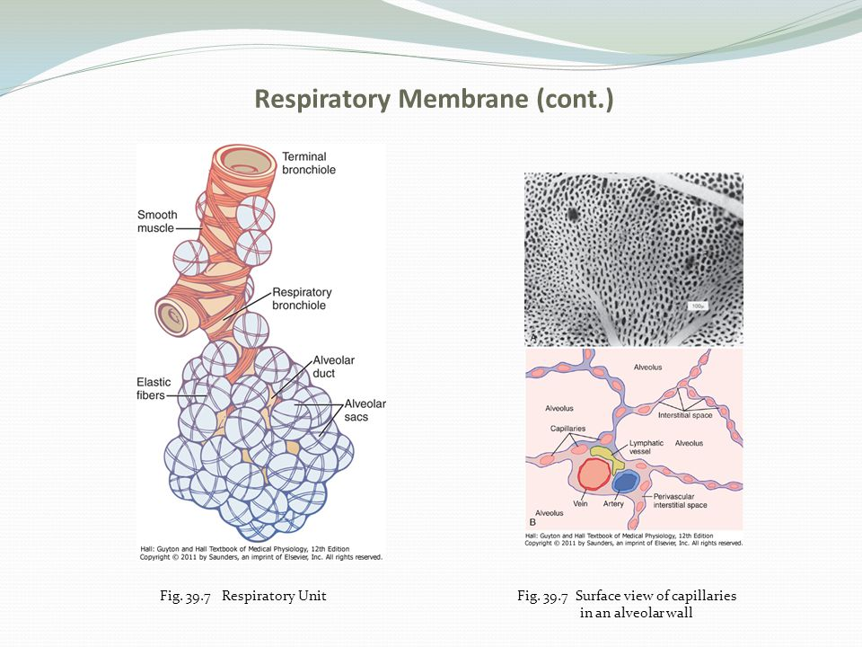

- Respiratory Unit (also called “respiratory lobule”), which is composed of a respiratory bronchiole, alveolar ducts, atria, and alveoli.
- There are about 300 million alveoli in the two lungs, and each alveolus has an average diameter of about 0.2 millimeter.
- Gas exchange between the alveolar air and the pulmonary blood occurs through the membranes of all the terminal portions of the lungs, not merely in the alveoli. All these membranes are collectively known as the respiratory membrane.
- Layers of the respiratory membrane:
- A layer of fluid containing surfactant that lines the alveolus and reduces the surface tension of the alveolar fluid
- The alveolar epithelium, which is composed of thin epithelial cells
- An epithelial basement membrane
- A thin interstitial space between the alveolar epithelium and the capillary membrane
- A capillary basement membrane that in many places fuses with the alveolar epithelial basement membrane
- The capillary endothelial membrane
- Respiratory membrane -
  - Distance
  - Surface area:
    - overall thickness of the respiratory membrane in some areas is as little as 0.2 micrometer and averages about 0.6 micrometer.
    - total surface area of the respiratory membrane is about 70 square meters
    - The total quantity of blood in the capillaries of the lungs at any given instant is 60 to 140 milliliters
    - This small amount of blood spread over the entire surface slowly and easily be oxygenated, it is easy to understand the rapidity of the respiratory exchange of O2 and CO2.
    - The average diameter of the pulmonary capillaries ≈ 5 micrometers, which means that red blood cells must squeeze through them.
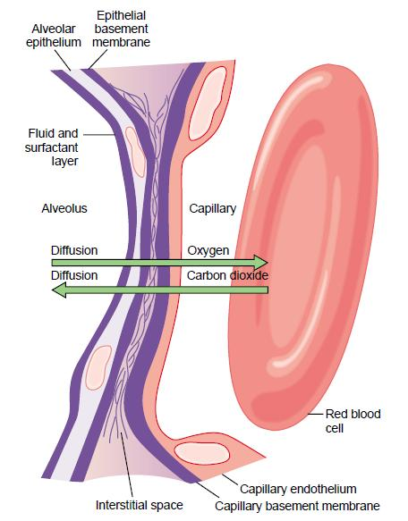
- Diffusion through respiratory membrane depend on:
- the thickness of the membrane
  - rate of diffusion through the membrane is inversely proportional to the thickness of the membrane
- the surface area of the membrane
- the diffusion coefficient of the gas in the substance of the membrane
- the partial pressure difference of the gas between the two sides of the membrane.
- Diffusion capacity: the volume of a gas that will diffuse through the res. membrane each minute for a partial pressure difference of 1mmHg
- diffusion coefficient for transfer of each gas through the respiratory membrane depends on the gas’s solubility in the membrane and, inversely, on the square root of the gas’s molecular weight.

Diffusion through respiratory membrane:
- Diffusion of Oxygen.
  - diffusing capacity for O2 under resting conditions averages 21 ml/min/mm Hg.
  - mean O2 pressure difference across the respiratory membrane during normal, quiet breathing is about 11 mm Hg.
  - about 230 milliliters of oxygen diffusing through the respiratory membrane each minute, which is equal to the rate at which the resting body uses O2
  - 65 ml/min/mmHg “exercise”

- Diffusion of Carbon Dioxide.
- 400 - 450 ml/min/mmHg “at rest”.
- 1200-1500 ml/min/mmHg “exercise”
- average of P CO2 gradient is 1mmHg

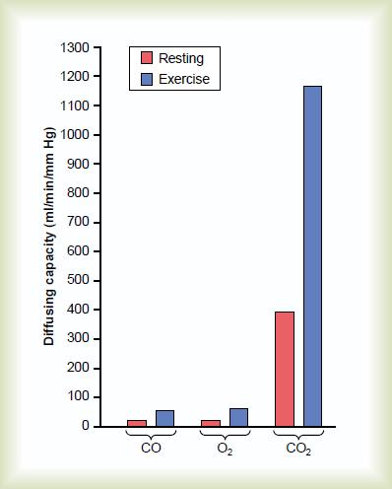
- diffusing capacity varies directly with the diffusion coefficient of the particular gas.
- the diffusion coefficient of CO2 is slightly more than 20 times that of O2

- air coming to alveoli with low perfusion or nearly no blood what is the composition of alveolar air in this case?
  - Composition of air is nearly atmospheric
- Blood coming to alveoli and the alveoli is blocked the composition of alveolar air ?
  - Arterial pulmonary / venous systematic
  - PO2=40/ PCO2= 46
- Ventilation but no blood alveolar air ?
  - Atmospheric: 149
  - Arterial :40
- How can we asses V/Q in case of pulmonary embolism and infraction (block in 1 pulmonary artery)?
  - We want to know which area is affected first and how weak it is; we give the patient radioactive substance in blood then we use special camera to decide if the problem is in ventilation or perfusion
    - No problem with the perfusion == radiation will reach the area
  - Also, we can give patient radioactive inhalation and then see if the radiation go to the alveoli or not

