HLS Physiology Sheet #1
(Blood Elements 3-3-2019)
By Ahmad Dabbour
Corrections : http://bit.ly/hlsphysio
- Now (in this system ) we will talk about the Blood .
#BLOOD : the fluid part of the Cardio-Vascular-Sys , and as we learned previously the function of the (CVS) is to generate pressure , and this pressure will push the Blood to different body tissues (Blood will carry and transport the nutrients and waste products to and from the different tissues .)
- How the Blood can do that ??
#the blood will move by the pressure gradient , by the velocity .. and also by the benefit of the surface area . (I think doctor wants to say that the surface area of the capillaries and the RBCs(the most important carrier in the blood )will participate in doing this function and make it more efficient .)
………………………………………………………………………………..
- What are the Functions of the Blood ??
(1) : Transportation ……
- Carrying the materials (substance ) to and from the tissues … mainly we talk about (Glucose , urea , ions …) , and these substance can be in the plasma (like : 1-GLu ,2-Urea,3-Ions ) or in the cells (like Hemoglobin in the RBCs) .

(2) : Regulation …..
- Mainly we talk about regulating the pH (acidity ) … it will be increased or decreased depending on the body needs with other conditions .
- Temperature : A) On the cold weather we have some vasoconstriction to decrease evaporation from the skin .
B) On the Hot weather or when the body temperature increased … we have more blood moves to the skin (More Blood volume to be evaporated … and this will decrease the temperature .)
- Osmotic : Colloid Osmotic Pressure ( The most significant part of the Blood in the process of exchanging substance between the blood and interstitial spaces .)
……………………………………………………………
(3) : Protection ….
- IMMUNITY .
- When the body exposed to invasion by organisms ( Virus , Bacteria ) .
- Against Bleeding : When there is an injured area or Hemorrhage.. the blood will form clotting to close the wound .( To stop the significant decreasing in Blood Volume ) .

- What are the blood Components ??
# Blood is a Liquid connective tissue …
(1) Blood Plasma (Fluid Part ) :
(A) Plasma Proteins :
- about (7.5 mlg) … the majority is for the Albumin ..
- Gamma-Globins .. mainly its part of our immunity.. production of anti-bodies .
- When we talk about plasma proteins , we talk at the same time about the Colloid Osmotic Pressure … and this depends on the nutrition , In poor countries : Less plasma proteins Less Colloid osmotic pressure Less inward forces in the Capillaries Accumulation of Fluids … ( Those people will have what we called ascites : accumulation of fluid in the abdomen , you may be think it's an obesity but actually it's some fluids . )

…………………………………………………………….
(B) Gazes :
- Here we talk about dissolved gazes in the blood , (in the fluid part which is the plasma) .
- We have about (98%) of Oxygen are carried with hemoglobin, and about (1.5 % - 2%) of oxygen are dissolved .
- This Dissolved part which involved in the exchange it's what we called the Partial Pressure of Oxygen (PTO ) … and the exchange depends on the pressure gradient between the Plasma Partial Pressure of Oxygen and The Interstitial Partial Pressure of Oxygen .
- Keep on your mind that the exchange happens between the Capillaries and the Interstitial spaces … and then between the Interstitial spaces and the Cells , not directly from the capillaries to cells.
- What we talked about Oxygen is also for the (CO2) , but in different quantities .
………………………………………………………
(C) Circulating Hormones :
- these hormones are released and circulate with the plasma .. until it reach their receptors to perform their functions .
- Other Hormones have a generalized effect ( All of the cells have receptors for this hormone ) … Like Insulin and Thyroxin .
- And also we have some Hormones which act locally at the point of releasing : Like Nor- epinephrine and epinephrine .

(2) Formed elements :
(A) Red Blood Cells :
- If we made centrifugation to the blood all the formed elements will precipitate in the lower part ( packed cell volume –PCV-) , and the plasma will be in the upper part .
- Packed Cell Volume = 45% … and this according to the number of RBCs , because the Bulk of this Volume is the RBCs ..
- other –Plasma - = 55% .

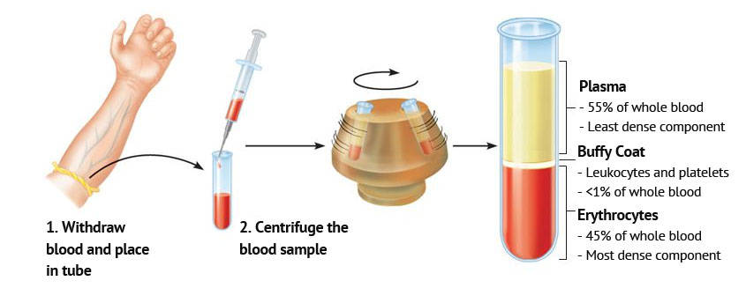

- The PCV will be less in the case with anemia ( may be about 40% -35%)… and in the case of polycythemia will be more : (18 , 19 , 20 Hemoglobin ) … and those people must donate some of the blood , otherwise the possibility to form embolism will be increased ( more viscosity of the blood less velocity Embolism ) .
- Smokers can have a physiological state of Polycythemia : because of Nicotine and Hypoxia , our body will form more RBCs .

- Main Function of RBCs is carrying the Hemoglobin .
- you should be Familiar with the structure of Hemoglobin from Biochemistry :
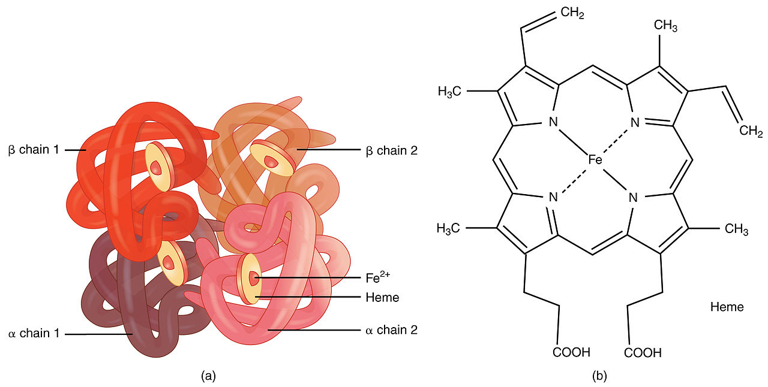

- Hemoglobin binds reversibly to Oxygen ( 98%) … and irreversibly with CO ( CO poisoning ) …. And also binds with CO2 , NO ( the vasodilator which can be carried with Hemoglobin .)
- This binding oxygen is only a storage not for exchange ,, the dissolved part (2%) is the only exchangeable oxygen .
- When there is an increased in the dissolved oxygen , Hemoglobin will bind with more oxygen to keep the partial pressure of oxygen within its normal range … and when there is a decreased in exchangeable oxygen , the oxygen will dissociate from hemoglobin to be dissolved in the plasma …..
To make it easy , imagine you have a lot of money .. simply you will put them in the bank except some money will gone to your pocket … and when you consume all of what you have in your pocket surly you will take from the bank ,,, and this what happens in our body … the money is the oxygen , the bank is the Hemoglobin and the pocket is the dissolved oxygen in the plasma .
- this curve from the internet just an additional figure to explain the concept .
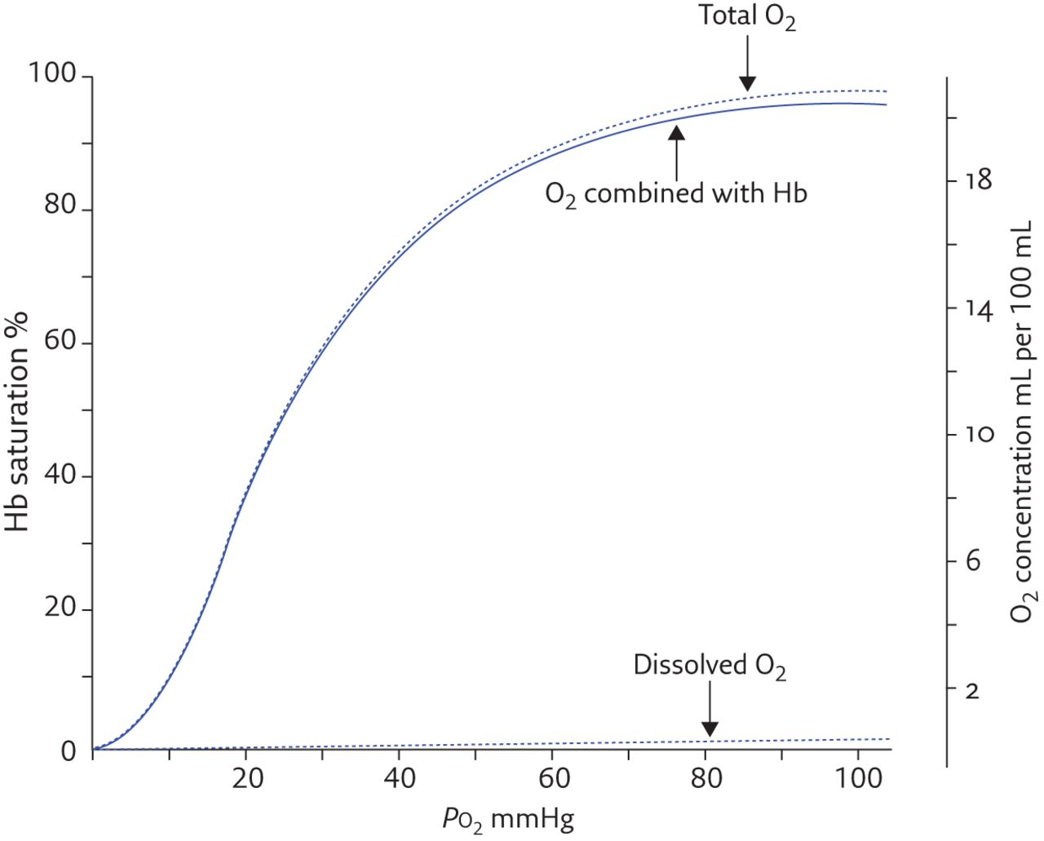

- RBCs are produced from Bone Marrow mainly >>> have a life span about 120 days >>> and Most of RBCs will be destructed in the spleen >>> So the spleen is the store of destructed RBCs >> and here you can find more hemoglobin to be recycled after has been released from the died RBCs …
……………………………………………………………………………….

(B) White Blood Cells :
- Mainly immunity .
- patient who has (AIDS) : the immunity cells be destructed and non-Functional , and those people will die by an infection ( easily to invade the body and make a lot of problems . )

……………………………………………………………………..
(C) Platelets :
- Not a complete cells >>> Fragments of Cells .
- The main function is in the Clotting >>> the First step in forming the clot is the platelets aggregation .
- Sometimes these clots form when the endothelium is rough , or when there is an injured endothelium ( disrupted part ) >> this will initiate the platelet aggregation and forming clots .
- People in middle age and above (>40) we advise them to take a baby aspirin (80 mlg) >>> the principle those people will have some roughly endothelium with atherosclerosis >>> and the aspirin will work as anti- platelet aggregation >>> will prevent the embolism and any non-expected thrombosis .

#Notes :
(1) Anything carried in the fluid is the Function of the plasma , and anything carried in the (RBCs ,WBCs , platelets ) is the function of the cells >>> because that most of the function of the blood are done by the plasma ( Gazes dissolved exchange ) , (Ions) , (Plasma proteinsmicrocirculation ) ,( Body temperature and pH) .

(2) Plasma can work in Blood Pressure Regulation ,, How ?!
- when there is a reduction in blood volume (mainly by plasma ) Cardiac output decreased Hypotension Baroreceptors and RAS regulation .

(3) If patient loss (1 L) of blood … and then we give him (2L) ,, what will happen ?!
- Volume of blood will be increased Hypertension RAS regulation is the main the regulator here to push the excess fluid by the kidney out of the body (Forming more urine ) .

