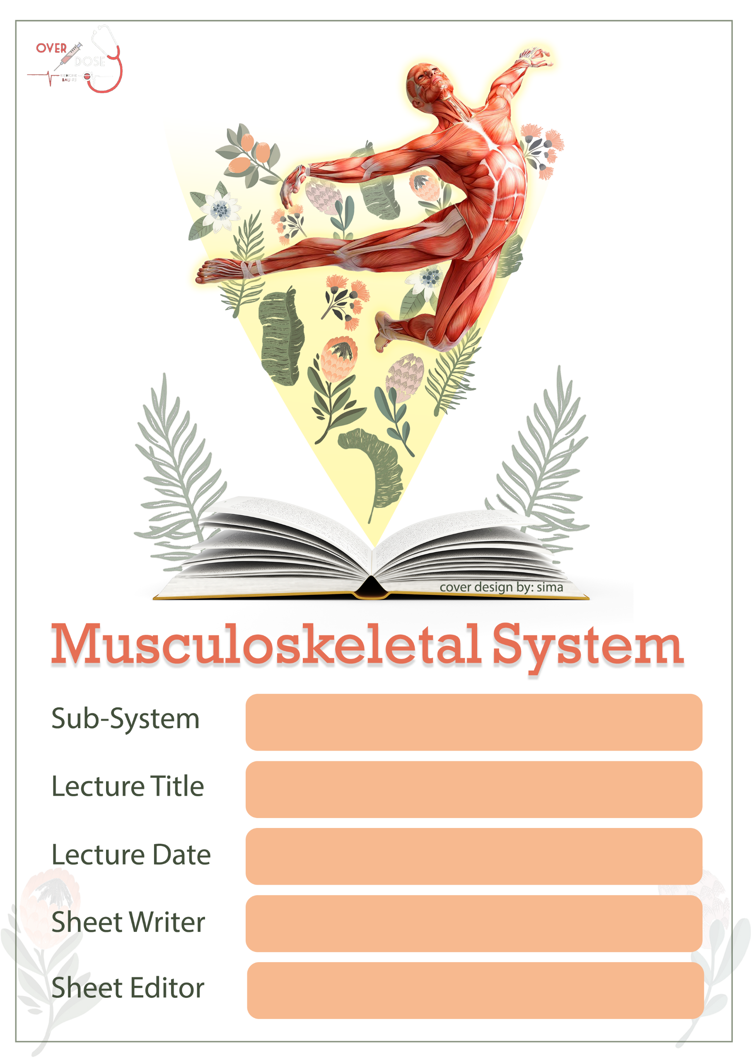

Anatomy

Joints of lower limbs 2

25 sep. 2019

Roa’a Saed Thaher

Hala Hani

**Sheet correction link:**

**bit.ly/mssanatomy**

**Important note:Every single information mentioned by the doctor or written in the slides is in the sheet, but with more organized way, so don’t worry about the fine differences. Getting the knowledge is what all matters.**

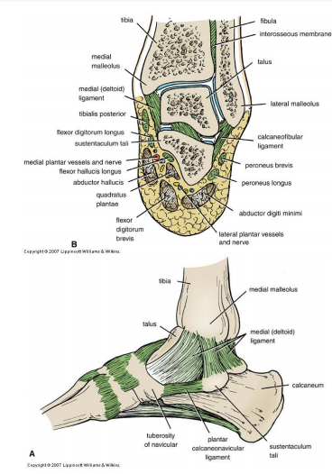

**Joints of the Foot and Toes**

* Subtalar joint
  + Medial and lateral talocalcaneal ligaments
  + Interosseous talocalcaneal ligament
* Talocalcaneonavicular joint
  + Planter calcaneonavicular ligament
* Calcaneocuboid joint
  + Bifurcated ligament
  + Long planter ligament
  + Short planter ligament

¬Talocalcaneonavicular and  Calcaneocuboid joints form the **midtarsal or transverse tarsal joints** ¬Eversion and inversion movements  happen at the midtarsal and  subtalar joints

{Sheet notes}

-The subtalar joint means talus connected to calcaneus.

-The interosseous talocalcaneal lig. :

Between the calcaneus and talus there is tunnel like structure or sulcus from above and below meet to form a sinus and in this sinus this ligament is located.

-Talocalcaneonavicular joint = talus + calcaneus + navicular

The talas and calcaneus poster. Both are connected to the navicular anter .

[ REMMEMBER: navicular is the bone which connect with the all other bones].

# The function of the ligament is to fix the joint .

-Midtarsal joint :

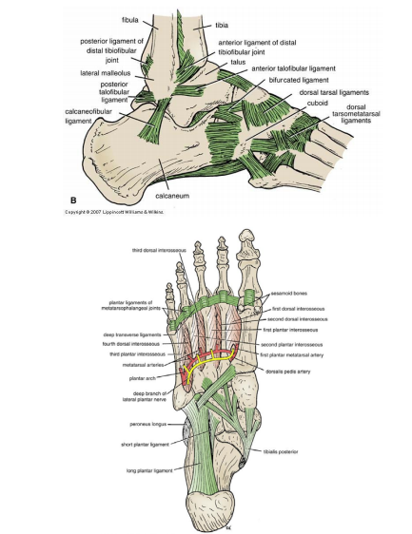Located in the area which : Posteriorly to it the calcaneus + talus & anteriorly to it the cuboid + navicular bones are located.

**Joints of the Foot and Toes**

* Cuneonavicular joint
  + Dorsal and planter ligaments
* Cuboideonavicular joint
  + Dorsal, planter and interosseous ligaments
* Intercuneiform and cuneocuboid joints
  + Dorsal, planter and interosseous ligaments
  + Same cavity with cuneonavicular joint
* Tarsometatarsal and intermetatarsal joints
  + Dorsal, planter and interosseous ligaments
  + For big toe there is separate cavity
* Metatarsophalangeal and  interphalangeal joints
  + Deep transverse ligaments

{Sheet notes}

-Cuneonavicular joint = cuneiform + navicular

-Cuboideonavicular joint = cuboid + navicular

-Tarsometatarsal = cuboid + cuneiform + tarsal bone

-Deep transverse ligament => connect the head of metatarsals .

(End of joints of the lower limbs1)

**Joints of the Lower Limb II**

**Knee Joint**

* Condyles of femur and condyles of tibia
* Hinge joint
  + Plane joint between femur and patella
* Flexion and extension and slight rotation
* Nerve supply: femoral, obturator, common peroneal, and tibial nerves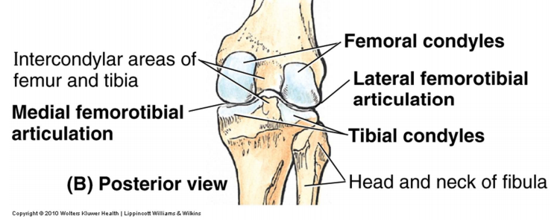

{Sheet notes}

-In the knee joint the participating parts are :

1)the condyle of femur

2) the condyle of tibia

- A hinge joint ( unidirectional) with a slight rotation medially & laterally.

**Knee Joint**: **Fibrous Capsule**

* Attachment

• Capsule is missing anteriorly

* Patella & tendons

• Gap posteriorly

* Popliteus m. tendon

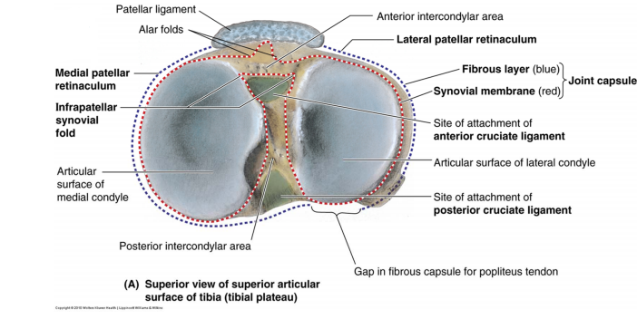

Sheet note:

-The attachment of the fibrous capsule:

the fibrous capsule is around the articular cartilage and then make a bridging wake on the edges of the bone, anteriorly there is a patella + quadriceps ligaments and patellar ligament , so the capsule will connect with these structures anteriorly as a continuation of the capsule

-Anteriorly in the capsule, instead of fibrous membrane there is a patella , patellar ligament and quadriceps femoris tendon we replace the capsule by them.

-The capsule posteriorly has a deficient area( a gap ) in the fibrous capsule epically to the popliteal tendon.

(The origin of the popliteal muscle is almost always within the capsule and the insertion go outside the capsule , and this is literally the importance of the gap , which is to send the popliteal muscle tendon)

**Knee Joint: Ligaments**

* Extracapsular ligaments:
  + Ligamentum patellae
  + Lateral collateral ligament
  + Medial collateral ligament
  + Oblique popliteal ligament
    - Expansion from the  semimembranosus tendon

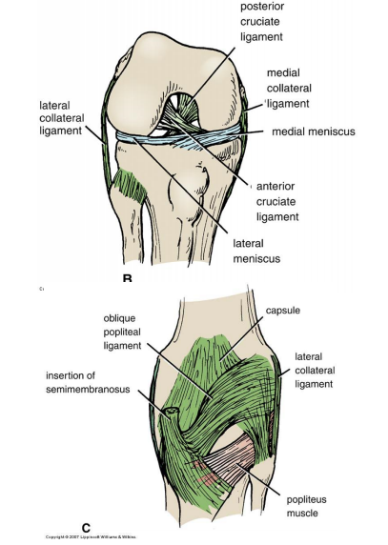

{Sheet notes}

The ligaments are divided into :

{Sheet notes}

The Extracapsular ligaments :

-Ligamentum patellae : fixation of the knee joint anteriorly

The lateral collateral ligament = Fibular collateral ligament

The medial collateral ligament = Tibial collateral ligament

-Oblique popliteal ligament : located in the popliteal fossa , and some thoughts said that it is an extension from the semimembranosus muscle tendon { This ligament fixes the knee joint posteriorly}

-The lateral and medial meniscus => separate between the femoral and tibial condyles, also they make the *compatibility* in the knee joint.

**\*\*Fibular Collateral Ligament**

* Lateral collateral ligament
* Attachments ….
* Popliteus tendon separates it  from lateral meniscus

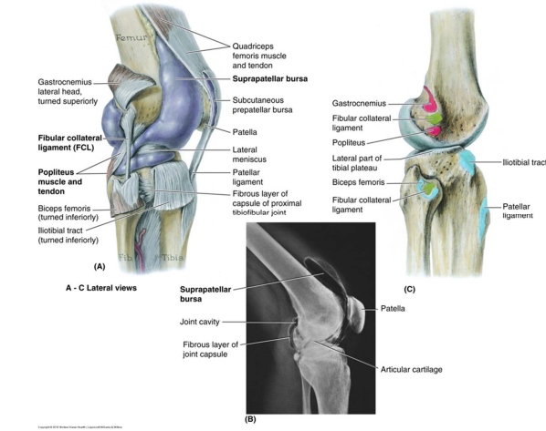

{Sheet notes}

- The *attachment* of lateral collateral ligament rise from the lateral epicondyles of femur toward the apex/head of fibula.

-Lateral collateral ligament : it is separated from the the *tendon of the popliteus muscle* separates the lateral collateral ligament from the *lateral disc* ,and this tendon (inside the capsule ) will separate the lateral collateral ligament from the capsule.

**Tibial Collateral Ligament**

* Medial collateral ligament
* Deep fibers attach to the  medial meniscus
* Attachments ….

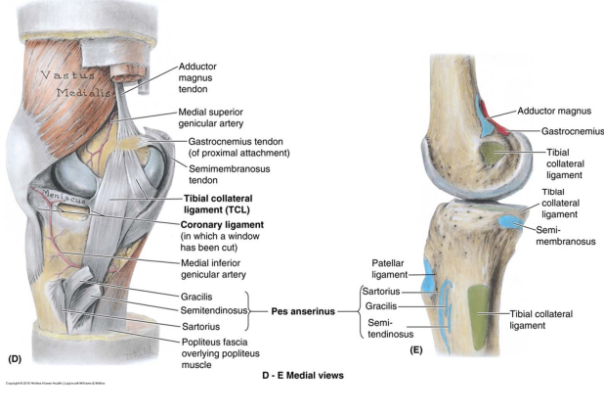

{Sheet note}-Medial collateral ligament : from medial epicondyles of femur up to the lateral surface of the condyle of tibia. {In this case , there is **no** separation between the medial collateral ligaments and the medial meniscus /capsule, so in this area an attachment will occur and it has a clinically importance will discussed later on}

**Knee Joint: Ligaments**

* Intracapsular ligament
* Cruciate ligaments
  + Anterior cruciate ligament
  + Posterior cruciate  ligament
* Anterior Cruciate Ligament

• Attachments …

• Orientation …

• Prevents:

1. Posterior displacement of femur
2. Anterior displacement of tibia
3. Hyperextension

* Posterior Cruciate Ligament
  + Stronger
  + Attachments …
  + Orientation …
  + Prevents:
    1. Anterior displacement of femur
    2. Posterior displacement of tibia
    3. Hyperflexion

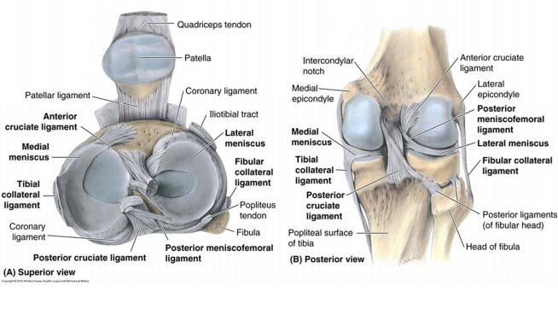

{Sheet notes} Intracapsular ligaments (aka: cruciate ligaments), located inside the capsule and consist of two ligaments.

* -The anterior and posterior cruciate ligaments are named due to their attachment with the tibia.
* -The ant and post cruciate ligaments connect the femur superiorly and the tibia inferiorly.
* -These two ligaments will going to cross each other , oriented superiorly and connect with the femur.
* -The origin / attachment of them from the tibia is *in between the condyles* (intercondylar eminence), anterior and posterior to the intercondylar eminence , an intercondylar area is located. So now we have an anterior and posterior *intercondylar area* and from this area the cruciate ligaments will originate .

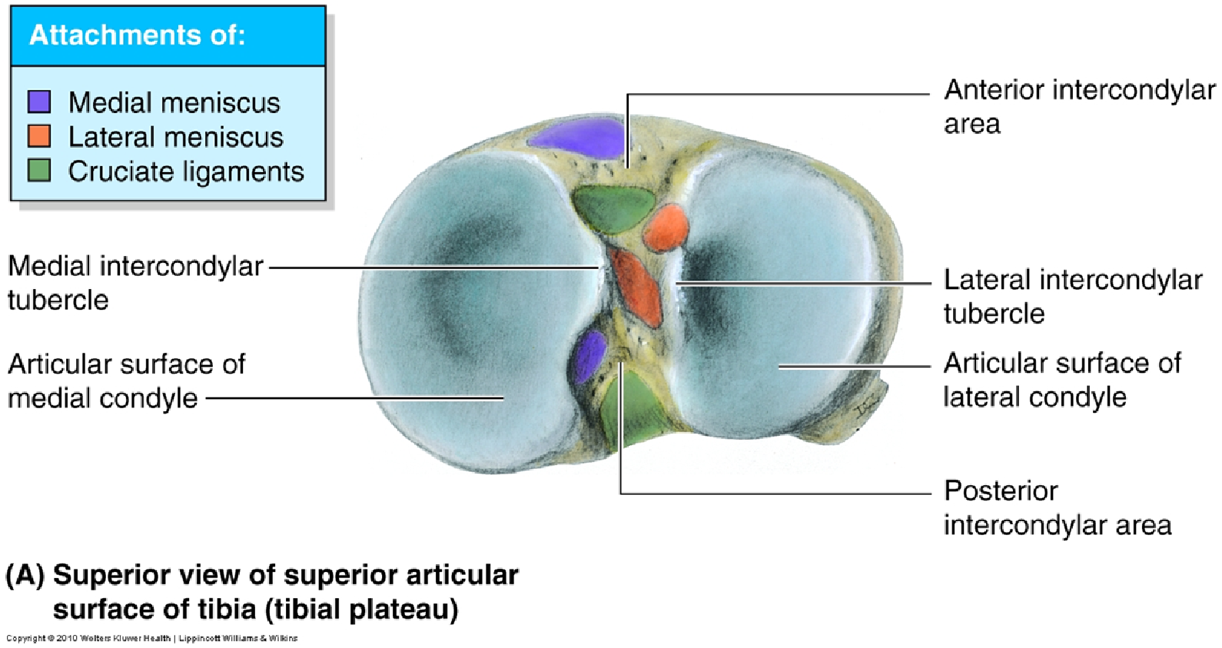

الدكتور حكى الصورة هاي و الوانها مهمة.. ولازم نعرف الريليشن لكل شي موجود فيها 😊

{Sheet notes}

-The two cruciate ligaments will go superiorly, the ant one will go post and the post one will go ant , and then a cross over and attachment will occur in the intercondylar fossa between the condyls (according to the femur).

-The posterior cruciate ligament :

=> stronger than the ant.

=>Attachments of the post cruciate ligament : from tibia to the post intercondylar area

=>Orintation: superior anteriorly then connect to the intercondylar fossa in the femur.

**Cruciate Ligaments: Injury**

* ACL injury is common
* PCL injury is rare
* Test of injury ……

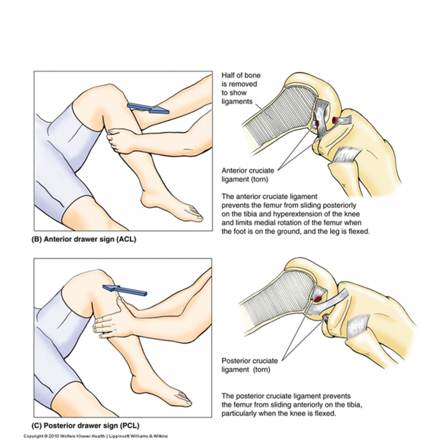

{ We can use this informations to test any cutting in the ligaments, the **ACL** more prone to the cut because the location (most anteriorly) and it is a weak ligament compared with the PCL }

-The cut in the ACL , if we move the tibia anteriorly,it will move.

-The cut in the PCL , if we move the tibia posteriorly,it will move

{Sheet notes}

-**Menisci** = cartilage disc (fibrocartilage)

Not a complete disc (like semilunar cartilage) surrounds by fibrous material and has an attachment on the tibia internally and externally so we will have a medial and lateral menisci.

-**Type of tissue:** A fibro cartilage tissue surrounded by fibrous tissue to make an attachment with the tibia.

-**Shape**: Crescentic / semilunar shape

-**Edges** …The edges all attached with tibia (its like of being a part of it)

- **Attachments**

* -On the periphery (medial or lateral) we have fibres connect it with the edges of the tibial condyles.
* -Medially it has a horns and this horns attach it with the intercondylar areas .
* -The medial meniscus , the insertions of its horns are far from each other compared with the lateral meniscus , so the ***lateral*** will be stronger.

-The connection between the medial collateral ligament and the medial meniscus will decrease the ***mobility*** , and increase the ***injuries*** that may occur due to two reasons :

1)the connection with the ligament

2) the shape of it, more wider angle than the lateral

-The lateral meniscus is separated from the lateral collateral ligament by the popliteus tendon.(stronger because it is not connected with ligament)

**Knee Joint: Synovial Membrane**

* Lines fibrous capsule
* Excludes ligaments,  menisci, & infrapatellar fat pad
* Synovial membrane  folds
  + Infrapatellar fold
  + Alar folds

{Sheet notes}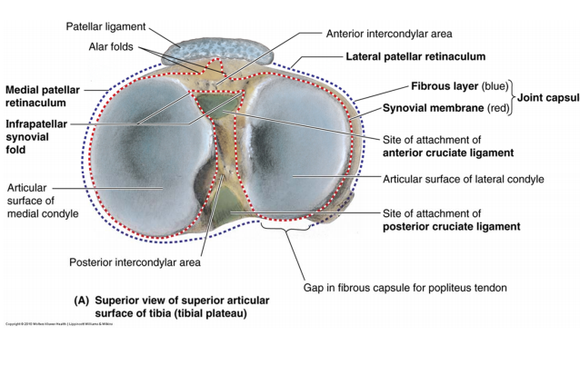

* There is a complexity in the synovial membrane due to the a lot of structures inside.
* *Synovial membrane* will attach with the **articular cartilage** and exclude any internal structure.
* *Synovial membrane* 🡪 lining to the fibrous capsule and will line the patella anteriorly.
* Behind the patella we have a fat pad , and also this pad must be excluded by making a fold like structure of *Synovial membrane* : alar folds .
* In the i**ntercondylar area** the attachment of cruciate ligaments are located and they also must be excluded, so the synovial membrane enter posteriorly then to the condylar (articular cartilage) then rotate around the cruciate ligaments .. and this will make a fold in the area ( infrapatellar synovial fold).

**Knee Joint: Bursae**

* Anterior bursae
* Suprapatellar bursa
  + Continuous with synovial membrane
  + Attached superiorly by articularis genus (from vastus intermedius)
  + Elevate bursa on extension
* Prepatellar bursa
* Superficial infrapatellar bursa
* Deep infrapatellar bursa

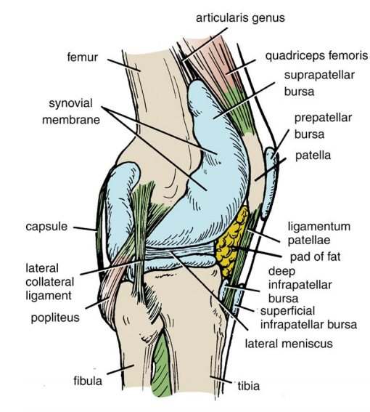

Posterior bursae

* Popliteal bursa*
* Semimembranosus bursa*
* Four bursae related to muscles tendons
  + Biceps femoris
  + Sartorius and gracilis
  + Medial head of gastrocnemius
  + Lateral head of gastrocnemius

* Continuous with synovial membrane

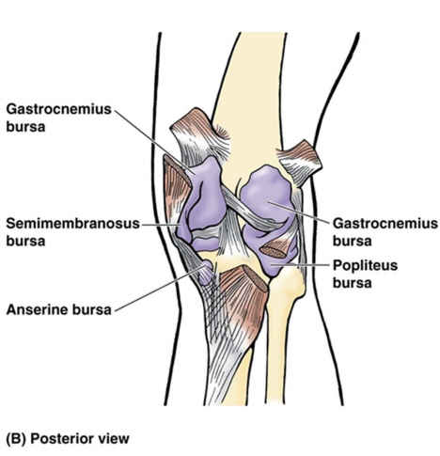

* {Sheet notes}
* A part from the bursa will be a continuation to the synovial membrane , and a part will be around the muscles by special bursae.
* Supra Patellar Bursa : from the above it is connected by a ligament like structure (articularis genus it is thought to be muscle fibre or tendon ) .*{The aim of the all bursae is to protect the knee joints and tendons }* with extension this bursae is elevated
* Popliteal bursa*🡺 popliteal muscle is part from the joint inside the capsule
* Semimembranosus bursa => extension from the synovial membrane
* No hyper extension in the knee joint like the elbow
* The lateral rotation degree is more than the medial one

**Knee Movements**

* Flexion ……
* Extension …..
* Rotation
* Mostly at flexion
* *Medial* rotation
  + Sartorius, gracilis, &  semitendinosus
  + **5° to 10°**
* Lateral rotation
  + Biceps femoris
  + **30°**

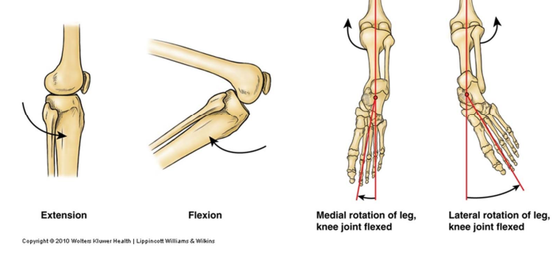

**Proximal Tibiofibular  Joint**

* Lateral condyle of the tibia and  head of fibula
* Plane joint
* Ligaments
  + Anterior and posterior ligaments
  + The interosseous membrane
* Nerve supply: common peroneal  nerve

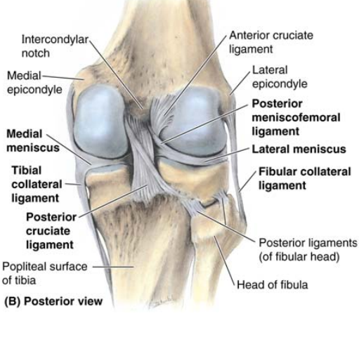

**Distal Tibiofibular Joint**

* Fibular notch and fibula
* Fibrous joint
* Ligaments:
  + Interosseous ligaments
  + Interosseous membrane
  + Anterior and posterior ligaments
  + Inferior transverse ligament
* Nerve supply: deep peroneal  and tibial nerves

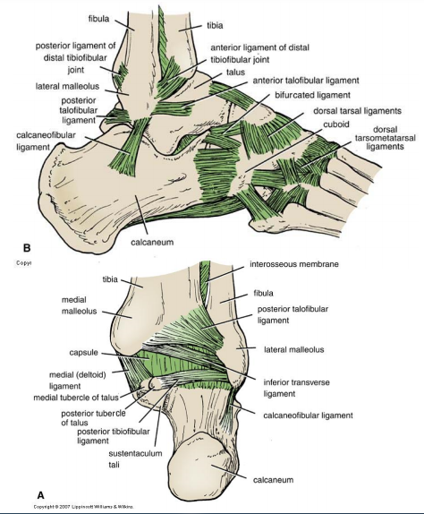

* {Sheet notes}
* Proximal Tibiofibular joint = head of fibula + post lateral surface of the lateral condyle of the tibia.
* The inferior transverse ligament connect the fibula and the tibia inferiorly.

**Ankle Joint**

* Distal end of tibia and fibula and the body of the talus
* Hinge joint
* Nerve supply: deep peroneal and tibial nerves

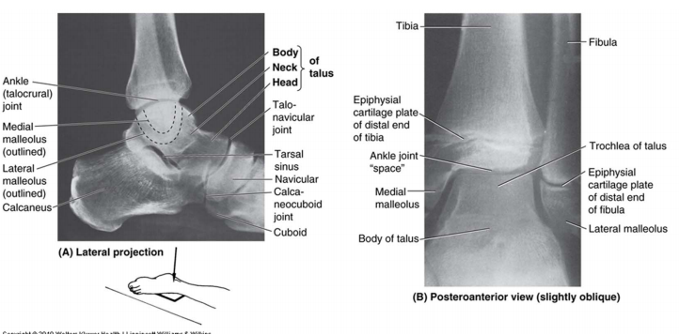

Ligaments:

* Medial (deltoid) ligament // Stronger
* Lateral ligament:
  + Anterior talofibular ligament
  + Calcaneofibular ligament
  + Posterior talofibular ligament

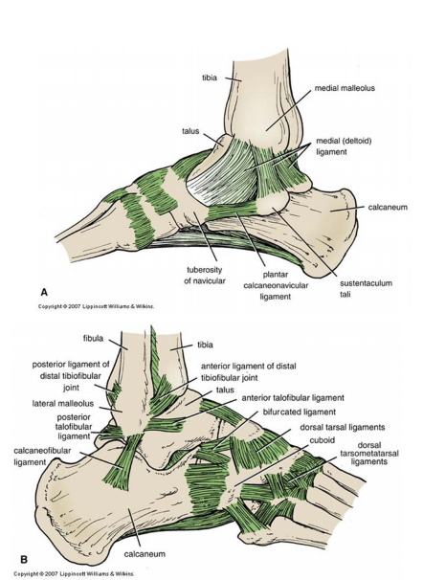

Ankle joint = the impression of the distal part of fibula and tibia inferiorly with the body of talus .

All the nerves that pass in any joint will participate in the innervation of that joint by articular branches (sensory branches)

-Medial ( deltoid ) ligament : connect the medial malleolar with the tarsus bones (talus) and the calcaneus and it is a very strong.

-Lateral ligament : anterior and posterior talofibular ligaments between the talas and fibula and Calcaneofibular ligament are very weak ligaments

**Ankle Joint: Movements**

* Dorsiflexion
  + Anterior compartment mm.
* Planter flexion
  + Lateral and posterior  compartments mm.

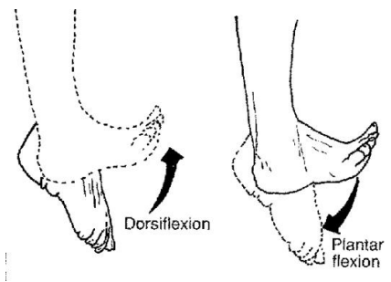

**Ankle Joint: Injuries**

* 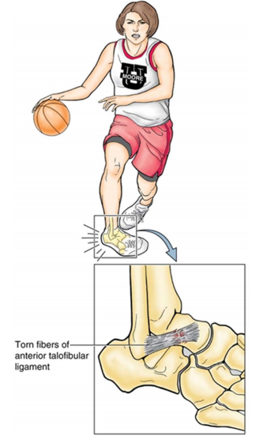Ankle injury > other major joint  in the body
* Ankle sprain
  + Mostly inversion injury
    - Lateral lig. sprain
      * Weaker
      * Mostly anterior talofibular lig.

-Most of the injuries : inversion toward the medial side , and the most affected part is the lateral side due to the weak ligaments.

-The medial is hard to have an injury on it (protected inside)

( the most ligament affected by this injury is : anterior talofibular ligament).

{The end of *joints of the lower limb ||* }

إذا كان الشغل مجهدة .. فإن الفراغ مفسدة

فعمل يجهدك .. خير من فراغ يفسدك 😊