Al Balqa Applied University
College of Medicine

Lecture 5
Ancylostoma duodenale, Fasciola hepatica,

Dr. Hala Al Daghistani
Ancylostoma duodenale (human hookworm)
Female hookworms are approximately 10 mm in length; males are slightly smaller and have a taxonomically characteristic copulatory bursa (broadened posterior end), which is usedto mate with females.

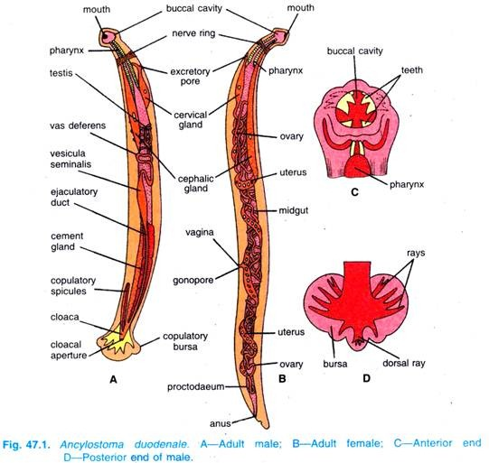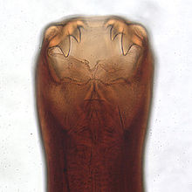
- Females can release more than 10,000 eggs per day into the feces, where

- larvae hatches from theegg within a day or two days.
- Larvae can survivein moist soil for several weeks
- These larvae penetrate host skin, migrate throughout the host and endup in the small intestine ( like Ascaris) where they mature into adult worms.
Pathology and Pathogenesis
- In the intestine, adult worms attach to intestinal villi with their buccal teeth and feed on blood and tissue.
- Afew hundred worms in the intestine can cause hookworm disease, which is characterized by severe anemia and iron deficiency.
- Intestinal symptoms also include abdominal discomfort and diarrhea. The initial skin infection by the larvae causes a condition known as “ground itch,” characterized by erythema and intense pruritus. Feet and ankles are common sites of infection.

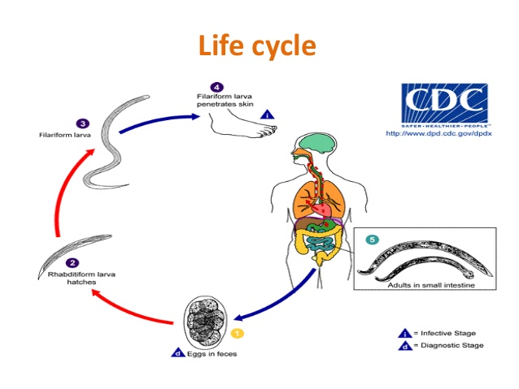
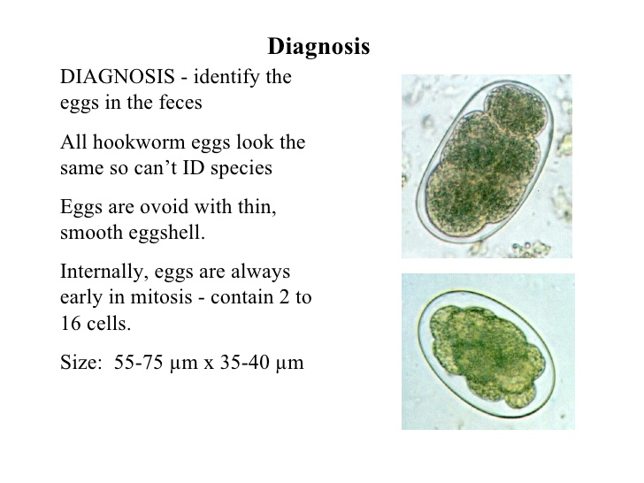

Fasciola hepatica (sheep liver fluke)
- Commonly found in the livers of sheep, cattle, and other herbivores, penetrates the intestinal wall, invades the liver tissue,and resides in the bile ducts.
- Acute infection causes abdominal pain, intermittent fever, eosinophilia, malaise, and weight loss due to liver damage.

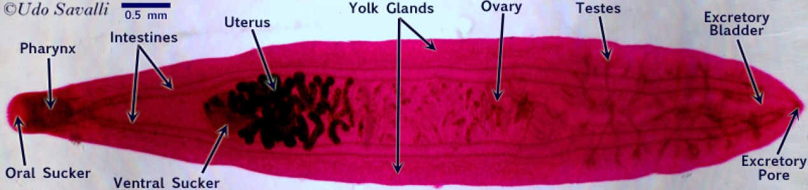
Fasciola hepatica is a fluke or flatworm, a type of helminth of the class Trematoda.
- It infects the livers of various mammals, including humans.
- The disease caused by the fluke is called fasciolosis or fascioliasis, which is a type of helminthiasis and has been classified as a tropical disease.
- Fasciola hepatica occurs in the liver of definitive host, including: cattle, sheep, buffaloes and human.
- Metacercariae are released from the freshwater snail, and form Cysts on various surfaces including aquatic vegetation
- Humans can often acquire these infections through eating freshwater plants such as watercress.
- Inside the duodenum of the mammalian host, the metacercariae are released from within their cysts.
- From the duodenum, they burrow through the lining of the intestine and into the peritoneal cavity. They then migrate through intestines and liver, and into the bile ducts.
- Inside the bile ducts, they develop into an adult fluke.
- The adult flukes can then produce up to 25,000 eggs per fluke per day.
- These eggs are passed out via stools and into freshwater. Once in freshwater, the eggs become embryonated, allowing them to hatch as Miracidia, which then find a suitable intermediate snail host.
- Inside this snail, the miracidia developinto to cercariae. The cercariae are released from the snail to form metacercariae and the life cycle begins again.

- During the acute phase, the immature worms begin penetrating the gut, causing symptoms of fever, nausea, swollen liver, skin rashes and extreme abdominal pain.
- The chronic phase occurs when the worms mature in the bile duct, and can cause symptoms of pain, jaundice, biliary tract obstruction, and anemia.

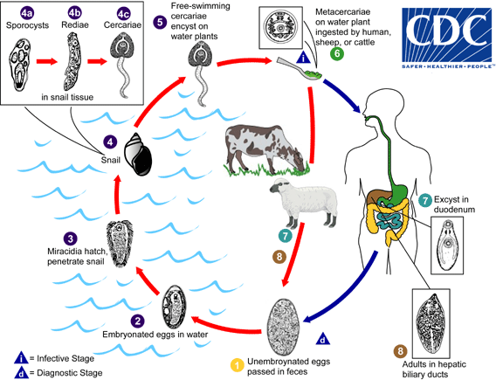
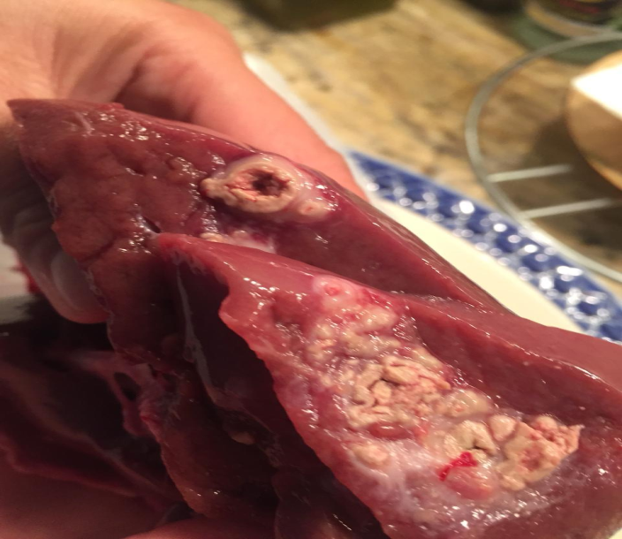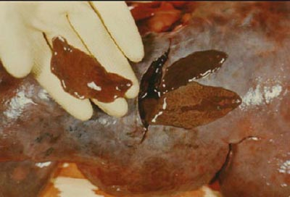

TaeniaSaginata (Beef tapeworm), TaeniaSolium (Pork tapeworm)

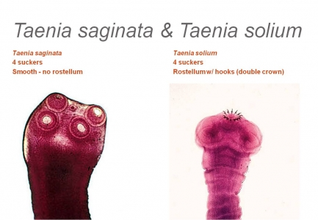
- If humans eat “measly beef” or “measly pork” containing the bladder-like larvae called cysticerci, they acquire infections of T. saginata and T. solium, respectively.
- The cysticerci, which are about the size of peas, develop into adult worms that can reach lengths of several meters in the intestine.
- Adult worms generally cause few problems, and most are asymptomatic; mild intestinal symptoms include diarrhea and abdominal pain.
- In the intestine, egg-filled terminal segments break off from the adult worm and pass out with human feces. When the eggs from human feces are consumed by cows (T saginata)or pigs (T solium), larvae hatch from the eggs, migrate, and encyst as cysticerci in various tissues, including cow muscle (beef) or pig muscle (pork).
- Humans become infected when they eat raw or undercooked meats containing the cysticerci. These cysticerci then develop into adult worms in the human intestine.
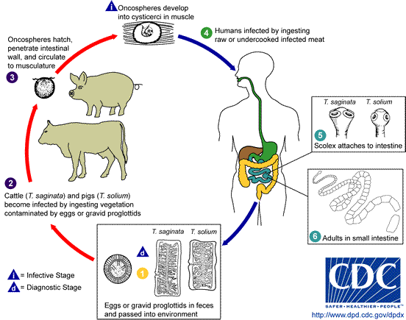
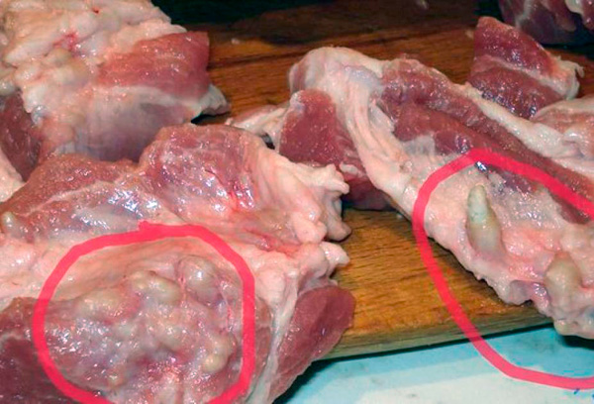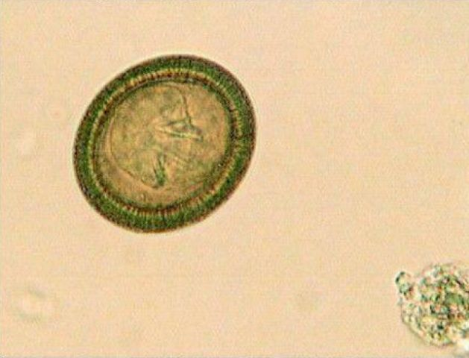

Hymenolepis nana (dwarf tapeworm)
Hymenolepis nana, the dwarf tapeworm of humans (and rodents), is only about 4 cm in length. It is found worldwide and is one of the most common tapeworm infections in humans owing to the fact that the eggs can short-circuit the usual developmental phase in an insect and infect humans directly from eggs passed in feces of other humans (direct life cycle).
- Alternatively, if the insect that harbors the larval stage is eaten, the larvae develop into adult worms in humans (indirect life cycle). Humans can be infected in both ways.
- The scolex bears a single circle of 20 to 30 hooks and also has four suckers. The neck is long and slender, and the segments are wider than long.

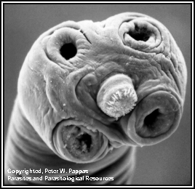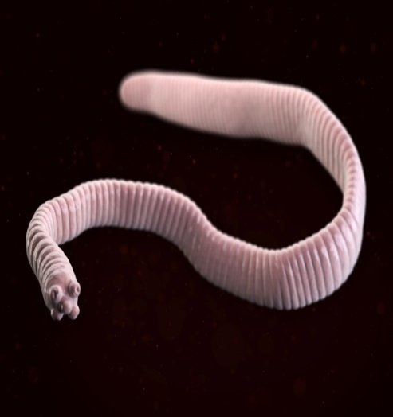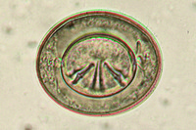

Hymenolepis nana lifecycle
- Infection is acquired most commonly from eggs in the feces of another infected individual, which are transferred in food, by contamination.
- Eggs hatch in the duodenum, releasing Oncospheres, which penetrate the mucosa and come to lie in lymph channels of the villi.
- An oncosphere develops into a cysticercoid which has a tail and a well-formed scolex
- In five to six days, cysticercoids emerge into the lumen of the small intestine, where they attach and mature.
- Direct contaminative infection by eggs is probably the most common route in human cases, but accidental ingestion of an infected grain beetle or flea cannot be ruled out.

