**Al Balqa App[lied University**

**College of Medicine**



## Lecture 5

## Ascaris lumbricoides

**Dr. Hala Al Daghistani**

Round worm –intestinal Nematode

* ***Ascaris*** are large: Females are 20–50 cm long, and males are 15–30 cm long.
* Humans acquire the infection after **eggs are ingested**; **the larvae hatch in the duodenum**, **penetrate through the mucosa**, **migrate in the circulatory system, lodge in lung capillaries**, **penetrate the alveoli**, and migrate from the **bronchioles to the trachea and pharynx.** larvae are **swallowed and return to the intestine and mature into adults.**
* After mating, females can release 200,000 eggs per day, which are passed in the feces.
* Eggs are infective after about 1 month in the soil and are infectious for several months.

**[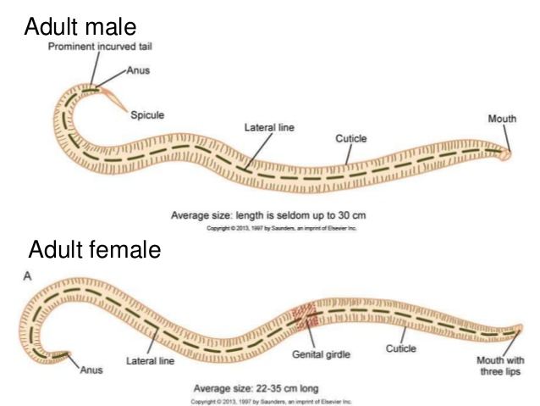](https://www.slideshare.net/akolagi09/ascaris-lumbricoides-trichuris-trichiura)**

Pathology and Pathogenesis

* If present in high numbers, **adult worms may cause mechanical obstruction of the bowel and bile and pancreatic ducts**. Worms tend to migrate if drugs such as anesthetics or steroids are given, leading to **bowel perforation** and **peritonitis, anal passage of worms, vomiting,** and **abdominal pain.**
* Larvae migrating through lungs induce an inflammatory response (**pneumonitis**), leading to **bronchial spasm, mucus production**, and **Löffler syndrome** (a disease in which [eosinophils](https://en.wikipedia.org/wiki/Eosinophil" \o "Eosinophil) accumulate in the lung in response to a [parasitic](https://en.wikipedia.org/wiki/Parasite) infection. associated with cough, eosinophilia, and pulmonary infiltrates).

[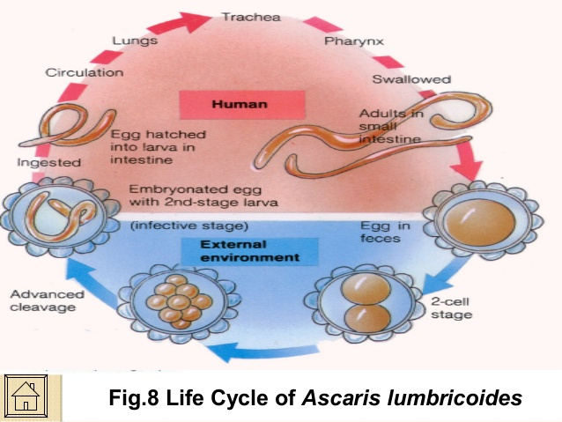](https://www.slideshare.net/nikecruz/pseudocoelomate-bs-biology-2ab-sy-20122013)

Diagnosis: Detection of fertilized and unfertilized eggs in the stool. The eggs covered with thick albumin coat.

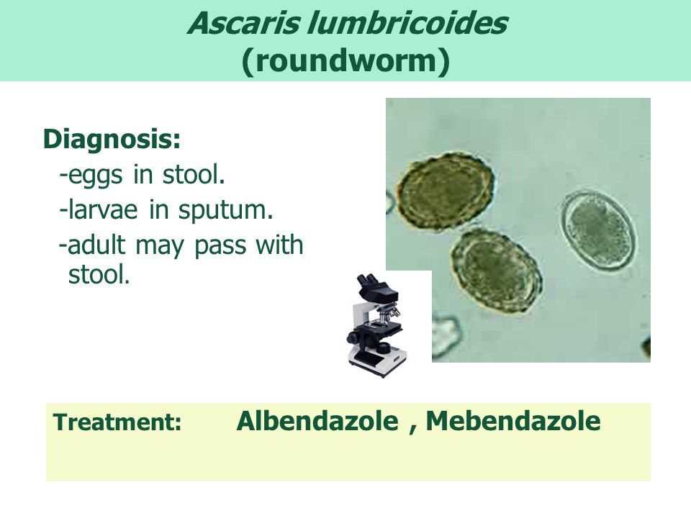[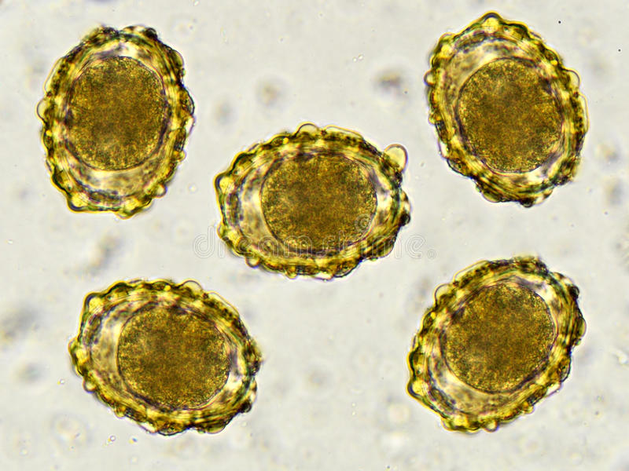](https://www.dreamstime.com/stock-photo-eggs-ascaris-lumbricoides-roundworm-stool-analyze-microscope-image80030579)

Enterobius vermicularis

(Pinworm)

* Female **pinworms** (about 10 mm in length) have a slender, pointed posterior end. Males are approximately 0.5cm in length and have a curved posterior end .
* Causes a condition known as “**Ground itch**,”
* They are the most common helminthic infection in the United States and infect mostly children.

[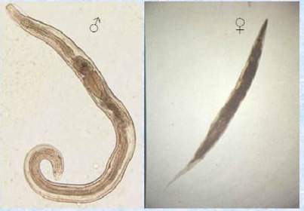](https://www.pinterest.co.uk/pin/506232814350674662/)

**Life cycle**

[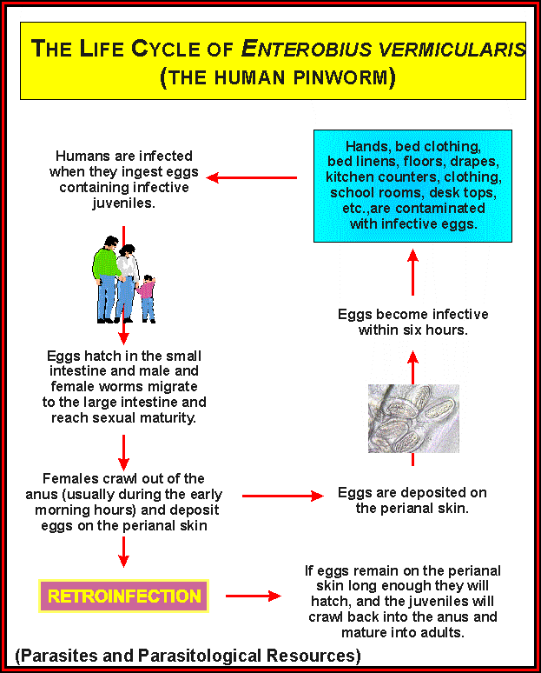](http://www.pathobio.sdu.edu.cn/sdjsc/parasiteimages/enterobius_lifecycle.html)

**Pathology and Pathogenesis**

* The main symptom associated with pinworm infections is perianal pruritus, especially at night, caused by a hypersensitivity reaction to the eggs that are laid around the perianal region by female worms, which migrate down from the colon at night.
* Scratching the anal region promotes transmission, as the eggs are highly infectious within hours of being laid (**hand-to-mouth transmission**).
* Irritability and fatigue from loss of sleep occur, but the infection is relatively benign.
* Eggs are recovered using the “**Scotch Tape” technique** in the morning before a bowel movement. Transparent Scotch Tape is applied directly to the perianal area, and then placed on a microscope slide for examination.
* Eggs are foot ball shaped, have a thin outer shell, and are approximately 50–60 μm in length.
* Infectious larvae are often visible inside the egg. The small adult worms may be seen in a stool O&P (ova and parasites) test.

[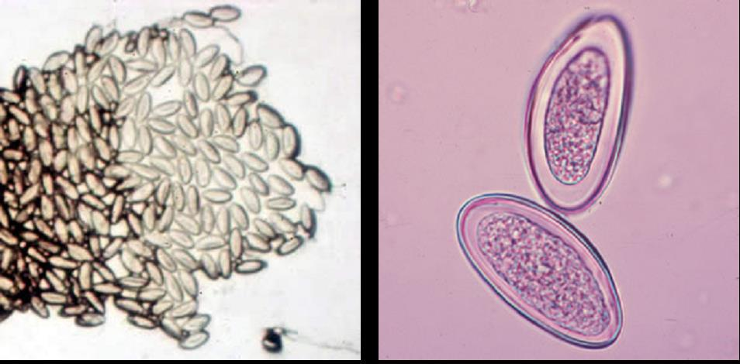](http://www.2020iscoming.info/else/enterobius-vermicularis-in-stool.coming)

***Trichuris trichiura***

**(Whipworm)**

* Adult female **Whipworms** are approximately 30–50 mm in length; adult male worms are smaller.
* The anterior end of the worms is slender, and the posterior end is thicker, giving it a “buggy whip” appearance, hence the name whipworm.
* **Adult whipworms inhabit the colon**, where male and female worms mate.
* Females release eggs that are passed in the feces, and eggs become infective after about 3 weeks of incubation in moist and shady soil.
* Humans acquire the infection by eating foods contaminated with infective eggs. Once eggs are swallowed, the larvae hatch in the small intestine, where they mature and migrate to the colon. (**The egg is football-shaped, thick-shelled and possess a pair of polar “plugs” at each end).**

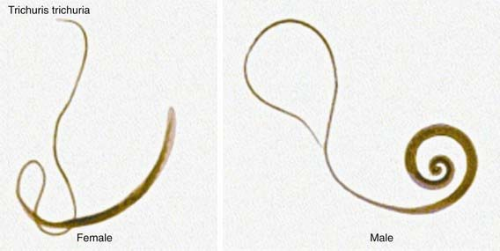[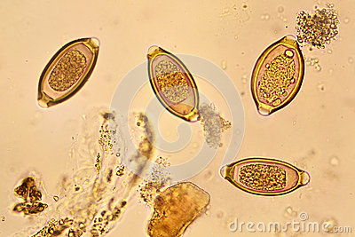](https://www.dreamstime.com/stock-photo-trichuris-trichiura-parasite-microscope-micro-labolatory-image58881687)

**Pathology and Pathogenesis**

* The anterior ends of the worms lodge within the mucosa of the intestine, leading to small hemorrhages with mucosal cell destruction and infiltration of eosinophils, lymphs, and plasma cells, abdominal pain, distention, and diarrhea.
* Severe infection may lead to profuse bloody diarrhea, cramps, tenesmus, urgency, and **rectal prolapse.**
* **Occasionally worms migrate to the appendix, causing appendicitis.**

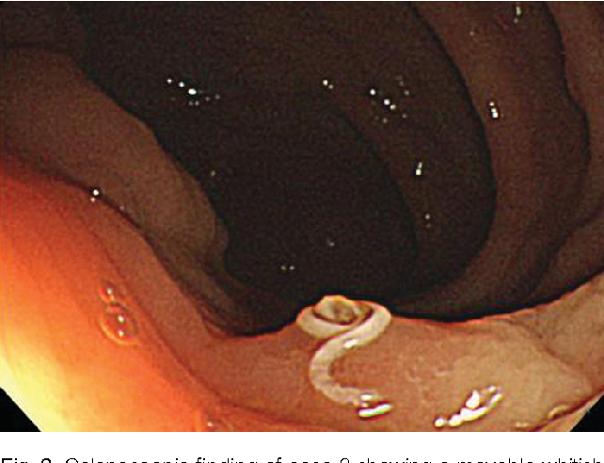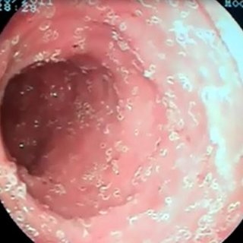

**T.trichiura in the colon**

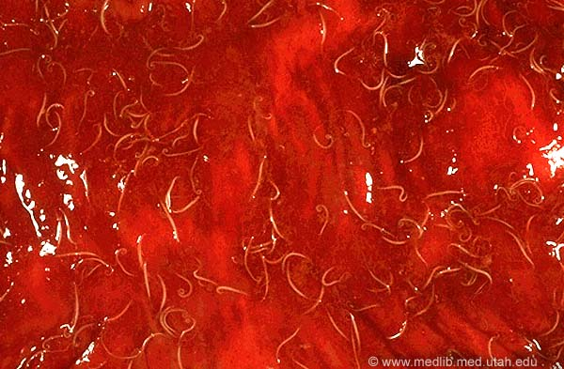

**APPENDICITIS**

[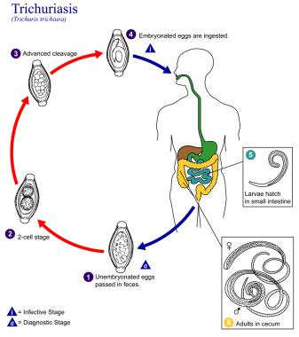](http://emedicine.medscape.com/article/788570-overview)

Toxocariasis (Dog Ground worm)

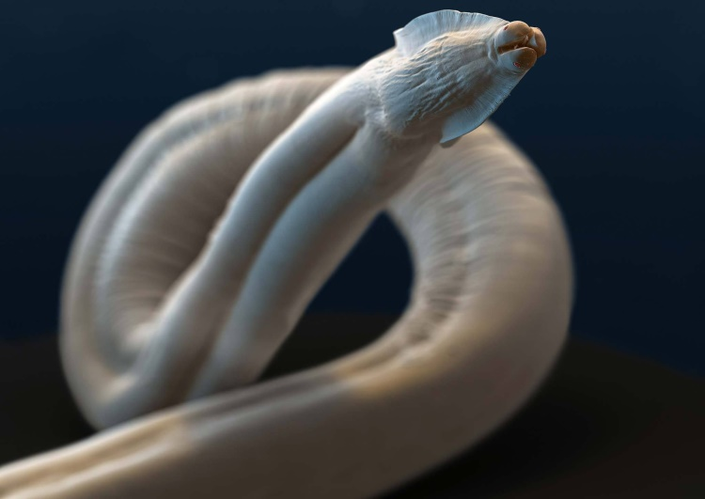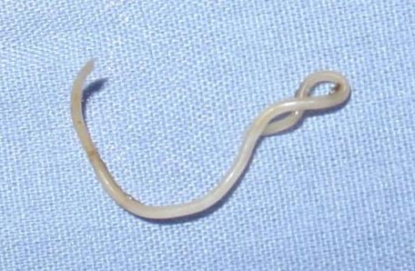

* **Toxocariasis** is an illness of humans caused by [larvae](https://en.wikipedia.org/wiki/Larvae) of either the:
* Dog (*[Toxocara canis](https://en.wikipedia.org/wiki/Toxocara_canis" \o "Toxocara canis)*)
* Cat (*[Toxocara cati](https://en.wikipedia.org/wiki/Toxocara_cati" \o "Toxocara cati)*)
* Fox (*[Toxocara canis](https://en.wikipedia.org/wiki/Toxocara_canis" \o "Toxocara canis)*).
* Humans normally become infected by ingestion of embryonated eggs (each containing a **fully developed**[**larva**](https://en.wikipedia.org/wiki/Larva), L2) from contaminated sources (soil, fresh or unwashed vegetables).
* Cats, dogs and foxes can become infected with *Toxocara* through the ingestion of eggs or by transmission of the larvae from a mother to her offspring
* Transmission to cats and dogs can also occur by ingestion of infected accidental hosts, such as earthworms, cockroaches, rodents, rabbits, chickens, or sheep.

**There are three main syndromes:**

* [**Visceral larva migrans**](https://en.wikipedia.org/wiki/Visceral_larva_migrans)**(VLM),** diseases associated with major organs
* **Covert toxocariasis**, which is a milder version of VLM
* **Ocular larva migrans (OLM),** in which pathological effects on the host are restricted to the eye and the [optic nerve](https://en.wikipedia.org/wiki/Optic_nerve)
* **Transmission of *Toxocara* to humans is usually through ingestion of infective eggs.**
* ***T. canis* can lay around 200,000 eggs per day. These eggs are passed in cat or dog feces.**
* Both *Toxocara canis* and *Toxocara cati* eggs require a **several week incubation** period in moist, humid weather, outside a host before becoming infective, so fresh eggs cannot cause toxocariasis.
* Humans are not the only accidental hosts of*Toxocara.* Eating undercooked rabbit, chicken, or sheep can lead to infection; encysted larvae in the meat can become reactivated and migrate through a human host, causing toxocariasis.
* Eggs hatch as second stage larvae (L2) in the intestines of the cat, dog or fox host. Larvae enter the bloodstream and migrate to the lungs, where they are coughed up and swallowed. The larvae mature into adults within the small intestine of a cat, dog or fox, where mating and egg laying occurs. Eggs are passed in the feces and only become infective after several weeks outside of a host. During this incubation period, molting from first to second (and possibly third) stage larva takes place within the egg.
* Second stage larvae will also hatch in the small intestine of an accidental host, such as a human after ingestion of infective eggs. The larvae will then migrate through the organs and tissues of the accidental host, most commonly the lungs, liver, eyes, and brain**. Since L2 larvae cannot mature in accidental hosts, after this period of migration*, Toxocara* larvae will encyst as second stage larvae.**

## Signs and symptoms

* Most cases of *Toxocara* infection are asymptomatic, especially in adults. When symptoms do occur, they are the result of migration of second stage *Toxocara* larvae through the body.
* **Covert toxocariasis** is the least serious of the three syndromes and is believed to be due to chronic exposure. Signs and symptoms of covert toxocariasis are coughing, fever, abdominal pain, headaches, and changes in behavior and ability to sleep. Upon medical examination, wheezing, [hepatomegaly](https://en.wikipedia.org/wiki/Hepatomegaly" \o "Hepatomegaly), and [lymphadenitis](https://en.wikipedia.org/wiki/Lymphadenitis) are often noted.
* In **VLM,** larvae migration causes inflammation of internal organs and sometimes the central nervous system. Symptoms depend on the organ(s) affected. Patients can present with fatigue, weight loss, anorexia, fever, headache, rash, cough, asthma, chest tightness, increased irritability, abdominal pain, nausea, and vomiting.
* **Ocular larva migrans (OLM)** is rare compared with VLM. Loss of vision occurs over days or weeks.

### Life cycle

### 

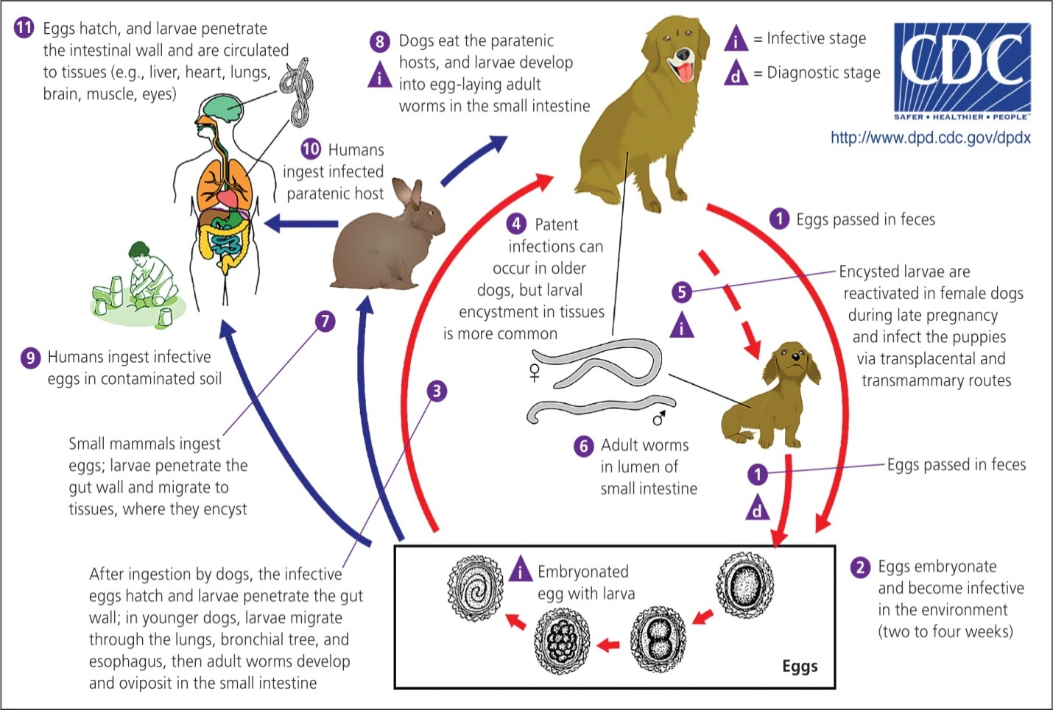

**Diagnosis**

* **Finding *Toxocara* larvae within a patient is the only definitive diagnosis for toxocariasis.** PCR, ELISA, and serological testing are more commonly used to diagnose *Toxocara* infection.
* Serological tests are dependent on the number of larvae within the patient, and are unfortunately not very specific

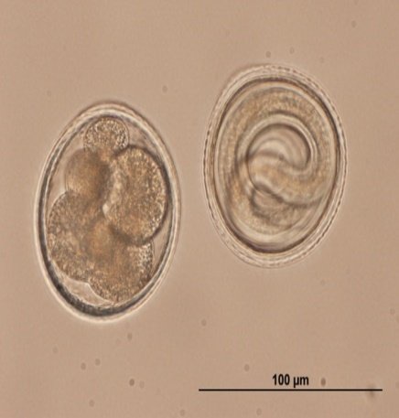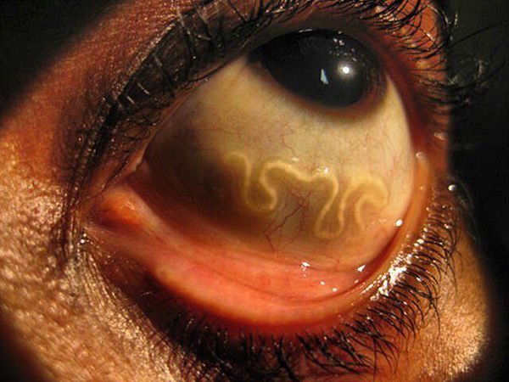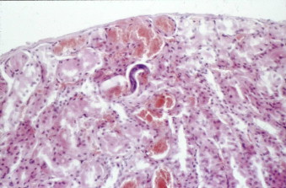

**Toxicara larvae in the renal cortex**

