# sheet 9

Al Balqa App[lied University
College of Medicine

Microbiology
Schistosoma

Done by :
- Raghad dweedar
- Tasnim badwan
Edited by :
- Rawan abd alaziz

The Organisms
- More than 200 million people are infected worldwide with Schistosoma species.
- The adult worms are long and slender (males are 6–12 mm in length; females are7–17 mm in length) and can live in copula for 10–20 years within the venous system .
#Copula (also known as gynaecophoric canal): is the place where female attaches to male .
# both male and female are separated from each other, they are not hermaphrodites.

- S.mansoni: inferior mesenteric veins of large intestine
- S.japonicum: inferior and superior mesenteric veins of small intestine
- S.haematobium:veins of urinary bladder.

#We can differentiate between their eggs by the location of the spine .

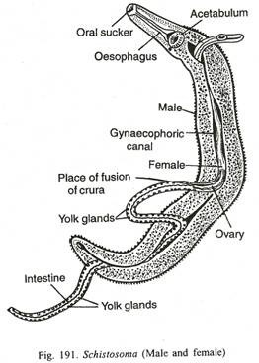

- Humans acquire the infection when they contact water infested with the Infectious cercariae. Cercariae are attracted to the warmth of a body and skin lipids and begin to burrow into exposed skin. Within 30 minutes, the cercariae have penetrated the epidermis and transformed into Schistosomules,which enter the peripheral circulation (the infective stage is cercariae not Schistosomules ), where they eventually become adults in the hepatoportal system or venous plexus surrounding the bladder.
- The female schistosomes begin releasing eggs approximately 5–8 weeks after infection.

Pathology and Pathogenesis

- The most significant pathology is associated with the schistosomeeggs, not the adult worms.
- Female schistosomescan lay hundreds or thousands of eggs per day within the venous system. When eggs are released, many are sweptback into the circulation and lodge in the liver (S mansoniand S japonicum) or urinary bladder (S haematobium)
- In chronic cases, blood flow to the liver is impeded ( # bcz of venous obstruction caused by the eggs ), which leads to portal hypertension, accumulation of ascites in the abdominal cavity, hepatosplenomegaly, and esophageal varices.

- In travelers to endemic countries, clinical findings of acute schistosomiasis include an itchy rash (swimmer’s itch)that occurs within an hour after cercariae penetrate the skin,followed by headache, chills, fever, diarrhea, and eosinophilia

# Each parasite penetrate the skin can cause itching.
# Adults lay egg that cicrculate to the liver and shed in the stool (if it is S.mansoni or S.japonicum ) or venous plexus of bladder (if it is S.haematobium).

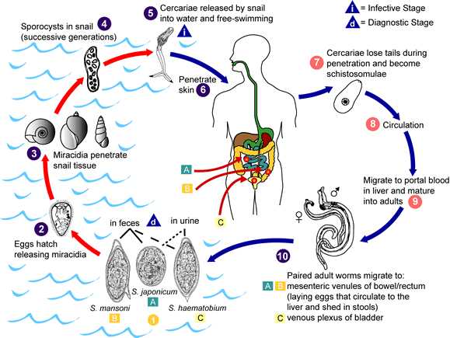

#Cercaria is the infective stage.
Diagnosis is by O&P:
- S.mansoni(lateral spine) egg in stool
- S.japonicum(nubby spine) eggs in stool
- S.haematobium(terminal spine) eggs in urine
#The spine cuases scratching where it penetrates.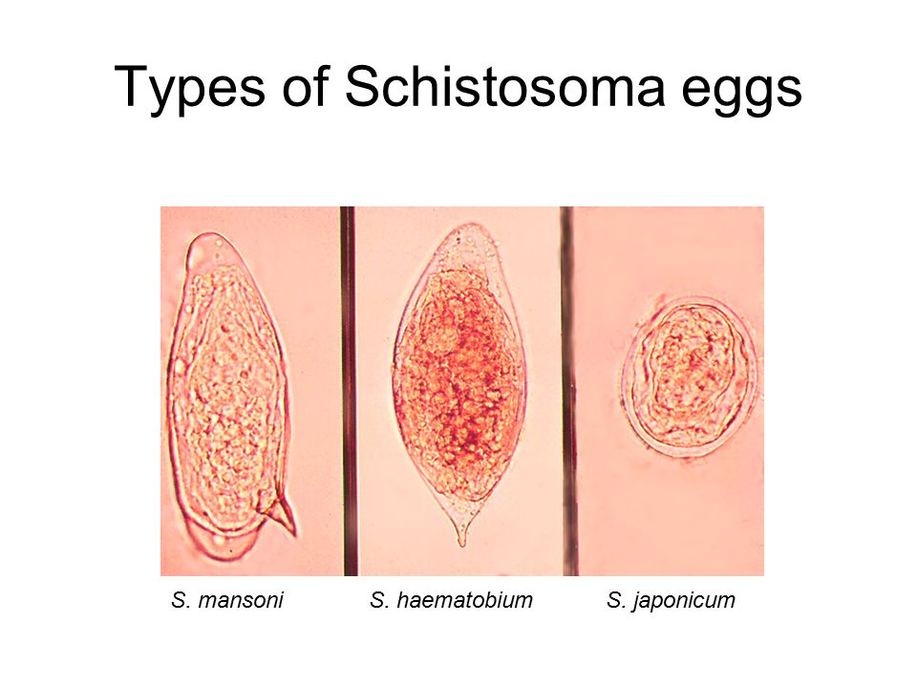

Echinococcus granulosus (hydatid cyst) مشوكة حبيبية

Echinococcus granulosus is a small, three-segmented tapeworm found in the intestine of dogs and others.
#It is different from others because it has two hosts
- intermediate host :human and herbivore(sheep ,rabbits……)
- definitive host :carnivores(dogs)
where the mating and producing the larvae happen

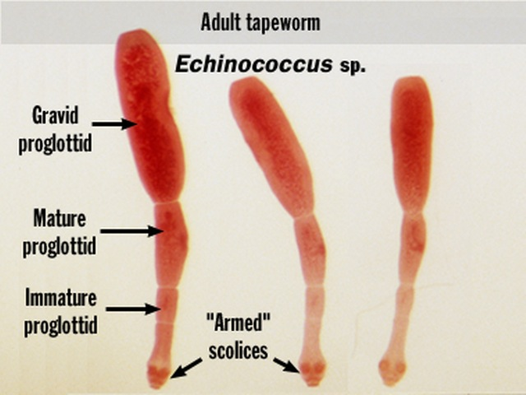
- The eggs leave these hosts and infect grazing animalsاكلات الاعشاب)).The larva hatches from the egg, penetrates the gut, and migrates to various tissues,especially liver, spleen, muscle, and brain.
- The larva of Echinococcus develops into a fluid-filled cyst called a hydatid cyst. The cyst contains germinal epithelium in which thousands of future larvae (called protoscolices) develop
- Inside the hydatid cyst, the protoscolices are contained within brood capsules. If the hydatid cyst ruptures, the brood capsules can spill out of the cyst, metastasize to other sites, and develop into a hydatid cyst. Thus, ingestion of a single egg can give rise to several hydatid cysts, each containing several brood capsules
- Humans are infected only by ingesting Echinococcus eggs from food contaminated with dog feces. The dog, in turn, can acquire the infection only from an infected herbivore (cyst). )sheet note:the liver of intermediate hosts contain fluid-filled cysts)
- Humans are only the intermediate and never the final host of this tapeworm.

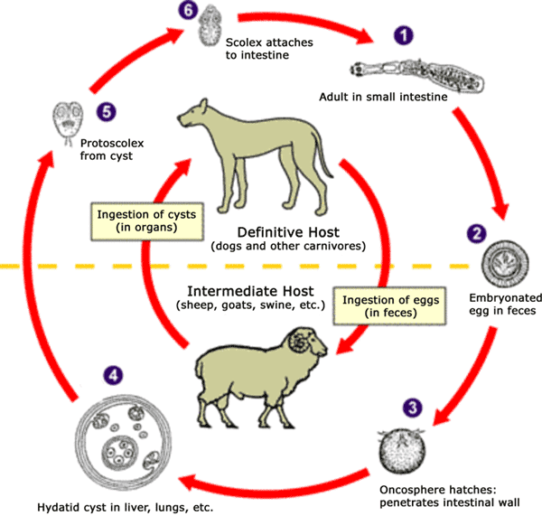
This is the sac that contain the eggs or cysts .
This sac presses on the organs or causes anaphylactic shock.

#Sheet note:
- Someone asks which of host attacks the other firstly?
The dogs because in their bodies the mating and producing eggs happen The contaminated grass (with eggs) is eaten by sheep ,the encystation happens in sheep ,if the carnivores eat the sheep that contain the cysts and then the cysts become free and go to the bloodstream
- The mating occurs in the small intestine
- In the intermediate hosts(human,sheep….etc),the mating doesn’t happen ,but the encystation (forming the fluid-filled cysts happen.)

Pathology and Pathogenesis
- Hydatid cysts can grow about 1–7 cm per year(sheet note:slow growth), and the symptoms depend on the location of the cysts in the body. The liver is the most common site, where compression, atrophy, portal hypertension from mechanical obstruction, and cirrhosis can occur.
- Extreme care must be taken when removing the cyst. If the cyst ruptures, the highly immunogenic hydatid fluid can lead to anaphylactic shock and brood capsules can metastasize to form additional hydatid cysts.

# Sheet note:
The doctor ask about what happen in patient with anaphylactic shock :hypotention ,vasodilation, due to histamine releasing
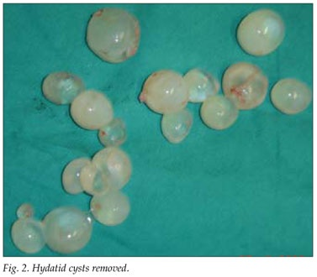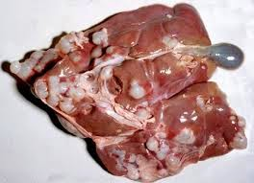

In conclusion:
- The lifecycle of E. granulosus involves dogs and wild carnivores as a definitive host for the adult tapeworm. Definitive hosts are where parasites reach maturity and reproduce. Wild or domesticated animals, such as sheep, and human serve as an intermediate host.
- The larval stage results in the formation of echinococcal cysts in intermediate hosts (human). Echinococcal cysts are slow growing, but can cause clinical symptoms in humans and be life-threatening. Cysts may not initially cause symptoms, in some cases for many years. Symptoms developed depend on location of the cyst, but most occur in the liver, lungs

