

**Al- Balqa Applied University**

**Faculty of Medicine Dr. Hala Al Daghistani**

**Lecture four**

**Rickettsia and Q-fever**

* **Human pathogens in the family *Rickettsiaceae* are small bacteria of the genera *Rickettsia* and *Orientia.***
* **Rickettsial diseases are a group of infections caused by the obligate intracellular bacteria *Rickettsia.***
* ***Rickttsia* is a Gram-negative, small, cocco-bacilli that can present as cocci or bacilli, non-motile, non-spore forming, highly pleomorphic bacteria. They are group of microorganisms that phylogenetically occupy a position between bacteria and viruses.**
* **These organisms are transmitted to humans by arthropods. Many rickettsiae are transmitted transovarially in the arthropods (passage of parasites or infective agents from the maternal body to eggs within the ovaries).**
* **Arthropods serves as both vector and reservoir.**
* **Rickettsial infections, typically are characterized by fever, rashes, and vasculitis.**

[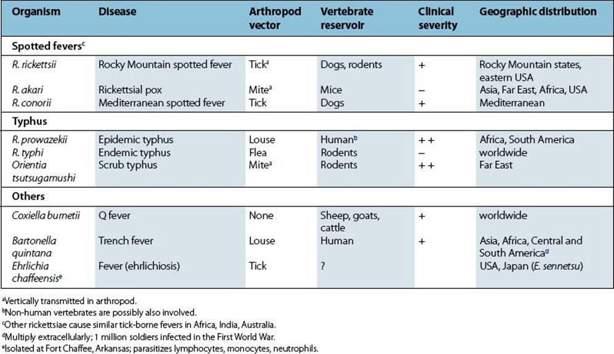](http://schoolbag.info/biology/microbiology/28.html)

**Coxiella burnetii**

* **Is a small obligate organism that has a membrane similar to gram-negative bacteria. *C. burnetii*, which causes Q fever, is resistant to drying, survive pasteurization at 60°C for 30 minutes, survive for months in dried feces or milk. This is deu to the formation of endospore-like structures *.***
* **Coxiellae grow only in cytoplasmic vacuoles.**

[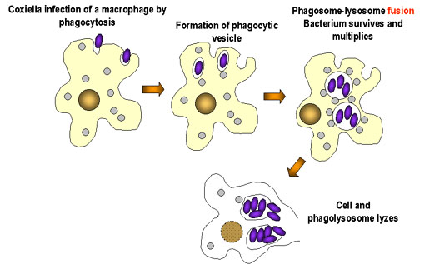](https://www.google.jo/url?sa=i&rct=j&q=&esrc=s&source=images&cd=&ved=0ahUKEwiph5TboJ_SAhXB6RQKHY3dD0EQjRwIBw&url=https://microbewiki.kenyon.edu/index.php/Coxiella&psig=AFQjCNHVffvtkv9ahg0plfYu4LYSSTs7og&ust=1487699755067886)

* **Can survive 7 to 10 days on wool at room temperature**
* **1 month on fresh meat in cold storage**
* **120 days in dust and more than 40 months in skim milk.**

**Coxiella burnetii has two antigenic phases:**

1. **During acute infection IgM and IgG antibodies against phase II antigens predominate**
2. **A persisting high titer of IgG antibodies against phase I is suspect for chronic infection**

**During the course of the infection, the outer membrane of the organism undergoes changes in its lipopolysaccharide structure, called phase variation. Differences in phase I and phase II antigen presentation can help determine if the infection is acute or chronic.**

[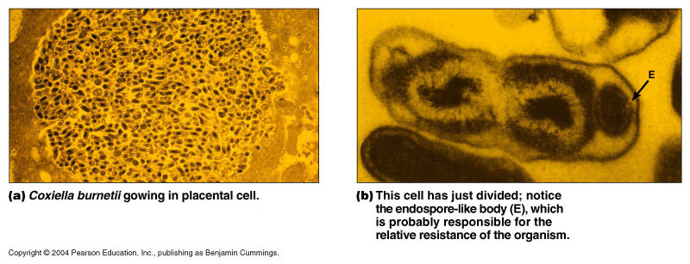](http://classes.midlandstech.edu/carterp/Courses/bio225/chap24/lecture4.htm)

**Epidemiology**

* ***C. burnetii* is found in ticks, which transmit the agent to sheep, goats, and cattle, but transmission by ticks to humans is uncommon.**
* **Workers in slaughterhouses have contracted the disease as a result of handling infected animal tissues.**
* ***C burnetii* is transmitted by the Respiratory pathway rather than through the skin.**
* ***R*ickettsiae are excreted in animals urine, feces, milk and Rarely transmitted to humans by ingestion of unpasteurized milk.**
* **The placentas of infected cows, sheep, goats, and cats contain the organism, and parturition creates infectious aerosols.**
* **Shedding of *C. burnetii* into the environment occurs mainly during parturition; over 109 bacteria/ gram of placenta are released at the time of delivery. Aerosol or direct transmission can occur when infected animals are processed as meat, or while assisting deliveries.**

* **Due to persistence of the organism in the environment, dried infective material can contaminate water, dust, and soil; *C. burnetii* has been isolated downwind up to ½ mile or more from a known source. Fomites (i.e., newborn animals, wool, bedding, clothing) can also be contaminated and serve as a source of infection.**
* ***C. burnetii* has been naturally and experimentally isolated from a variety of arthropods, (mainly ticks but also cockroaches, fleas, lice, mites). Feces of infected arthropods can serve as a source of *C. burnetii* infection and can remain infective for at least 19 months.**

**Other ways for transmission are**

1. **Person-to-person transmission (extremely rare).**
2. **Transplacental transmission may occur, resulting in congenital infection.**
3. **Transmission from blood transfusions, bone marrow transplants, and intradermal inoculations have also been reported.**
4. **Transmission via sexual intercourse has been hypothesized for a rare number of human cases.**

**Epidemiology**

* **Q fever is a zoonosis with worldwide distribution.**
* **The animal reservoir is large and include many wild and domestic mammals, birds, and arthropods. However, the primary reservoirs are considered to be cattle, sheep, goats, and ticks.**

**Human disease**

* **Incubation: 2 to 5 weeks**
* **Very low numbers of organism may cause disease**
* **Humans are dead-end hosts**
* **Disease**
  + **Asymptomatic (50%)**
  + **Acute**
  + **Chronic**
* ***Coxiella* can cause Endocarditis, Pneumonitis and Hepatitis.**

**Acute infection**

* **Flu-like, self limiting**
* **Atypical pneumonia (30 to 50%)**
* **Hepatitis**
* **Skin rash (10%)**
* **Myocarditis, meningoencephalitis, pericarditis**
* **Death: 1 to 2%**

**Chronic disease:**

* **1 to 5% of those infected**
  + **Prior heart disease, pregnant women, immunocompromised, all are at risk**
  + **Endocarditis, hepatitis, Cirrhosis, Osteomyelitis**

[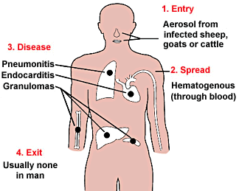](https://www.google.jo/url?sa=i&rct=j&q=&esrc=s&source=images&cd=&ved=0ahUKEwjy57Pm4dvSAhWGCywKHZdTAzMQjRwIBw&url=https://aldarzins.wordpress.com/&psig=AFQjCNFddUIeqB8Ywbx1juoxszAnvSIT1A&ust=1489779049972957)

[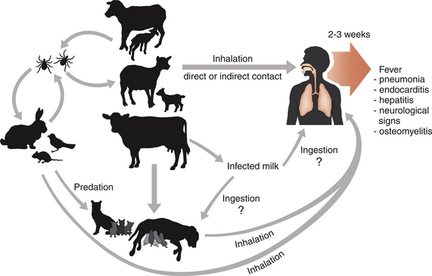](http://veteriankey.com/coxiellosis-and-q-fever/)

**Clinical Findings**

* **Chronic Q fever lasts more than 6 months. Infective endocarditis is the most common form of disease in this phase.**
* **Blood cultures for bacteria are negative??? Antibody titer increase significantly.**

**Laboratory Tests**

1. **Culture & isolation**
   * **Difficult & dangerous because of the highly infectious nature of rickettsiae**

**2. Serologic test**

* + **Weil-Felix test: based on cross-reactivity between some strains of Proteus & Rickettsia**

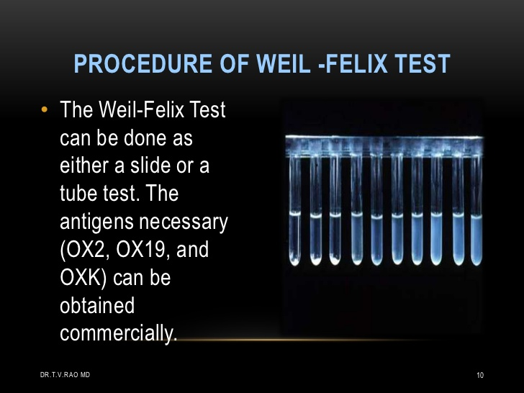

* + **Complement fixation: not very sensitive & time consuming.**
  + **Indirect fluorescence (EIA): more sensitive & specific; allows discrimination between IgM & IgG antibodies which helps in early diagnosis**
  + **Direct immunofluorescence: the only serologic test that is useful for clinical diagnosis, 100% specific & 70% sensitive allowing diagnosis in 3-4 days into the illness**
  + **Rikettsial outer membrane LPS antigen were used for detection of antibody.**
  + **PCR has been useful in diagnosing culture-negative endocarditis caused by *C burnetii*.**

**Results interpretation;**

**In acute Q fever, the phase II antibody is usually higher than the phase I titer, often by 4-fold.**

**In chronic Q fever, Serum specimens drawn late in the illness demonstrate significantly higher phase I titers, sometimes much greater than 4-fold.**

**Prevention**

* **The presently recommended conditions of “high-temperature, short-time” pasteurization (HTST) at 71.5°C for 15 seconds are adequate to destroy viable *Coxiella* species.**
* **For *C burnetii*, an investigational vaccine made from infected egg yolk sacs is available.**