Anatomy lecture
Nerves of the upper limb
26-9-2019
Hadeel Tawalbeh
Yaqeen Majed
بسم الله نبدأ...
*Sheets content: it contains all the notes the doctor said and was not mentioned in the slides so, please check the slides mentioned in this sheet, I divided this sheet into headers to make it easier to you when studying: Introduction, Brachial plexus, Relation to axillary artery, The M shaped key, Musculocutaneous nerve, Median nerve, Radial nerve, ulnar nerve, axillary nerve.
Corrected form
Introduction
The nerve supply comes from the spinal nerve; the spinal nerve is divided into ant. division and post. division. The post. division supplies back muscles whereas the ant. division goes anteriorly and supplies the ventral surface of the body, they normally tend to unite and form plexus (E.g. cervical plexus, brachial plexus, lumbar plexus, and the sacral plexus) and then they give rise to the terminal nerves.
Brachial plexus
There are five ventral spinal rami supplying the upper limb: C5/ C6/ C7/ C8/ T1. They made a net of plexuses called brachial plexuses that give rise to the nerves supplying the upper limb.
Recall: there are only 7 vertebrae and 8 cervical spinal nerve.

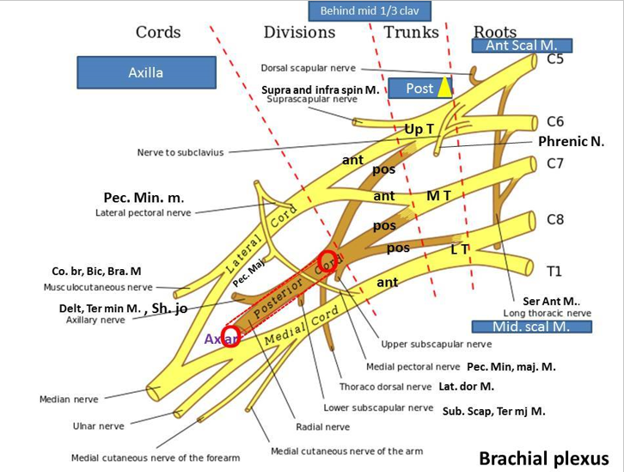
As you can see in this picture:

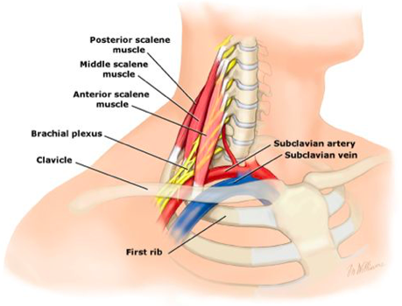
- Those roots came from the brachial plexuses and rise up from the upper caine?? sth* 3:34 of the vertebrae to the intervertebral foramen passing between two muscles: the anterior scalene muscle (anteriorly) and medial scalene muscles (posteriorly) towards the axilla passing below the med third of the clavicle (check the photo).

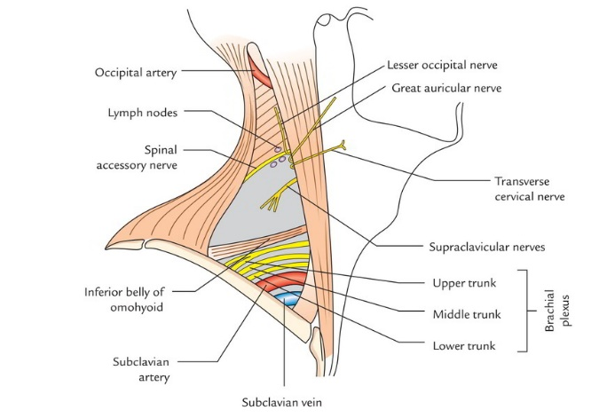
- The roots then unite with each other to form trunks and this happens behind the mid third of the clavicle as the following:
C5 + C6 | C7 | C8 + T1
Upper trunk | Middle trunk | Lower trunk

- Then they’ll go to the posterior triangle of the neck where they’ll divide into ant. and post. Divisions.
مثل الأشجار لها عروق ثم الجذوع ثم الأعضان.
Firstly, they divide in the posterior triangle, then their divisions will unite and go towards the axilla passing above the 1st rib

- These divisions will unite to form cords as the following:
Ant. up T + Ant M T | All posterior divisions | Ant. L T
Lateral cord | Posterior cord | Medial cord

*Note: The cords were named according to their relations to the axillary artery as medial, lateral and posterior to it.
The overall route: Spinal cord> intervertebral foramen> between medial and anterior scalene muscles > posterior triangle of the neck (behind the mid third of the clavicles)> Axilla.
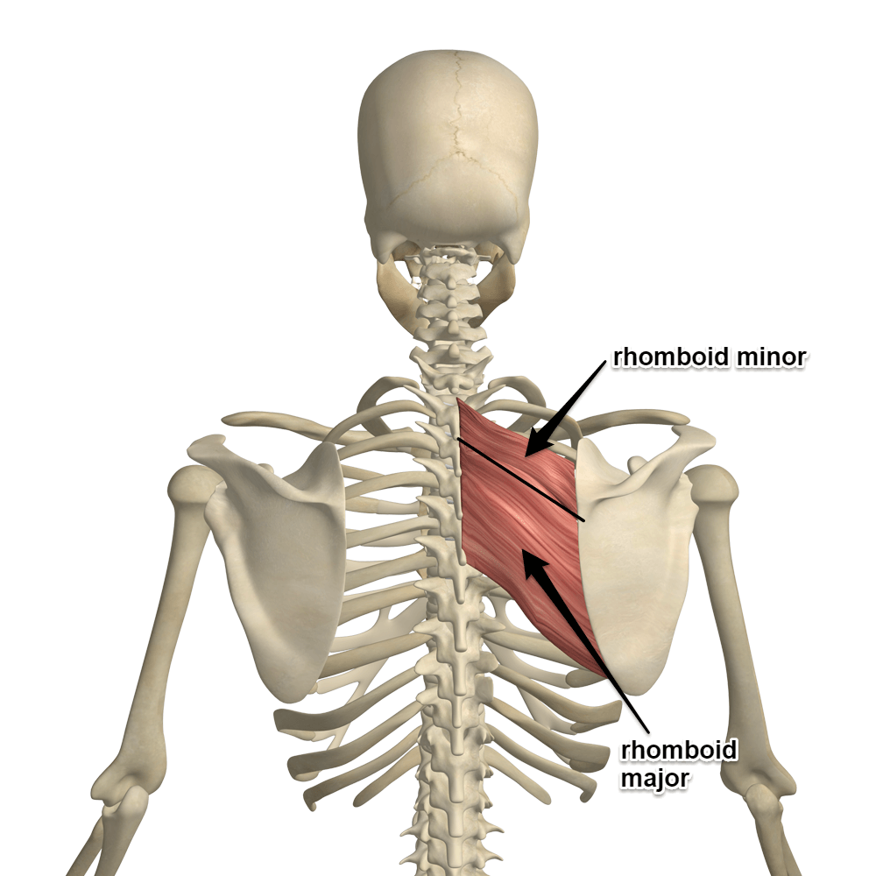
Now, let’s talk about the branches of this net of nerves:
- Roots:
  - C5: will give rise to the dorsal scapular nerve that will innervate the rhomboid minor and rhomboid major muscles.
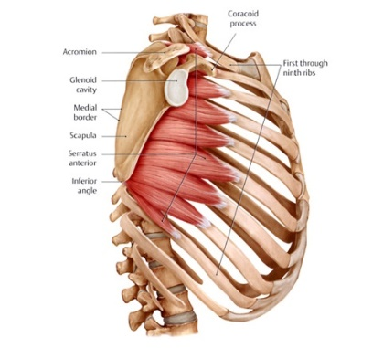
  - C5, C6, C7: will give rise to a nerve called long thoracic nerve passes downward behind the roots to the lateral side of the chest innervating the serratus anterior muscle
  - C5, C6: give origins of the phrenic nerve.

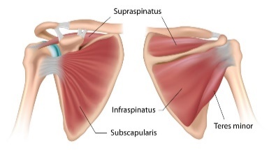
- Trunks:
  - The upper trunk: suprascapular nerve that innervates supra and infra spinatus muscles.
- Cords:
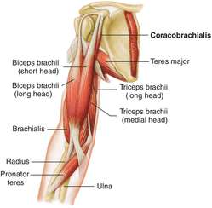
  - Lateral cord (3):
    - lateral pectoral nerve that innervate pectoralis minor muscle.
    - Lateral root for the median nerve.
    - Musclocatenous nerve that innervates coracobrachialis, Biceps and brachialis muscles.

  - Medial cord (5):
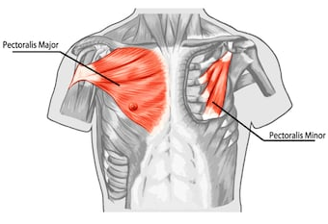
    - Medial pectoral nerve that innervates pectoralis minor and major muscles by penetrating pectoralis minor muscle towards pectoralis major muscle.
    - Medial cutaneous nerve of the arm.
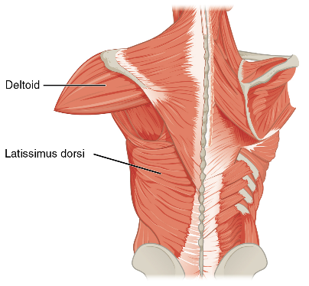
    - Medial cutaneous nerve of the forearm.
    - Ulnar nerve.
    - Medial root of the median nerve.

  - Posterior cord (5):
    - Upper subscapular nerve.
    - Thoracodorsal nerve that innervate the latissimus dorsi muscle.
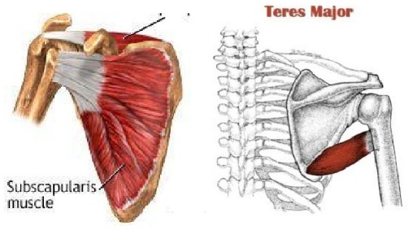
    - Lower subscapular nerve innervates subscapular and terse major muscles.
    - Radial nerve.
    - Axillary nerve surrouds the neck of humeres and innervate deltoid and teres minor muscles and the shoulder joint.
Relation to axillary artery
The axillary artery passes behind the pectorals minor muscle where it’ll be divided into 3 parts:
- The 1st part before the muscle.
- The 2nd part behind it.
- The 3ed part after it.
Remember: The cords were named according to their relations to the axillary artery as medial, lateral and posterior to it.

The M shaped key
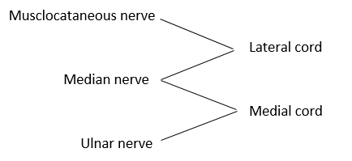
Lateral root
Medial root
Note: This is very useful is surgical procedures.

Musculocutaneous nerve
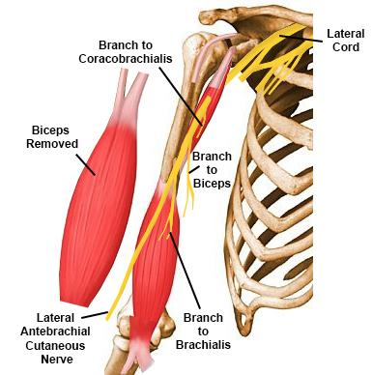
This nerve is lateral most nerve in the M shape mentioned previously, supplies the muscles of the ant. aspect of the arm (e.g. biceps, coracobrachialis, brachialis). This nerve pierces the coracobrachialis muscle and then passes between the biceps and the brachialis muscle downwards and then continues as a lateral cutaneous nerve of the forearm.
Check slide (5,4)
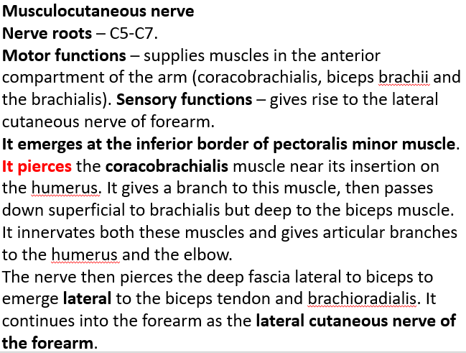
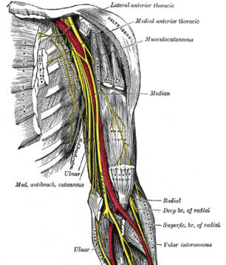
Median nerve
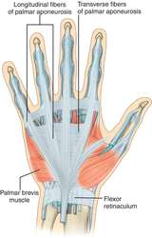
- When the medial nerve enters the wrist to passes underneath the ventral palmer aponeurosis also called transverse carpal ligament. This aponeurosis functions as a bridge covering the underneath median nerve, flexor digitorum superfascialis tendon, flexor digitorum profundus tendon and flexor policies longus. If this bridge was injured or if there was an inflammation inside the carpal tunnel (e.g. rheumatic fever/arthritis), the median nerve will be compressed resulting in an injury or death to both the nerve and the thenar muscle (aesthesia). This condition is called the carpal tunnel syndrome. The best intervention can be done to stop the problem from progression is to increase the carpal tunnel space by removing the ventral palmar aponeurosis.
- the recurrent branch is a motor innervation
- The palmer digital branch is cutaneous innervation
- If the median nerve was cut, aesthesia will result (loss of sensation in this area)
Check slides (6-10)
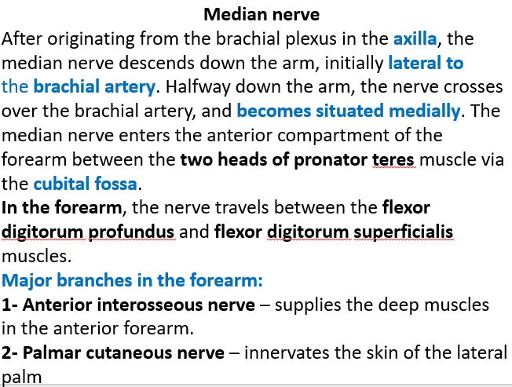
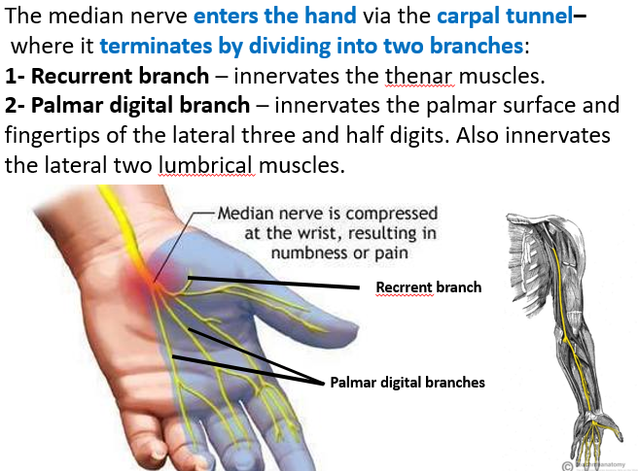

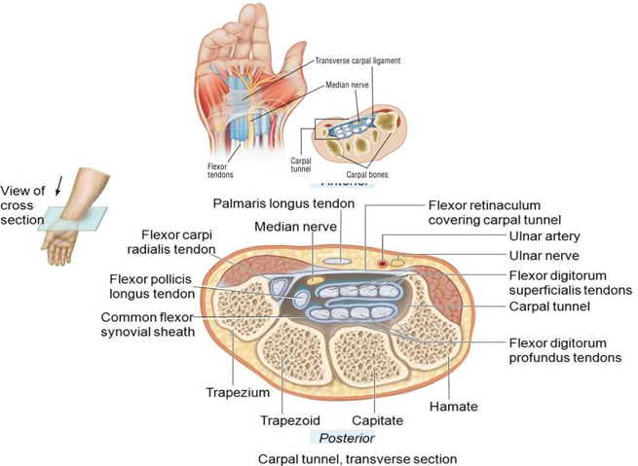
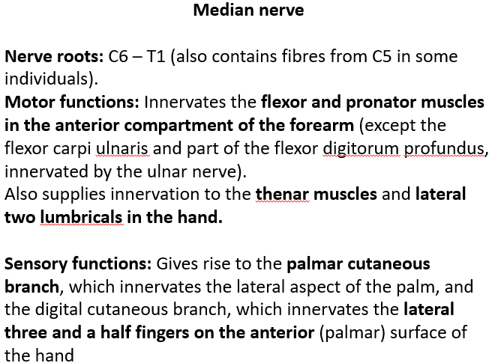

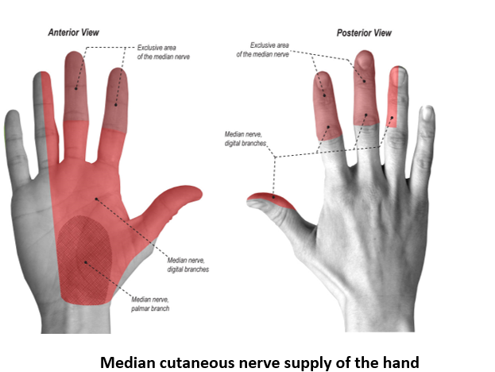
Ulnar nerve
- The ulnar nerve route: passes through the medial side of the brachial artery subcutaneously behind the medial epicondyle where it’s palpable. In the forearm, the ulnar nerve pierces the two heads of the flexor carpi ulnaris, and travels deep to the muscle, alongside the ulna and medial to the ulnar artery. In the hand it is divided into superficial and deep branches, the superficial supplies the ring and small finger and the deep branch supplies most of the hand muscles.
There was apart I couldn’t get clearly (39:42) and I think it’s important
Check slides (11-16)
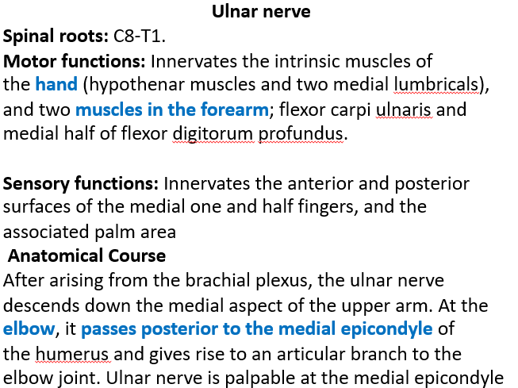
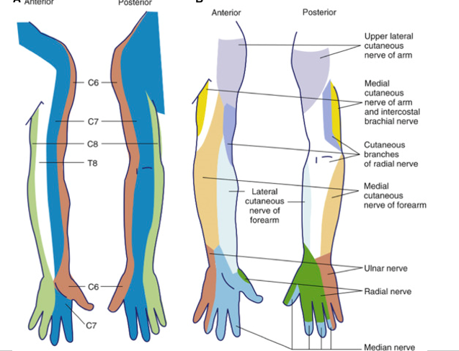
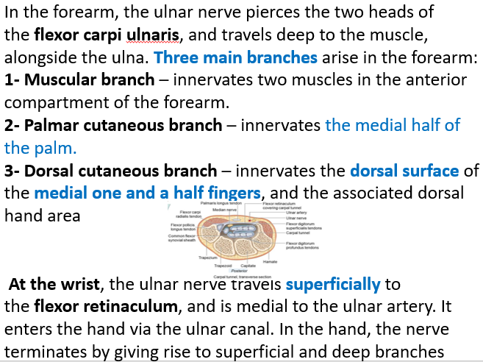
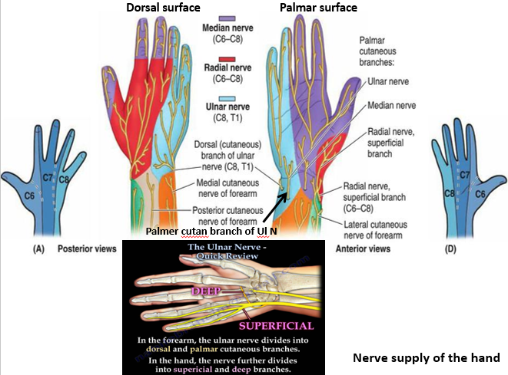
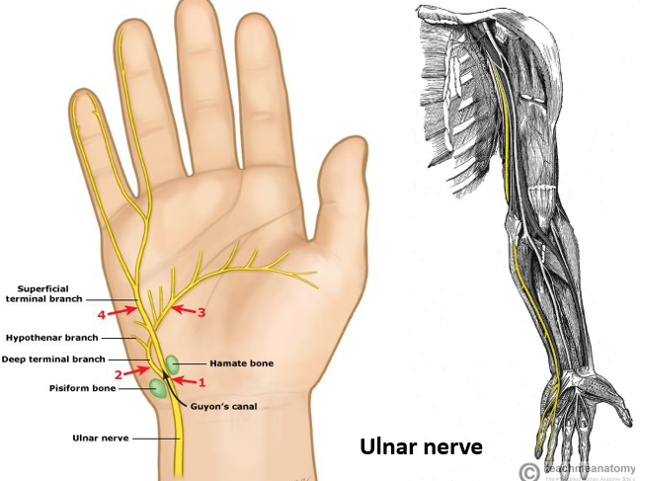

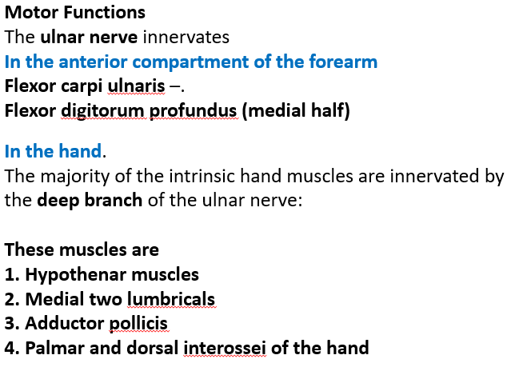
Radial nerve
Comes from the post. Cord along the subscapularis muscle, It exits the axilla (through the Triangular Interval) inferiorly and supplies branches to the long and lateral heads of the triceps brachii. The radial nerve then descends down the arm, travelling in a shallow depression within the surface of the humerus, known as the radial groove. As it descends, the radial nerve wraps around the humerus laterally, and supplies a branch to the medial head of the triceps brachii. During much of its course within the arm, it is accompanied by the profunda brachii branch of the brachial artery. It appears anteriorly in the arm between brachialis and brachio radialis muscles.

The triangular interval is made by long head of the triceps and the lateral head of the triceps.
- The radial nerve passes through the axilla, which makes it susceptible to injury. It can be compressed against the humerus by crutches, causing crutch paralysis. Resulting in wrist drop.
Check slides (17-23)
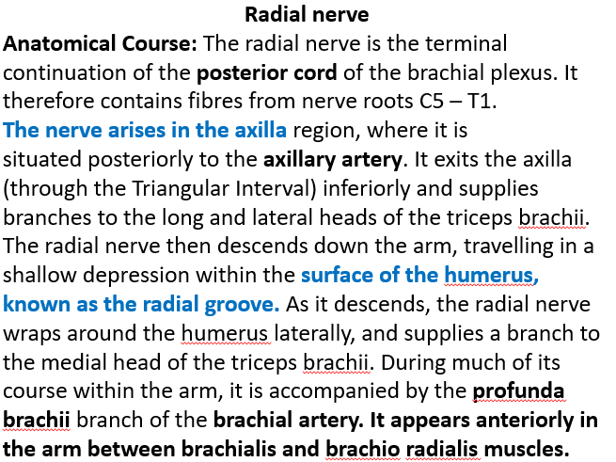

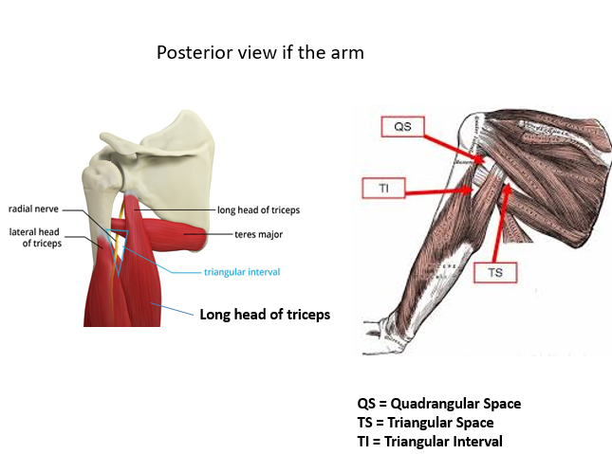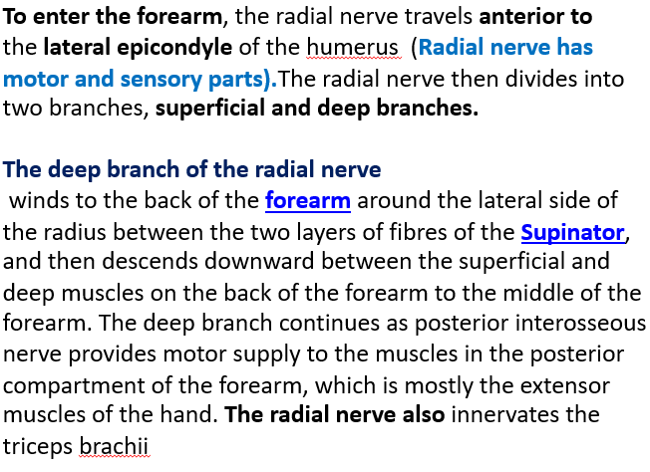
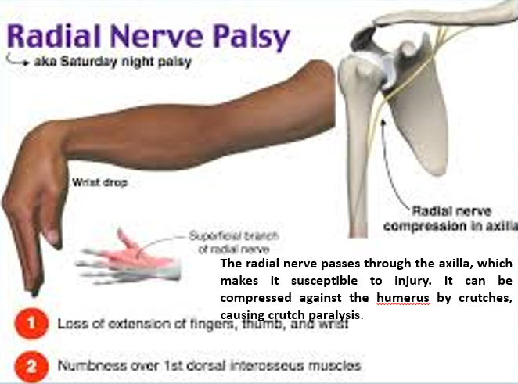
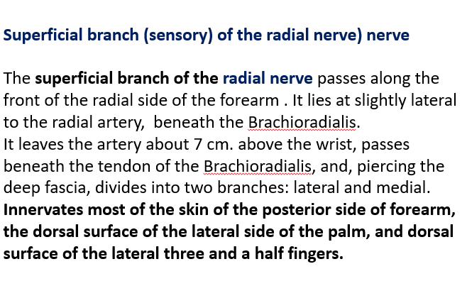
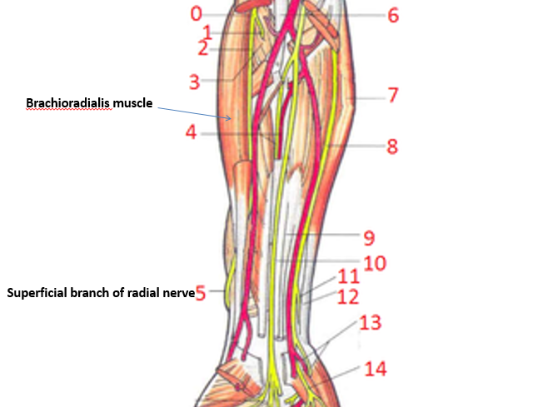

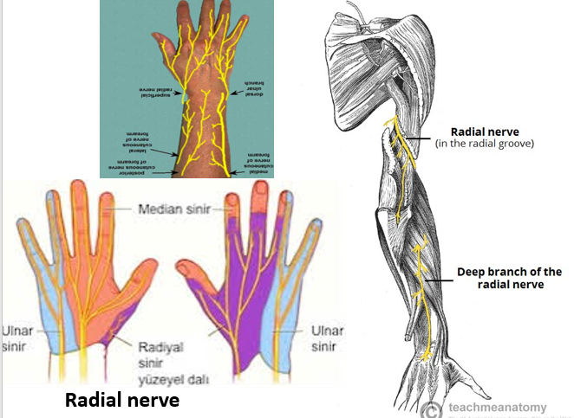
Axillary artery
- Fracture in the surgical neck of the humerus result in nerve damage and paralysis of the deltoid muscle.
Check slides (24,25)

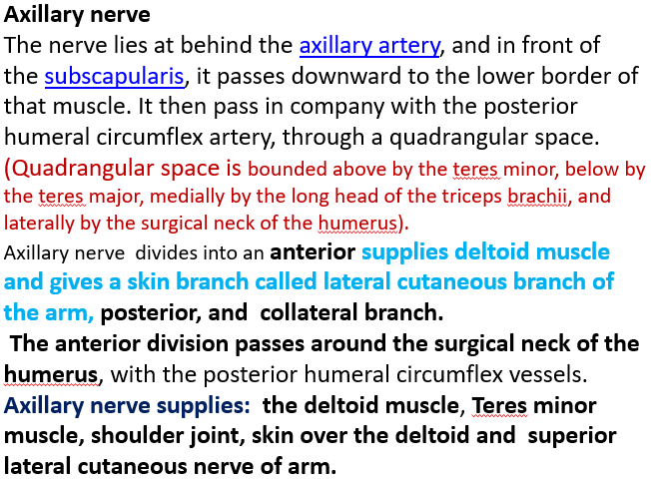
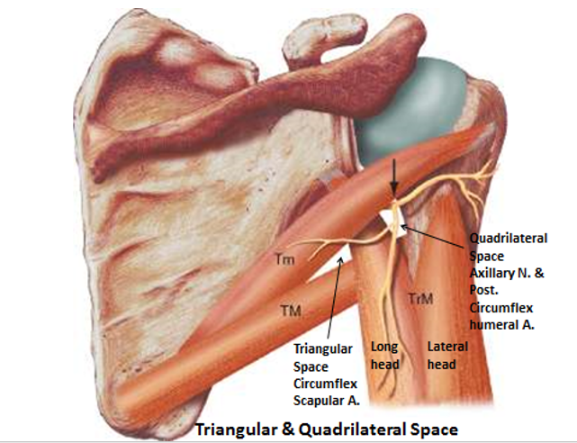

The End

