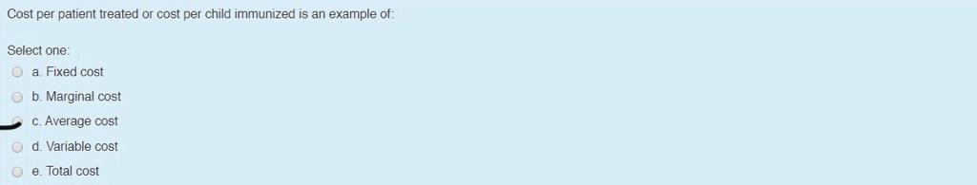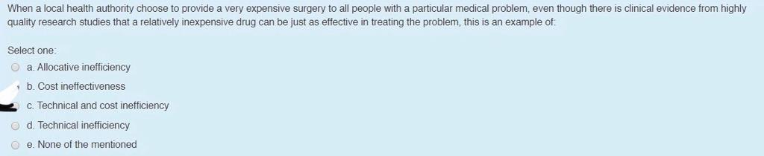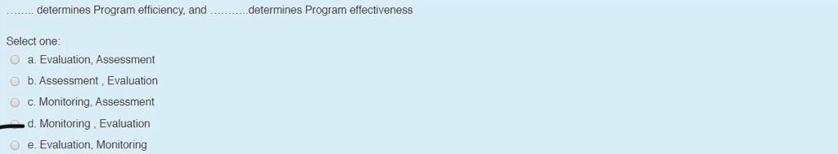

***Health Economics and Policies-Midterm***

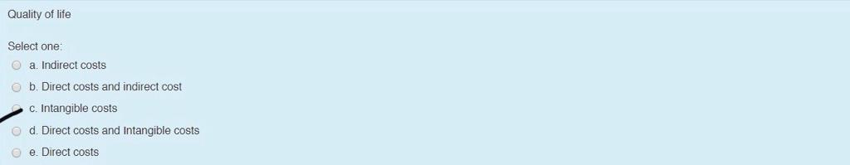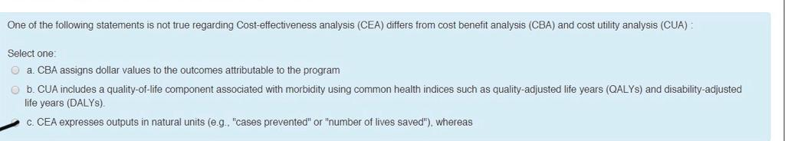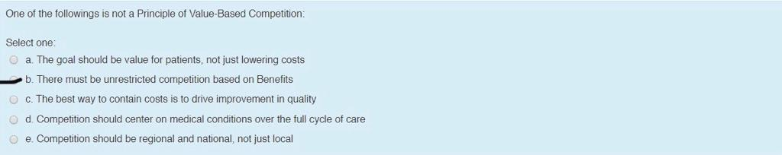

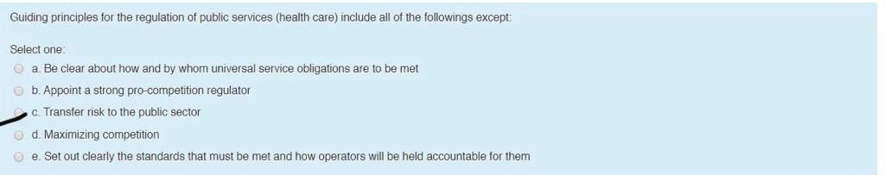

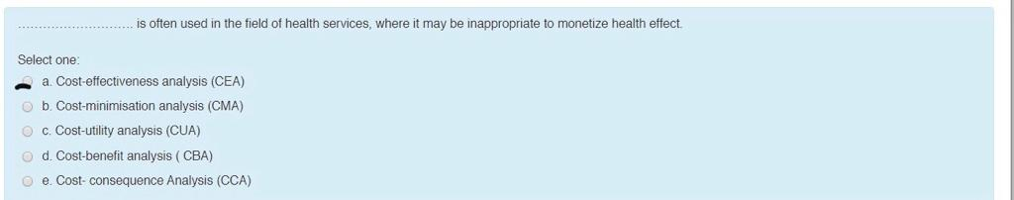

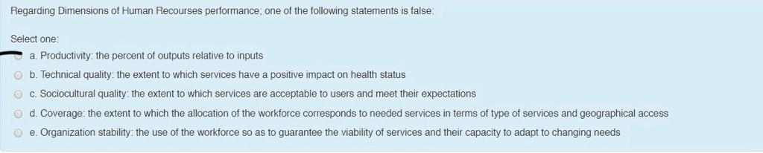

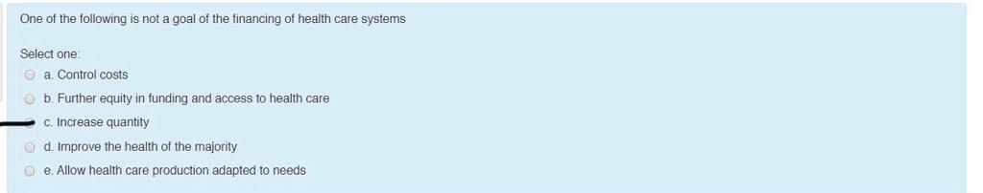

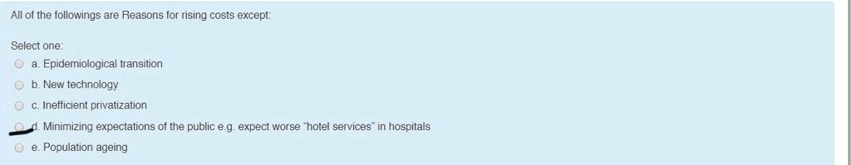

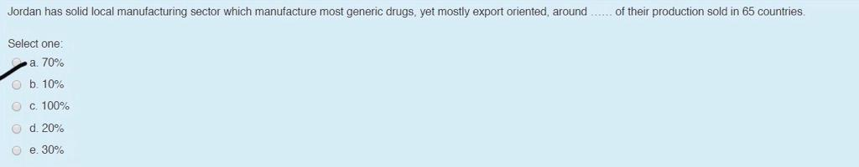

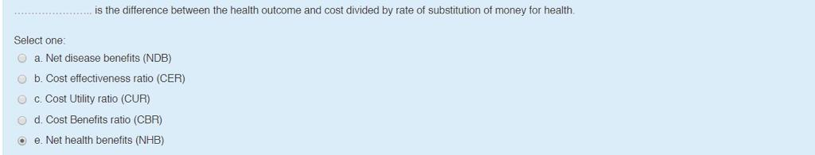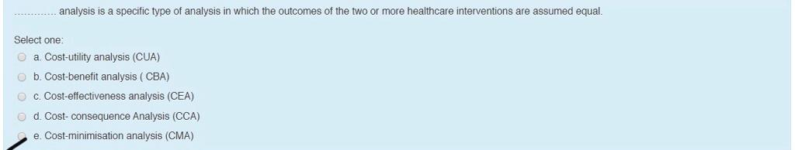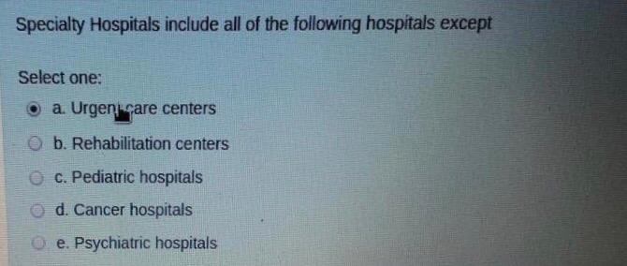

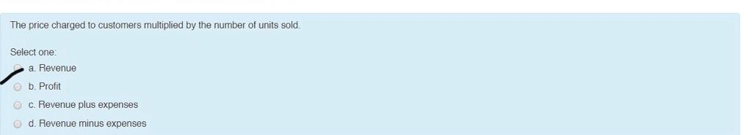

***Collected by: REEM ALSARHAN***

Which of these is not one of the activities of Human Resource Management?

-Recruitment & selection

-Training and development

-Performance appraisal and feedback

-Pay and benefits

-Labor regulation***

Which of these is not one of the activities of financial administration?

-Budgeting

-Accounting

-Auditing

-Purchasing

-Evaluation***

Which of these countries apply National Health Service?

-United Kingdom***