L5- Dna Repair
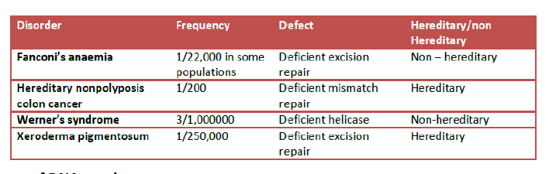
Fanconi anaemia (FA)
- It is a rare genetic disease. Among those affected the majority develop cancer, most often acute myelogenous leukemia, and 90% develop bone marrow failure (the inability to produce blood cells) by age 40. About 60–75% of people have congenital defects, commonly short stature, abnormalities of the skin, arms, head, eyes, kidneys, and ears, and developmental disabilities.

Lynch syndrome (HNPCC or hereditary nonpolyposis colorectal cancer)
It is an autosomal dominant genetic condition that has a high risk of colon cancer as well as other cancers including endometrial cancer (second most common), ovary, stomach, small intestine,
hepatobiliary tract, upper urinary tract, brain, and skin. The increased risk for these cancers is due to inherited mutations that impair DNA mismatch repair. It is a type of cancer syndrome.
Werner syndrome (WS)
It is also known as "adult progeria", is a rare, autosomal recessive progeroid syndrome (PS), which is characterized by the appearance of premature aging. The median and mean ages of death are 47–48 and 54 years, respectively. The main cause of death is cardiovascular disease or cancer.
Xeroderma pigmentosum
It is a rare autosomal recessive genetic disorder of DNA repair in which the ability to repair damage caused by ultraviolet (UV) light is deficient.
L7 Mutations
Known disorders in humans include:
Deletions
1) Wolf-Hirschhorn syndrome, which is caused by partial deletion of the short arm of chromosome 4
2) Jacobsen syndrome, also called the terminal 11q deletion disorder.
Duplications
Known human disorders include Charcot-Marie-Tooth disease type 1A, which may be caused by duplication of the gene encoding peripheral myelin protein 22 (PMP22) on chromosome 17.
L10 Transcription Part 2
SLE : Systemic lupus erythematosus is an auto immune disease
Production of a.b. to one of the snRNPs,U1-snRNP
Rash on the forehead & cheek bones, giving the wolf like appearance.
Severe kidney damage may follow with arthritis, accumulation of fluid around the heart, & inflammation of the lungs.

