Inferential statistics

Scatter Plot

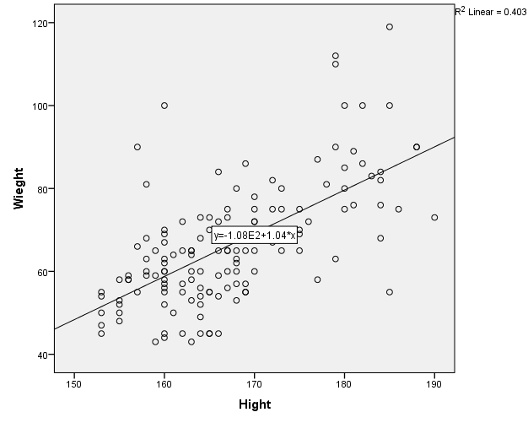

Correlations
1-

Correlations
 |  | Wieght | Hight
Wieght | Pearson Correlation | 1 | .635**
 | Sig. (2-tailed) |  | .000
 | N | 137 | 137
Hight | Pearson Correlation | .635** | 1
 | Sig. (2-tailed) | .000
 | N | 137 | 137
**. Correlation is significant at the 0.01 level (2-tailed).

2-

Correlations
 |  |  | Income | Education
Spearman's rho | Income | Correlation Coefficient | 1.000 | .371**
 |  | Sig. (2-tailed) | . | .000
 |  | N | 137 | 137
 | Education | Correlation Coefficient | .371** | 1.000
 |  | Sig. (2-tailed) | .000 | .
 |  | N | 137 | 137
**. Correlation is significant at the 0.01 level (2-tailed).

T-test
1-
Group Statistics
 | Sex | N | Mean | Std. Deviation | Std. Error Mean
Wieght | male | 39 | 79.90 | 14.924 | 2.390
 | female | 98 | 61.08 | 11.117 | 1.123
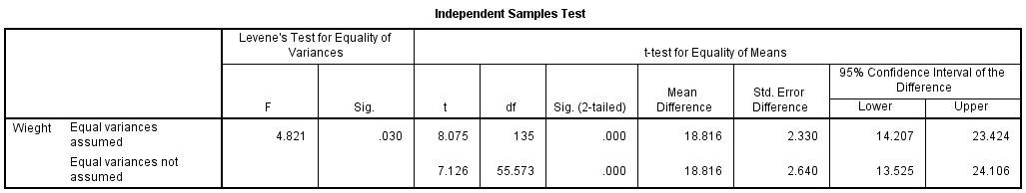
2-

Paired Samples Statistics
 |  | Mean | N | Std. Deviation | Std. Error Mean
Pair 1 | Hight | 167.34 | 137 | 9.102 | .778
 | BMI | 23.48 | 137 | 3.956 | .338

Paired Samples Correlations
 |  | N | Correlation | Sig.
Pair 1 | Hight & BMI | 137 | .214 | .012

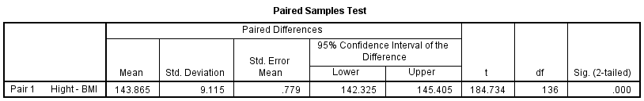

Chi- square
1-
Sex * student Smoking Crosstabulation
Count
 |  | Smoking |  | Total
 |  | yes | No
Sex | male | 13 | 26 | 39
 | female | 14 | 84 | 98
Total |  | 27 | 110 | 137

Chi-Square Tests
 | Value | df | Asymp. Sig. (2-sided) | Exact Sig. (2-sided) | Exact Sig. (1-sided)
Pearson Chi-Square | 6.396ª | 1 | .011
Continuity Correction^{b} | 5.249 | 1 | .022
Likelihood Ratio | 5.963 | 1 | .015
Fisher's Exact Test |  |  |  | .017 | .013
Linear-by-Linear Association | 6.350 | 1 | .012
N of Valid Cases | 137
a. 0 cells (.0%) have expected count less than 5. The minimum expected count is 7.69.
b. Computed only for a 2x2 table

2-

Family Income * Bodymass Crosstabulation
Count
 |  | Bodymass |  |  |  | Total
 |  | underweight | Normal | overweight | Obese
Income | <500 | 0 | 4 | 1 | 1 | 6
 | 500-999 | 7 | 28 | 12 | 1 | 48
 | >=1000 | 3 | 47 | 25 | 8 | 83
Total |  | 10 | 79 | 38 | 10 | 137

Chi-Square Tests
 | Value | df | Asymp. Sig. (2-sided)
Pearson Chi-Square | 9.272ª | 6 | .159
Likelihood Ratio | 9.773 | 6 | .135
Linear-by-Linear Association | 2.689 | 1 | .101
N of Valid Cases | 137
a. 6 cells (50.0%) have expected count less than 5. The minimum expected count is .44.

3-

Parentsmoke * student Crosstabulation
Count
 |  | Smoking |  | Total
 |  | yes | No
Parentsmoke | no | 10 | 80 | 90
 | both | 6 | 5 | 11
 | Father only | 10 | 22 | 32
 | mother only | 1 | 3 | 4
Total |  | 27 | 110 | 137

Chi-Square Tests
 | Value | df | Asymp. Sig. (2-sided)
Pearson Chi-Square | 15.405ª | 3 | .002
Likelihood Ratio | 13.798 | 3 | .003
Linear-by-Linear Association | 7.361 | 1 | .007
N of Valid Cases | 137
a. 3 cells (37.5%) have expected count less than 5. The minimum expected count is .79.

4-

Sex * Typesmoke Crosstabulation
Count
 |  | Typesmoke |  |  |  | Total
 |  | cigarette | hookah | e-cigarette | both
Sex | male | 6 | 2 | 1 | 3 | 12
 | female | 1 | 9 | 0 | 2 | 12
Total |  | 7 | 11 | 1 | 5 | 24

Chi-Square Tests
 | Value | df | Asymp. Sig. (2-sided)
Pearson Chi-Square | 9.226ª | 3 | .026
Likelihood Ratio | 10.368 | 3 | .016
Linear-by-Linear Association | .140 | 1 | .708
N of Valid Cases | 24
a. 6 cells (75.0%) have expected count less than 5. The minimum expected count is .50.

5-

Tawjihi * Cumm Crosstabulation
Count
 |  | Cumm |  |  |  | Total
 |  | 2-2.49 | 2.50-2.99 | 3-3.49 | 3.50-4
Tawjihi | <90 | 3 | 5 | 0 | 0 | 8
 | 90-95 | 30 | 43 | 25 | 13 | 111
 | >95 | 4 | 6 | 2 | 6 | 18
Total |  | 37 | 54 | 27 | 19 | 137

Chi-Square Tests
 | Value | df | Asymp. Sig. (2-sided)
Pearson Chi-Square | 10.839ª | 6 | .093
Likelihood Ratio | 12.071 | 6 | .060
Linear-by-Linear Association | 4.811 | 1 | .028
N of Valid Cases | 137
a. 7 cells (58.3%) have expected count less than 5. The minimum expected count is 1.11.

