**Al Balqa App[lied University**

**College of Medicine**

Lecture 2

Salmonella, Shigella, and Campylobacter

**Dr. Hala Al Daghistani**

**Salmonella and enteritis**

Salmonellae are often pathogenic for humans or animals when acquired by the oral route. They are transmitted from animals and animal products to humans, where they cause enteritis, systemic infection, and enteric fever.

**Morphology and Identification**

-Most isolates are motile, never ferment lactose or sucrose, Form acid and sometimes gas, produce H2S.

-Survive freezing in water for long periods.

[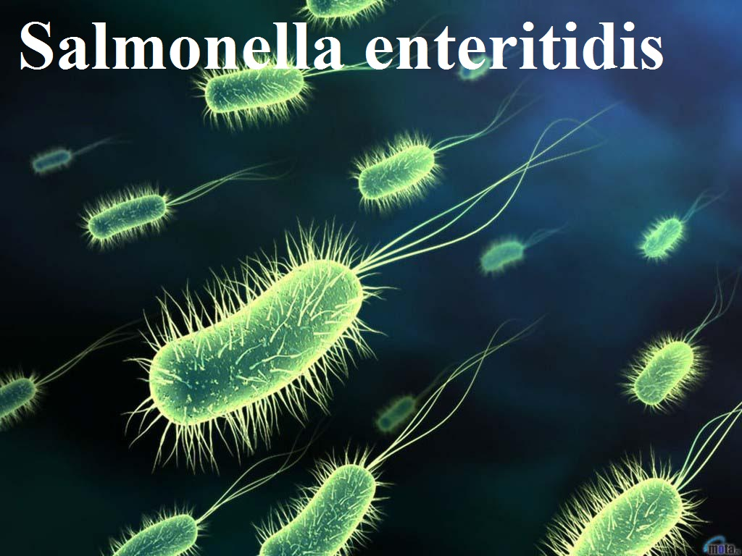](https://www.thinglink.com/scene/656949012783431)

**Pathogenesis and Clinical Findings**

* The animal reservoir for human infection is the poultry, pigs, rodents, cattle, pets (from turtles to parrots), and many others.
* The organisms almost always enter via the oral route, usually with contaminated food or drink. The mean infective dose to produce clinical or subclinical infection in humans is 105–108 salmonellae

**Salmonellae produce three main types of disease in humans, but mixed forms are frequent**

**Pathogenicity of Salmonella**

**Enterocolitis**

* This is the most common manifestation of salmonella infection.
* In the US, S. Typhimurium and Salmonella Enteritidis are prominent, but enterocolitis can be caused by any of the more than 1400 group I serotypes of salmonellae.
* Eight to 48 hours after ingestion of salmonellae, there is **nausea, headache, vomiting, and profuse diarrhea, with few leukocytes in the stools**. **Low-grade fever is common, but the episode usually resolves in 2–3 days**.
* **Inflammatory lesions of the small and large intestine are present**.
* Bacteremia is rare (2–4%) except in immunodeficient persons.
* Blood culture results are usually negative, but stool culture results are positive for salmonellae and may remain positive for several weeks after clinical recovery.

**Diagnostic Laboratory Tests**

**Bacteriological Methods for Isolation of Salmonellae**

**1**. Differential medium cultures

2. **Selective medium cultures** (S-S agar, Bismuth sulfide agar, DCA…)

3. **Enrichment cultures** (tetrathionat, selinite broth)

4. Final identification (biochemical tests-API)

Immunity: Active immunity, and Passive immunity (immunity that an infant acquires from its mother).

Epidemiology

* Many animals, including cattle, rodents, and fowl, are naturally infected with a variety of salmonellae and have the bacteria in their tissues (meat), excreta, or eggs.
* The high incidence of salmonellae in commercially prepared chickens has been widely publicized.
* The problem probably is aggravated by the widespread use of animal feeds containing antimicrobial drugs that favor the proliferation of drug-resistant salmonellae and their potential transmission to humans.

**The vaccine**: Purified Vi antigen, or live attenuated vaccine

*Shigella Dysenteriae*

The natural habitat of shigellae is limited to the intestinal tracts of humans and other primates, where they produce **bacillary dysentery.**

**Morphology and Identification**

**Growth Characteristics**

* All shigellae ferment glucose (except of ***Shigella sonnei)***
* Shigellae form acid from carbohydrates but rarely produce gas.

**Pathogenesis and Pathology**

* *Shigella* infections are almost always limited to the gastrointestinal tract
* Shigellae infection is highly communicable
* the infective dose is on the order of 103 organisms (it usually is 105–108 for salmonellae and vibrios).
* The essential pathologic process is invasion of the mucosal epithelial cells (eg, M cells) by inducing phagocytosis, escape from the phagocytic vacuole, multiplication and spread within the epithelial cell cytoplasm, and passage to adjacent cells. Microabscesses in the wall of the large intestine and terminal ileum lead to necrosis of the mucous membrane, superficial ulceration, bleeding, and formation of a “pseudomembrane” on the ulcerated area. As the process subsides, granulation tissue fills the ulcers, and scar tissue forms.

[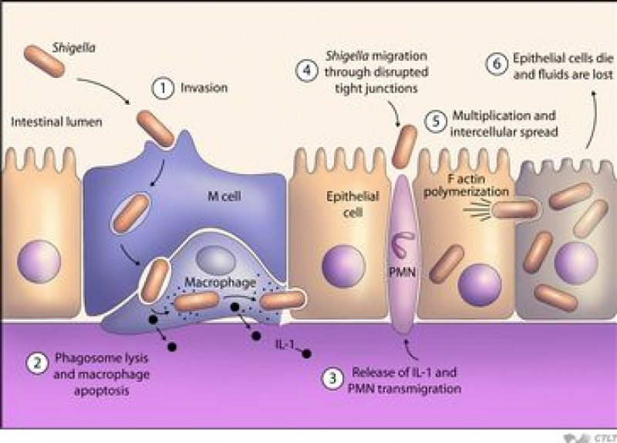](https://gazettereview.com/2015/04/drug-resistant-shigella-bacteria-hits-united-states)

**Toxins produced by Shigella spp.**

**A. Endotoxin**

**B. *Shigella Dysenteriae* Exotoxin**

* *S dysenteriae* type 1 (Shiga bacillus) produces a heat-labile exotoxin that affects both the gut and the central nervous system.
* In humans, the exotoxin also inhibits sugar and amino acid absorption in the small intestine.
* Patients with Shigella flexneri or *S. sonnei* infections develop antitoxin that neutralizes S. dysenteriae exotoxin in vitro.
* Acting as an **enterotoxin**, it produces diarrhea as does the *E. coli* Shiga-like toxin, perhaps by the same mechanism.
* Acting as a “**neurotoxin**,” this material may contribute to the extreme severity and fatal nature of *S. dysenteriae* infections and to the CNS reactions (ie, meningismus, coma).
* the invasion of the large intestine, resulting in later dysentery with blood and pus in the stool. The toxic activity is distinct from the invasive property of shigellae in dysentery.
* After a short incubation period (1–2 days), there is a sudden onset of abdominal pain, fever, and watery diarrhea. The diarrhea has been attributed to an exotoxin acting in the small intestine

**Specimens**

* Specimens include fresh stool, mucus flecks, and rectal swabs for culture. Large numbers of fecal leukocytes and some red blood cells often are seen microscopically.
* Serum specimens, if desired, must be taken 10 days apart to demonstrate a rise in titer of agglutinating antibodies.

**Culture**

* The materials are streaked on differential media (e.g. MacConkey or EMB agar) and on selective media (Hektoen enteric agar or Salmonella–Shigella agar), which suppress other Enterobacteriaceae and gram-positive organisms. Colorless (lactose-negative) colonies are inoculated into TSI agar.
* Nonmotile colonies should be subjected to slide agglutination by specific Shigella antisera.

**Serology**

* Normal persons often have agglutinins against several Shigella species. However, serial determinations of antibody titers may show a rise in specific antibody. Serology is not used to diagnose Shigella infections.

**Immunity**

* Infection is followed by a type-specific antibody response. Injection of killed shigellae stimulates production of antibodies in serum, but fails to protect humans against infection (**Host immunity is serotype-specific and protective against reinfection by the same serotype).**
* IgA antibodies in the gut may be important in limiting reinfection; these may be stimulated by live attenuated strains given orally as experimental vaccines.

Campylobacter jejuni

* Campylobacter cause both **diarrheal** and **systemic diseases**
* Campylobacter infection of domesticated animals also is widespread.
* *Campylobacter jejuni*  is a common cause of diarrhea in humans.

**Morphology and Identification**

**A. Typical Organisms**

*C jejuni* and the other campylobacters are gram-negative rods with comma, S, or “gull wing” shapes

. They are motile, with a single polar flagellum.

[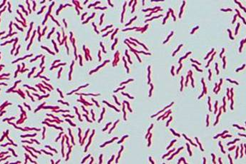](https://www.studyblue.com/notes/note/n/bacteria-names-name-and-gram-stain/deck/17336)

**B. Culture**

* **Skirrow’s medium** contains vancomycin, polymyxin B, and trimethoprim to inhibit growth of other bacteria, O2 (5% O2) with added CO2 (10% CO2).
* Incubation of primary plates for isolation of *C jejuni* should be at 42C. thus simplifying the identification of *C jejuni.*

**Growth Characteristics**

* *C. jejuni*  are positive for both oxidase and catalase.
* Nitrate reduction, hydrogen sulfide production, hippurate tests, can be used for further identification of species.

**Antigenic Structure and Toxins**

* The campylobacters have **lipopolysaccharides** with endotoxic activity. **Cytopathic extracellular toxins** and **enterotoxins** have been found, but the significance of the toxins in human disease is not well defined.

**Pathogenesis and Pathology**

* The infection is acquired by the **oral route** from food, drink, or **contact with infected animals** or animal products, especially poultry.
* The organisms multiply in the small intestine, invade the epithelium, and produce inflammation that results in the appearance of red and white blood cells in the stools.
* The sites of tissue injury include the **jejunum, the ileum, and the colon**. Most strains of *C. jejuni* produce a toxin (cytolethal distending toxin) that hinders the cells from dividing and activating the immune system. This helps the bacteria to evade the immune system and survive for a limited time in the cells
* Occasionally, the bloodstream is invaded. **Localized tissue invasion coupled with the toxic activity** appears to be responsible for the enteritis.
* The most common routes of transmission are fecal-oral, ingestion of contaminated food or water, and the eating of raw meat. Foods implicated in campylobacteriosis include
* **raw or under-cooked poultry**
* **raw dairy products**

Campylobacter is sensitive to the stomach's normal production of hydrochloric acid: as a result, the infectious dose is relatively high, and the bacteria rarely cause illness when a person is exposed to less **104** organisms. People taking antacid medication (e. g. people with gastritis or stomach ulcers) are at higher risk of contracting disease from a smaller amount of organisms, since this type of medication inhibits normal gastric acid.

**Clinical Findings**

* Clinical manifestations are acute onset of **crampy abdominal pain**, profuse **diarrhea** that may be **bloody,** **headache**, **malaise**, and **fever**.
* Certain serotypes of *C. jejuni* have been associated with postdiarrheal **Guillain**-**Barre** **syndrome**, a form of ascending paralytic disease.
* **Reactive arthritis and Reiter’s syndrome** may also follow acute campylobacter diarrhea.

**Diagnostic Laboratory Tests**

**A. Specimens:** Diarrheal stool is the usual specimen.

**B. Smears:** Gram-stained smears of stool may show the typical “gull wing”shaped rods. May show the typical darting motility of the organisms.

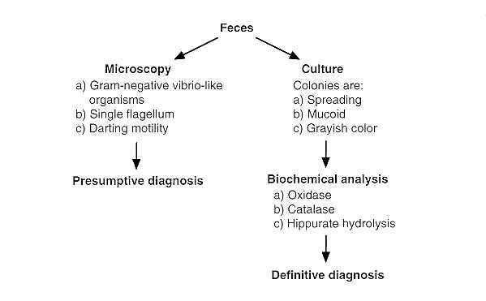

*Campylobacter fetus*

* *C fetus* has two subspecies, *fetus* and *venerealis. C fetus* subspecies *fetus* is an opportunistic pathogen that causes systemic infections in immunocompromised patients. The gastrointestinal tract may be the portal of entry when *C fetus* causes bacteremia and systemic infection. The presence of the S protein as a surface capsule correlated with the ability of the bacteria to cause bacteremia after oral challenge.