

**Al Balqa App[lied University**

**College of Medicine**

Lecture 3

Virus associated gastrointestinal infection

**Dr. Hala Al Daghistani**

**Rotaviruses**

* Rotaviruses are a major cause of diarrheal illness in human (infants), and young animals, including calves and piglets.
* Infections in adult humans and animals are also common.
* Among the rotaviruses are the agents of
* Human infantile diarrhea
* Nebraska calf diarrhea
* Epizootic diarrhea of infant mice

Classification and Antigenic Properties

* Are icosahedral viruses approximately 75 nm in diameter that comprise three protein layers, giving them a distinct wheel-like appearance under the electron microscope.
* The viral capsid encloses 11 segments of dsRNA
* There are nine species of rotavirus, referred to as A, B, C, D, E, F, G, H, and I based on antigenic epitopes of the structural protein VP. These can be detected by immunofluorescence, enzyme-linked immunosorbent assay (ELISA), and immune electron microscopy (IEM).
* Five serotypes are responsible for the majority of human disease. **Group A rotaviruses are the most frequent human pathogens.**
* There are six viral proteins (VPs) that form the virus particle. These structural proteins are called VP1, VP2, VP3, VP4, VP6 and VP7. In addition to the VPs, there are six [nonstructural proteins](https://en.wikipedia.org/wiki/Nonstructural_protein) (NSPs), that are only produced in cells infected by rotavirus. These are:  [NSP1](https://en.wikipedia.org/wiki/NSP1_(rotavirus)), [NSP2](https://en.wikipedia.org/wiki/NSP2_(rotavirus)), [NSP3](https://en.wikipedia.org/wiki/NSP3_(rotavirus)), [NSP4](https://en.wikipedia.org/wiki/NSP4_(rotavirus)), [NSP5](https://en.wikipedia.org/wiki/NSP5_(rotavirus)) and [NSP6](https://en.wikipedia.org/wiki/NSP6_(rotavirus)).

**[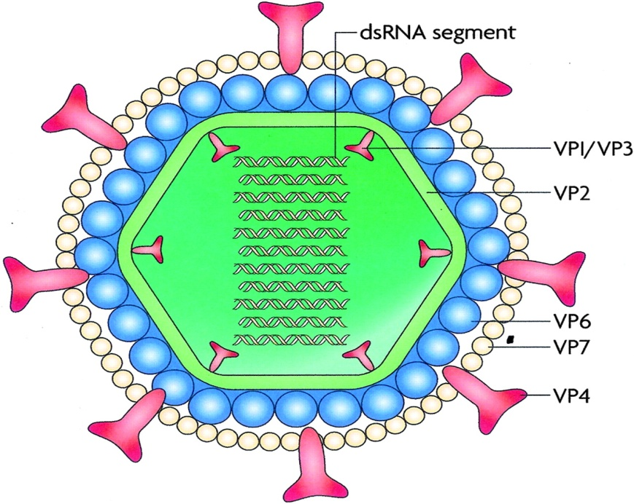](http://www.onlinebiologynotes.com/rotavirus-classification-structure-composition-properties-replication-mode-transmission-pathogenesis-clinical-symptoms-laboratory-diagnosis-treatment-prevention-control/)**

**Pathogenesis**

* Rotaviruses infect cells in the villi of the small intestine.
* They multiply in the cytoplasm of enterocytes and damage their transport mechanisms.
* One of the rotavirus-encoded proteins, NSP4 (non structural protein 4), is a viral enterotoxin that induces diarrhea by infecting the mature enterocytes in the mid and upper villous epithelium of the small intestine, which ultimately leads to cell death, villous atrophy, and diarrhea.
* Mechanisms that have been proposed to explain the diarrhea include the following: malabsorption secondary to enterocyte death, villus ischemia , and a toxin-like effect of (NSP4) plays a key role in rotavirus fluid secretion
* Damaged cells may slough into the lumen of the intestine and release large quantities of virus, which appear in the stool (up to 1012 particles per gram of feces).
* **Diarrhea caused by rotaviruses may be due to impaired sodium and glucose absorption as damaged cells on villi are replaced by nonabsorbing immature crypt cells**.
* It may take from 3 to 8 weeks for normal function to be restored.

[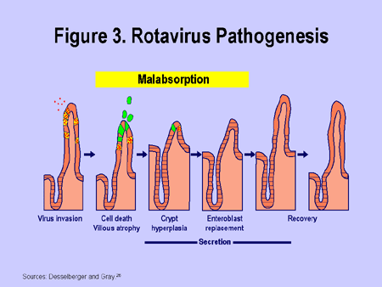](https://www.medscape.org/viewarticle/545158)

**Clinical Findings and Laboratory Diagnosis**

* Rotaviruses cause the major portion of diarrheal illness in infants and children worldwide but not in adults.
* There is an incubation period of 1–3 days.
* Typical symptoms include:
* watery diarrhea
* fever
* abdominal pain
* vomiting, leading to dehydration.
* In infants and children, severe loss of electrolytes and fluids may be fatal unless treated.
* Viral excretion in the stool may persist up to 50 days after onset of diarrhea.
* Adult contacts may be infected, as evidenced by seroconversion, but they rarely exhibit symptoms
* Laboratory diagnosis rests on demonstration of virus in stool collected early in the illness and on a rise in antibody titer. Virus in stool is demonstrated by enzyme immunoassays (EIAs). Genotyping of rotavirus nucleic acid from stool specimens by the polymerase chain reaction (PCR) is the most sensitive detection method.

**Epidemiology and Immunity**

* Rotaviruses are the single most important worldwide cause of gastroenteritis in young children. Estimates range from 3 to 5 billion for annual diarrheal episodes in children younger than 5 years
* Rotavirus infections usually predominate during the winter season.
* Symptomatic infections are most common in children between ages 6 months and 2 years, and transmission appears to be by the fecal–oral route.
* Asymptomatic infections are more common with successive reinfections.
* Local immune factors, such as secretory immunoglobulin A (sIgA) or interferon, may be important in protection against rotavirus infection.

Adenoviruses

* Adenoviruses can replicate and produce disease in the respiratory, gastrointestinal, and urinary tracts and in the eye.
* Many adenovirus infections are subclinical, and the virus may persist in the host for months.
* Adenoviruses display icosahedral symmetry, with capsids composed of capsomeres. There is no envelope.
* Adenoviruses are unique among icosahedral viruses in that they **have a structure called a “fiber” projecting**

[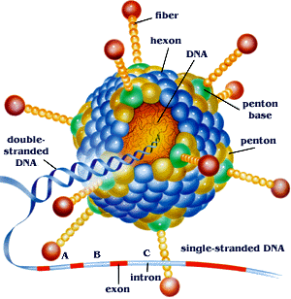](https://microbewiki.kenyon.edu/index.php/Adenovirus-based_Gene_Therapy:_a_Promising_Novel_Cancer_Therapy)

**Adenovirus infections in humans**

**Pathogenesis**

* Adenoviruses infect and replicate in epithelial cells of the gastrointestinal tract.
* They usually do not spread beyond the regional lymph nodes.
* Viruses may persist as latent infections for years in adenoids and tonsils and are shed in the feces for many months after the initial infection.
* In fact, the name “adenovirus” reflects the recovery of the initial isolate from explants of human adenoids.
* Most human adenoviruses replicate in intestinal epithelium after ingestion but usually produce subclinical infections rather than overt symptoms.

Gastrointestinal Disease

* Many adenoviruses replicate in intestinal cells and are present in stools, but the presence of most serotypes is not associated with gastrointestinal disease. However, **two serotypes (types 40 and 41)** have been etiologically associated with infantile gastroenteritis and may account for 5–15% of cases of viral gastroenteritis in young children.
* Adenovirus types 40 and 41 are abundantly present in diarrheal stools. The enteric adenoviruses are very difficult to cultivate.

Coronaviruses

[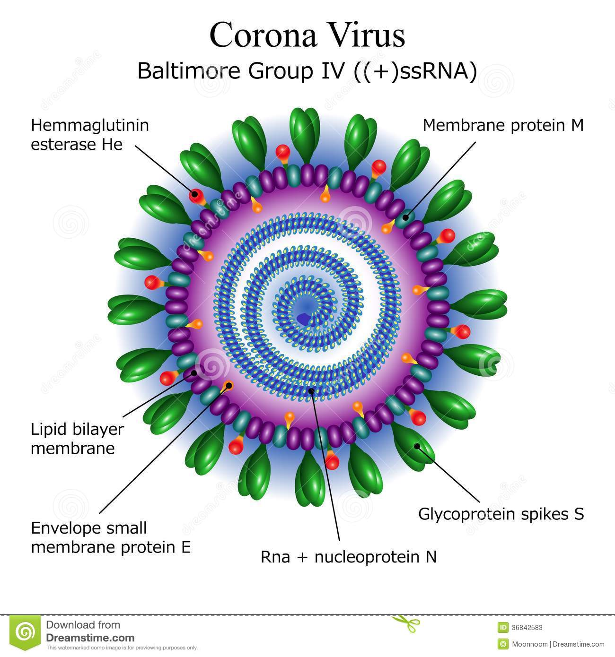](https://www.dreamstime.com/stock-photos-diagram-corona-virus-particle-structure-file-eps-format-image36842583)

Spherical shape with helical nucleocapsid, enveloped, ssRNA, linear, and nonsegmented. Consist of **two glycoproteins** and **one phosphoprotein**. Some viruses contain a **third glycoprotein, hemagglutinin esterase (**shorter spike-like protein (HE) , used for invading the host cells

**Proteins that contribute to the overall** structure **of all** coronaviruses **are the**

* **Spike (S)**
* **Envelope (E)**
* **Membrane (M)**
* **Nucleocapsid (N).**

**Listing of human coronaviruses**

* [Human coronavirus 229E](https://en.wikipedia.org/wiki/Human_coronavirus_229E)
* [Human coronavirus OC43](https://en.wikipedia.org/wiki/Human_coronavirus_OC43)
* [SARS-CoV](https://en.wikipedia.org/wiki/SARS_coronavirus)
* [Human Coronavirus NL63](https://en.wikipedia.org/wiki/Human_Coronavirus_NL63) (HCoV-NL63, New Haven coronavirus)
* [Human coronavirus HKU1](https://en.wikipedia.org/wiki/Human_coronavirus_HKU1)
* [Middle East respiratory syndrome coronavirus](https://en.wikipedia.org/wiki/Middle_East_respiratory_syndrome_coronavirus) (MERS-CoV)

**Pathogenesis**

* Coronaviruses primarily infect the [upper respiratory](https://en.wikipedia.org/wiki/Upper_respiratory_tract) tract,  and also the [gastrointestinal tract](https://en.wikipedia.org/wiki/Gastrointestinal_tract) of mammals and birds. Six different currently known strains of coronaviruses infect humans.
* Coronaviruses tend to be highly species-specific.
* Infections in vivo may be disseminated, or localized.
* The disease is marked by epithelial cell destruction and loss of absorptive capacity.

**Laboratory Diagnosis**

**A. Antigen and nucleic acid detection**

* Enteric coronaviruses can be detected by examination of stool samples by electron microscopy.
* Polymerase chain reaction (PCR) assays are useful to detect coronavirus nucleic acid in stool samples.

**B. Serology**

* Because of the difficulty of virus isolation, serodiagnosis using acute and convalescent sera is the practical means of confirming coronavirus infections.
* ELISA and hemagglutination tests may be used. Serologic diagnosis of infections is possible using a passive hemagglutination test in which red cells coated with coronavirus antigen are agglutinated by antibody-containing sera.

**ASTROVIRUSES**

[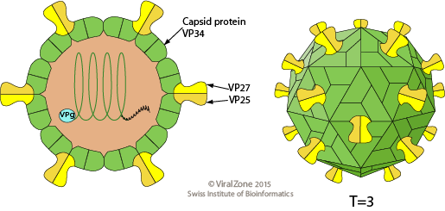](https://viralzone.expasy.org/by_species/27)

Astrovirus **originated from 'astron', a Greek word for star because of the five-pointed or six-pointed side projection which can be detected by electron microscopy.**

Astrovirus has a non-segmented, ss[**RNA**](https://en.wikipedia.org/wiki/RNA) genome within a [**non-enveloped**](https://en.wikipedia.org/wiki/Viral_envelope) icosahedral [capsid](https://en.wikipedia.org/wiki/Capsid). Human astroviruses have been shown in numerous studies to be an important **cause of** [**gastroenteritis**](https://en.wikipedia.org/wiki/Gastroenteritis) **in infant and young children worldwide** and may be shed in extraordinarily large quantities in feces.

At least **eight serotypes** of human viruses are recognized. The main mode of Astrovirus transmission is by contaminated food and water. Young children in childcare backgrounds or adults in military barracks are most likely to develop the disease. The virus may be shed for prolonged periods by immunocompromised hosts.

Astroviruses are now recognized as a cause of [gastroenteritis](https://en.wikipedia.org/wiki/Gastroenteritis) in children, whose immune systems are underdeveloped, and elderly adults, whose immune systems are generally somewhat compromised

The incubation period of the disease is approximately 3-4 days. Infection in some rare cases leads to [dehydration](https://en.wikipedia.org/wiki/Dehydration). The severity and variation in symptoms correlate with the region the case develops in. This could be due to climatic factors influencing the life cycle. Malnutrition and immunodeficiency tend to exasperate the condition, leading to more severe cases. Symptoms will reduce by themselves, after 2 to 4 days.

Pathogenicity

* Astroviruses cause gastroenteritis by causing destruction of the intestinal epithelium
* Inhibition of usual absorption mechanism
* Loss of secretory functions
* Decrease in epithelial permeability in the intestines.

**Signs and symptoms**

The main symptoms are

* [**diarrhea**](https://en.wikipedia.org/wiki/Diarrhoea)**e**
* **Nausea**
* [**vomiting**](https://en.wikipedia.org/wiki/Vomiting)
* [**fever**](https://en.wikipedia.org/wiki/Fever)
* **malaise and abdominal pain.**

**Diagnosis**

[**Electron microscopy**](https://en.wikipedia.org/wiki/Electron_microscopy)**,** [**ELISA**](https://en.wikipedia.org/wiki/ELISA)**,** [**immunofluorescence**](https://en.wikipedia.org/wiki/Immunofluorescence)**, and PCR were used for detecting virus antigens or viral nucleic acid in the stools of infected people.**

Norwalk Virus and Norwalk-Like Viral Agents

[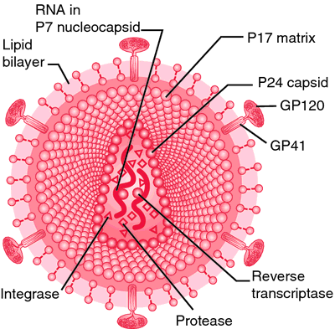](https://medical-dictionary.thefreedictionary.com/Norwalk+virus)

* **Norwalk virus was first detected in stools of patients with Gastroenteritis** (Winter Vomiting Disease) **in Norwalk, Ohio in 1968.** Also calledstomach flu or viral gastroenteritis.
* **45% are food-borne and 52% are raw shellfish associated.**
* **They tend to cause rapid (explosive) epidemics in places of close contact such as cruise ships, nursing homes, hospitals and camps.**

**Epidemiology**

* **Noroviruses are found worldwide and cause more than 23 million cases of gastroenteritis every year in the US.**
* **There are asymptomatic infections in which the patient is infectious, and sheds the virus. The infective dose may be very low and virus may continue to be secreted during the convalescent period.**
* **Norwalk food poisoning has most often been associated with contaminated ice, water, raw shellfish, salads, sandwiches, and cookies.**
* **The virus is destroyed by cooking, but not by freezing.**

**Clinical Features**

* **Adults and children are affected. The infection has a relatively short incubation period of about 24 hours. The resulting illness is short (less than 3 days).**
* **The most prominent symptoms are is vomiting, nausea, abdominal cramping and watery diarrhea accompanied by headache, fever and malaise.**