HLS physiology sheet #2
(RBC 4-3-2019)
BY : Duha hyasat
Correction Link: bit.ly/hlsphysio
*REVISION OF PLASMA
O2 present in the blood in 2 forms :
oxyhemoglobin form in the RBC (98%) and dissolved form in the plasma (2%) which is involved in the exchange process not hemoglobin part , when the dissolved o2 pass to the tissues (interstitium ) the partial pressure of o2 in the blood will be reduced so the o2 will be released from hemoglobin to be dissolved in plasma and this will increase the partial pressure of O2 and the exchange will be occured .
the dissolved part of O2 and CO2 is the main part that regulate the exchange of o2 and co2 .

the function of plasma :
- Carrying the plasma proteins,ions and hormons
- Regulate the temperature and BP
- Transport of o₂ and co₂ to interstitium
*NOW WE WILL GO TO RBCs
Production of RBC :
- Early embryonic life : nucleated RBC >> Yolk sac
- Middle trimester :liver (mainly) ,spleen and lymph nodes
- Last month of gestation and after birth >> exclusively from bone marrow

After birth, Between the age of 0 to 5 years all bones of the body form RBCS ,and from 5-20 the shaft of long bones like humerus form RBCS ,after 20 Y the head of long bones continue to form RBCS ,after 30 the membranous bones (sternum and ribs ) will form RBCS and then gradually the formation of RBCs will decrease with age .
Erythropoiesis : the formation of RBCS
Formation of RBCs ,WBCs and platelets arise from the same stem cell which is in the bone marrow
Nutrients are needed for the formation of RBCs and the most important one is erythropoietin ,hormone secreted by the kidney and stimulate the formation of RBCs .
The stimulus that increase the secretion of erythropoietin is hypoxia most potent stimulus

Hypoxia (less O₂) >> stimulate the secretion of erythropoietin which stimulate the formation of RBCs from the stem cells in bone marrow and the increasing of RBCs number will increase hemoglobin which will increase the O₂ capability in blood
Another factors increase the erythropoietin production : Androgen (sex hormone ),alkalosis and chaticholamines

People with kidney disease ,they don’t have erythropoietin and mostly they develop anemia so we give them erythropoietin injections .
*ERYTHROPOIESIS ; STEM CELLS (hemocytoblast) >>committed cells (proerythroblast )>>early erythroblast >>late erythroblast >>normoblast >>reticulocyte >>erythrocyte
The suffix cyte indicates to mature cell and blast indicates to immature cell
Reticulocyte is the last step before the formation of mature erythrocyte .
There are few number of reticulocytes in the blood , they are mainly present in the bone marrow .
Some of reticulocytes present in the blood before the maturation of RBCs .
The factors that cause hypoxia :
- Low blood volume
- Low hemoglobin
- Poor blood flow
- Anemia
- Pulmonary disease
Sundus asked “how the increasing of RBCs will increase the O₂ IF there is low O₂ to combine with Hb ?
The increasing of RBCs will increase their ability to carry more available O_{2 .}

*after the increase of RBCs ,hypoxia either will remain or not according to the severity of disease

Destruction of RBCs : RBCs are destroyed in the spleen (red blood cell graveyard ) (مقبرة الدم )
Anemia : reduction the availability of hemoglobin

The types of anemia :
- Microcytic (RBCs are small)
- Hypochromic anemia : (hypo=less,chromic=color) in which RBCs are paler than normal (no enough iron to form Hb )
- Aplastic anemia : caused by failure of bone marrow development
- Megaloblastic ; large RBCs due to deficiency in vitamin B12 ,folic acid and intrinsic factor
# intrinsic factor : substance secreted by the stomach which enables the body to absorb vitamin B12
- Pernicious anemia : (فقر الدم الخبيث )
Caused by atrophy of stomach mucosa or gastroectomy , is type of megaloblastic anemia
- Hemolytic anemia : due to hemolysis or abnormal breakdown of RBCs
- Hereditary
- Sickle cell(abnormal Hb)
- Erythroblastosis fetalis : abnormal presence of erythroblasts in blood
- Thalassaemia ; impairment of Hb production
Polycythemia ; abnormal increase in RBCs no , it could be either physiologic or pathologic
Physiologic Ex ; secondary polycythemia due to hypoxia (heavy smokers )
Pathologic : polycythemia vera ,in which bone marrow makes too many RBCs
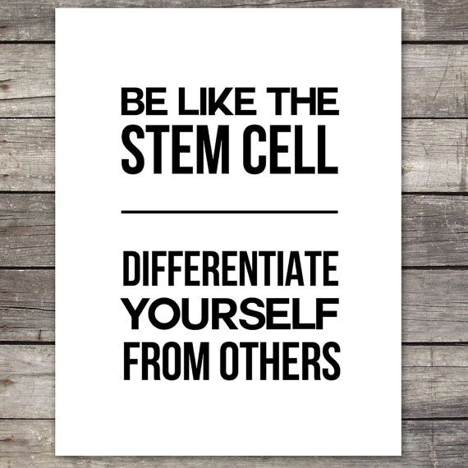

END THE SHEET ,
YOU SHOULD READ THE SLIDES

