# lec 11

Anatomy of the liver and pancreas

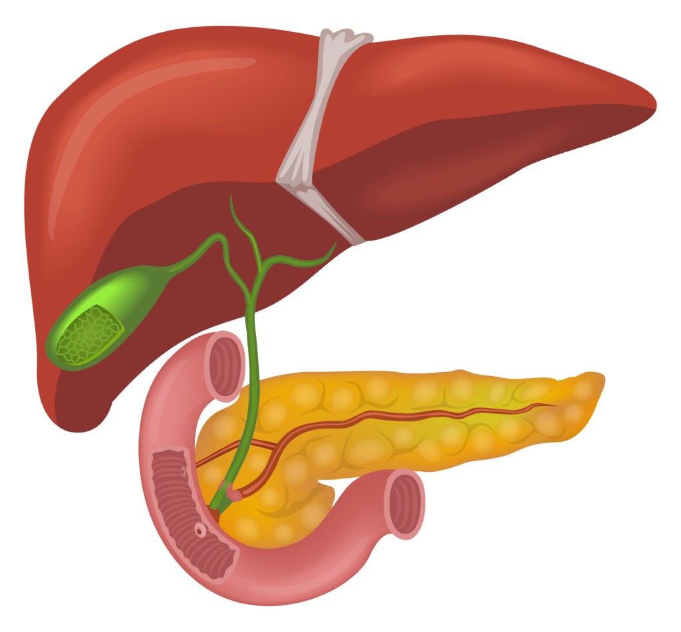

By : Raghad dweedar & Tasnim badwan & Rawan Abd alaziz

Liver is the largest organ in the body located under the ribs(right costal margin) & the diaphragm in the right hypochondrial region and normally its lower margin can be palpated below the ribs, the liver has 2 lobes( rt. & lt.)
Which are separated by interlobar fissure , the liver is wedge shape
It has round surface underneath the ribs & diaphram (diaphragmatic surface) and irregular surface adjacent to visera facing backward downward to the left (viseral surface) .
In diaphragmatic surface we have falciform ligament which is part of ventral mesentry of small intestine that attaches the liver to Anterior abdominal wall above the umbilicus .
If you are looking at viseral surface you will find the left lobe and right lobe and the fissure between them.
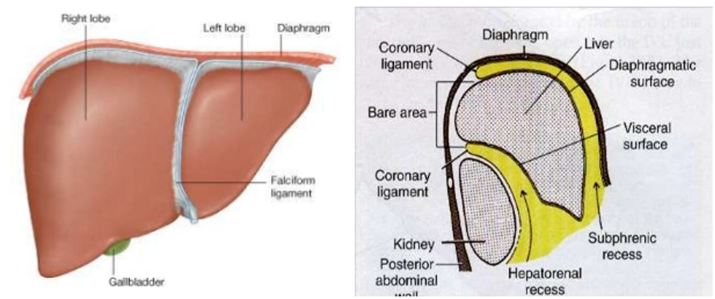
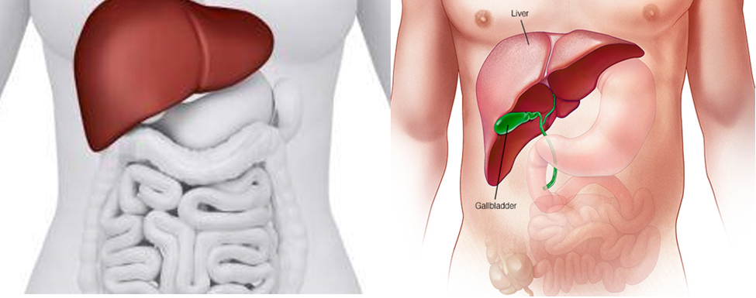

In diaphragmatic surface we have falciform ligament which is part of ventral mesentry of small intestine that attaches the liver to Anterior abdominal wall above the umbilicus
If you are looking at viseral surface you will find the left lobe and right lobe and the fissure between them
During the embryonic life The liver develop in the ventral mesentry of the foregut dividing it into lesser omintum & falciform ligament .
The umbulical vein go through the lower margin of the falciform ligament then upward in the interlobar fissure between the rt & lt loop.
Interlobar fissures contain : not sure about this
- ligamintum venosum (the remenat of the ductus venosus)
- ligamentum teres ( the remenant of the umbilical vein )

Fetal circulation:
Heart pumps blood into the aorta >> supply body organ >> ends throgh 2 common iliac artery (lt and rt : each one is divided into external and internal iliac artery) this blood is deoxgenated >> from these 2 artery branches go to >> the placenta where the blood well be oxgenated again >> from placenta oxigenated blood will go through umbilical vein >> to ductus venosus ( there is no need for the blood to go to the liver since it was first processed in the placenta so it will be bypassed through this duct) >> IVC >>Rt atrim >> Lt atrium through foramen ovali >> Lt ventricle >> aorta again .
# for better understanding:https://youtu.be/mJPgq3VLOr0

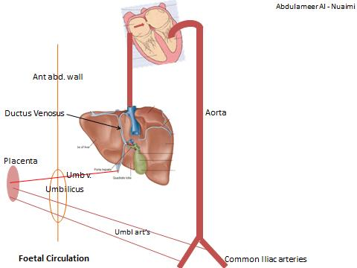

NOTE:
1- a very little amount of blood will enter the Rt ventricle since the blood will not enter the pulmonary circulation Bcz the lung is yet solid organ.
This blood in the Rt ventricle when reach bulmonary trunk will enter the aorta throgh ductus arteriosus therby bypassing pulmonary circulation .
2- the blood in fetal circulation is a mixture of arterial and venous blood, Bcz fully O2 saturated blood will be harmfull to the cells.
That’s why we take antioxidant such as vitamin C ,to be protected from the damage caused by high conc. Of O2 (from aging)
Afetr birth these embryonic organs will be obstructed :
- Ductus venosus >> ligamentum venosum
- Ductus arteriosus >> ligamentum arteriosus
- Foramen ovali >> patent .
The liver weight is 1.5 kg , it is the largest organ in the body.
The right loop of the liver contain subdivisions :
- Cudate loop
- Cuadrate loop
The relations of the cudate loop : The caudate section of the liver is connected to the right lobe by a narrow bridge called the caudate process
- IVC at right side
- Ligamentum venosum at the left
- Porta hepatis as a transverse slit inferiorly
The quadrate loop relations :
- Ligamentum teres at the left side
- Porta hepatis superiorly
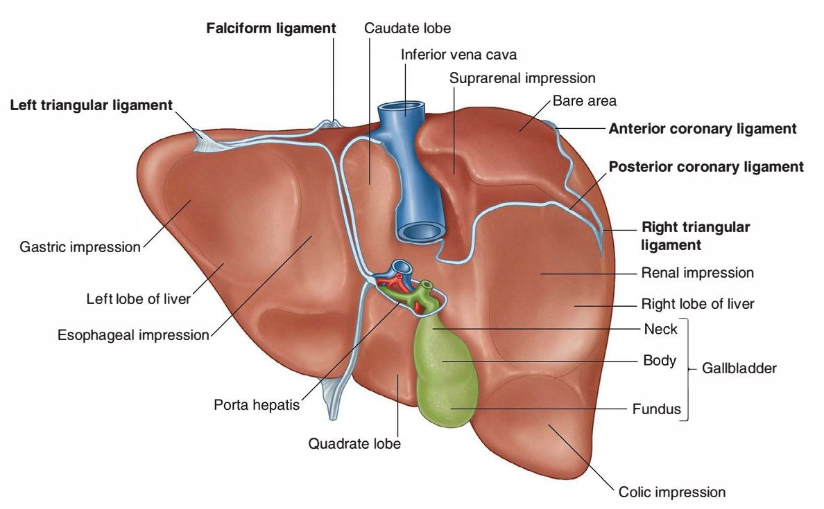
- Gallbladder on the right side.

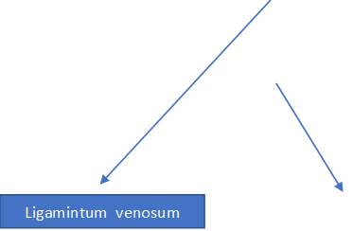

Ligamintum teres
Ligament of the liver attach it to the posterior abdomial wall & diaphragm :
1-falciform ligament :(part of the ventral mesentry) ,on the diaphragmatic surface ,and divide the liver into Lt & Rt loops .
2- ligamentum teres : umbilical vein remenamt .
#The liver is covered from all sides by peritoneum except one region that is called bare area
#((any organ try to enter the peritoneum, peritoneum is a ball inside the abdomen ;the intestine and other organs enter it ,the liver like other organ try to enter the peritoneum, the peritoneum covers the liver from all side except from the posterior (bare area;in the posterior or(dorsal) surface of the liver.
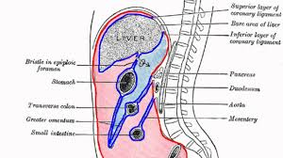
The peritoneum covers the inferior part of the liver ,then it reflects anterior to the kidney then it goes to posterior abdominal wall
From bare area ,The peritoneum reflects and covers the diaphragm(so, the peritoneum attaches to the diaphragm(as the shape of the dome)
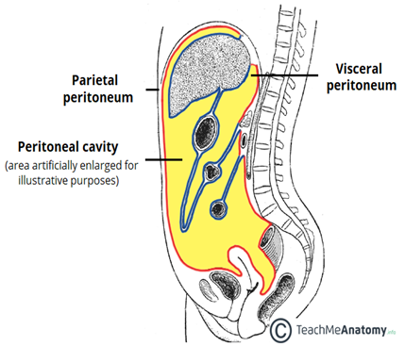
Bare area touch the diaphragm

#A Student asks if the liver is retroperitoneal organ or not(because the presence of bare area) ?
The liver is intraperitoneal organ (this information from internet)
#The liver is connected to diaphragm by :
1-falciform ligament
2-coronary ligaments : consists of an upper and a lower layer.
1)The upper layer(superior coronary ligament) is formed by the reflection of the peritoneum from the upper margin of the bare area of the liver to the under surface of the diaphragm, and is continuous with the right layer of the falciform ligament.
2)The lower layer(inferior coronary ligament) is reflected from the lower margin of the bare area on to the right kidney and suprarenal gland.
3-right and left triangular ligaments .
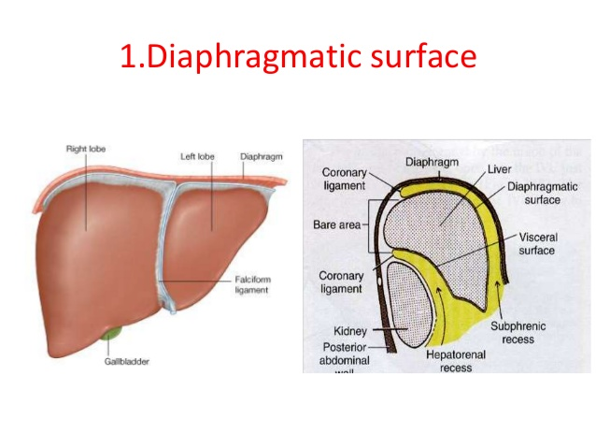
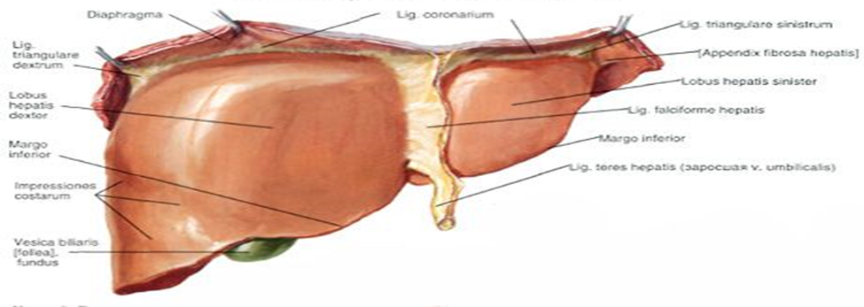

superior

inferior

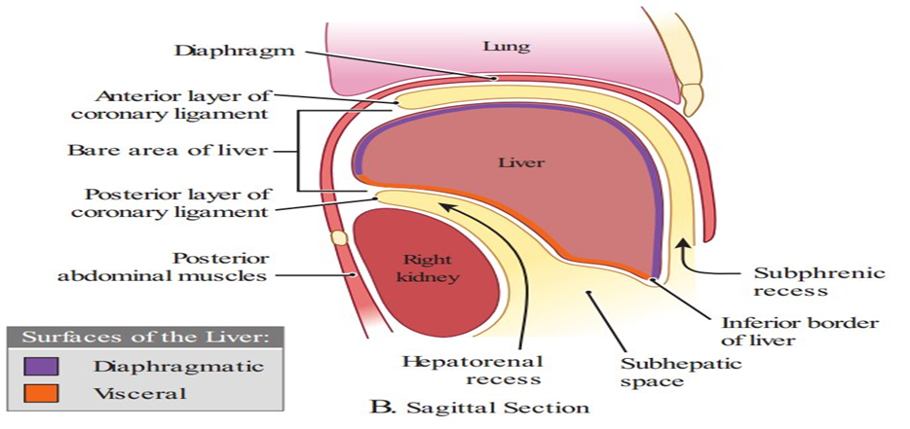
Coronary ligaments:
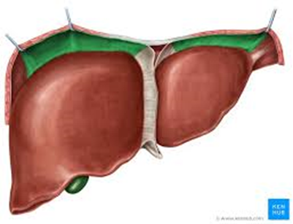

#The superior and inferior coronary ligament meet in the right and form triangular ligament .
#From these ligaments(superior, inferior coronary ligaments& triangular ligament),the peritoneum reflects to the upper surface of liver
#The bare area extends to the left and from here the coronary ligaments make the left triangular ligament .

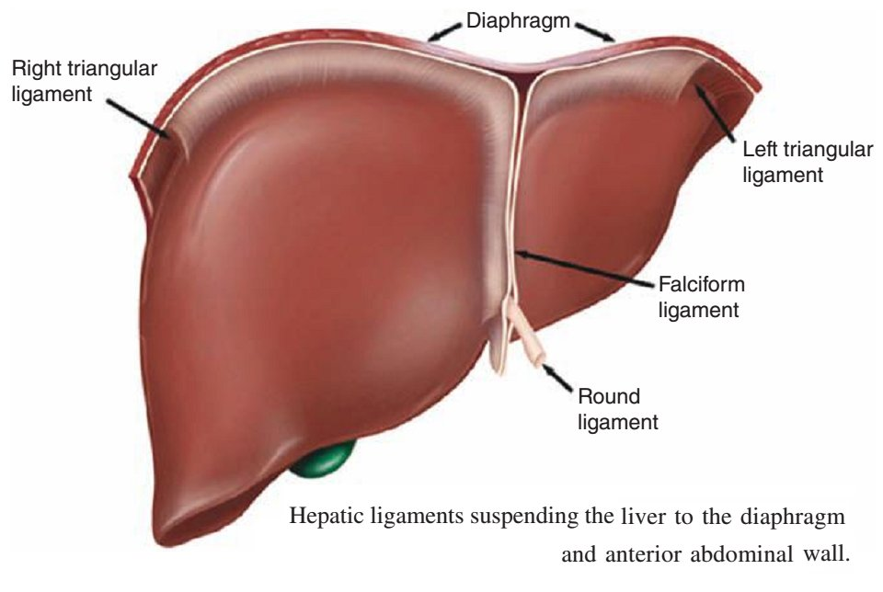
So, these ligaments are reflection of peritoneum to the under surface of the diaphragm
So, the lever is suspended to diaphragm and the bare area attach to diaphragm and the benefit from this is :rocking artificial respiration .
Someone who can’t breath ,we do artificial respiration
The the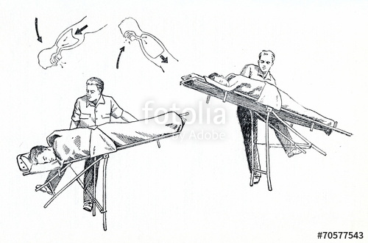
The patient sleep on the bed horizontally, we left the bed from the head of the patient <<< the liver goes down and pulls the diaphragm with it <<< the chest expands <<<the oxygen enters <<<(the inspiration)
We left the bed from the feet<<<the liver presses on the diaphragm <<<pressing on the lungs <<<the air expell <<<(expiration).

Relation of the liver:
The liver has two surfaces :1)diaphragmatic surface: extened from anterior abdominal wall <<<under diaphragm <<<<to the posterior (become visceral surface)
2)visceral surface
Anteriorly : 1)anterior abdominal wall
2)the diaphragm
posteriorly :1)lesser omentum (attached to 1)porta hepatis/2)ligaments in inter lober fissure/3)inferiorly it attach to lesser curvature of the stomach )
so, the lesser omentum is located behind the visceral surface of the liver(behinf the caudate lobe)
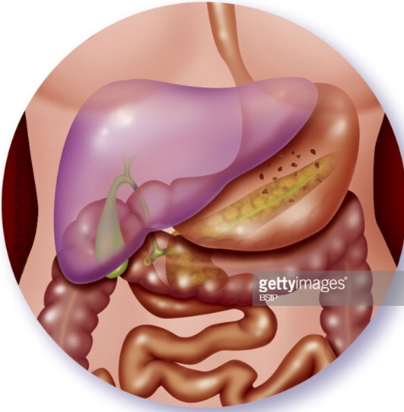
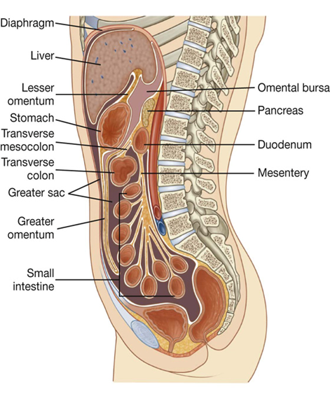
posteriorly to lesser omentum <<lesser sac behind to it 1)pancreas 2)L. kidney 3)L. suprarenal

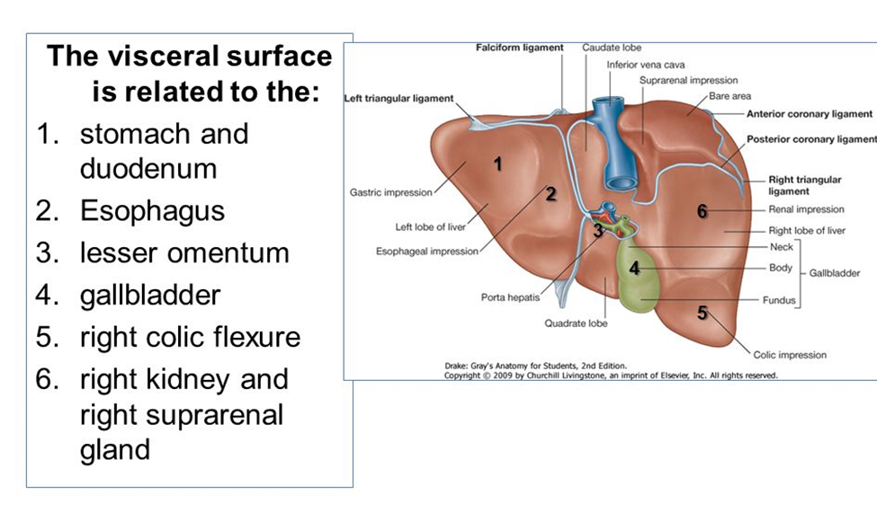

Blood supply of the liver
<>The hepatic artery, a branch of the celiac artery, comes to free margin of lesser omentum divides into right and left terminal branches (each branch for one lobe) that enter the porta hepatis.
*Rt. terminal branch gives off cystic artery (supplies the gallbladder).
##REMEMBER
Branches of the Celiac Trunk
- Left Gastric Artery
- Common Hepatic Artery (This artery gives off the right gastric artery, hepatic artery proper and gastroduodenal artery which gives off superior pancreaticoduodenal artery and rt. Gastroepiploic)
- Splenic Artery

Free Margin of lesser omentum contains: common bile duct, hepatic artery and portal vein.
***the hepatic artery inter the porat hepatis then divides into Rt and Lt hepatic artery each inter the related loop of the liver .
***From the right a branch goes to the gallbladder which called cystic artery
***Along with it is a vein also which goes to the portal vein .
<>The portal vein divides into right and left terminal branches that enter the porta hepatis it carries the blood from intestine to liver in order to detoxify it .
<>The lymph vessels leave the liver and enter several lymph nodes in the porta hepatis. The efferent vessels pass to the celiac nodes
Lymph travel from surface of liver through bare area NOTE: bare area in contact with inferior vena cava and rt. Supra renal gland
Lymph go from diaphragmatic surface of liver to anterior mediastinal lymph nodes (to chest)
Metastasis of carcinoma in liver:
1-Diaphragmatic surface >> anterior mediastinal lymph nodes
2- Visceral surface >> celiac lymph nodes along the lymphatics that run around the hepatic artery and portal vein
** the lymph goes side to side with the artery
3- Inside the liver (deep surface) >> posterior mediastinal lymph nodes along inferior vena cava and hepatic vein
<> sympathetic and parasympathetic nerves from the celiac plexus (around celiac artery we have celiac ganglia). Parasympathetic supply to ganglia from rt. And lt. or post. And inf. Vagi Sympathetic supply to ganglia from greater splanchnic nerve that arises from T5 to T9.
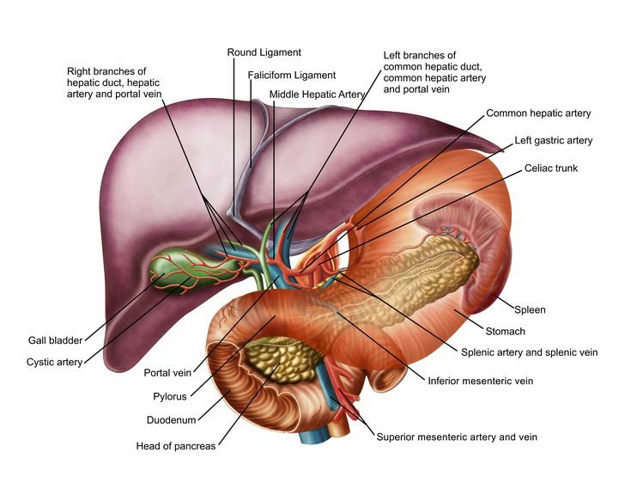
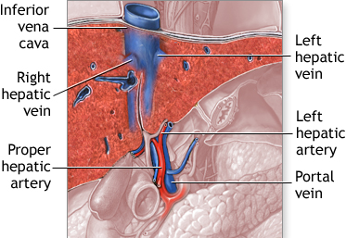
Histology of Liver
The liver is divided into thousands of small units called lobules by thin layer of connective tissue.
Each lobule is about 1mm in diameter and roughly hexagonal in shape.
The Lobule is composed of radiating double plates of liver cells (Hepatocytes) separated by a Vascular sinusoidal network.
Each lobule has a central vein in the middle and portal triads at the vertices.
Each portal triad contains branch of hepatic artery, portal vein and Bile duct.
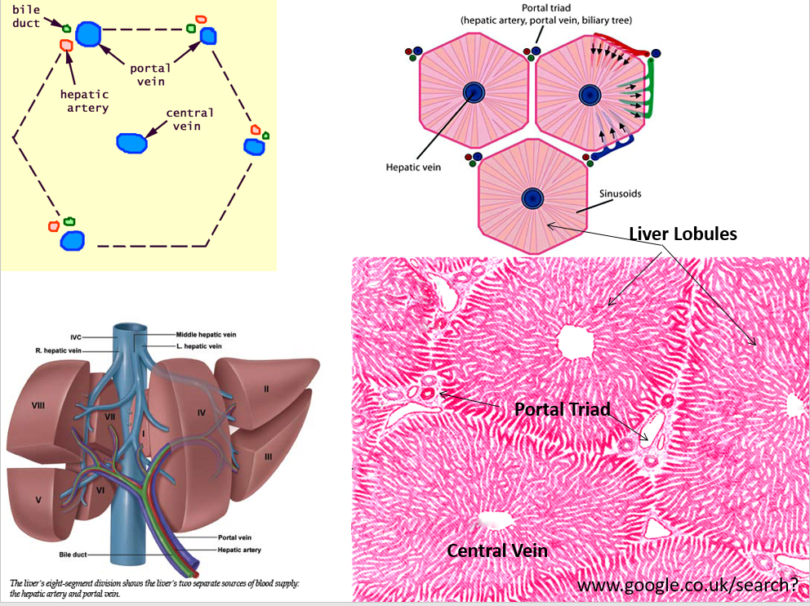
Sinusoids have an incomplete lining of highly fenestrated endothelial cells, some of these cells are macrophagic In function (reticulo-endothelial cells), they are called Kupffer cells (#they filter the blood
the hepatocytes form a plate of double layer of cells between the plates there are spaces called sinusoid coverd by kupffer cells ).
The space between endothelium and hepatocytes is called the Space of Disse. In these spaces, lymph is collected and delivered to lymphatic capillaries. Lymph is collecting in hepatic duct outside the liver.
Blood from the branches of hepatic artery and portal vein**(non processed blood) in the Portal triad, drains into sinusoids and then to the central vein. Central Veins carry the blood **(processed blood after being modified in the siusiod)to hepatic veins which end in the Inferior vena cava.
Bile is formed by liver cells and is discharged into the bile canaliculi within layers of the cell plates, and then drains into bile duct of the triads (rt. And lt. bile ducts connect to form common bile duct).
Note: the direction of bile is opposite to direction of blood (look at the picture below)
