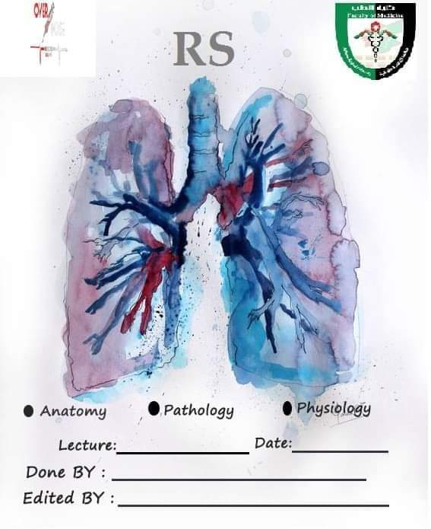
Anatomy slide6/ record 4
Hadeel Tawalbeh
Yaqeen Al-Osofy
30th of oct
بسم الله الرحمن الرحيم
ملاحظات: يحتوي هذا الشيت على الملاحظات التي ذكرها الدكتور فقط وتلك الملاحظات مرتبة حسب ورودها في السلايدات.
Slide 3: The Trachea
- The trachea, inf. edge of the cricoid cartilage and the larynx (especially, the thyroid cartilage) are superficial structures of the cervical region.
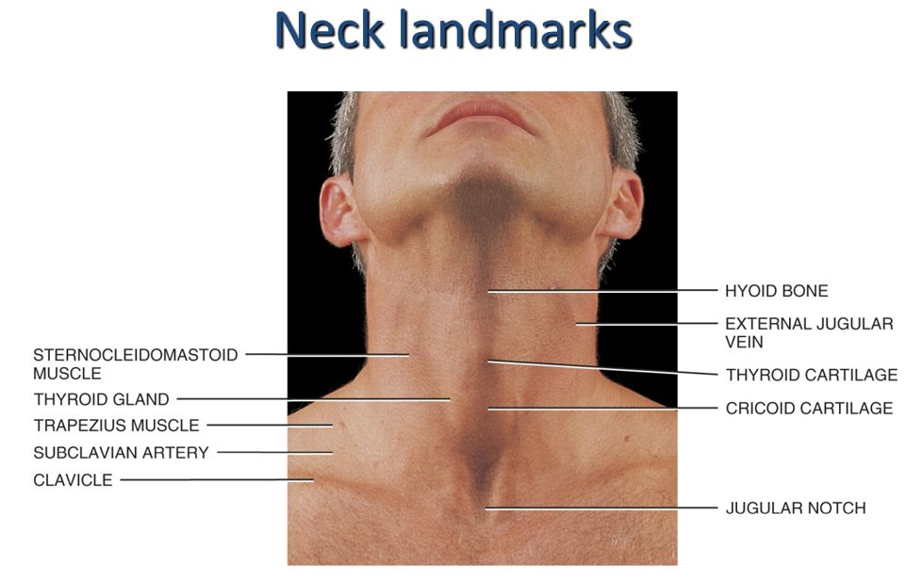
- After the cricoid cartilage, you can count the tracheal rings.

- The lumen of the larynx is continuous with the lumen of the trachea, these tubes are opened and they are supported by cartilage compared to the esophagus which is a continuation of the laryngopharynx (these tubes are collapsed mostly).

- The regions where the trachea passes through cervical region is the superior mediastinum occupying its anterior wall then it will form carina where it bifurcates. The trachea doesn’t cross the inf. level of the sup. mediastinum because the heart is located immediately inf. to it.

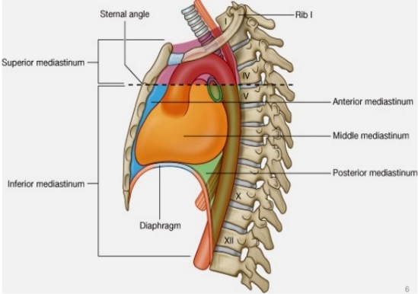
Clinical note:
the narrow trachea causes some problems to newly born babies

- The lumen is supported by c-shaped cartilage to allow the continuous opening of the lumen. These types of cartilage have deficient area located posteriorly towards the esophagus. If the tracheal cartilage were complete rings, there will be swallowing difficulty…more of a blockage or sth.
Slide 5: Trachea/ nerve and blood supply
- The recurrent laryngeal nerves which is a branch of the vagus nerve will get closer to the trachea to further innervate the larynx.
- The recurrent laryngeal nerve innervates (from Google):
  - Most of the larynx except for the cricothyroid m.
  - General visceral sensory fibers from the region inf. to the glottis.
  - Inf. constrictor m. and the cricopharyngeus m. post.
  - Source: https://www.ncbi.nlm.nih.gov/books/NBK470179/
- Recall the origin of the following arteries:
  - Inf. thyroid a.: subclavian a. > thyrocervical trunk > inf. thyroid a.
  - Brachial a.: from the descending thoracic aorta.
**we found an interesting google note about the brachial a.:
The left bronchial arteries (superior and inferior) usually arise directly from the thoracic aorta.
The single right bronchial artery usually arises from one of the following:
- 1) the thoracic aorta at a common trunk with the right 3rd posterior intercostal artery
- 2) the superior bronchial artery on the left side
- 3) any number of the right intercostal arteries mostly the third right posterior.
Source: https://en.wikipedia.org/wiki/Bronchial_artery
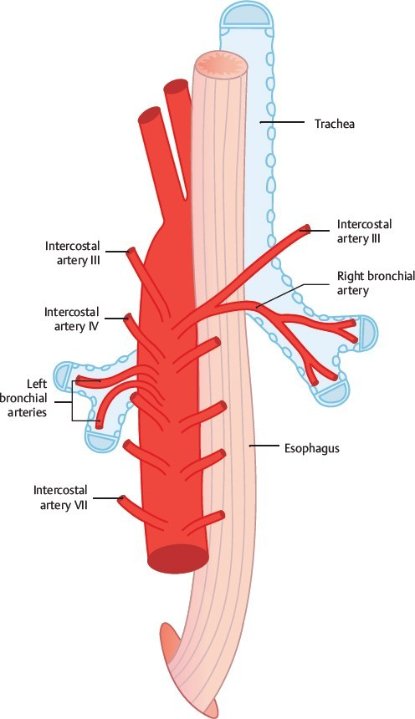

Slide 6: Trachea/ lymphatic drainage – clinical note:
Lymph nodes are important in the case of infection, it also aids in the process of cancer metastasis

Slide 7: tracheal relations in the neck/ cervical region.
- Anterior relations:
  - Deep fascia/ pretracheal fascia (green color)
  - The skin
- Anterior lateral relations:
  - Infrahyoid muscles / extrinsic muscles of the larynx (omohyoid/ sternohyoid/strenothyroid / thyrohyoid)
  - Thyroid gland
- Posterior relations:
  - Esophagus.
- Posterior lateral relations:
  - Recurrent laryngeal n.
  - carotid sheath (carotid a. + jugular v. + deep cervical lymph nodes + vagus nerve).
Slide 8: Trachea/ Relations in the Thorax (superior aperture section)
- Almost the same as the previous one with some small changes (right pic):
  - we can see the left recurrent nerve.
  - No thyroid
  - No carotid sheath
  - The major blood vessels, almost located anterolateral regards the trachea.
  - Lateral: The apexes of the lungs.
- Within the superior mediastinum (left pic): what I the relation between the trachea and…
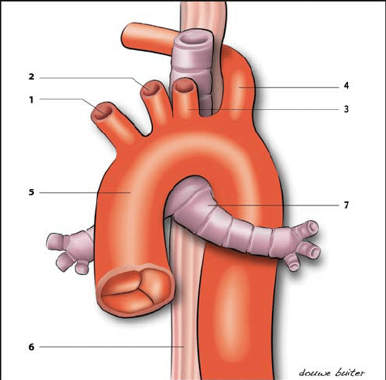
  - Arch of the Aorta: the trachea is posterior and to the right HOW? Ant. Part of the arch of the aorta is ant. to the trachea and the post. Part of the aorta is left To the trachea.
  - Superior vena cava: RT. and ant.
  - Vagi nerves: post. with the esophagus passing through the post. mediastinum behind the heart eventually post. to trachea and the hilum of the lung.
  - Phrenic nerves: ant. With the vena cava (the right phrenic only)
  - Esophagus: posterior.
**Recall, the trachea is located in the mid line whereas the svc is on the right side of the sternum (surface anatomy)

Slide 10: Bronchi and Bronchioles
- The physiological and the anatomical classification of this system:
  - From the alveoli to the terminal bronchioles > respiratory portion.
  - From the nose to the terminal bronchioles > conducting portion.
(Writer note: I “think” the terminal bronchioles are considered among the respiratory portion in this classification)
**Note: some text books consider the alveoli as the only respiratory portion whereas the others and the doctor support the previously mentioned classification due to the fact that the terminal bronchioles supply the lobules
** then, the doctor asked us to consider the system that were explained in physiology lectures.

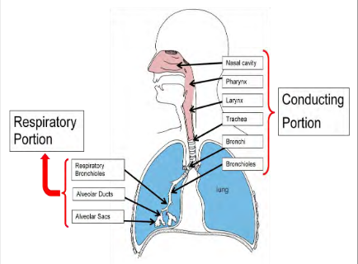
Slide 11: Bronchi.
- The division of the primary bronchus mainly occur in the hilum of the lungs, except for the 1st/ sup. Lobular bronchi which divides outside the lung and enter the lungs along the stem of the other two lobular branches
**writer note: I “think” the doctor main only the right 1st/ sup. Lobular branch.
Clinical note:
The Lt. primary branches is more horizontal + narrower + longer due to the presence of the heart in the Lt. side. The clinical consequences of this, is that: Inhalation of a foreign body goes to the Rt. branch as it’s vertical + wider and thus easier to get rid of it compared to Lt. one.

Slide 13: Bronchi/ Relations
- What’s the relation between the primary bronchi, the pulmonary a. and pulmonary v. in general?
  - The vein: ant. Regard the bronchus
  - The artery: ant. Regard the bronchus
  - From sup. To inf.: a. > bronchus > v.
  - The artery is the most sup. and ant. Structure.
- More more relations:
  - The azygous arch loop around the Rt. primary bronchus.
  - The aortic arch loop around the Lt. primary bronchus.
  - Ant. to Rt. primary bronchus and the SVC where the arch of azygous actually terminate.
  - Descending aorta > post. to Lt. primary bronchus
Slide 14: Pleurae.
- The difference between body’s serous membranes and the pleurae: the fact that there are two serous membranes.
- The parietal pleura: ant., post., lat., but not medially because of the presence of the mediastinal surface.
- ابتعرفوا الفشة تبعت الخواريف..بتلاحظوا أنه الlobes منفصلة عن بعضها البعض عن طريق ال fissures
Slide 15: Pleurae.
- مرحلة الانتقال بين الparietal وال visceral تكون حول hilum
- تكون متصلة من تحت ب pulmonary lig. عشان بعملية التنفس الhilum بطلع وبنزل داخل ال.pleural cuff
- In the pleural cavity, the space between the parietal and vessel is estimated in millimeters.
- The parietal layer, it’ll remain attached to the rib cage until it reaches to 12th rib and then ascends towards the diaphragm.
- Recall, the diaphragm is a dome like structure. The level of its apex reach almost the 6th -5th approximately rib about 10cm.

** Extra notes: the diaphragm has 2 domes and a central tendon:
- Rt. dome: reach the upper border of the 5th rib
- Lt. dome: reach the lower border of 5th rib
- Tendon: lays at the level of xiphisternal joint.
**Why is the right dome higher than the left one?
Due to the presence of the liver underneath

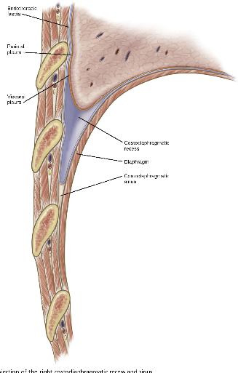
The costodiaphramatic recess is an empty area (LUNGS DON’T REACH IT), between the diaphragmatic pleura + costal pleura (costophrenic angle)
Clinical note:
As this recess is located most inferiorly, it is the most susceptible for the accumulation of pus, abscess or fluids.

Slide 16: Pleura: Innervation
- The parietal part of serous mesoderm is treated as somatic structure > innervated by somatic nerves > which is affected by all somatic changes. E.g. pain in the skin will be just like that in the parietal pleura.
- The visceral pleura is treated like the pulmonary tree, just like the pulmonary plexuses from the vagi + sympathetic trunk.

Slide 17: Lungs
- Shape: pyramidal/ conical shape > the base of the diaphragmatic. Which is concave making the dome of the diaphragm.
- The cardiac notch + the lingual + present only in the ant. Border of the Lt. lung.
Slide 18: Right Lung: Impressions
- The impression: reflect serous internal structures of the mediastinum.
- Rt. lung: **Some of them, especially those with notes.
  - cardiac impression on both sides (most prominent in the Lt. side).
  - SVC: ant. To hilum.
  - Azygous arch: superiorly.
- Lt. lung: **Some of them, especially those with notes.
  - Arch of aorta and descending aorta + cardiac impression.
Slides 20-22: Lobes & Fissures
- In the Rt. lung, the oblique fissure between the sup. and inf. lobe whereas the horizontal fissure between the sup. and the mid lobe.
- In the Lt. lung, the oblique fissure is very oblique to the point in which the sup. lobe mostly ant. and inf. lobe mostly posteriorly.

- Auscultation in the lung:

  - In the Rt.:
    - We can hear all lobes from the ant. Aspect. Especially, the sup. + med.
    - Posteriorly, you cannot hear the middle lobe.
  - In the Lt.:
    - Ant. lobe: we here from the ant. aspect
    - Post. lobe: we here from the post. aspect
Slide 23: Bronchopulmonary Segments
- They are the anatomical and functional structures. If one of them was injured, the others won’t be affected.
- The number of segments is 10 for each lung , arranged as the following:
  - Lt.: 5 sup. + 5 inf.
  - Rt.: 3 sup. + 2 mid. + 5 inf.
Slide 25: Structures within a Lobule of Lung
- The segments are divided into lobules the place where respiration actually happen. Each lobule has its own terminal branches and venules and arterioles.
Slide 26: Lungs: Blood Supply
- Lungs, bronchi, and visceral pleura: from the systemic circulation.
- Alveoli: from the pulmonary circulations and systemic circulation (systemic circulation because it needs o2 supply and some of the deoxygenated blood in the alveoli region also travel back with pulmonary circulation).

The end
Best of luck

