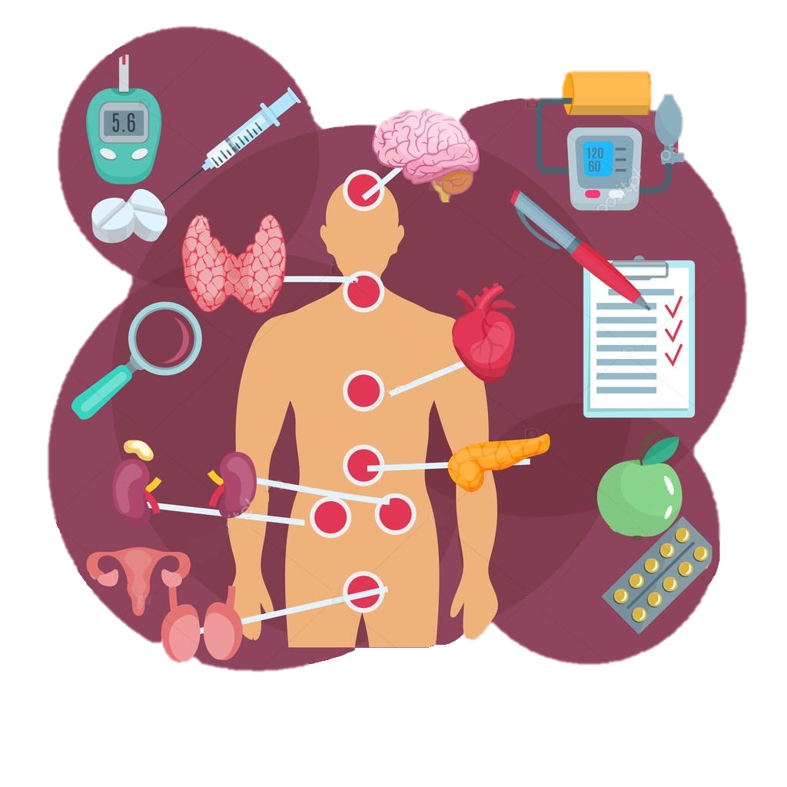
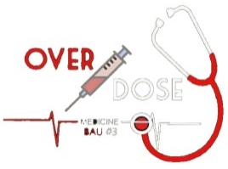

Sheet correction link: bit.ly/?????
Note: this sheet includes everything in slides. Notes are preceded by #.
j
Sub-system: Anatomy
Lecture Title: Lecture (2)
Lecture Date: 2/12/2019
Sheet Writer: Shahd Alqatu
Sheet Editor: Amal Haj Ahmad
THE ENDOCRINE SYSTEM
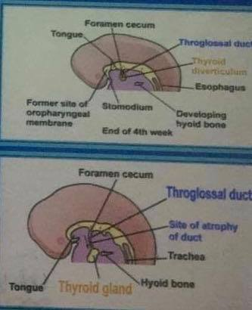
# The anterior part of the foregut is just behind the oropharyngeal membrane where the tongue develops(inside the oral cavity).

#Hard palate, teeth , gums and the anterior two thirds of the tongue >> they all originate from ectoderm but the posterior third of the tongue is originated from endoderm.

#Anterior to the oropharynx there is the oropharyngeal isthmus (where the buccopharyngeal membrane exists) . Anterior to the oropharyngeal isthmus من جهة الفم)) is ectodermal but posterior is endodermal .

# The tongue is divided into dorsal and ventral surfaces , and the dorsal surface is divided into anterior two thirds & posterior third by sulcus terminalis (on the dorsal surface of tongue) .At the apex of sulcus terminalis there is a pit (defect) called foramen cecum.
** oropharyngeal membrane = buccopharyngeal membrane .

Development of thyroid gland

-Thyroid gland is the first endocrine gland to develop.

-By the end of the 4th week, gland primordium appears as a small endodermal thickening in the floor of primitive pharynx.

-The developing thyroid migrates
down (#from foramen cecum) to its final site as the thyroglossal duct, ventral to the hyoid and larynx.

-By the end of the 5th week, thyroglossal duct degenerates and the isolated thyroid, now consisting of 2 lobes connected by isthmus. It continues to migrate, reaching its final position in the 7th week.
.
#Remember that in the beginning it was one bud then divided into 2 buds giving the lobes.
# Parathyroid glands precede and reach its position in the 6thweek.

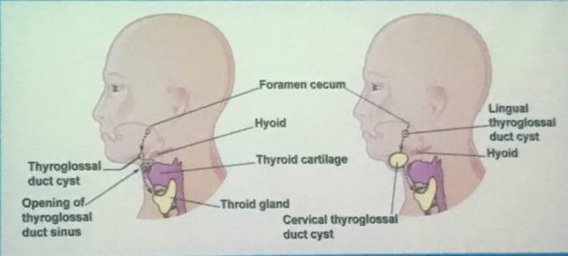
Usually, thyroglossal duct degenerates and its only remnant is the foramen cecum. Occasionally, a portion of the duct persists as an enclosed thyroglossal cyst or as a thyroglossal sinus which opens on the surface of the neck .

#It happens when the duct loses it’s program because of sick or malnourished mother, hereditary factors ,or exposure to radiation..etc.

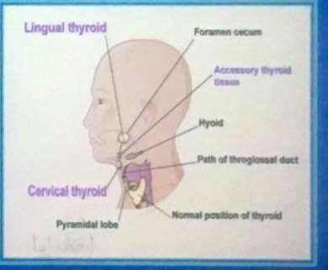
ECTOPIC THYROID GLAND
-Infrequently, an ectopic thyroid is located along the normal path of its descent from the tongue.

- In 90% of cases this represented by lingual thyroid glandular tissue.

-Incomplete descent of thyroid results in a sublingual thyroid that appears high in the neck, at or just inferior to the hyoid bone.

- In 70% of cases, an ectopic sublingual thyroid is the only thyroid tissue present.?!Care should be taken to prevent accidental surgical removal of the only thyroid tissue present.

# It could be also cervical , retrosternal or thoracic.
# One of ectopic thyroid gland signs is when baby open his mouth appears as frog mouth.
# Extra note from the doctor:
-Oogenesis is initiated in the embryonic stage .
-The oocyte is the causal of chromosomal abnormalities because it stays arrested in metaphase of meiosis 2 until fertilization by sperm .So it stays for long time and it is more prone to harm.
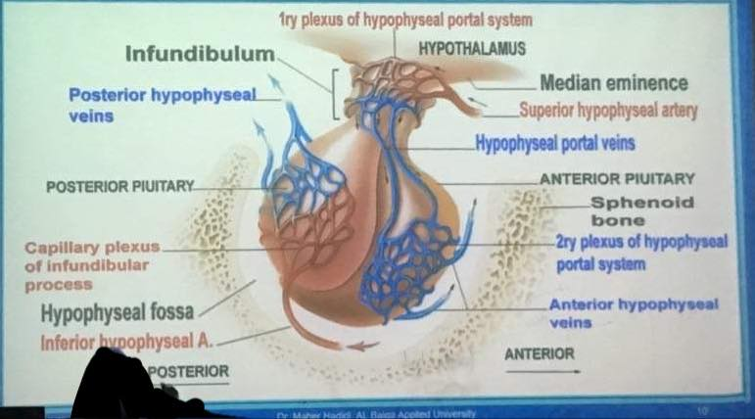
Pituitary gland

-Pea-shaped gland, located within the hypophyseal fossa.( #it weighs about 5 grams).

-Below hypothalamus to which it is connected by neural pathways. (#in the center of the skull).

-Produce hormones that regulates growth, development, metabolism and homeostasis.

- Composed of two parts :
1. Anterior pituitary, adenohypophysis (glandular part), ~75% of the gland. Three parts in adults:
* Pars distalis is the larger portion,
*Pars tuberalis that forms a partial coat around the infundibular stalk.
(# It is a sleeve like extension of the anterior pituitary .).
* Pars intermedia . (# Extra note: It is the boundary between anterior and posterior pituitary and has unknown function )

2. Posterior pituitary ,Neurohypophysis, composed of neural tissue and nerve fibers from hypothalamic area.
Consist of 3 parts:
* Median eminence
* Pars nervosa
*Infundibular stalk .

Hypophyseal Portal System

# Note: Internal carotid artery passes through cavernous sinuses on both sides of the hypophyseal fossa and gives 2 superior & 2 inferior hypophyseal arteries .

-Hypothalamic hormones that release or inhibit anterior pituitary hormones reach the anterior pituitary through arteries.
- In hypophyseal portal system, blood flows from one capillary plexus in the hypothalamus into a portal veins, then into another capillary plexus of anterior Pituitary.

- At the junction of the median eminence and the infundibulum, the superior hypophyseal arteries divide into a capillary network called the 1ry plexus of hypophyseal portal system. (#arterial plexus )

-From the 1ry plexus, blood drains into the hypophyseal portal veins that descend external to the infundibulum.

- In post pituitary, hypophyseal portal veins divide again and form 2ry plexus of hypophyseal portal system. (#venous plexus)

#The secondary plexus now contain blood rich hormones which will goes to anterior hypophyseal veins .
#Hormones are concentrated in the glands but in the general circulation are diluted .
# The portal system is mainly related to the anterior pituitary (the glandular part ).
# Both primary and secondary plexuses consist of fenestrated capillaries .

# Extra note :
The hypophyseal portal system is a system of blood vessels in the microcirculation at the base of the brain, connecting the hypothalamus with the anterior pituitary. Its main function is to quickly transport and exchange hormones between the hypothalamus arcuate nucleus and anterior pituitary gland.
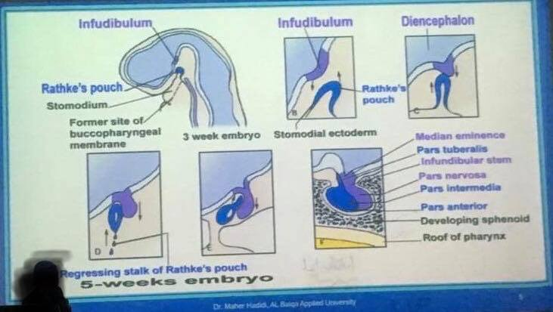
Development of Pituitary Gland

-Develops from two ectodermal sources.

- During the 3rd week, Rathke’s pouch develops as a dorsal upgrowth from the ectoderm of the roof of the stomodeum .
(# this will form the glandular “anterior pituitary”)

-Concurrently( # at the same time ), the neural diverticulum develops as a ventral downgrowth from the floor of the diencephalon .
(# this will form the neural “posterior pituitary”)

-By 5th week, glandular diverticulum elongates, loses its connection with the stomodeum and forms a separate sac that contacted with the neural infundibulum .

#infundibulum grows ventrally
# the glandular part and the neural part will meet each other at the hypophyseal fossa ).

-Pituitary develops from stomodeum forms the adenohypophysis that divides into: *Pars anterior.
* Pars tuberalis.
*Pars intermedia.

- Pituitary from the hypothalamus forms the neurohypophysis that divides into: *Pars nervosa.
* Median eminence.
*Infundibular stem.

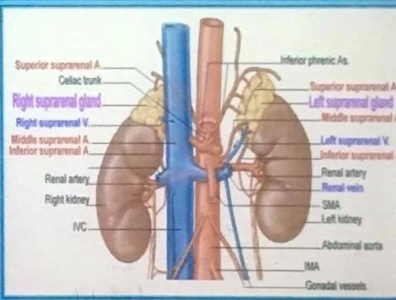
Suprarenal glands (Adrenal gland)

-Are 2 retroperitoneal organs lying on the upper pole of each kidney.

- Surrounded by the perirenal fat and the renal fascia but separated from the kidneys by the perirenal fat.
(#perirenal fat acts as shock absorbent and renal fascia is important for fixation of suprarenal in its position .)

-Right suprarenal: pyramidal in shape and caps upper pole of the right kidney
- Lies behind right lobe of the liver and the IVC.
- Rests posteriorly on the diaphragm.

- Left suprarenal: crescent in shape and extends along medial border of the left kidney from the upper pole to the hilus.
- Lies behind pancreas lesser sac and the stomach , and posteriorly on the diaphragm.
(# diaphragm is posterior to both right and left suprarenal glands.)

Arterial supply:
#suprarenal glands are highly vascularized.
Three arteries usually supply each adrenal gland:
- The superior suprarenal artery, a branch of the inferior phrenic artery(which is a branch from aorta above the celiac trunk) .
2)The middle suprarenal artery, a direct branch of the abdominal aorta.

3)The inferior suprarenal artery, a branch of the renal artery.

Venous drainage :
The venous drainage of the adrenal (suprarenal) glands is typically comprised of a single vein draining each adrenal gland:

1) left suprarenal vein drains into the left renal vein.

2) right suprarenal vein drains directly into the inferior vena cava.

