Anatomy sheet #12
Liver and pancreas pt2
Done by: Aseel Salameh ,Zain Alsharrab
- If you come by any mistake please report it to 2023od@gmail.com

- Corrections link: bit.ly/gitanatomy

- Bile flows from the liver through left and right hepatic ducts which unite in the porta hepatis to form common hepatic duct.
Left and right hepatic ducts are in the left and right lobes of the liver, respectively.
- Common hepatic duct runs in the free margin of the lesser omentum.
- Common hepatic duct unites with the cystic duct to form common bile duct.
- Common bile duct also runs through the free margin of the lesser omentum and has a length of 3 inches.
- The first inch(UPPER THIRD) runs in the free margin of the lesser omentum
- The second inch(MIDDLE THIRD) is behind the first part of the duodenum
- The third inch(LOWER THIRD) is behind the head of the pancreas meeting the pancreatic duct in the ampulla of Vater away from the pyloric sphincter by 4 inches and surrounded by the sphincter of Oddi .
The pancreatic duct has a spiral valve that prevents the bile from going through the pancreatic duct.
The sphincter of Oddi opens when meals are ingested and closes during rest, therefore bile remains stored in the gallbladder and is not secreted in the duodenum.
Gallbladder absorbs water from the bile resulting in a concentrated bile which is one if its functions.

- Gallbladder is a small cyst on the visceral surface of the liver and has primary functions of storing and concentrating bile.

- It consists of three parts:
- Fundus; projecting below the lower margin of the liver and is covered entirely by peritoneum.
RELATIONS:
Anteriorly: transverse colon

- Body; is adherent to the surface of the liver and is covered inferiorly by peritoneum. The body is in contact with the second part of the duodenum.
- Neck; has a spiral valve to prevent kinking of the neck and is in contact with the first part of the duodenum.
Prevent kinking means prevent closing of the neck
Histology of the gallbladder:
Gallbladder mucosa is thrown in folds and is similar to hexagonal shapes or bee hives and has rugae. The gall bladder is a simple muscular sac. The inner surface of the gall bladder is covered by the mucosa which shows a honeycombed appearance and is thrown into nomerous folds (rugae). The sufrace is made up of a simple columnar epithelium. The epithelial cells have microvilli, called brush boarders, and look like absorptive cells in the intestine. Underneath the epithelium is the lamina propria. The wall of the gall bladder does not have a muscularis mucosae and submucosa.
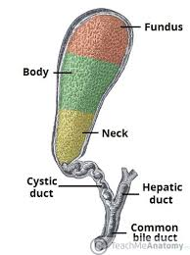
The muscularis externa (muscle layer) contains bundles of smooth muscle cells (not striated), collagen and elastic fibres. On the outside of the gall bladder is the adventitia, it is a thick layer of connective tissue, which contains large blood vessels, nerves and a lymphatic network. In the unattached region, there is an outer layer of mesothelium and loose connective tissue (the serosa).
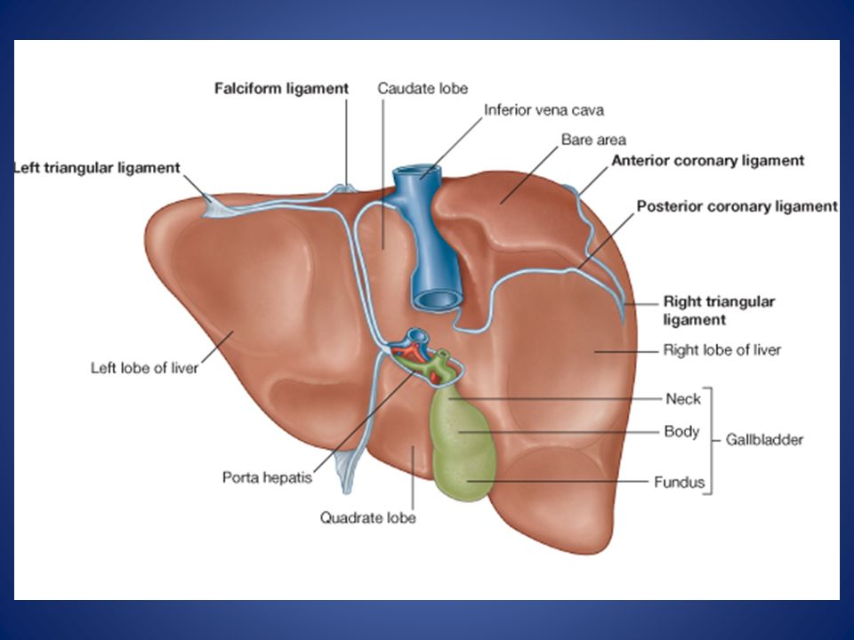

Anatomy of the pancreas :
The Pancreas
Pancreas is a soft lobulated organ located retroperitoneally across the posterior abdominal wall, it sits behind the stomach across the back of the abdomen.
It is described as an organ having head, neck, body, and tail.
The head is disc-shaped and lies within the concavity of the duodenum

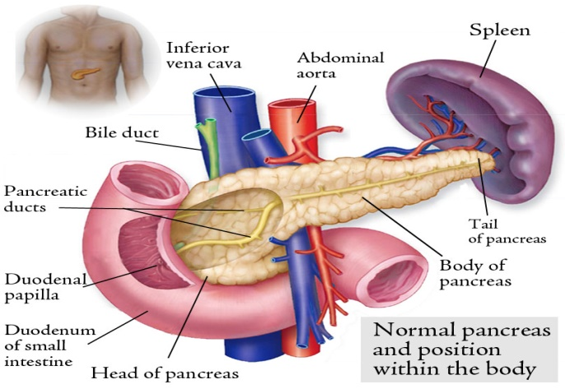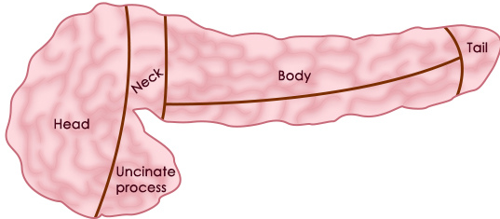
Relations of the pancreas :
- The head
- Anterior : attachment of transverse mesocolon (extend from the head of the pancreas until the tail ) & transverse colon (under the transverse colon there are coils of small intestine & above it , is the gallbladder )
- Posterior : common bile duct & inferior vena cava مهم
## Part of the head extends to the left behind the superior mesenteric vessels(superior mesenteric artery & vein), it is called Uncinate process.

- Neck
- Anterior : hepatic artery
- Posterior : portal vein

- Body
- Anterior : attachment of transverse mesocolon , transverse colon & the lesser sac (anterior to the lesse sac : stomach)
- Posterior : aorta , splenic artery & vein , Left renal vein , left kidney & suprarenal gland

- The body extends to the left side and ends as a tail near the hilus of the spleen.

Between the spleen and the kidney Lienorenal ligament : a ligament that contain :
- Tail of the pancreas
- Splenic artery & vein
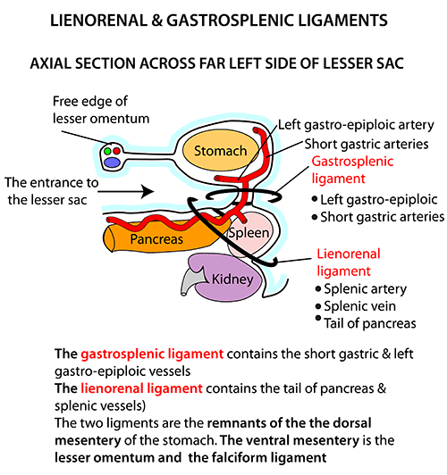
Extra figure \\ note: the doctor talked just about lienorenal ligament
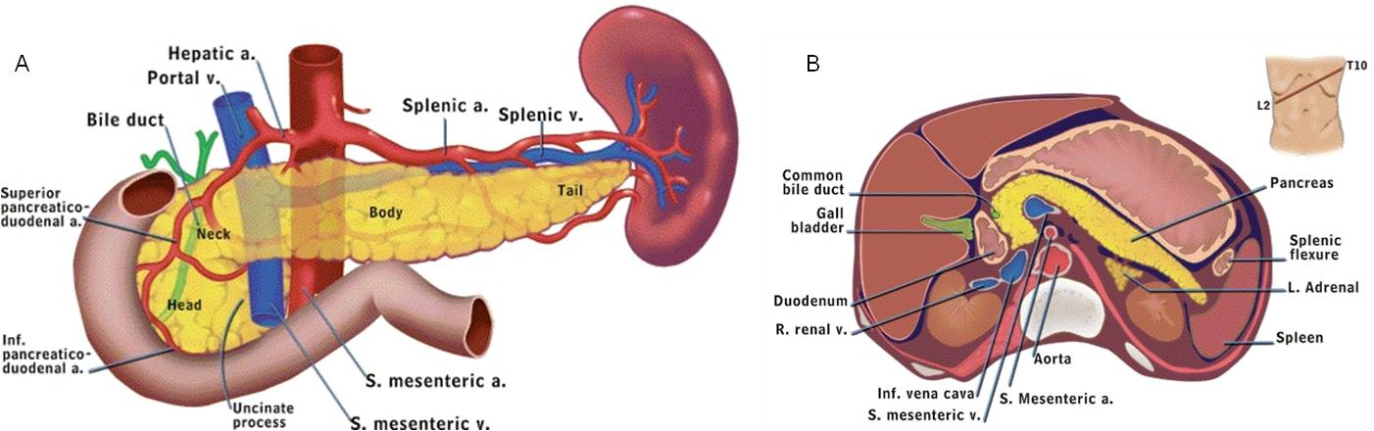

Blood supply :
- Splenic artery
- Sup. & inf. pancreaticoduodenal artery

Venous drainage :
- Splenic vein
- Sup. & inf. pancreaticoduodenal vein

These veins drain to portal circulation
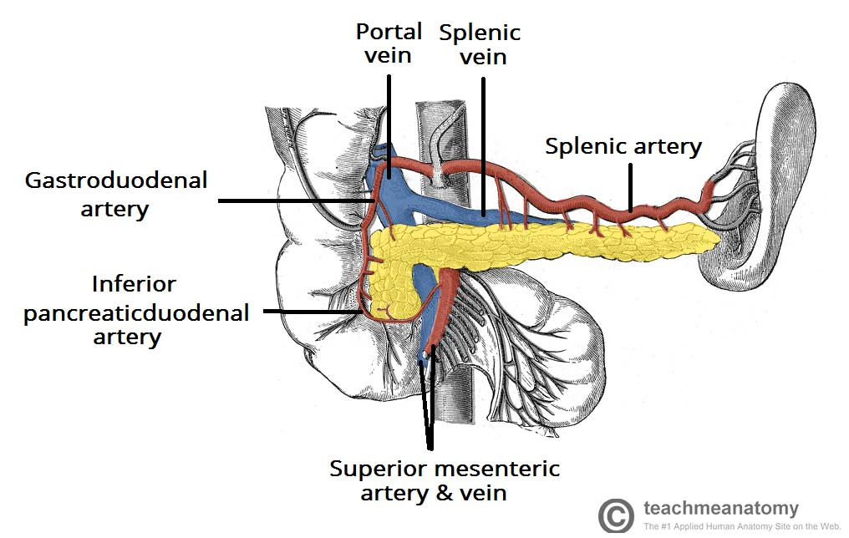
Extra figure

In order to make it easy to memorize relations , the doctor drew this picture :
- Pillow inferior vena cava ( and the head of the baby = the head of pancreas)
- Arm of the mother portal vein ( and the neck of the baby = the neck of pancreas )
- The bed (not sure) splenic artery and vein , left renal vein ( the body of the baby = body of pancreas)//
- Umbilicus of mother helium of spleen ( baby’s legs = tail of pancreas )

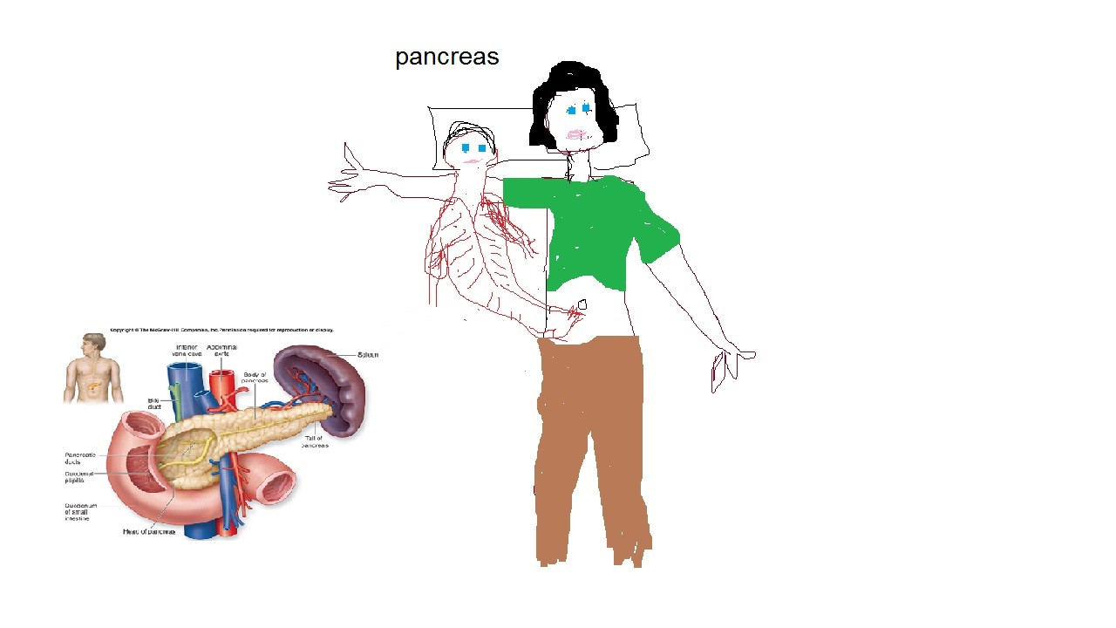

The pancreas is made up of two types of glands,
1-An exocrine gland that secretes digestive enzymes and Sodium bicarbonate into the duodenum through the main and accessory pancreatic ducts. Both ducts are usually interconnected.

2- An endocrine gland, which consists of the islets of Langerhans, secretes hormones into the bloodstream.
Islets of Langerhans are named for the German physician Paul Langerhans, who first described them in 1869. The normal human pancreas contains about 1,000,000 islets.
Cells of islets of Langerhans
1-Beta cells (β-cells), they make about 65-80% of the cells in the islets and produce Insulin.
2-alpha cells (α-cells), 15-20%, they produce an opposing hormone, Glucagon which releases glucose from the liver and fatty acids from fat tissue.
3-Delta cells (δ-cells), 3-10%, they secrete somatostatin a strong inhibitor of somatotropin, insulin, and glucagon; its role in metabolic regulation is not yet clear. Somatostatin is also produced by the hypothalamus and functions to inhibit secretion of growth hormone (somatotropin) by the pituitary gland.
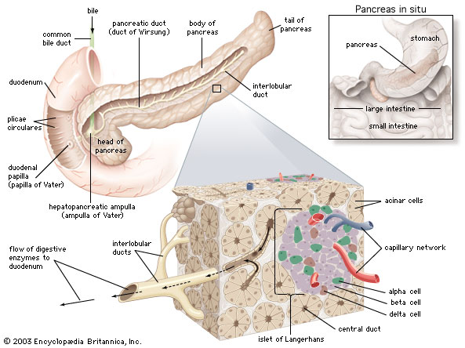

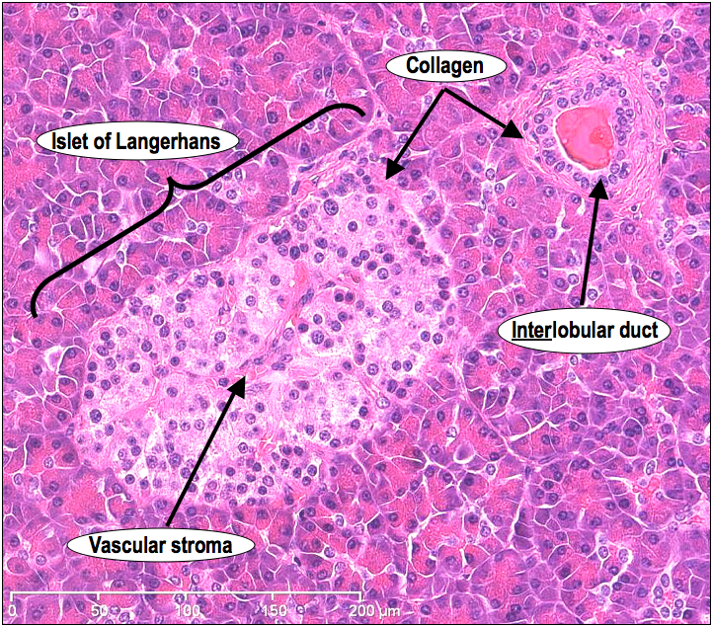

مريض السكري يأخذ نوعين من الابر
في حال كان الغلوكوز في الدم عالي نعطي انسولين و في حال اعطيناه جرعة زيادة و انخفض السكر في الدم لاقل من 50- 60
و ظهرت عليه العلامات (رجفة و لون وجهه شاحب) هون بنعطي ال glucagon

