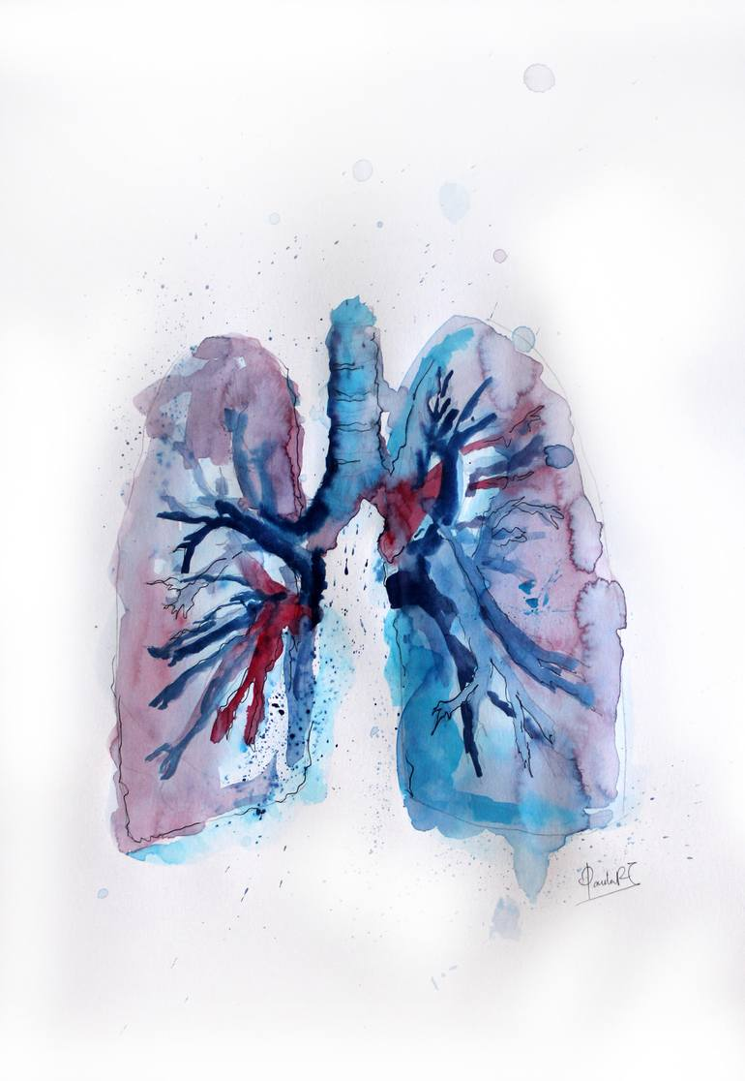

THE RESPIRATORY SYSTEM
Sub-system: patholoy
Lecture Title: sarcoidosis (restrictive lung Dz )
Lecture Date: 14/11/2019
Sheet Writer: Nour Adel Shahin

Sarcoidosis # (اللحمانية)
Modified
Sheet note after # , slides in boxes
Remember: Restrictive lung Dz > chronic diffuse interstitial lung Dz > granulomatous > sarcoidsis .
What is the sarcoidosis ? **a multisystem disease , unknown etiology , noncaseating granulomatous inflammation in many tissues and organs # any organ in the body .
**bilateral hilar lymphadenopathy or lung involvement (or both), visible on chest radiographs, is the major finding at presentation in most cases .
**Eye and skin involvement each occurs in about 25% of cases, and either may occasionally be the presenting feature of the disease.
Microscopic findings in granuloma :
Schaumann and asteroid bodies inside the granulomas .
# schaumann (concentric calcifications , purple in color ) # asteroid (needle-shape structure crystals ) .
** Extra note : in pathology, Schaumann bodies are calcium and protein inclusions inside of Langhans giant cells as part of a granuloma .
epidemiology :
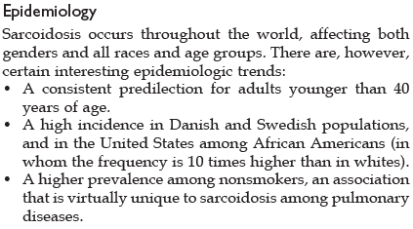#no differences between genders .
Pathogenesis :
#even we said that the causes are unknown .
But , Several immunologic abnormalities in sarcoidosis suggest the development of a cell-mediated response to an unidentified antigen. The process is driven by CD4+ helper T cells
# in general , helper T cell activate macrophages that make the granuloma ….. , so keep in mind that there is some immunologic abnormalities that suggest development cell mediated response to unidentified antigen by T cells that activate the granulomatous inflammation at the end . (تم استجابة زائدة في الجسم )

organs involved :
lungs :
lungs…90% of cases # remember the most common manifestation .
…with tendency to localize in the connective tissue around bronchioles and pulmonary venules and in the pleura (“lymphangitic” distribution)
# it's similar to the anatomy of lymphatics .
…5% to 15% of patients, the granulomas eventually are replaced by diffuse interstitial fibrosis, resulting in a so-called “honeycomb lung”
# 5-15% (few) from patients that have lung involvement (5-15 % from 90%) that may progresses to the end-stage lung Dz (honeycomb lung ) , it's extensive عنيف fibrosis , sever form .
Lymph nodes :
Hilar and paratracheal lymph nodes are enlarged in 75% to 90% of patients, while one-third present with peripheral lymphadenopathy
#the second most manifestation .

Skin :
especially erythema nodosum…sarcoidal granulomas uncommon in these lesions… lupus pernio .
#the skin manifestation :
1) EN : the most common skin lesion , even though there is little EN in non-caeseating granuloma , it associated with : sarcoidosis , pancolitis , …etc.
extra : remember : EN is skin inflammation is located in fatty layer of skin associated with more than one Dz .

2) sarcoidal granuloma .

3)lupus pernio : important for clinical …..
Student asked the doctor : Is this same as systemic lupus erythematosus ?
Ans : no , this lupus is different from lupus erythematosus .
And keep in mind that we have lupus vulgaris which is TB in skin .
These terms will be helpful for us in clinical , the prof said .

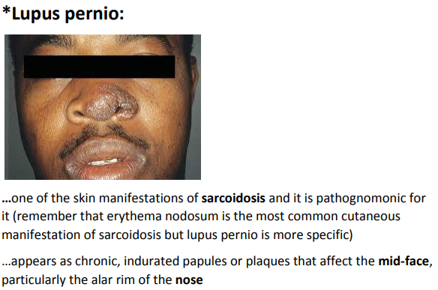

Eyes and glands :
Eye & lacrimal glands…1/5 to 1/2 # nearly 25% of patients (iritis or iridocyclitis, unilateral or bilateral) , also choroiditis, retinitis, optic nerve involvement * suppression of lacrimation>>>>>sicca syndrome.
#the sarcoidosis can affect any part of eye .
# sicca syndrome : clinical syndrome that inhibit the lacrimation (xeroophthalmia :جفاف العين ) and salivation (xerostomia : جفاف الشفاه ) .
Also , it can occur in Sjogren's syndrome ( autoimmune Dz affect salivary glands ) .
Unilateral or bilateral parotitis with painful enlargement #swelling in <10%...xerostomia
**Combined uveoparotid involvement is designated Mikulicz syndrome
# uvea in eye and parotid gland ( salivary gland ) we call it mikulicz syndrome #we said that it can affect any part of eye (uvea )
Extra note : uvea is the pigmented layer of the eye, lying beneath the sclera and cornea, and comprising the iris, choroid, and ciliary body.
Others :
Spleen, liver and bone marrow: commonly involved by microscopic granulomas but less commonly with clinical manifestations
# microscopic more than clinical ??? that u will find structural changes under microscope more than symptoms such as hepatitis for ex .

Hypercalcemia…Why?
# if we back to the immunological abnormalities that lead to sarcoidosis , we have to know that the activation of macrophages can produce the active form of vit.D which will increase the calcium in Bld , and this hypercalcemia can lead to metastatic calcification or dystrophic calcification .

#NOTE : is not necessary for this condition(sarcoidosis ) to occur in lung even though is the most common manifestation , it may occur only in skin or only in eye .
(بمعنى انها ممكن تكون بالعين مثلا بدون الرئة وهكذا )

clinical notes :
**Many are asymptomatic…incidentally on x-ray or autopsy: bilateral hilar lymphadenopathy
#it can appear on x-ray in any organ , bcz it affects any organ .

** Any organ of the previously mentioned may be the presenting one

** In 2/3s of symptomatic patients: respiratory (dyspnea, dry cough) or constitutional signs & symptoms (fever, weight loss, night sweats etc.)
#the prof said that we must be familiar to night sweats causes "some of them " :
- hodgkin's lymphoma
- TB
- Sarcoidosis
- Brucellosis (malta fever ) .

** For diagnosis:
1- Clinical, radiographic and biopsy findings after excluding other causes especially TB may cause noncaseating granulomas.
# first in diagnosis , u have to rule out everything that may involve or any known cause for granulomatous inflammation (caseating or non-caseating ) such as : TB (caseating granuloma) , fungal infection hypersensitivity pneumonitis (non-caseating) , occupational lung Dz (Berylliosis or chronic beryllium Dz ).

2-ACE is increased in the blood and in bronchoalveolar lavage…about 60% of cases

3-CD4+ T cells are increased around the granulomas and in bronchoalveolar lavage while there is peripheral T cytopenia

# what is the bronchoalveolar lavage ?
Broncoscopy (تنظير للقصبات )
is a medical procedure in which it involves fluid is squirted into a small part of the lung and then collected for examination (cytopathology >> have cells and fluids for diagnosis ). It is typically performed to diagnose lung disease.
# ACE high in Bld and bronchoalveolar lavage but CD4+ T cells high in Bld and few in bronchoalveolar lavage .

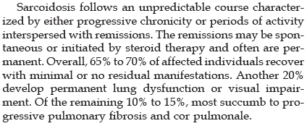
#the course is different from patient to patient .
#معظم الحالات بصيرremission .
# ممكن يرجع ينصاب فيها المريض وممكن لأ
#cor pulmoale : lung fibrosis .

What is the Lofgren syndrome ?
# It is acute presentation of :
- hilar lymphadenopathy
- erythema nodosum
- arthralgia or arthritis

best luck for all .

