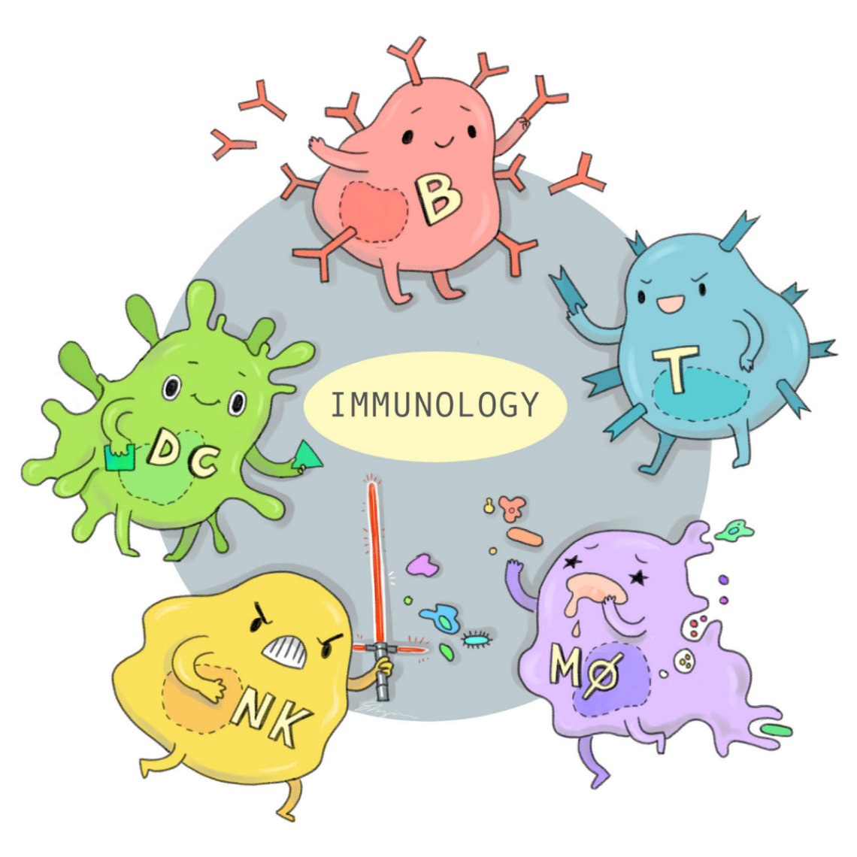

LECTURE: Tumor immunology.
DATE: 23/12/2019
Done by: Mohammad Ghanayem
This is the final lecture for this semester!!!!!!!

Immune surveillance
General concept: constant control on any cell that have any different “odd” character to the normal one.

A little explanation:
Always there is an immune response to any cell that have cancerous transformation.
So, there are different type of cells may develop to cancer, if they had the chance (e.g. UV light alone change skin cells).
So, normal immunocompetent human have immune surveillance that control numerous numbers of abnormal cells.

"Immune surveillance Quality control”

Indexes about immune surveillance:
1) Immunodeficient individuals have an increased incidence of some types of tumors.
2) Some tumors have intra-tumoral lymphocytic infiltrate which play an extra rule- this tumors have better prognosis ex: seminoma in testes has better prognosis than other germ cell tumors.
3) Enlargement of draining lymph nodes of the tumor due to the reactive *hyperplasia.
*This enlargement is reactive hyperplasia not metastases because it’s not uncommon that lymph node get larger around the tumor. Some times it’s thought to be metastatic tumor but actually it’s a hyperplasia as a response to the tumor.
Reactive lymphadenopathy immune system against tumor cells
Cancer immunotherapy
General concept: Therapeutic blockade of inhibitory receptors such as PD-1 and
CTLA-4 leads to tumor remission.
James P. Allison is a scientist had the Nobel Prize for discovering new cancer treatment that leads to prolong the survival period in metastatic melanoma patients.
He works on antI-CTLA-4 and anti-PD-1.

You can skip it bcs doctor Ali explain it to students who didn’t study it.
*quick recap to immune tolerance*
T-cells needs two signals to be activated:
1) Binding of TCR to MHC and antigen.
2) Its need a second signal from *CD28 on its surface.
*If CTLA-R or PD-1 on the surface of T-cell activated instead of CD28, the second signal will be blocked.

So, Allison works on antibodies against CTLA-4 and PD-1 to keep T-cell activated against tumor cells.
NOTE; side effect of these drugs is “auto-immunity”.

Some of cancer characteristics are:
1) Run from apoptosis.
2) Over proliferation.
3) Autonomous.
4) Evasion of immune system. By overexpression of CTLA-4 and PD-1 that bind to APC so it distract ABC from binding to CD28 on T-cell.
Tumors antigens:
General concept: is an antigenic substance produced in tumor cells, i.e., it triggers an immune response in the host.
Quick recap:
Driver mutation: contribute to tumor progression and usually specified (there are common and they are known such as: we know that loss of TP53 its driver mutation).

Passenger mutation: neutral mutation that had no functional consequences on tumor growth, they are numerous in numbers and huge diversity.
So a lot of these mutation we don’t its actual oncogenesis (such as: in SCC the UV light will do a lot of changes but not all of them we can explain them)

1) Products of oncogene or mutated tumor suppressor gene.
This products not found normally in the body.
Driver mutation
A) Tumor suppressor gene products:
Mutated p53 protein. Normal P53 called guardian of the genome.
B) Oncogene products:
-abnormal RAS.
-Bcr/Abl fusion protein.
In chronic myeloid leukemia CML Philadelphia chromosome 9:22. Abl (non-receptor tyrosine kinase) on Ch9 transfer to Ch22 and fused with Bcr proliferation of the cell.

2) Mutated self-protein that doesn’t contribute to tumorigenesis.
Passenger mutation

Extra note: Deviating from what is considered proper or normal
3) Over expressed or aberrantly expressed self-protein.
Genes that give minimal amount of protein product become overexpression of this products without any gene changing or abnormal products. “Just abnormal amounts” so they will be targeted by the immune sys as tumor antigen.
A) HER-2 in breast cancer. Tyrosine kinase lead to proliferation.
B) Tyrosinase in melanoma.
C) gb100 mainly in melanoma.
-AGE
D) *Cancer/testis antigens MAGE, RAGE, GAGE, AND BAGE in melanoma.
*genes products are expressed only in fetus or specific organs in adult hood are called oncofetal antigens and it may return to function in tumor cells, so it considered as a new antigens “tumor antigens”.
In serum
Other oncofetal antigens:
- α-fetoprotein (AFP). Expressed normally in fetus and its gene found in adult but it’s not activated.
AFB found in: -hepatocellular carcinoma.
-yolk sac tumor.
- Carcinoembryonic antigen (CEA). In colon cancer.

4) Viral oncogene: viral particles carry a gene that encodes for an overactive oncogene to make a tumor.
A) HPV (16, 18 and 33(lesser)) in – Cervical adenocarcinoma and SCC.
--anogenital cancer
-oropharyngeal (esp., tonsils)
Gene products: E6 degrades P53 E7bind RB so RB release E2F from it.
All of these increase proliferation
Inactivate P21 & P21 (CDKIs).
B) EBV in –Burkett lymphoma. Nearly all of endemic African Burkett lymphoma is EBV.
--nasopharyngeal carcinoma.
EBV EBNA-1(Epstein-Barr nuclear antigen) have no obvious rule in oncogenesis.

C) HHV-8 in Kaposi sarcoma.
HHV-8LANA-1(Latency-associated nuclear antigen) have an obvious rule in oncogenesis.
5) Altered cell surface glycolipids and glycoproteins.
Myosin is a large glycoprotein. An abnormality in carbohydrate part of the myosin lead to reveal of its protein part so it will marked as tumor antigen to immune sys.
-CA-19-9(imp) in – pancreaticobiliary
--ovarian mucinous cancer
-MAC-1, MAC-2 and MAC-4 …..

6) Cell type-specific differentiation antigens.
Antigens help to find out the type of cancer by immunohistochemistry.
One of these is cytokeratin which is intermediate filaments found normally in cells. It concentrate depend on the type:
CD-7: upper GI.
Imp NOTE: it concentrate in ratios not completely restricted.

CD-20: lower GI.
CD-19-9: pancreaticobiliary.
TTF-1: thyroid cancer Thyroid transcription factor-1
Ex: if we had adenocarcinoma in esophagus and adenocarcinoma in colon and we need to differ btw them if it takes the CD-20 its moves more to the lower GI but if it takes CD-7 not CD-20 move more to the upper GI.(((in ratios)))
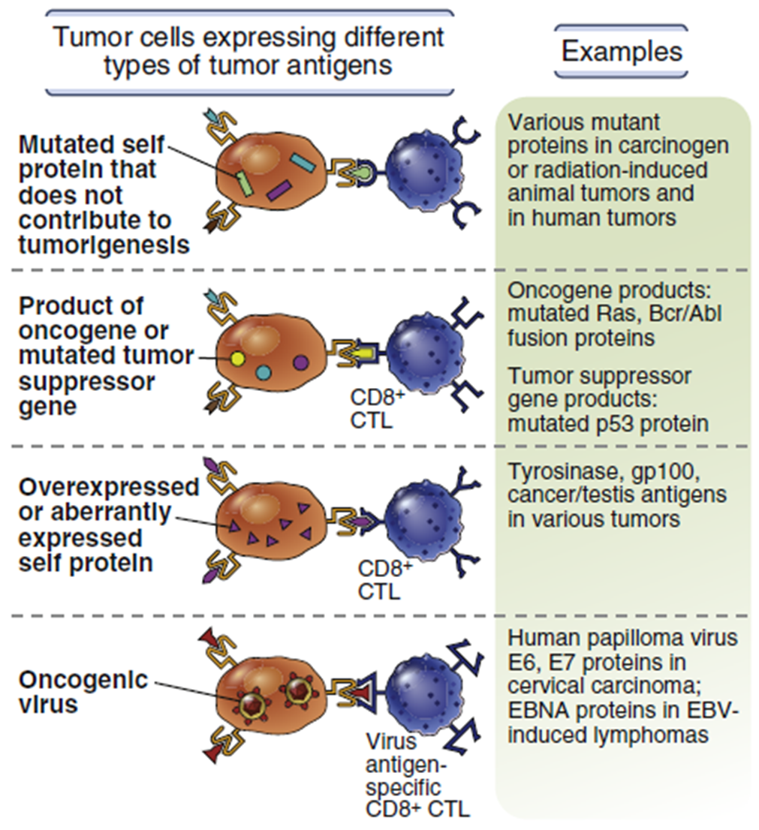
Tumor markers: is a biomarker found in blood that can be elevated by the presence of one or more types of cancer.
By immunohistochemistry
Its imp in follow up more than diagnosis.
Not much sensitive, not much specific.
CEA | Colon cancer
AFP | Yolk sac cancer  Hepatocellular carcinoma
CA-19-9 | pancreaticobiliary
CA125 | Ovarian cancer
Prostate specific antigen PSA | Prostate cancer
CA-199 | Pancreatic cancer
TSTA (tumor specific transplantation antigen) TATA (tumor associated transplantation antigen
Are unique to tumor cells, they may be proteins that are expressed on normal cells during fetal development when the immune sys is undeveloped and unable to respond.
Are unique to tumor cells and don’t occur on normal cells under any condition.

Mechanisms:
1) Like any cytoplasmic protein, tumor antigens may enter the MHC-1-processing pathway and be recognized by CD8+ T cells
2) Tumor cell may be phagocytosed and there content leaked out so the phagocytosed extracellular antigen will be recognized by MHC-2 -----CD4+ cells.
3) Natural killer cells: induced by IL-2 and IL-15 amd these cytokines may be used for treatment. NOTE: it’s dangerous to give cytokines systemically so we give it locally.
4) Role of macrophages.

Escape from immune system:
1) Selective outgrowth of antigen-negative variants.
It’s better to tumor cells to have hidden antigen than uncovered antigens. Actually uncovered antigens will attacked by immune sys and disappeared and hidden antigen will stay alone
2) Loss or reduced expression of MHC molecules, But that will trigger NK cells.
A double-edged sword
3) Activation of immunoregulatory pathway.
A) Downregulation of costimulators (p7) on APCs as a result: CTLA-4 is engaged more than CD28

B) Increased PD-L1 and PD-L2 surface proteins on tumor cell which will activate PD-1 receptor on T cell that blocks the second signal.

4) Secretion of immunosuppressive factors by cancer cells
-TGF-beta -Galectins -IL-10

5) Induction of regulatory T cells (Tregs)

Therapies
-Cytokines - Monoclonal antibodies (anti-CTLA-4, anti PD-1) -Vaccines (HPV16, 18)

GOOD LUCK

