*Toxins can be (inhaled / insufflated (snorted) / orally ingested / injected / absorbed dermally)
*common targets of toxicity include ( central nervous system, lungs, kidney, heart, liver, blood, acid/base and electrolyte balance of the body)
*lifethreatening toxic effect >>profound increases or decreases in ( blood pressure / heart rate / breathing /body temperature )or any dangerous dysrhythmias
*EMERGENCY TREATMENT OF THE POISONED PATIENT
- Airway, breathing, and circulation(ABC) are assessed and addressed initially
-Acid/base and electrolyte disturbances, along with an acetaminophen and salicylate blood level >> assessed as laboratory results are obtained
-administering oxygen and obtaining intravenous access and placing the patient on a cardiac monitor >> if altered mental status >> “coma cocktail”
“coma cocktail” consists of; intravenous ((dextrose to treat hypoglycemia // naloxone to treat possible opioid or clonidine toxicity // Thiamine for ethanol-induced Wernicke encephalopathy))
-assessment for decontamination can occur >> once the patient is stabilized and this may includes :
1- flushing of the eyes with saline or tepid water to a neutral pH for ocular exposures
2- rinsing of the skin for dermal exposures
3- administration of gastrointestinal (GI) decontamination with gastric lavage, activated charcoal, or whole bowel irrigation (utilizing a polyethylene glycol electrolyte balanced solution)
- Several substances do not adsorb to activated charcoal (lead and other heavy metals, iron, lithium, potassium, and alcohols) >> limited to coingested products
* Elimination enhancement by HUM-(Hemodialysis / Urinary alkalinization / Mutiple-dose activated charcoal)
1- Hemodialysis (if certain properties are met by the toxin and they include:( low protein binding/ small volume of distribution/ small molecular weight/ water solubility) // examples methanol, ethylene glycol, salicylates, theophylline, phenobarbital, and lithium.)
2- Urinary alkalinization (enhances the elimination of salicylates or phenobarbital // Increasing the urine pH with intravenous sodium bicarbonate>> transforms the drug into an ionized form>> prevents reabsorption // goal urine pH is 7.5 to 8 and ensuring that the serum pH does not exceed 7.55 )
3- Multiple-dose activated charcoal (enhances the elimination of theophylline, phenobarbital, digoxin, carbamazepine, valproic acid // works by creating a gradient across the lumen of the gut >> Medications traverse from areas of high concentration to low concentration >> medication already absorbed to cross back into the gut to be adsorbed by the activated charcoal // blocks the reabsorption of medications that undergo enterohepatic recirculation(like phenytoin) //
Bowel sounds must be present prior to each activated charcoal dose to ensure movement of the GI tract and prevent obstruction)
----------------------------------------------------------------------------------------------------------------------------------------
***Acetaminophen (toxic when metabolic pathways become saturated)
* undergoes metabolism by sulfation, glucuronidation, and N-hydroxylation by the cytochromeP450 system
* When a toxic amount of acetaminophen is ingested, the first two processes are overwhelmed and more acetaminophen is metabolized by the cytochrome P450 system to a hepatotoxic metabolite (N-acetyl-p-benzoquinoneimine, NAPQI).>> glutathione is depleted, leaving the metabolite to produce toxicity
* in therapeutic acetaminophen ingestions, the liver generates glutathione, which detoxifies NAPQI
* antidote for acetaminophen toxicity, N-acetylcysteine (NAC), initially works as a glutathione precursor and glutathione substitute and assists with sulfation.
Later on, NAC may function as an antioxidant to aid in recovery (NAC is the most effective when initiated 8 to 10 hours postingestion)
* acetaminophen toxicity (4) phases (1-phase one (0-24)h – loss of spetite and malaise /2-phase two (24-72)h abdominal pain and increase liver enzymes
3-phase three (72-96)liver necrosis,jaundice,encephalopathy,renal falire and death / 4-phase four (>4 days to 2 weeks) organ failure and resolution of semptoms.

*** Alcohols
1- (Methanol-(in windshield washer fluid and model airplane fuel) and ethylene glycol-(in radiator antifreeze))
*themselves relatively nontoxic and cause mainly CNS sedation
* methanol and ethylene glycol are oxidized to toxic products (formic acid in the case of methanol/ glycolic, glyoxylic, oxalic acids in the case of ethylene glycol)
* Fomepizole inhibits this oxidative pathway by blocking alcohol dehydrogenase. It prevents the formation of toxic metabolites and allows the parent alcohols to be excreted by the kidney.
* Hemodialysis is often utilized to remove the already-produced toxic acids
* cofactors are administered to encourage metabolism to nontoxic metabolites (folate for methanol, thiamine and pyridoxine for ethylene glycol)
* If untreated (methanol causes blindness,metabolic acidosis,seizures,coma /Ethylene glycol causes renal failure, hypocalcemia, metabolic acidosis,heart failure
2- Isopropanol (rubbing alcohol, isopropyl alcohol):
* metabolized to acetone via alcohol dehydrogenase / cannot be further oxidized to carboxylic acids, and therefore, acidemia does not occur
* Isopropanol is a known CNS depressant and GI irritant. ((No antidote is necessary))

*** Carbon monoxide ( مصادره حرق و هيك معروفة)
* after inhalation binds to hemoglobin to produce carboxyhemoglobin. >> reducing oxygen delivery >> may produce “cherry red” skin.( presence of this highly oxygenated blood) >>
* binding affinity of carbon monoxide to hemoglobin is 230-270 greater than O₂
* can occur also after inhalation or ingestion of methylene chloride found in paint strippers >> metabolized to carbon monoxide through the cytochrome P450
*Symptoms like hypoxia //* brain and heart showing the greatest sensitivity //* high exposure >> seizures, coma, and death
*management of a carbon monoxide–poisoned patient(removal from source of carbon monoxide and institution of 100% oxygen by nonrebreathing face mask or endotracheal tube. // if severe intoxication >> oxygenation in a hyperbaric chamber

*** Cyanide
* products of combustion ,cyanide salts used in electroplating, and hydrogen cyanide may be produced during photographic developing and petroleum refining
* cyanide quickly binds to many metalloenzymes, thereby rendering them inactive
* toxicity occurs as a result of the inactivation of the enzyme cytochrome oxidase (cytochrome a3), leading to the inhibition of cellular respiration.
* even in the presence of oxygen, tissues such as the brain and heart, which require a high oxygen demand, are adversely affected
* Death can occur quickly due to respiratory arrest of oxidative phosphorylation and production of adenosine triphosphate
* new antidote, hydroxocobalamin (vitamin B12a) –(IV)- bind the cyanide and produce cyanocobalamin (vitamin B12) without the worry of hypotension or methemoglobin production
* older cyanide antidote kit comprises sodium nitrite to form cyanomethemoglobin and sodium thiosulfate to accelerate the production of thiocyanate, which is much less toxic than cyanide and is also quickly excreted in urine.
* In patients with smoke inhalation and cyanide toxicity, the induction of methemoglobin with sodium nitrite should be avoided unless the carboxyhemoglobin
concentration is less than 10%. Otherwise, the oxygen-carrying capacity of blood becomes too low.

*** Iron
* may show up on an abdominal radiograph
* Toxic effects can be expected with as little as 20 mg/kg--// 60 mg/kg may be lethal.
* quantity ingested and patient’s weight, and the elemental iron concentration >> assessment of potential toxicity can be made
* A serum iron level should be obtained, since levels between 500 and 1000 μg/dL have been associated with shock and levels higher than 1000 μg/dL with morbidity and mortality
* latent period or may progress quickly to hypovolemia, metabolic acidosis, hypotension, and coagulopathy.> hepatic failure , multisystem failure, coma, death
* Deferoxamine, an iron-specific chelator >> binds free iron, creating ferrioxamine to be excreted in the urine
* intravenous route for deferoxamine is preferred, but hypotension may occur if rapid boluses are administered instead of a continuous infusion

***lead
* From old paint, drinking water, industrial pollution, food, and contaminated dust((inorganic lead salts - most chronic))
* Adults absorb about 10% of an ingested dose / children absorb about 40%. يعني الطفل يحتاج كمية اقل للتسمم (ربع الكمية)
* Inorganic forms of lead are initially distributed to the soft tissues and more slowly redistribute to bone, teeth, and hair
* it impairs new bone formation and causes increased calcium deposition in long bones visible on x-ray
* appear on an abdominal radiograph if present in the GI tract (radiopaque)
* Lead has an apparent blood half-life of about 1 to 2 months // half-life in the bone is 20 to 30 years // Chronic exposure > serious effects on several tissues
* chelators can be utilized in the treatment of lead toxicity //
* levels are( > 45 μg/dL, but < 70 μg/dL in children, succimer (dimercaptosuccinic acid, DMSA), an oral chelator
* levels > 70 μg/dL or if encephalopathy is present, dual parenteral therapy ( dimercaprol given IM and calcium disodium edetate given IV)
* Dimercaprol is suspended in peanut oil and should not be given to those with a peanut allergy

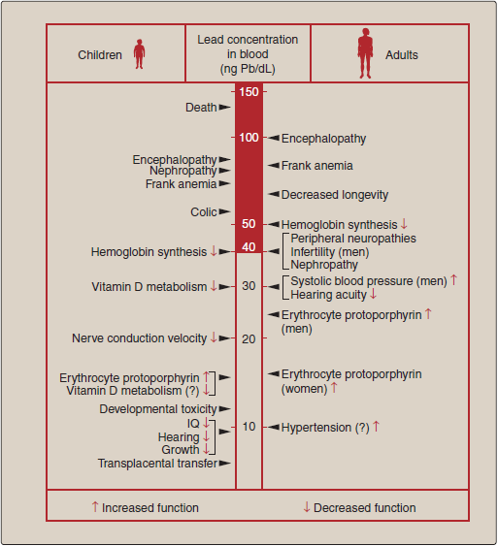
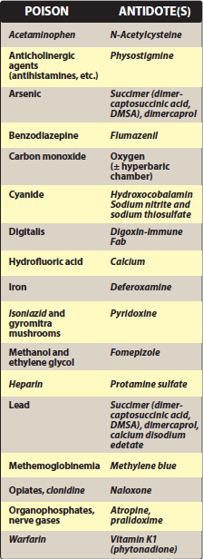

*** Organophosphate and carbamate insecticides
* toxicity through inhibition of acetylcholinesterase, with subsequent accumulation of excess acetylcholine producing nicotinic(mydriasis, fasciculations, muscle weakness, hypertension) and muscarinic(diarrhea, urination, miosis, bradycardia, bronchorrhea, emesis, lacrimation, salivation) effects
* Carbamates reversibly bind to acetylcholinesterase, whereas organophosphates undergo an aging process to ultimately irreversibly inactivate the enzyme.
* Organophosphate nerve agents, such as sarin, soman, tabun, have same mechanism of action, but the aging process is more rapid compared to insecticides
* Atropine, a muscarinic receptor antagonist >> treat muscarinic effects(IV or IM)
* pralidoxime an oxime to reactivate cholinesterase>> treat nicotinic effects(IV or IM)

