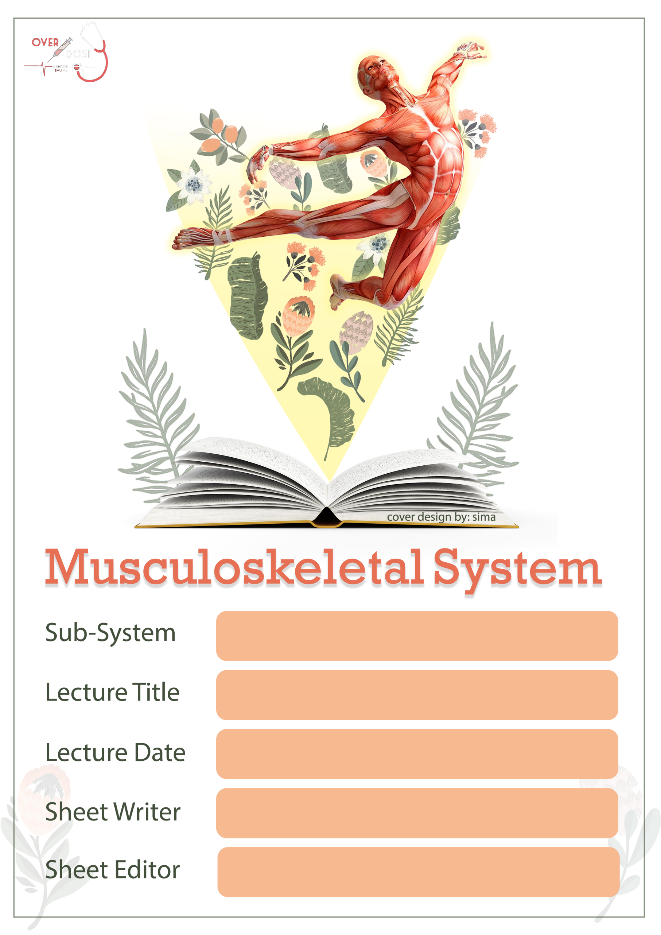
10-11-2019
Posterior compartment of the thigh; sciatic nerve and popliteal fossa
Anatomy
Yaqeen Majed
Hadeel Tawalbeh
Sheet correction link: bit.ly/mssanatomy

The posterior compartment of the thigh
(Review from the previous lec)
- Muscle of The posterior compartment of the thigh are the:
NOTE: The biceps femoris has:
- long head originated from ischial tuberosity and supplied by tibial nerve.
- short head originated from linea aspera supplied by common peroneal nerve
** both head united to insert into head of fibula .
- Biceps femurs.
- semitendinosus muscle.
- semimembranosus muscle.
- the hamstring part of adductor Magnus.

- Innervation:
Note: the adductor portion is innervated by the post. Division of the obturator n. while the hamstring portion is innervated by sciatic n.
all supplied by sciatic nerve.

- Arterial supply:
- inferior gluteal artery.
- profunda femoris artery (perforating artery)

- Origin:
most of these muscles originate from ischial tuberosity. Most of these muscles crossing the joint except the short head of the biceps femoris and the hamstring of the adductor Magnus.
NOTE: Common hamstring origin (CHO) is ischial tuberosity

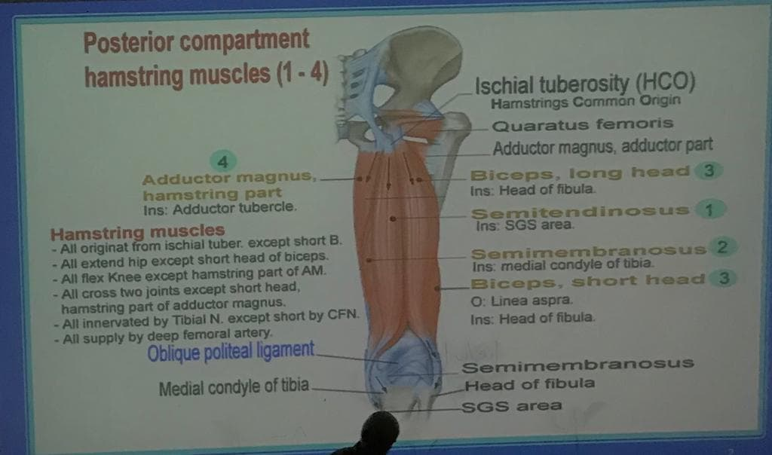
Sciatic nerve
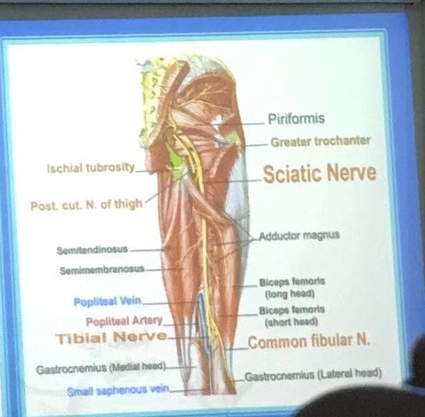
Sciatic nerve is a largest nerve in the body which makes it very important. It originates from lumbosacral plexus L4 (Lower border only); L5; S1; S2; S3. Leave from greater sciatic foramen then cross below the piriformis muscle then continue between greater trochanter and ischial tuberosity. Above the superior angle of popliteal fossa, it divides to 2 branches:

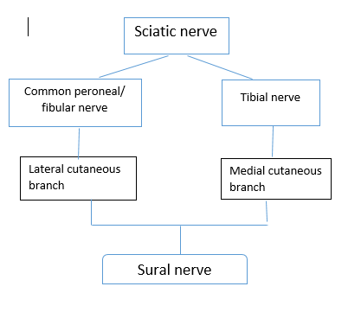
- tibial nerve [with popliteal vessels].
- common peroneal” fibular” nerve [cross into medial border of biceps femoris].
NOTE: Any muscle that work on two joint; has two opposite action.

Clinical notes:
1) Any fracture in the neck of fibula effects common peroneal nerve and biceps femoris.
2) when we wear high boots in winter; this leads to lateral compression to the common peroneal nerve causing paresis (not paralysis).
- paresis: partial.
- Paralysis: complete.
3) SCIATICA: compression on the roots of the sciatic nerve due to the heavy weight. Especially in obese people and age more 40-50.
4) Femoral neck fracture symptoms: the most common symptoms are pain in the groin that gets worse when you put your weight on your hip or try to rotate the hip. With a femoral neck fracture, your leg may appear shorter than your uninjured leg, or your leg may be extremely rotated laterally (cuz the lateral rotators (sciatic trap ms.) are stronger than the medial ones) with your foot and knee turned outward.
وقال الدكتور: انه الاسعافات الاولية لهذه الحالة القيام بربط أصابع القدم الكبيرة بأي اشي مثلا شال او سلك
Google: help causality to lie down > place some support alongside the leg> call emergency> immobilize the leg by splinting to the other leg.
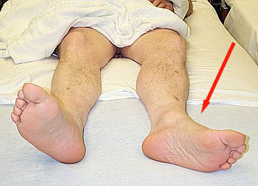

- There are 4 muscles located anterior to sciatic nerve:
- superior gamellus. 3. inferior gamellus.
- obturator internus. 4. Quadriceps femoris.

Sural nerve
A nerve in the calf region (sura) of the leg. It is made up of branches of tibial nerve and common fibular nerve (two common branches of sciatic nerve). the nerve runs down the mid-calf m. to the ankle along the skin from the mid-posterior popliteal fossa to just behind lateral malleolus and forward along the lateral aspect of the foot.

Popliteal fossa
Diamond shape space; located behind the knee joint
Popliteal fossa
Borders:
- superomedial:
-semimembranosus.
-semitedinosus.
- suprolateral: biceps femoris.
- inferomedial: medial head of the gastrocnemius.
- infrolateral: lateral head of the gastrocnemius.
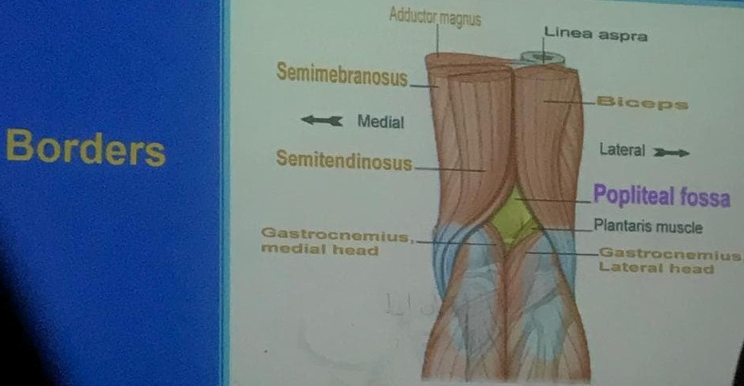
Roof:
NOTE:
THE SMALL SAPHENOUS VEIN ;SURAL NERVE AND POSTERIOR CUTANEOUS NERVE PIERCE THE DEEP FASCIA.
- skin
- superficial fascia
- deep fascia
- Post. Cut. N. of thigh
- Small saph. N.
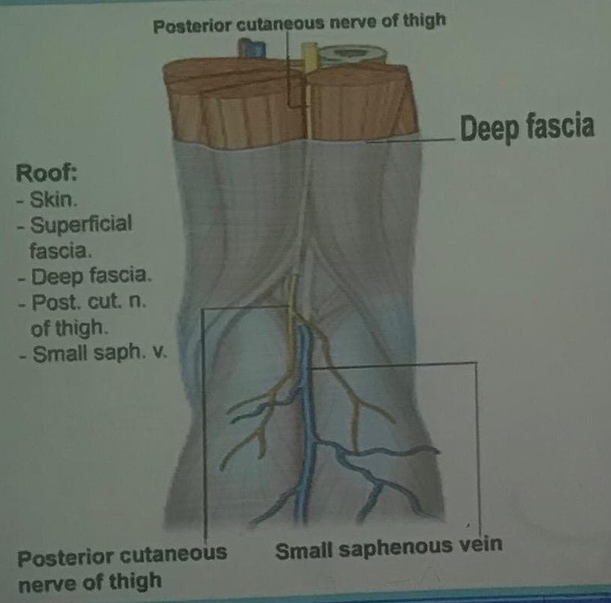

Floor:
Clinical note:
Any posteriorly dislocation in knee joint effects to the floor of popliteal fossa.
- the popliteal surface of femur.
- the capsule of knee joint.
- popliteus muscle.
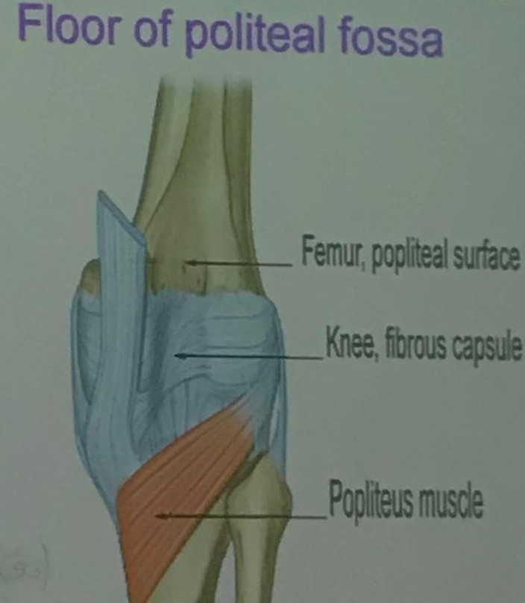

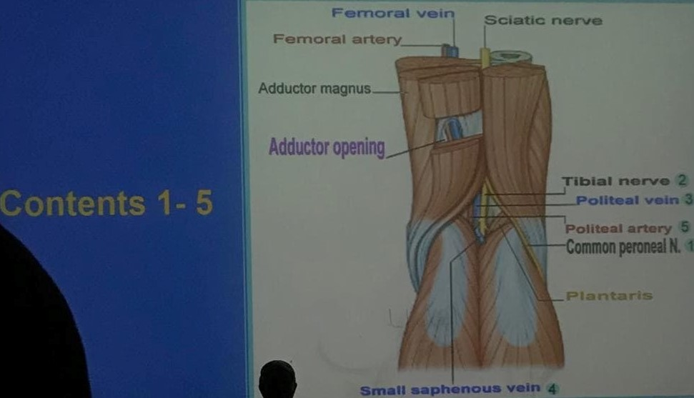
Contents: *from superficial to deep

- Sciatic nerve: and its branches; because the sciatic nerve may divide in the middle of the lower part of popliteal fossa (tibial and common peroneal n.)
- popliteal vein: arises at the lower border of popliteus muscle; ascends through the popliteal fossa and passes through the adductor canal (opening); becoming the femoral vein.it receives tributes:
- anteriotibial vein
- postrior tibial vein.
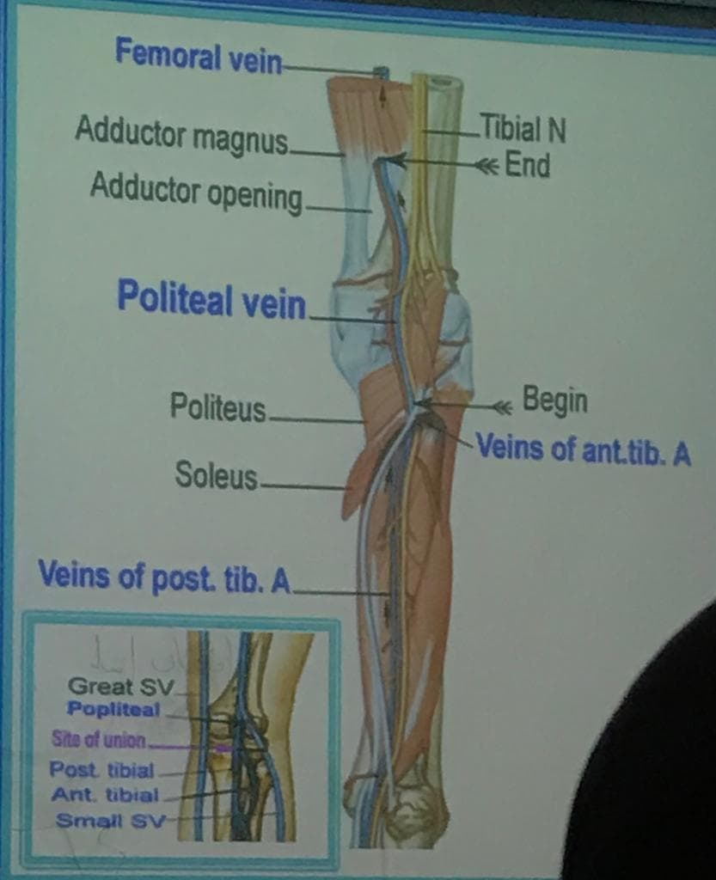
- popliteal artery:
- posterior and deepest one.
- it is not easy to feel the pulsating of popliteal Artery.
- continuation of femoral artery crosses through adductor foramen then to popliteal fossa and end in the lower border of popliteus muscle to divide into 2 main branches:
- Anterior tibial artery: supply the anterior components of leg. posterior
- tibial artery: supply the posterior and lateral components of leg.
- other branches: genicular “articular “branches:
- superior lateral 4. superior medial
- inferior lateral 5. inferior medial
- middle
- These braches forms periarticular genicular anastomosis:
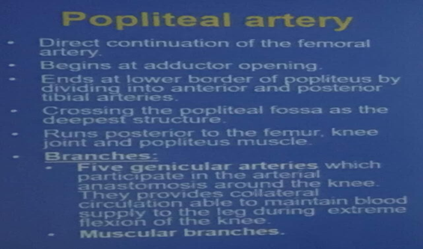
a network of vessels surrounding the knee that provides collateral circulation capable of maintaining blood supply of the leg during full” excessive”flexion which may kink ” يتشابك او متعقد “the popliteal artery
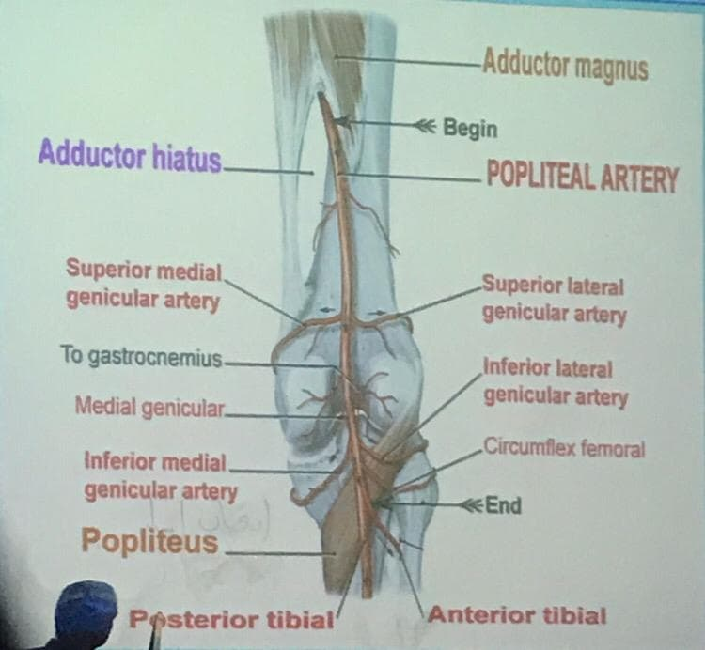
NOTE:
USUALLY THE ARRANGMENT OF VEINE ;ARTERIES AND NERVES (from superfacial to deep) IN THR BODY in THIS PATTERN [ V.A.N]----(VEIN .ARTERY .NERVE ) ;BUT IN POPLITEAL FOSSA THE ARRANGMENT IS [N.V.A]----(NERVE .VEIN .ARTERY).
NOTE:
Popliteal pad of fats:
protects the other contents (veins; nerves and arteries) from kink.

GOOD LUCK

