Anatomy
Joints of the Lower Limb/part I
25/9
Rashed Arabiyat
Mahmoud Fraihat

Sacroiliac Joint:

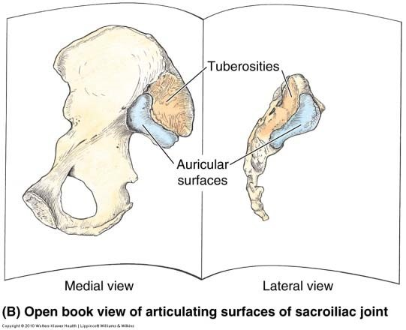
• Auricular surfaces of the sacrum and the iliac bone
• No movement; transmit body
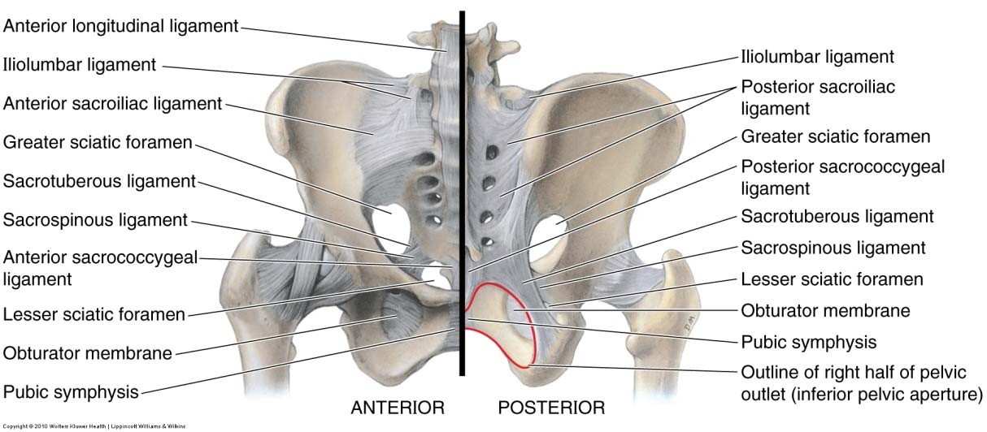
weight from the vertebral column to pelvis
• In elderly people synovial cavity
disappear and becomes fibrous joint
• Nerve supply: sacral spinal nerves
- Sacroiliac joint is between sacrum and ilium of hip bone.
- The participating parts of ilium are Auricular surface and tuberosities(with rouphness medially).
- Sacroiliac joint is mixed joint (synovial and fibrous)
- Auricular surface is the synovial part (plane joint).
- The interosseous sacroiliac ligament (between tuberosities of sacrum and iliac bone)
- Because of presence of The interosseous sacroiliac ligament, the sacroiliac joint is immobile joint (with some exceptions like in delivary under effect of hormons).
- With time, even the synovial part will become fibrous part.

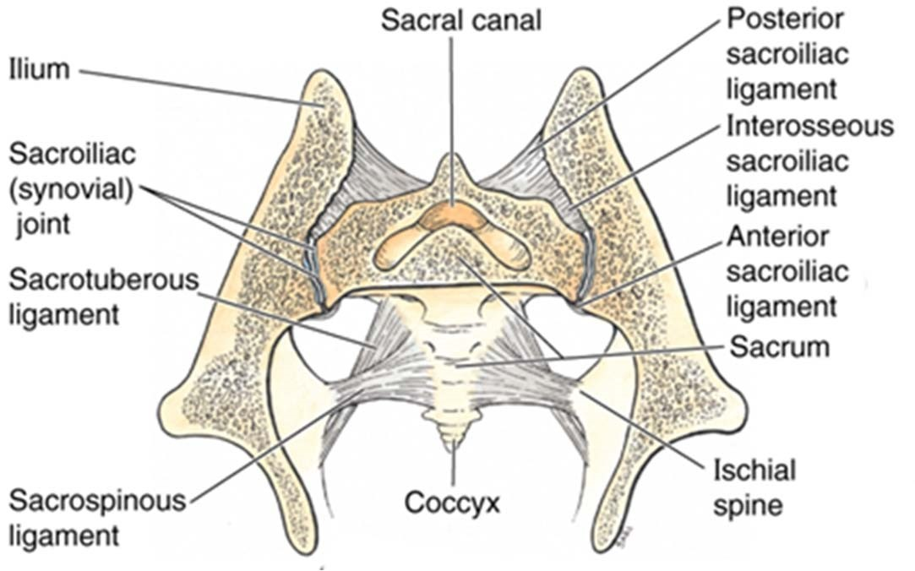
Associated ligaments

• Posterior sacroiliac ligament

•Interosseous sacroiliac ligament

(between tuberosities of sacrum and iliac bone)

• Anterior sacroiliac ligament.

• Accessory ligaments

Sacrotuberous ligament :(b/w sacrum and ischial tubercle)

Greater sciatic foramen
ischial spine separates between lesser and greater sciatic notch.
Because the presence of these ligaments and its connection with sacrum ; the greater and lesser sciatic notches become foramens .

Sacrospinous ligament : (b/w sacrum and ischial spine)

Lesser sciatic foramen
( *** in the internet, both of these foramens associated with both ligament not only one of them)

Iliolumbar ligament: between the lower lumber vertebrae (5th) and ilium which gives extra support to the joint.

- The pelvis diaphragm(floor) separate the true pelvis from perineum which is outside the pelvis.
- The greater sciatic foramen is the outlet of the pelvis.
- We can go from Pelvis to gluteal region throw the greater sciatic foramen
- We can go from Gluteal region to perineum throw lesser sciatic foramen

Hip Joint:

• The participating parts:
- head of the femur and the acetabulum
• Type: Ball and socket joint

• Movements: All movements

• Most movable joint next to shoulder

• On standing transmits body weight through hip bone to head & neck of femur

• Nerve supply: femoral, obturator, and sciatic nerves and nerve to the quadratus femoris m.

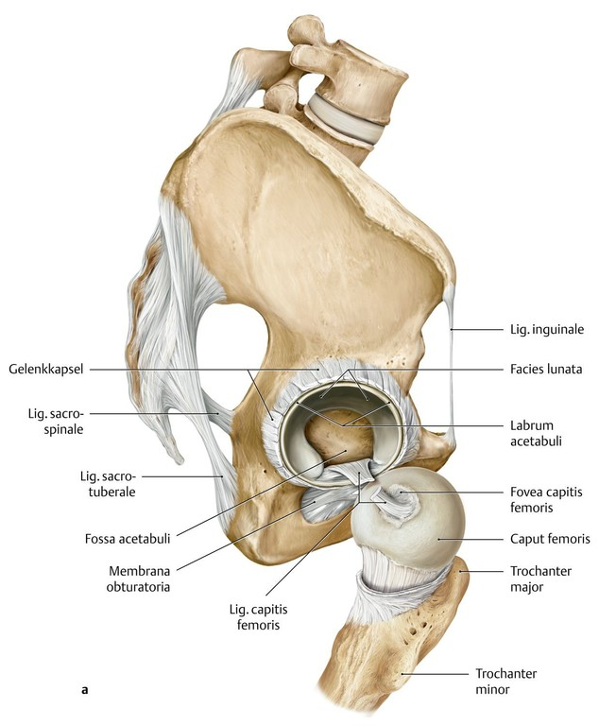
Hip Joint: Components:

• Head of femur
-Fovea for lig. of femoral head ( No articular cartilage )
• Neck of femur
• Acetabulum
- Lunate surface (Articular part): part of synovial cavity
• Acetabular fossa: it is not an articular part so there will be no direct attachment between it and head of femur. It will be the attachment site for an intracapsular ligament and there will be a fat pad here.
• Acetabular rim not continuous rim because there is missing part inferioposteriorly called Acetabular notch. (***as in the internet, it is anteroinferiorly)
- Remember: the edges of the articular cartilage is the attachment of synovial membrane
- The fibrous capsule could directly cover the synovial membrane (the insertion of the Capsule will be the articular cartilage), or could be a little far from it.
- the insertion of fibrous capsule of the hip joint is in the distal part of neck of femur (not into the edge of the articular cartilage).

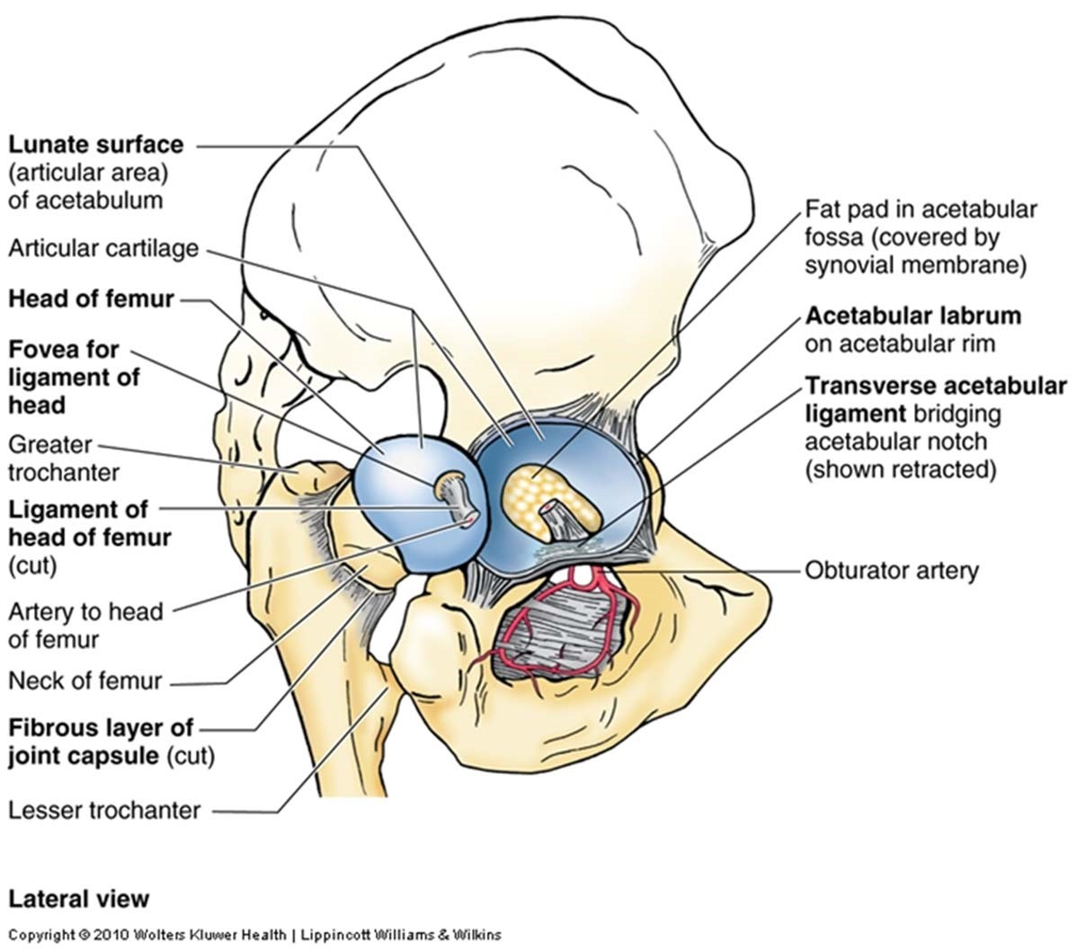
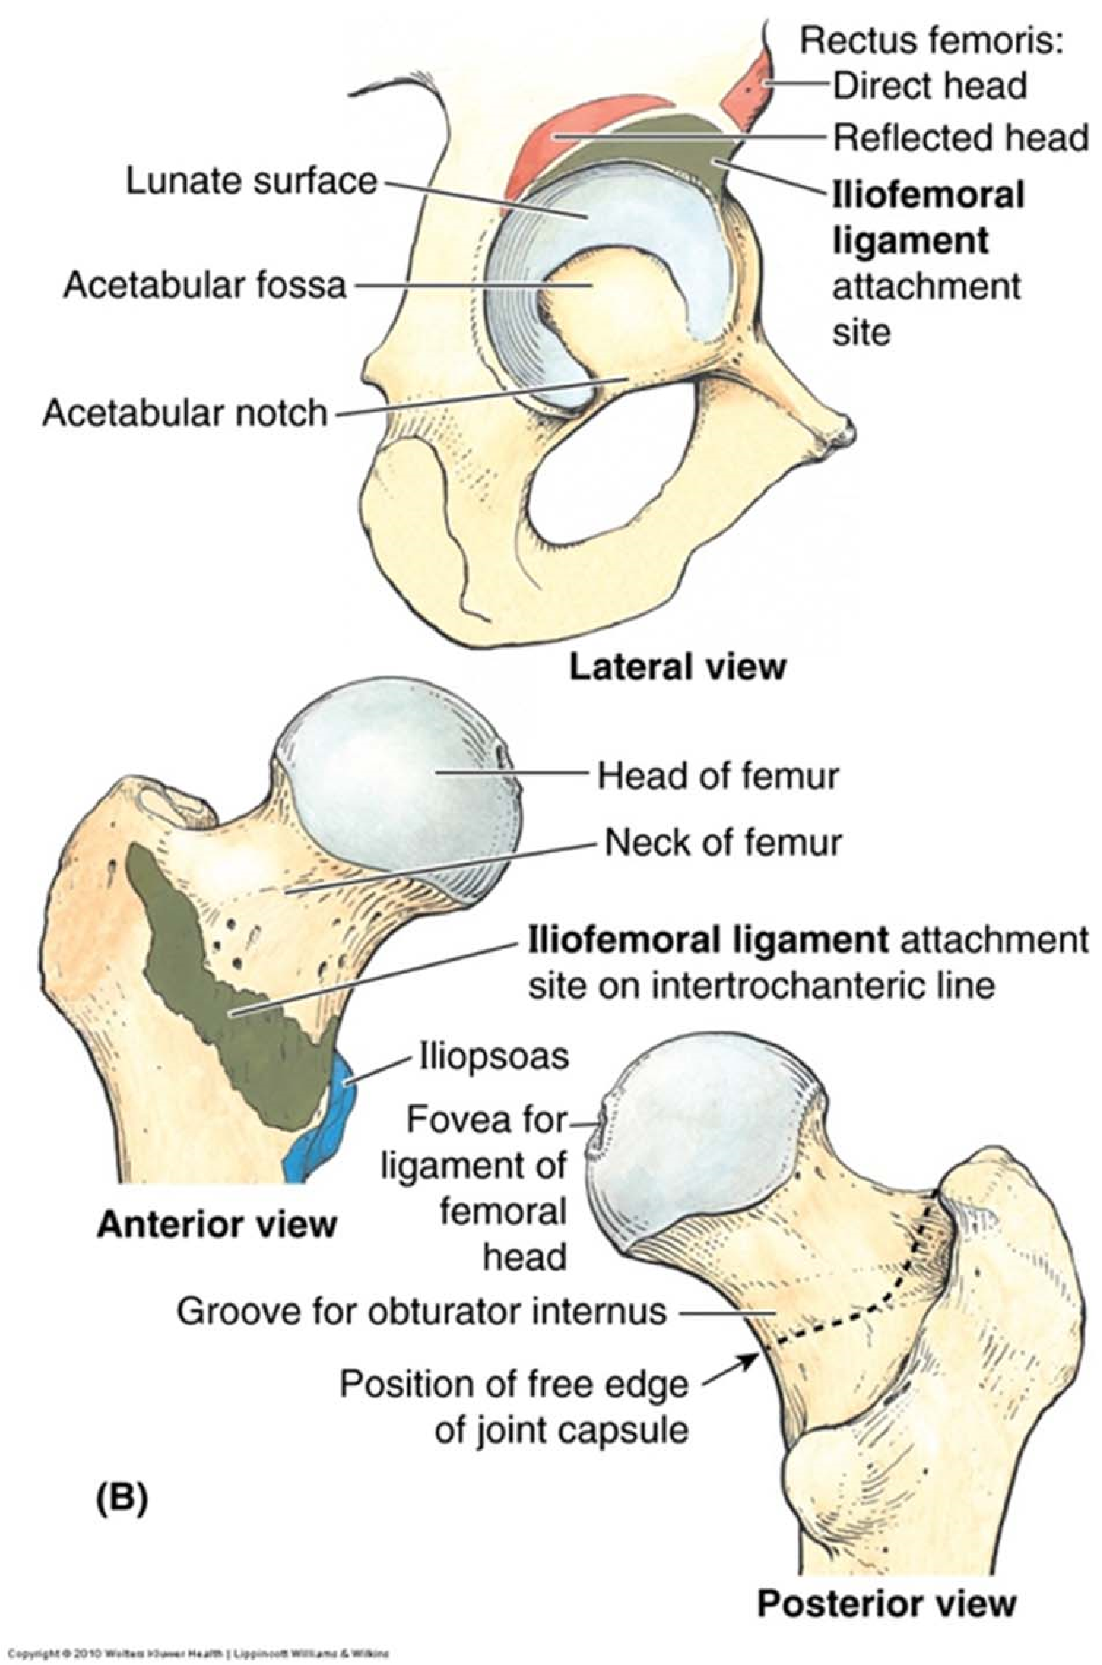
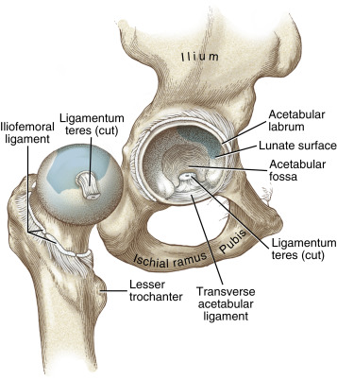
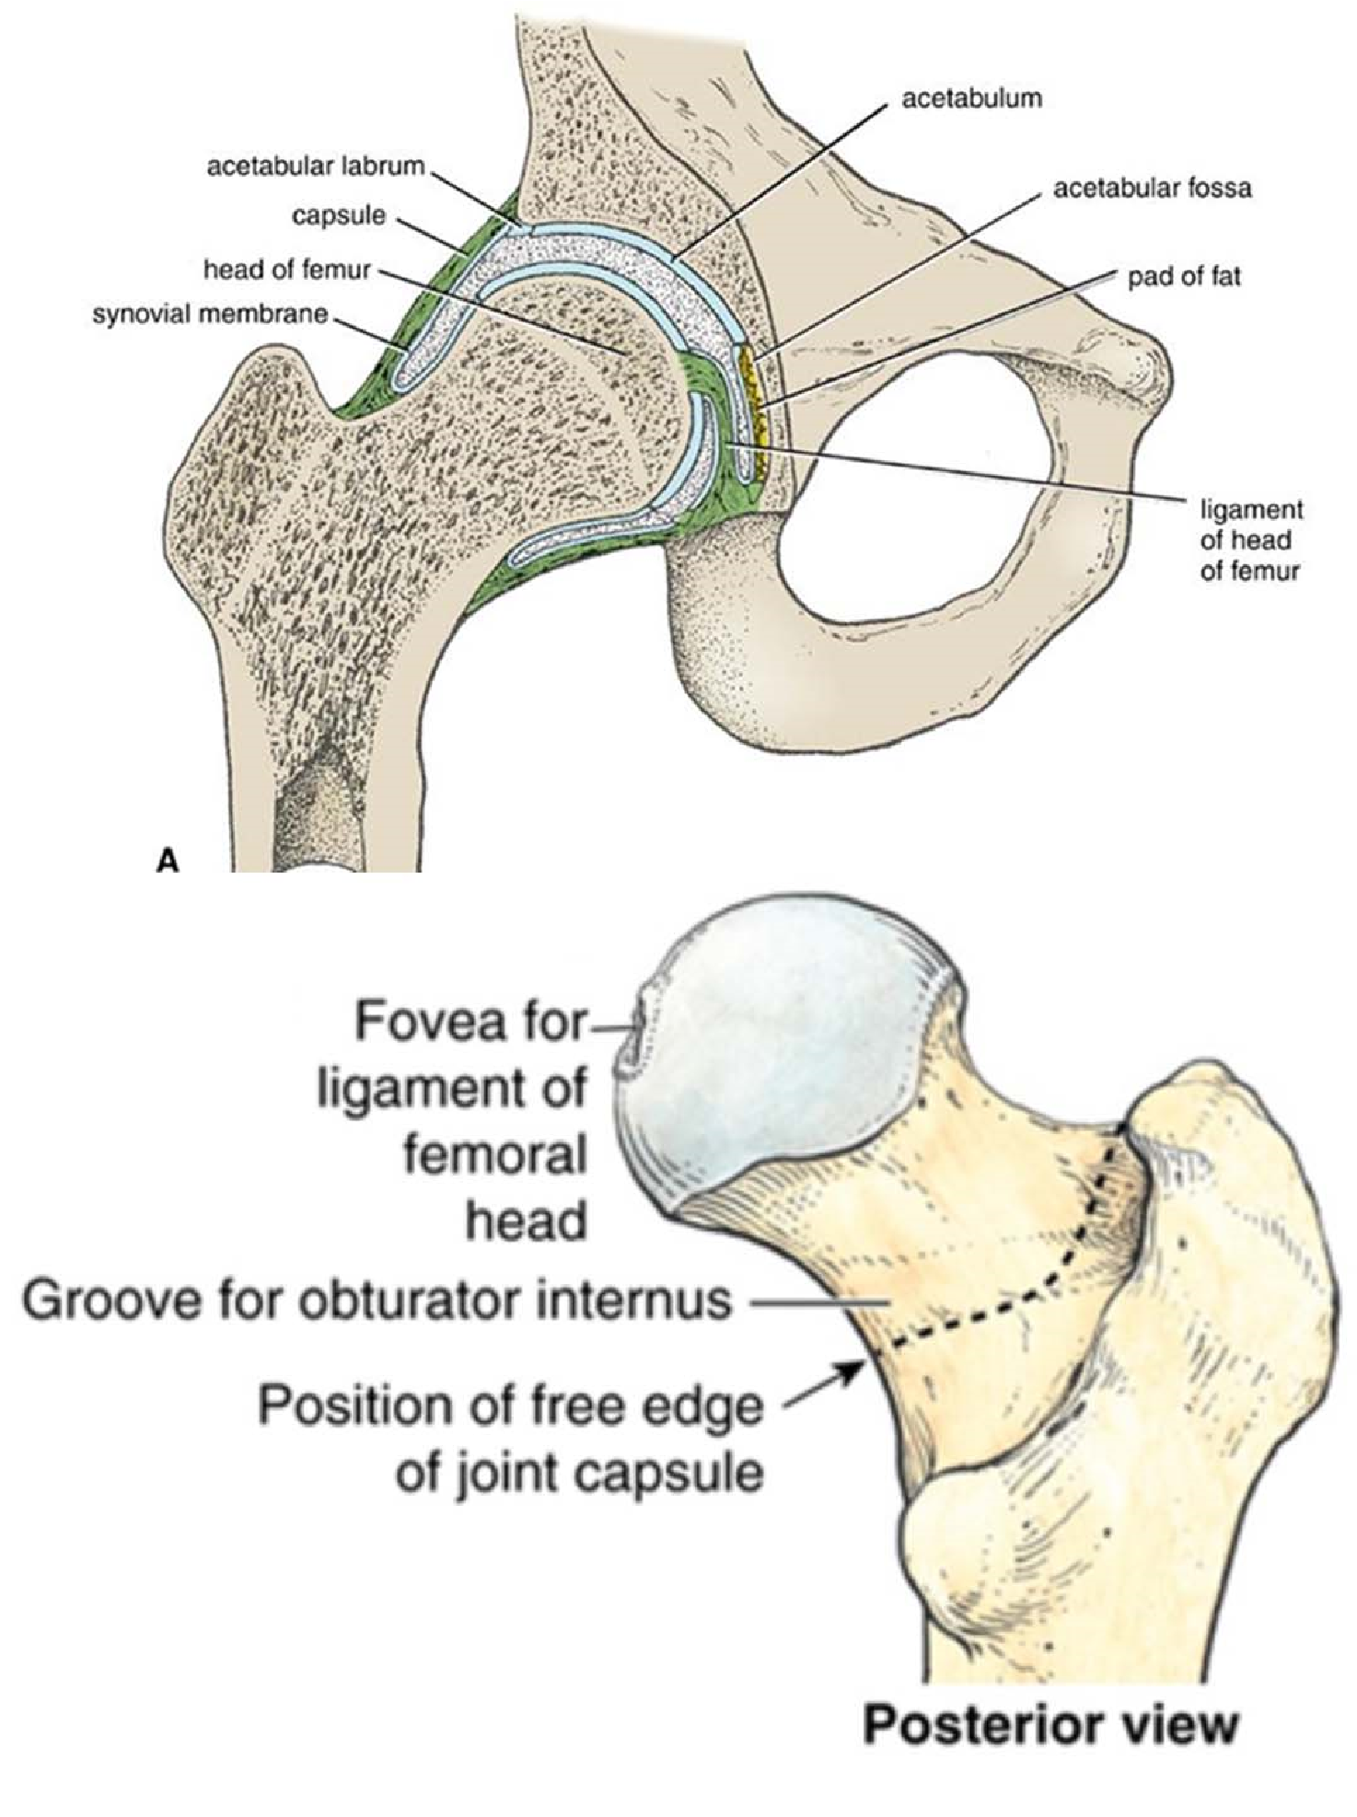
- Acetabulum isn’t enough to occupy the head of femur , so the acetabular labrum (cartilage) increases the deapth of the acetabulum
- The Acetabular notch is bridged by transverse acetabular ligament to complete the circle.

Hip Joint:fibrous Capsule:
• Proximal attachment
- Acetabular labrum
-Transverse ligament
• Distal attachment ( neck of the femur)
• Anteriorly
- Intertrochanteric line
• Posteriorly
- Free edge: (there is no attachment with the neck of femur)
****dotted line is the end of fibrous capsule without an attachment with bone
This part of the bone is the Intertrochanteric crest ( the place where there is no attachment with the capsule)
-synovial membrane protrude out of this area and make bursa

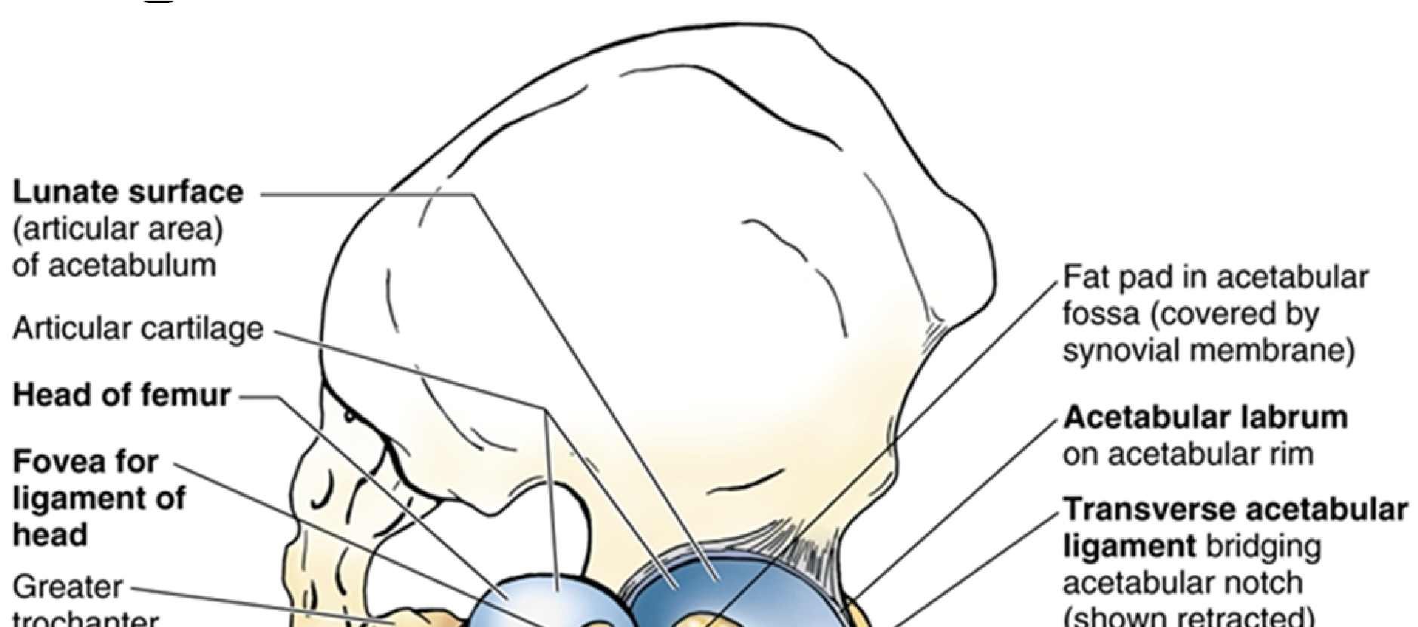
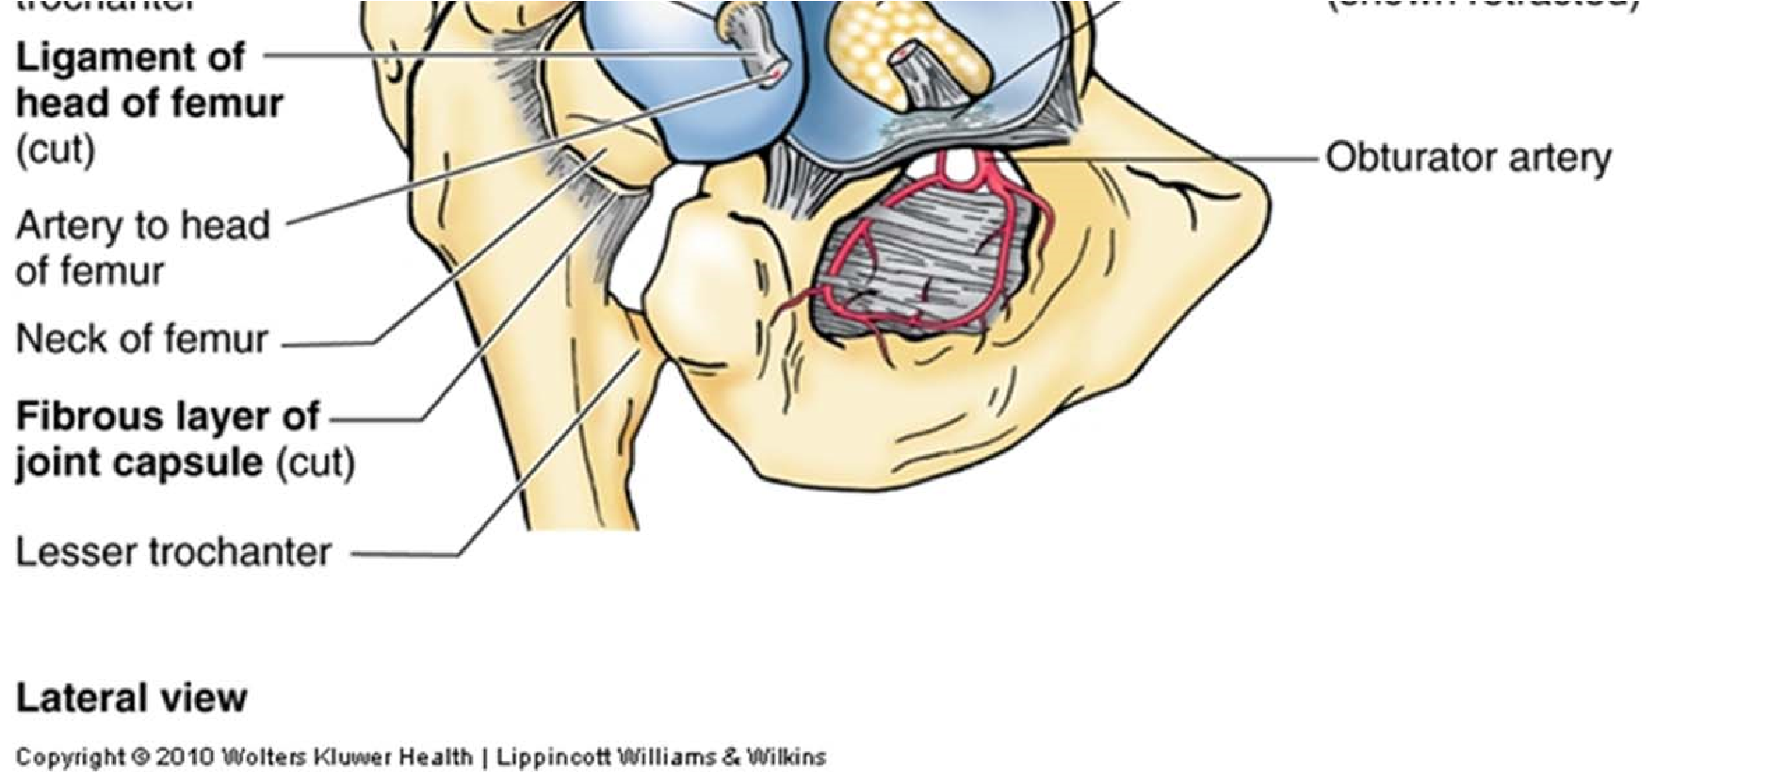
Hip Joint: Ligaments
• Intracapsular ligaments
Any joint that have intracapsular ligaments means that it has high level of stress. And it will help fixation of the joint. (Also the knee joints)
- Transverse acetabular ligament
• Bridge the notch(which form a tunnel like structre for passage of BVs
• Entrance of BVs (blood vessels)
- Ligament of the head of the femur
• Transverse lig. & edges of notch
• Fovea capitis: (depression in the head of femur where the intercapsular lig attach)

• Extracapsular ligaments :

• very strong and thick ligaments, and they cover the whole capsule
(3 ligaments, each one of them comes from of bone of hip bones)
• Iliofemoral ligament
• The Strongest. • inverted Y‐shape
Attachments
• AIIS (anterior inferior iliac spine) —> proximal attachment
• Intertrochanteric line (ITL) (behind the capsule)
• Superior – anterior (the sup. and ant.parts of capsule are supported by this lig)
• Function: Prevent hyperextension during standing
*most movement of the hip joint is flection and extention

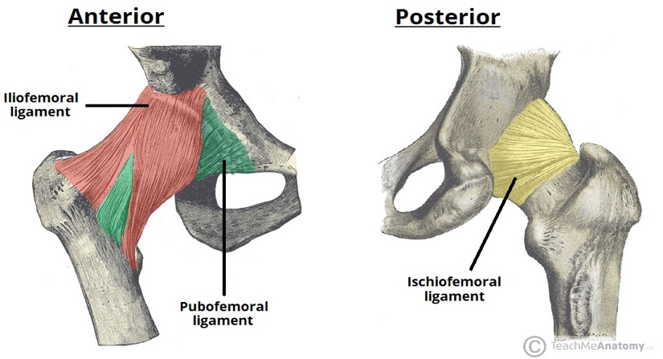
• Pubofemoral ligament :

• Triangular shape

• Attachments:

• Superior ramus of pubis

• The inferior part of the intertrochanteric line

• Function: Limits extension and abduction. Support: Anterior ‐ inferior
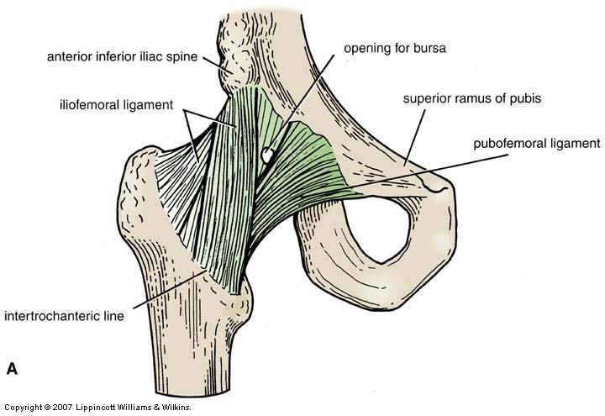
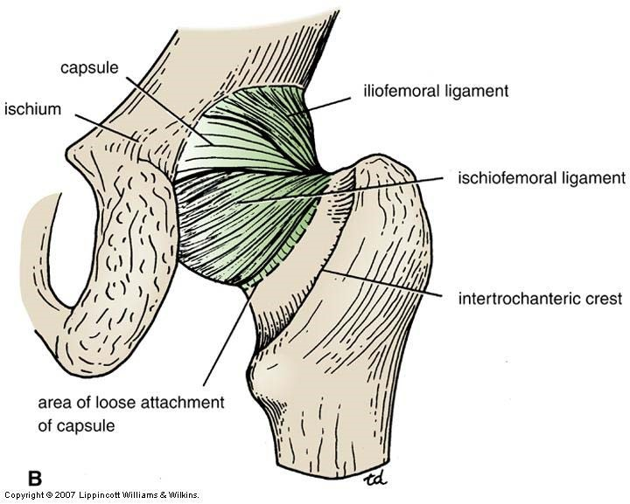
• Ischiofemoral ligament
• The weakest • Spiral shape
• Attachments
• Ischial part of acetabular rim
• Greater trochanter
*doesn’t attach posteriorly to keep the free edge opens
•Function Limits extension and
medial rotation
*It supposed to prevent flection
But actually, it prevents extension due to its orientation (Twisting)
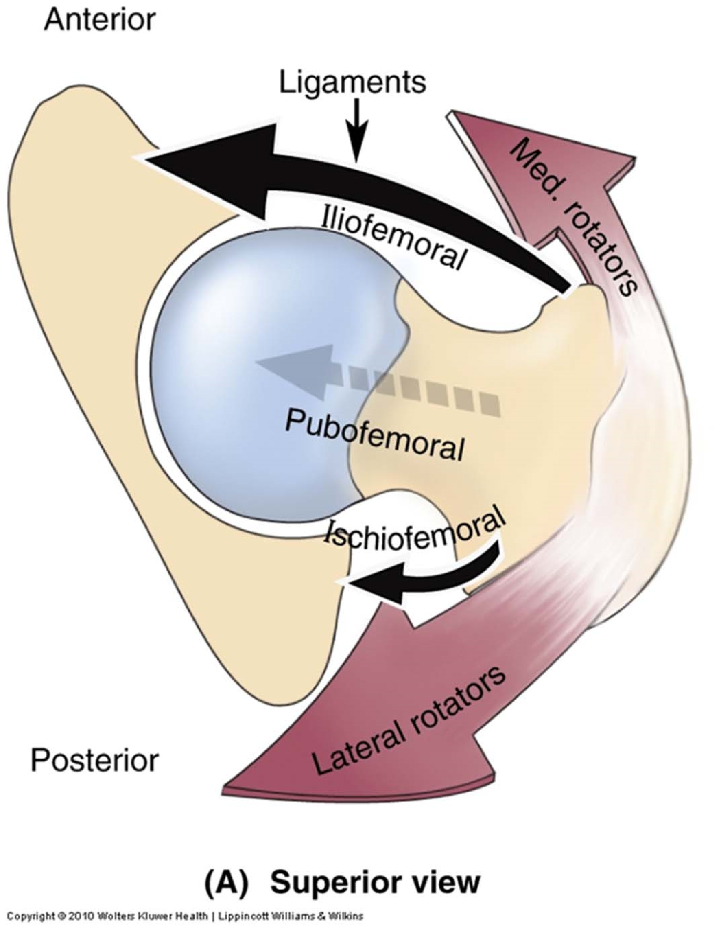
•Relative strength of ligaments compared to muscles
• Anteriorly: Strong ligament and weak muscles (Iliofemoral ligament)
• Posteriorly: Weak ligament and strong muscles (Ischiofemoral ligament which is weak and with strong muscles like Gluteal and lateral rotator muscles)
*so the bulk of these muscles is unbalanced

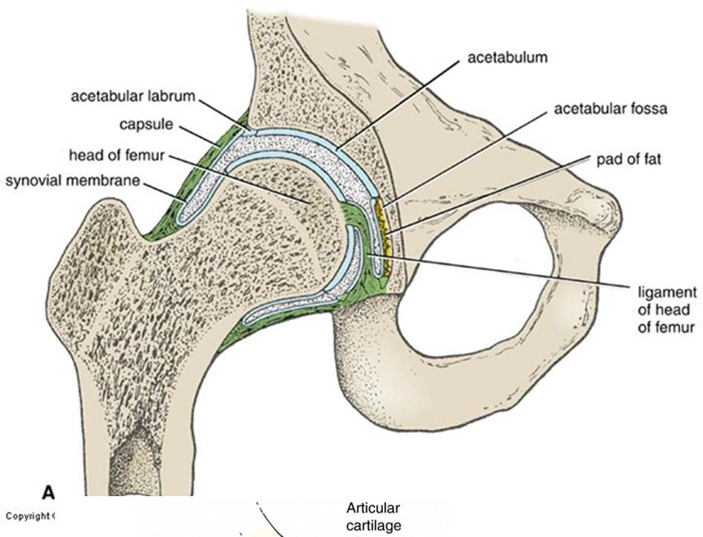
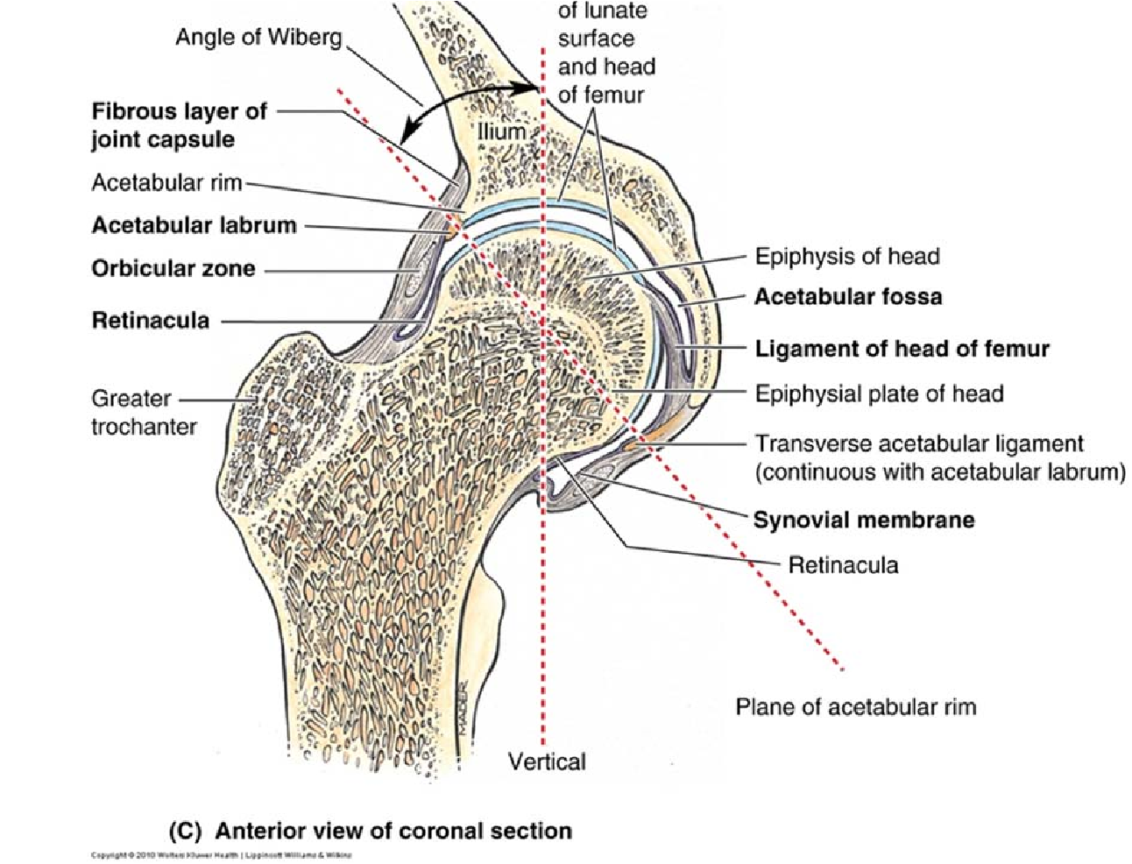

Hip Joint: Synovial Membrane
• Attached to articular surfaces (which are in the head not the neck)
• Lines capsule
• Covers (means exclude the following structures)
-Transverse lig.
- Ligament of head of the femur
- Pad of fat in acetabular fossa
- Neck of femur
• Synovial fold (retinaculum)
- At free edge of capsule
Synovial membrane contain only synovial fluid ,so if there is any structure inside the fibrous capsule (ligaments, fats, or maybe muscles) it has to be excluded from synovial cavity.
In other words synovial membrane lining fibrous capsule but excludes other structures
( بده يلف يدبر راسه (
The attachment of synovial membrane starts from the edges of articular cartilage and runs down to cover (exclude) the neck then it reflex backward
Remember: articular surface of the acetabulum is the lunate surface

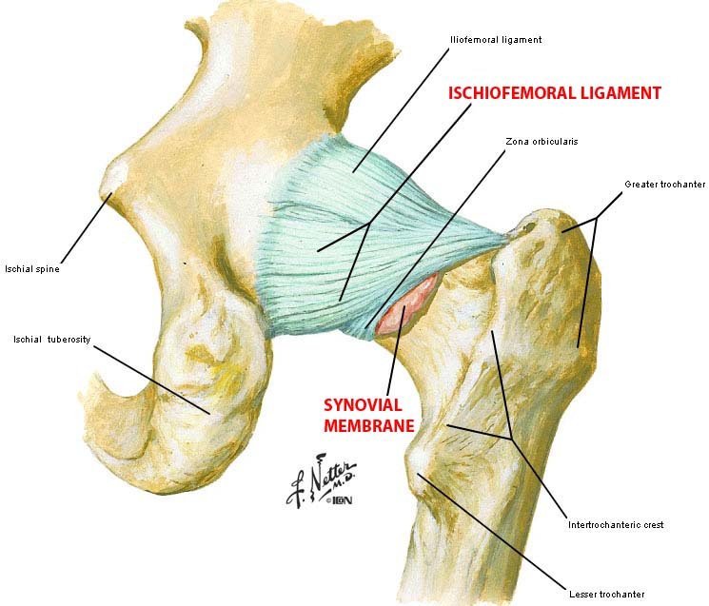
• Synovial fold (retinaculum)
- Because of protrusion of synovial membrane out of the free edge it becomes thicker (in order to resist forces) which is called Synovial fold /retinaculum.
- Note :synovial membrane is very thin membrane composed of simple cuboidal synovial cells above areolar C.T
- Outside the areolar C.T becomes dense C.T (thicker)
- Its located posteriorly
Bursae:
- It can be a cushion like structure or an extension of synovial membrane
- To protect joint or tendon from each other
- Sometimes it a tendon sheet like structure
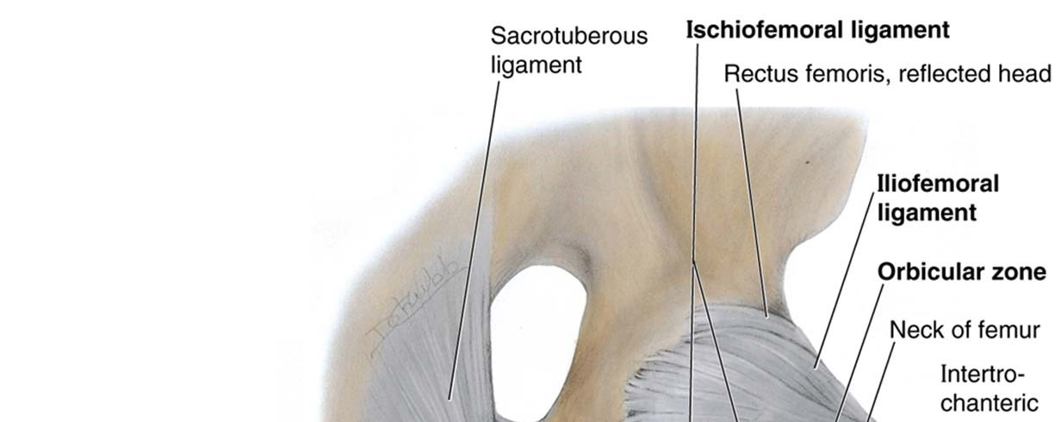
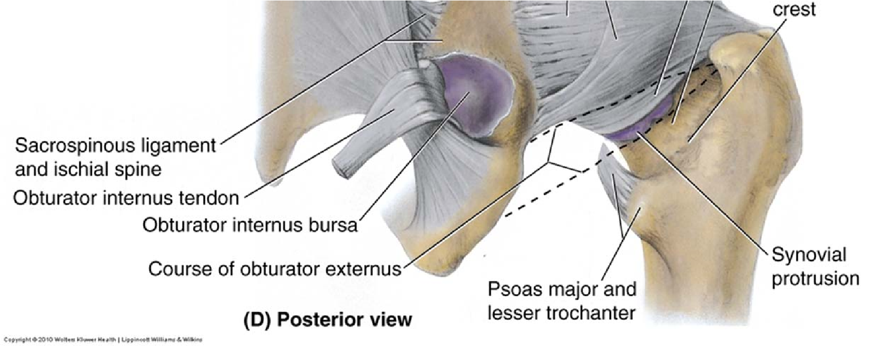
• Psoas bursa
• Anterior continuation of synovial membrane ( there is a defect in the Iliofemoral ligament for it)
related to iliopsoas muscle (one of muscles that across the joint anteriorly with direct relation to the joint, so psoas bursa protect the joint from this muscle).
• Bursa for obturator externus muscle
• Posterior synovial protrusion ( it is a continuation of the synovial membrane)
• Through the free capsule edge(extension of free edge)
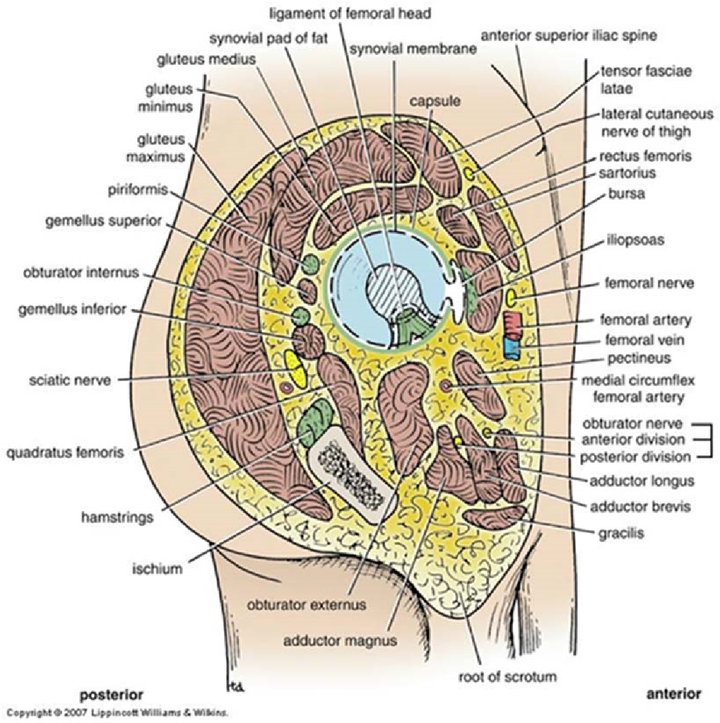
• Obturator internus bursa: separated from the synovial membrane

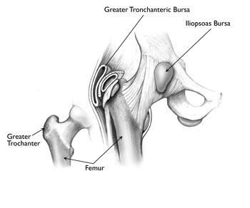

Movements:
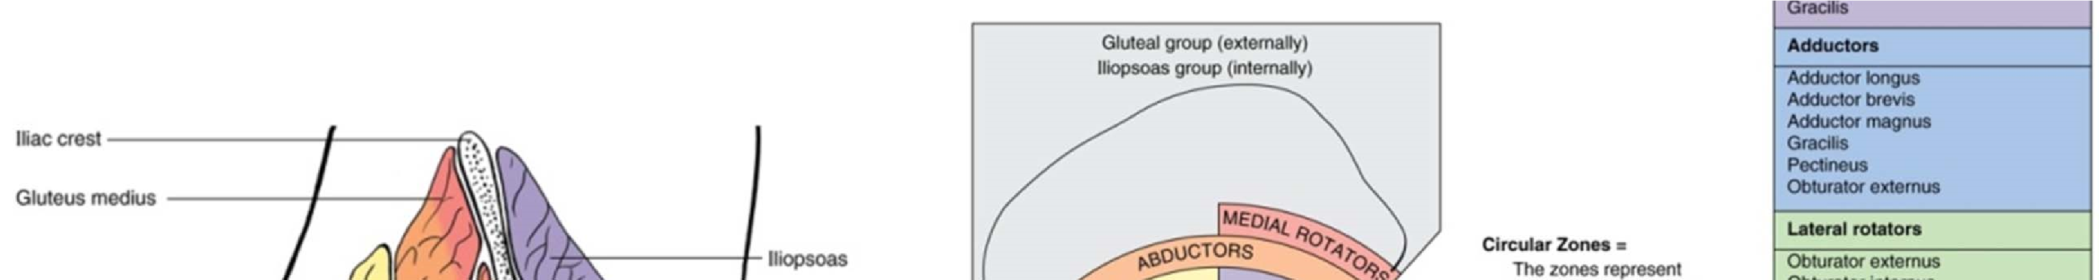

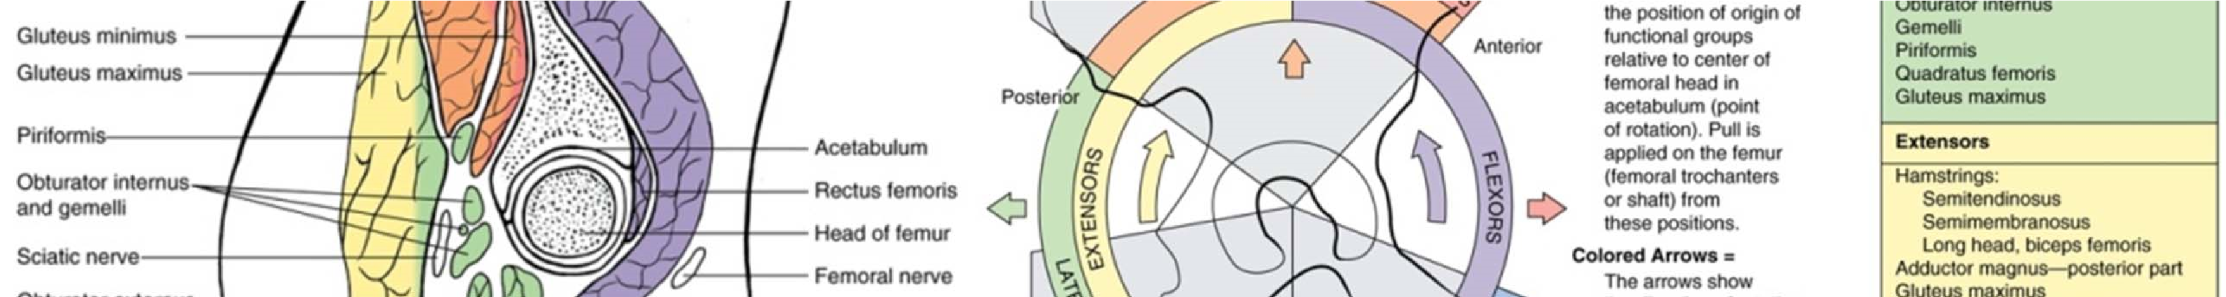

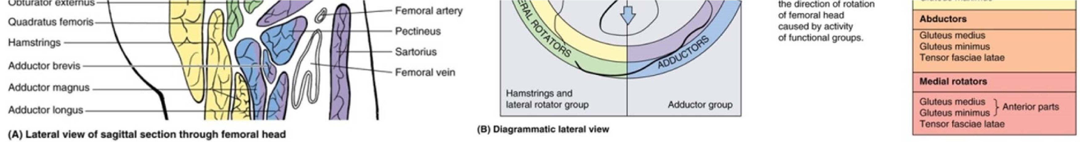

Relations : (relations is very important because any problem in the hip joint like dislocation for example will affect these structures that is related to it)
• Anteriorly: content of the femoral tringle (Entrance of vital structure from abdomen toward thigh is inferior of inguinal lig. toward femoral tringle.)
• Content of femoral triangle: rectus femoris Muscle, iliopsoas Muscle, pectineus Muscle, femoral nerve, femoral artery and femoral vein.
- rectus femoris Muscle (one of Quadriceps femoris muscle (rectus femoris, vastus lateralis, vastus medialis, and vastus intermedius) all of them origin from the femur except the rectus femoris which origins from the hip joint. rectus femoris cross the hip joint and it has 2 actions: flection of the hip joint and extension of the knee joint)
• Posteriorly: gemellus superior muscle , obturator internus Muscle , gemellus inferior muscle, quadratus femoris Muscle, Sciatic nerve
• Superiorly:gluteus minimus Muscle, piriformis Muscle: very important muscle which can be highly affected by movement. It can affected the sciatic nerve because it go through the greater sciatic with the sciatic nerve and it can compresses the sciatic nerve.
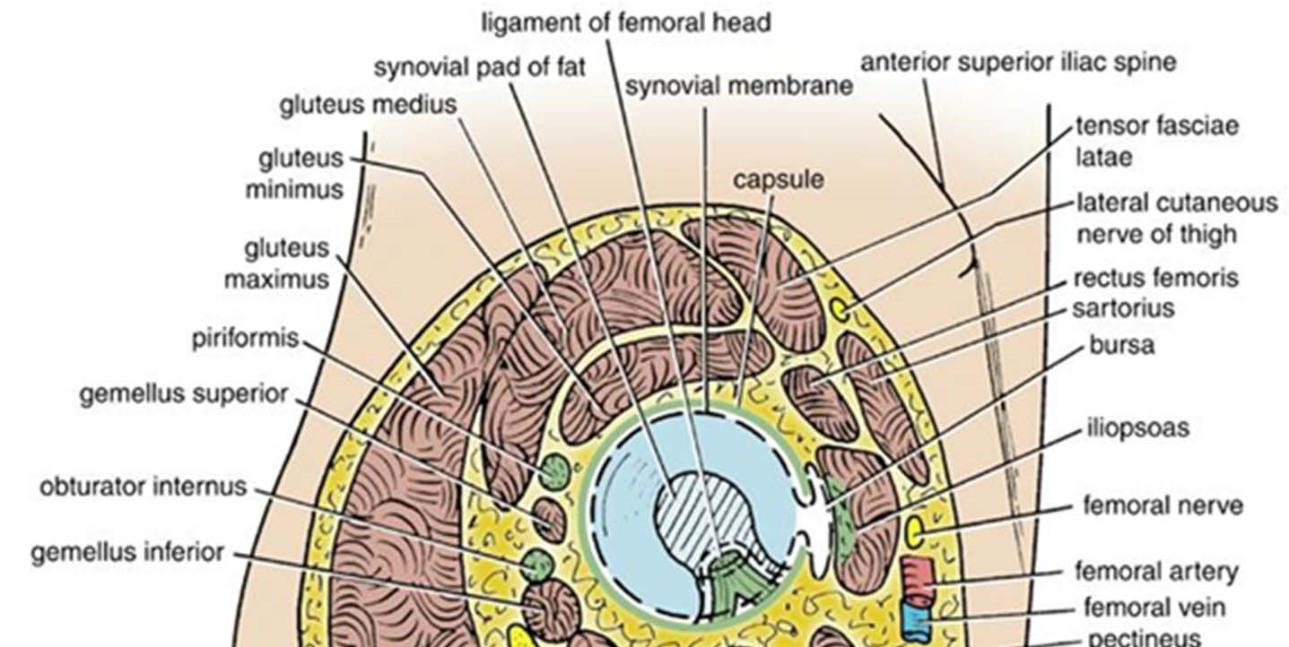
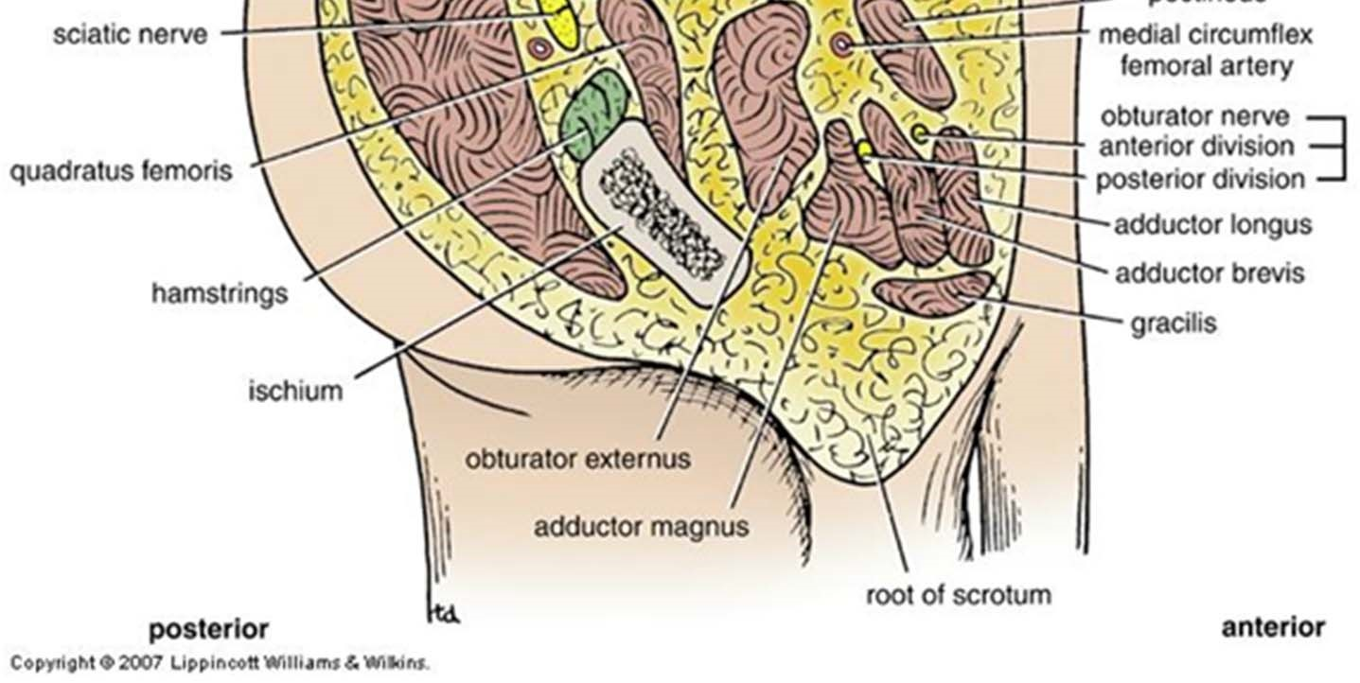
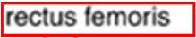
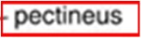
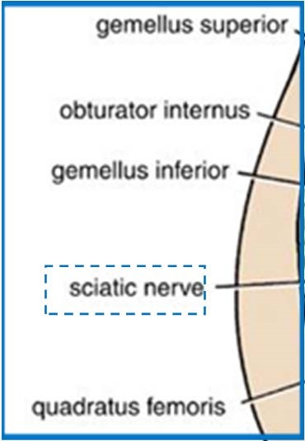
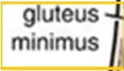
• Inferiorly: obturator externus, adductor magnus.

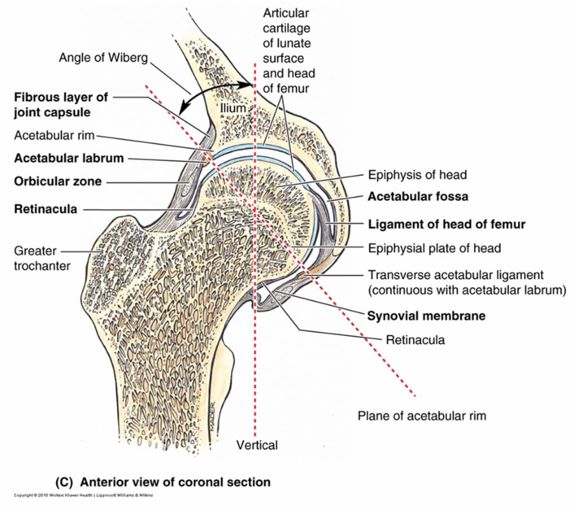
Hip Joint: Stabilizing Factors
• Acetabular labrum (Deepens the socket)
& transverse lig.
• Intracapsular lig. • Extracapsular ligaments
• Muscles traversing hip joint
• Orientation of acetabulum (inferio-laterally) to head of femur
• Superiorly located
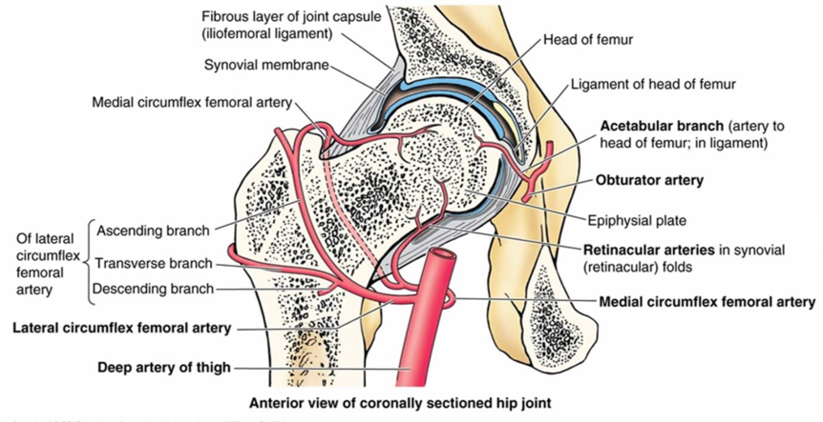
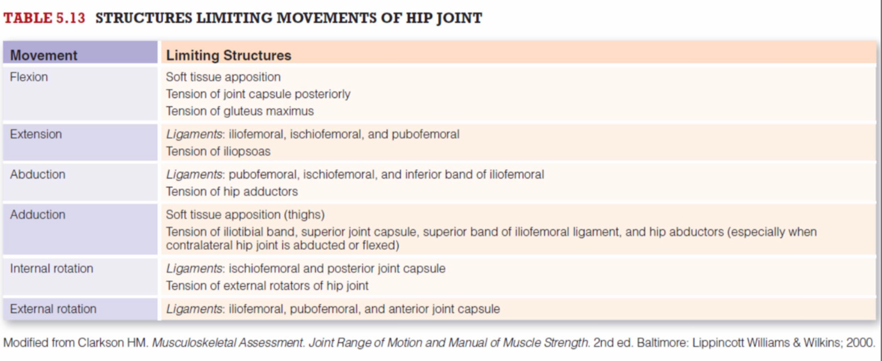
Hip Joint: Blood Supply
• Medial & lateral circumflex
- From profundal femoris
• Artery to the head of the femur
- From obturator artery
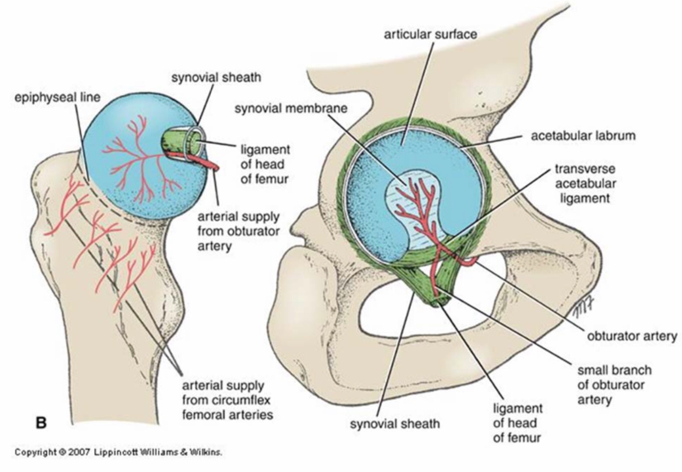
• Retinacular arteries
- Mainly from medial circumflex
- Inter from free edge of capsule

Sometimes when there is a fraction in neck of the femur, it will cause a necrosis in head of the femur. Even though the head has its own blood supply, it is not sufficient without the blood supply that come from the neck ( distal blood supply).

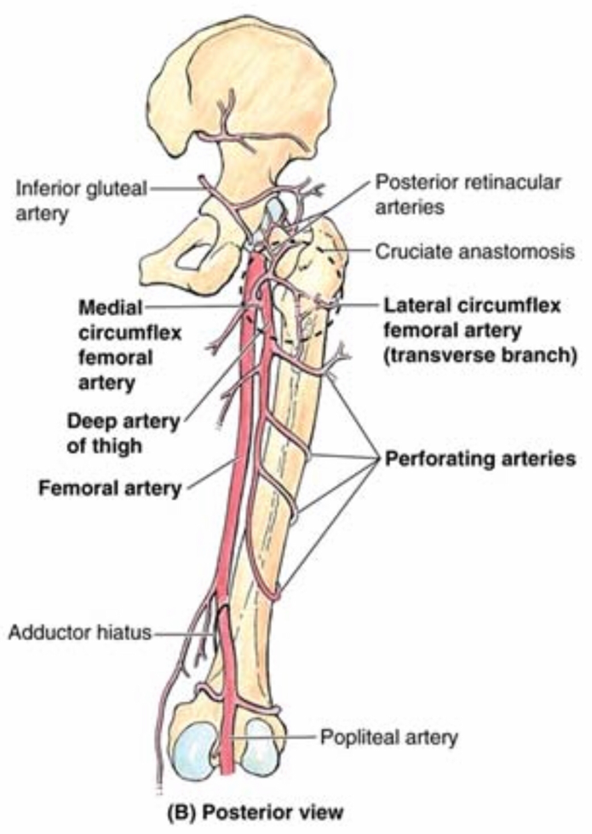
Hip Joint: Arterial Anastomosis
• Trochanteric anastomosis
- Superior gluteal a.
- Inferior gluteal a.
- Medial femoral circumflex a. • Lateral femoral circumflex a.
• Cruciate anastomosis
- Inferior gluteal a. (Superiorly)
- Medial femoral circumflex a. (Medially)
- Lateral femoral circumflex a. (Laterally)
- 1st perforating a. from profuna (inferiorly)

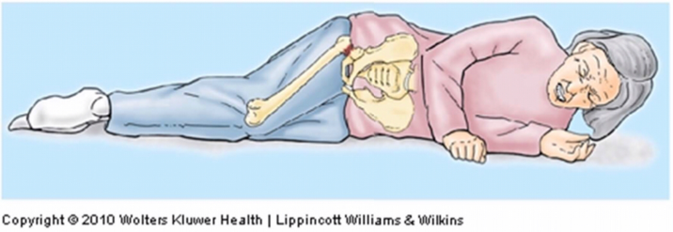
Hip Joint: Fracture
• Fracture of femoral neck
- Disruption of blood supply to the head
- Avascular necrosis ( Blood supply from artery to the head of the femur usually is not enough)
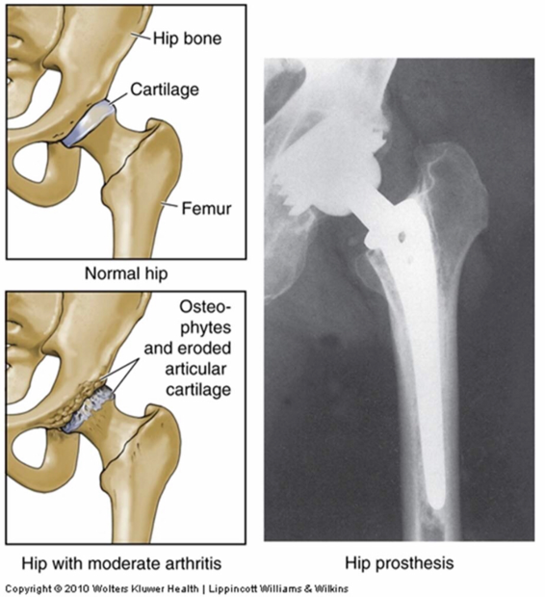
- In elderly
- Female > Male ( Osteoporosis)
Surgical Hip Replacement
- In traumatic injuries or degenerative diseases
- Replace head and neck of femur
- Often acetabulum lined by metal or plastic socket

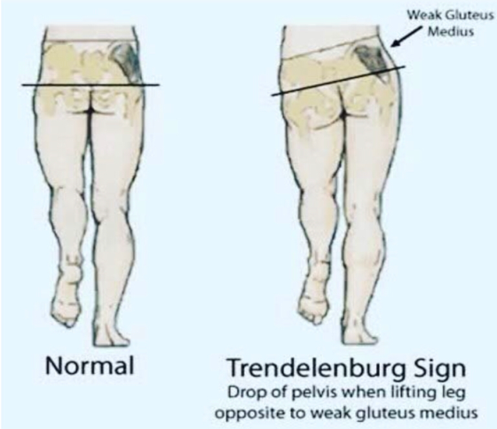
Dislocation of Hip Joint
- Congenital dislocation of hip joint
- Common 1.5/1000
- Female > Male
- Affected limb looks shorter ( Superior displacement)
- Positive Trendelenburg sign:
- Hip appear to drop to one side during walking
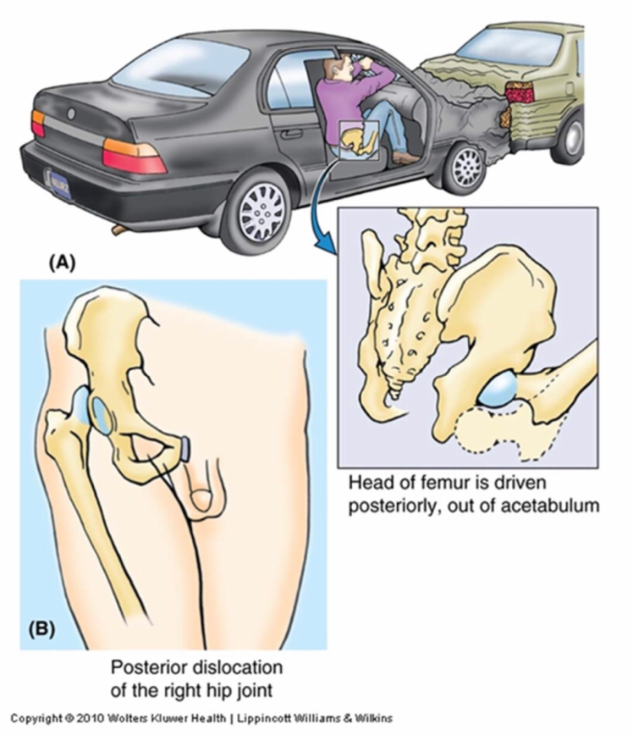
- Inability to abduct hip

- Acquired hip dislocation
- Rare
- Posterior dislocation more common
- In car accidents
- When femur is flexed, adducted, and medially rotated
- Sciatic nerve injury

